TimeTracker for SharePoint Manual

Table of contents

1 Introduction 2
1.1 Requirements 2
1.2 Data Storage 2
2 Basic Features 3
2.1 Premium Features 3
3 Permissions 3
3.1 Administrator 3
3.2 Users 3
4 Upload in App Catalog 4
5 Installation of TimeTracker 5
5.1 Add As A Web Part - Activate on Site Collection 5
5.2 Add on Microsoft Teams 6
6 Use TimeTracker 7
6.1 SharePoint Office 365 Modern Experience 7
6.2 Microsoft Teams 7
6.3 Usage 8
6.4 Display Records 10
6.5 Settings 10
6.6 Generate Reports 11
7 Uninstall 15
7.1 From Site Collections 15
7.2 From MS Teams 16
7.3 From SharePoint Tenant 16
8 Contact 17

Introduction
SharePoint is a one-stop platform for team collaboration, with robust capabilities. We extend the capabilities of SharePoint with our solution TimeTracker for SharePoint which allows team members to log attendance via SharePoint Modern Web Part and MS Teams.
This app can be published in SharePoint site collection home page by using a modern web part. The app can directly be added in Microsoft Team also.
Multi-device access allows employees to Log-in and Log-out without a hassle. The app is integrated in the MS Teams and available for Mobile, a Tablet, Desktop app, or browsing on the Web.
Rules and policies for Breaks and Working Hours ensure compliance and work safety.
Excel report with attendance records can be forwarded to supervisors to review and approval and then processed in other processes or systems.
Supervisors and HR get an overview of current attendance at any time, can report all data, and adjust if needed.
For a project or Client Billing, a new team or SharePoint site can be created, and team members can report attendance from there.
The supported language is English.
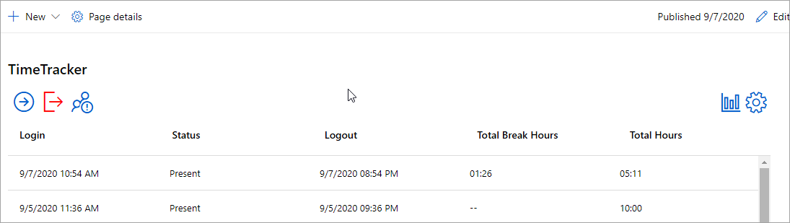

Requirements
To use TimeTracker, you need to have SharePoint in Office 365. It workes well with SharePoint Modern Experience. Supported browsers are Microsoft Edge, Internet Explorer 10 and higher and the latest version of Google Chrome or Mozilla Firefox.
MS Excel 2010 and above for reports.

Data Storage
TimeTracker for SharePoint is used on a SharePoint site, and here the first instance of TimeTracker creates a ShaePoint list one for attendnace data and a settings.
It is possible to have more than multiple installations on different site colelctions. If there is an existing installation in a site, any new additions of TimeTracker will use the same SharePoint list and a settings, no matter which edition it is.

Basic Features
- Easy In-Out, Break-in, and Break-out by just tapping on the screen
- Modern and affordable electronic mobile attendance logging
- Quick setup and easy to use - anyone can start using it within a few minutes
- Convenient access to attendance data using your Microsoft Teams
- Supervise attendance anytime in a real-time from anywhere
- Policies - manage the start and end hours, half-day, late coming
- Monthly summary powerful reports to Excel for the employee or entire team
- Generate reports by client/project for easy invoicing
- Manage multiple admin and manager roles
- Data stored on the SharePoint’s lists

Premium Features
To get the below-mentioned premium features you need to subscribe to the paid version of TimeTracker.
- Notification emails for weekly/monthly reports
- Appearance customization of the main screen with company logo
- Export to PowerBI to create a reporting dashboard using graphs and charts

Permissions
Standard SharePoint permissions are used for TimeTracker.

Administrator
To install TimeTracker you must be a site collection administrator or have administrator permission over the site collection.
The Global Admin must have to upload the TimeTracker.sppkg file to the app catalog.

Users
People who need to work with tasks must be added in either Visitor or Member or Owner group of the SharePoint site where TimeTracker is installed.

Upload in App Catalog
TimeTracker is uploaded as package content.
The Global Admin or SharePoint Admin can upload the TimeTracker.sppkg file to the app catalog.
The contents are then packaged into a .sppkg file. The package format is similar to a SharePoint add-ins package and uses Microsoft Open Packaging Conventions to package your solution.
- Go to your site's app catalog and select “Apps for SharePoint”.
- Upload or drag and drop the TimeTracker.sppkg file to the app catalog.
Click on the checkbox to “Make this solution available to all sites in the organization”.
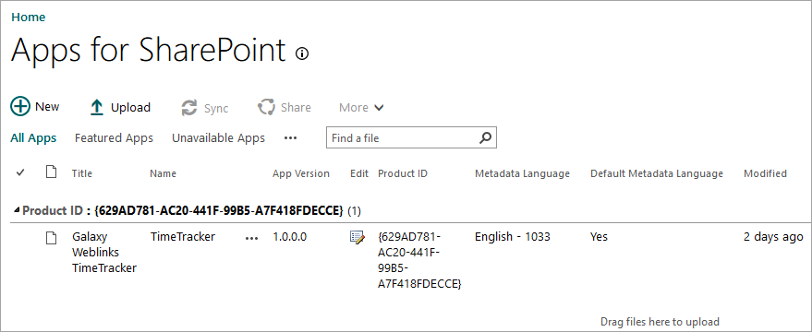
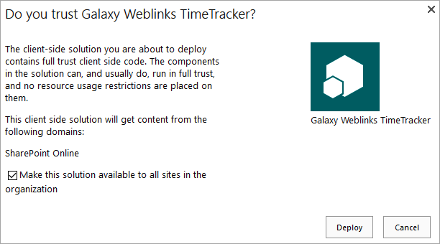

Installation of TimeTracker
The installation of TimeTracker is very easy and just like Add-in.

Add As A Web Part - Activate on Site Collection
The TimeTracker works like Add-in and available to all SharePoint modern site. The Site Owner needs to add the web part on the home screen of the site collection.
To add a web part:
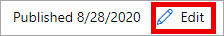
- Go to the homepage of the site collection and click Edit on the right to edit the page.
- Go ‘+’ from the to add section layout.
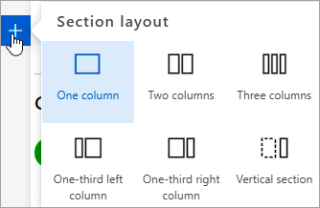

- Click ‘+’ to add a new web part and type TimeTracker in searcha nd select it.

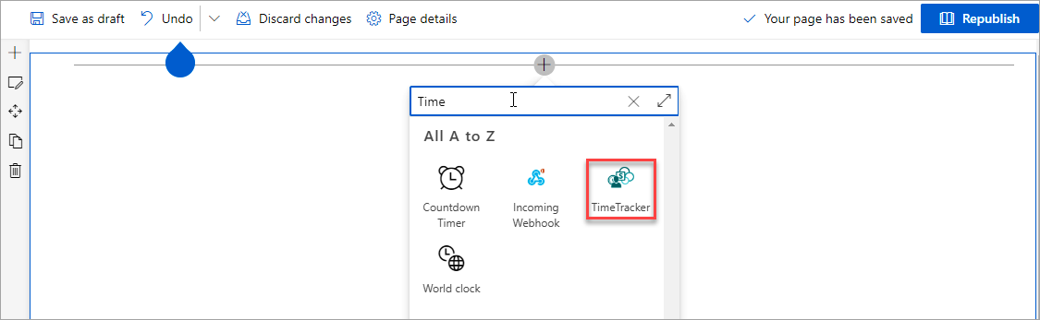
- Republish the page and TimeTracker is ready to use.
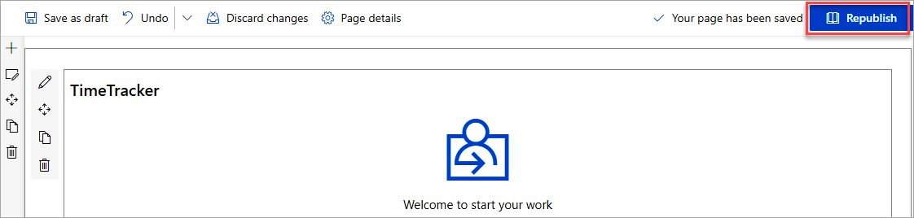

Add on Microsoft Teams
TimeTracker works with MS Teams also.
- Go to MS Teams and click on the ‘Teams’ from the quick launch.
- Select the Team where you want to add TimeTracker and go to ‘+’ to add a tab.

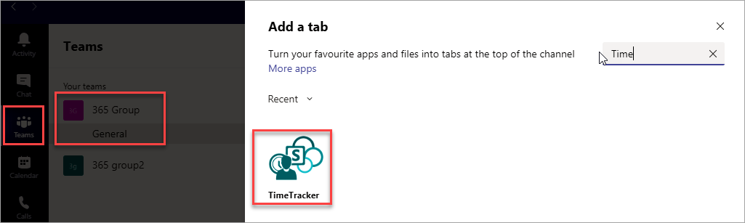

- Search for ‘TimeTracker’ and click on the Save button.

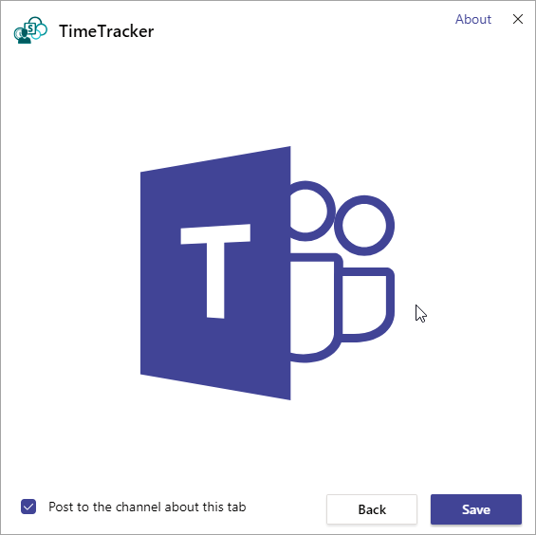
A new tab will be displayed named TimeTracker.

Use TimeTracker
TimeTracker for SharePoint is a very interactive and user-friendly solution. The user needs to tap/click on the screen and the user or a team member will see the Login button on the top of the screen.

SharePoint Office 365 Modern Experience
TimeTracker has a very contemporary design. It runs flawlessly on MS Teams and SharePoint in Office 365 using the Modern web part.

Microsoft Teams
When the user opens the MS Teams app either on the mobile device or desktop app, he/she needs to go the Teams tabs first.
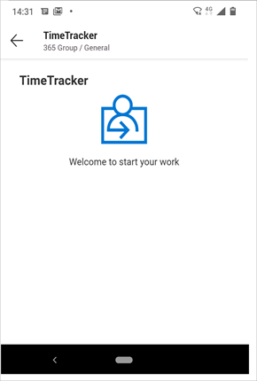

Usage
When the user logs in, a welcome message with the login icon appears on the team member’s screen. Once the user logged in for a day, the login button will not be displayed again for that particular day.
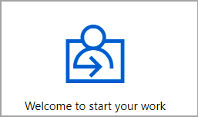
Thereafter users will have options either to take breaks or logout for the day.

Users can take more than one break in a day and TimeTracker calculates total break time.
When the user login, the tentative logout time will be displayed as per the working hour's policy set by the admin.

As shown, according to the company policy the working hours set as 8 hours for a day by the admin. A user logged in at 10.00 am will see the 06.00 pm as the logout time.

The login and logout icon will display only once in a day. Once the user logged out, he can not log in again for that particular day.
Start Break – a user can start the break by clicking on the “->” icon. The user can take more than 1 break in a single day.

End Break – A user can end the break by clicking on the “” icon. TimeTracker will calculate the total break time and display it in the list.

After login users can see the ‘Start Break’, ‘Logout’ and toggle button with ‘View My Reports, and ‘View All Reports’ options.

Display Records
The default display for Admin will be his/her own records only. The Admin can toggle from the icon ‘View My Reports’ and ‘View All Reports’.
View My Reports – The click of the button will display the last 30 days of attendnace records of the user only.

View All Reports – The click of the button will display the last 7 days of attendnace records of all the users.

TimeTracker displays the Login time, Status of the user, Logout time, total break hours (if any), and total working hours.
The user with Owner permission will be able to configure/edit TimeTracker settings and can set values/policies for the Start Time, Default working hours, Consider late if delay by hours, and Consider half day for less than hours.

Settings

The settings icon will appear only for the user with Administrator permission.

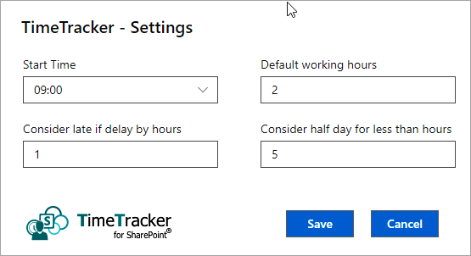

- Start Time
Site Owner can set a specific time to start the day. The start time can be set from 00.00 till 23.30 and in the multiple of 30 minutes.
- Default working hours
When the Admin sets the default working hours; the TimeTracker calculates the End Time as per settings.
- Consider late if delay by hours
This feature helps HR to identify the latecomers easily. The HR/Admin can set the policy. The Admin can directly see the status either from the screen or from reports.
In the example mentioned below, we have set 2 hours to consider late. When the employee is late by more than 2 hours he will consider late for the day.
- Consider half day for less than hours
This feature will help the HR/Admin to identify the team member who is on half-day. The Admin can directly see the status either from the screen or from reports.
In the example mentioned below, we have set 5 hours to consider half a day for less than 5 hours.
We have set 5 mandatory working hours. If an employ will work for less than 5 hours it will consider as half day.

Generate Reports

Users and Admin both can generate reports from the Statistics icon.
The admin can generate reports of all employees of the organization. There is an option to generate reports of each employee separately.

There are two limitations to reports.
- The icon of generating reports is not available in the Mobile device.
- Admin can not Group By Employee in All Reports section.
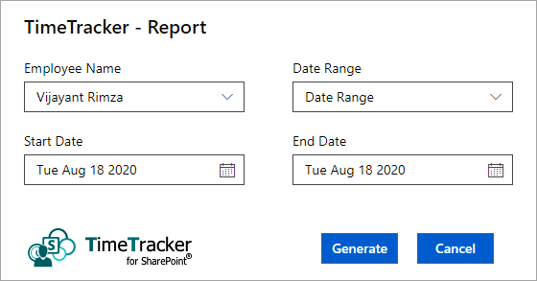

Report Range can be selected in the format of the Start Date and End Date. Other options are Week, Month & Year, Today, and Yesterday. Users can generate the reports in Excel.
Excel reports are generated by different parameters by default. Three tables are corresponding to three graphs associated with it.

The reports are managed with Pivot functionality and the user can edit or modify as per specific requirements.

- Home Tab – Home tab displays the three default report types

  - User Status by Day
  - User Total Office Hrs by Day
  - User Total Break Hrs by Day

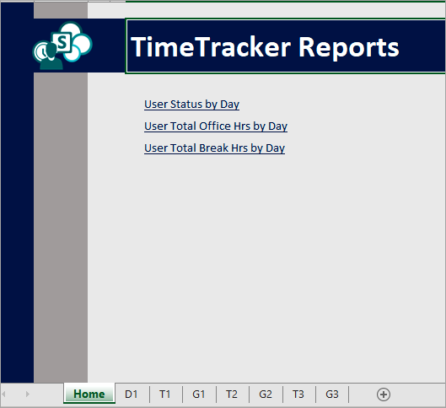

- D1 Tab – The tab displays all the records generated from the TimeTracker.

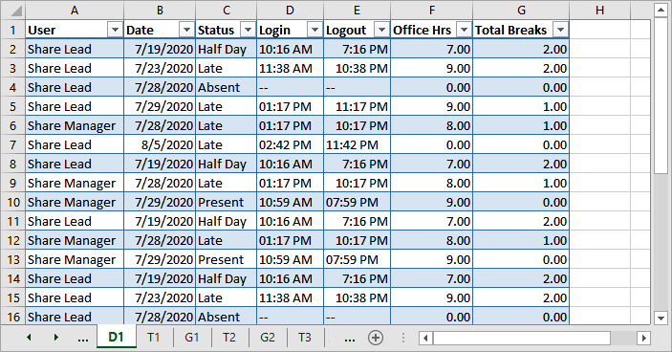

- T Tab – The T tabs are the default reports on fixed parameters generated by the pivot table.
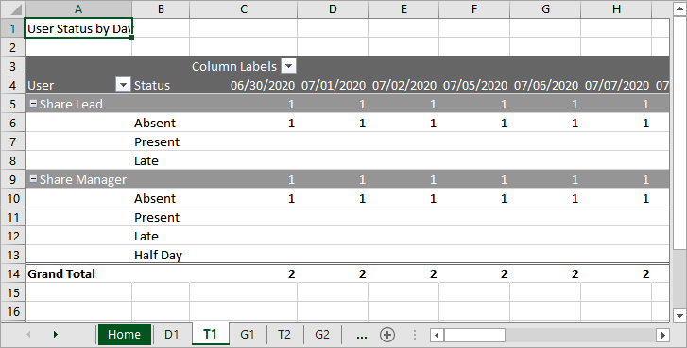
- G Tab – The G tabs are the graphs associated with the T tabs.

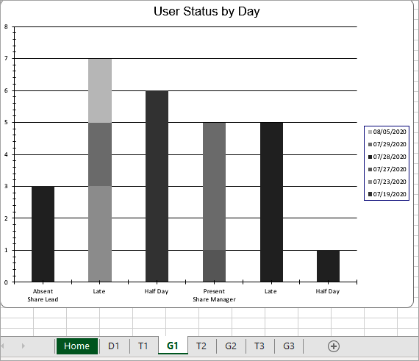

Uninstall

Should TimeTracker not be used anymore, you can remove it. TimeTracker can directly be removed from the web part.

From Site Collections
Edit the homepage of the site collection, go to TimeTracker and click on the delete button to remove TimeTracker from the site collection.

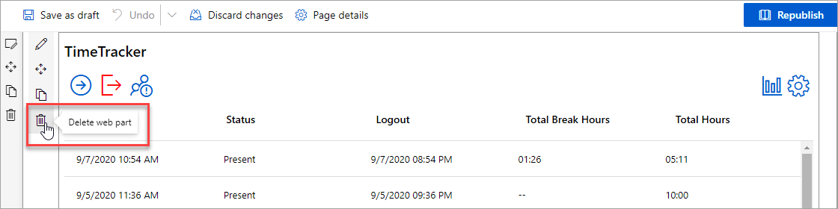

From MS Teams

To remove TimeTracker for SharePoint from MS Teams
- Go to the Teams tab in the quick launch and the team site ollection from where you want to remove.
- Under the TimeTracker dropdown third option is ‘Remove’.
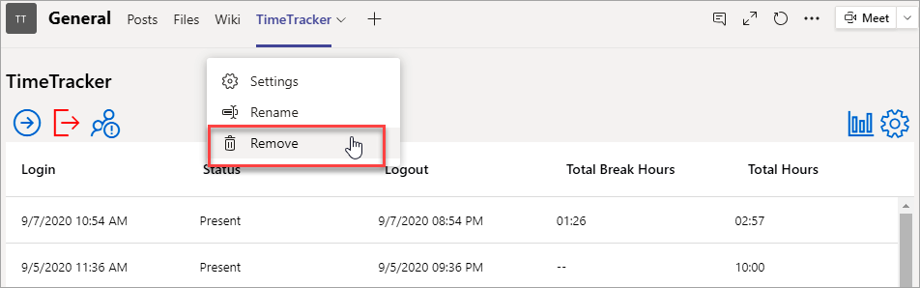

From SharePoint Tenant
To remove the TimeTracker from the tenant the Administrator must ensure to remove from all site collections and subsites.
Go to App Catalogue and select ‘Apps for SharePoint’ from the quick launch. Select the Add-in TimeTracker and delete it.
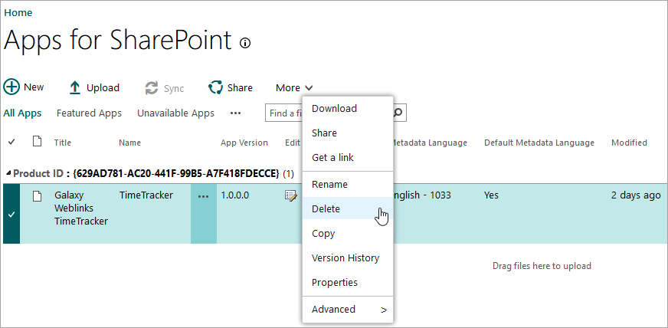

Contact
The TimeTracker solutions are supposed to be very easy to deploy, use, and manage. However, if you have any kind of problem or questions about our software, there are several ways of contacting us:

E-mail | support@bizsolutions365.com | Technical issues
 | sales@bizsolutions365.com | General and sales issues
Telephone | +91 780 600 6234
Online Chat | www.bizsolutions365.com

