TimeCard Workgroup User Manual

Content

1 Introduction 3

1.1 Language 3

2 User Roles 3

3 User installation 3

3.1 Start installation 3

3.2 Database Selection 7

4 Personal Settings 9

4.1 Tags 9

4.2 General Settings 10

4.2.1 Filter Appointments 11

4.2.1.1 Recurring Appointments 11

4.2.1.2 Private Appointments 11

4.2.1.3 All Day Appointments 11

4.2.2 Time Manipulation 11

4.2.3 Language Selection 12

4.2.4 Export to Excel Options 12

4.2.5 Rate 12

4.3 Report To 12

5 Work with TimeCard in the Outlook Calendar 13

5.1 The *TimeCard* Ribbon Group 13

5.2 Create New Appointments with *TimeCard* Values 13

5.3 Set *TimeCard* Values on Existing Appointments 14

5.4 Copy appointments 14

5.5 Categories Field 15

5.5.1 Color Code Tag Values 15

5.5.2 Remove TimeCard Tag Values 15

5.6 Admin Enabled Features 16

5.6.1 Expenses 16

5.6.2 E-mails/Domains Settings 16

6 Report with TimeCard 17

6.1 Reporting Dialog – Main Purpose 17

6.2 Choose Date Ranges 18

6.3 Display Options 18

6.4 Change Appointments Within The Reporting Dialog 18

6.5 Grid 18

6.6 Report on behalf of 19

6.7 Export to Excel 20

6.8 Customization of the Excel template 21

6.9 Print Report 21

6.10 Send Report 22

7 Statistics 23

7.1 Default Reports 23

7.2 Custom Reports 25

8 Upgrade 26

9 Remove TimeCard 26

# Introduction

With *TimeCard* users both plan and report their time inside the Outlook Calendar. We hope that you will get a good understanding of *TimeCard* by studying this manual and the online video demonstrations. You are welcome to print the manual or parts of it and use it within your organization. You may also change or add text or images so that the manual better suits your needs.   
  
All screen shots in the manual are taken from a PC with Microsoft Windows 10 and Office 2016, English versions, but *TimeCard* also works with lower Office versions, from 2007, and with the operative systems Windows Vista and 7. To use *TimeCard* it is also necessary to have Internet Explorer 9 or higher installed.  
  
Sections 7-11, which are the sections of this manual that concerns all users, are also gathered in a separate edition, which may be downloaded from [the *TimeCard Workgroup* Manual page.](https://bizsolutions365.com/our-products/timecard/timecard-workgroup/tcwg-manual/)

## Language

The language of *TimeCard* automatically defaults to the same as the Office language of the user’s actual PC. We currently support Danish, Dutch, English, Finnish, French, German, Italian, Norwegian, Portuguese, Spanish and Swedish. When a database is used for reporting and shared settings, each user has the option of selecting any one of these languages instead of the default system language in his/her Personal Settings.

# User Roles

*T*here are two different manuals for *TimeCard Workgroup*, depending on what role the user has when it comes to *TimeCard*. This manual is for users. There is another manual for administrators.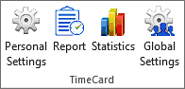

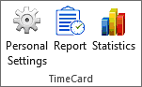**Users** *cannot* see and manage the Global Settings, and they can only see their own statistics.

Users cannot decide about what database should be used for sharing and reporting but must select the database configured by the administrator.

You become a user by installing *TimeCard* with the file **TimeCardUserSetup.msi**.

# User installation

Once the administrator has performed the administrator installation, TimeCard must also be installed on all the user machines. This is done with the **TimeCardUserSetup.msi**, which can be downloaded from [the bizsolutions365.com website](https://bizsolutions365.com/our-products/timecard/timecard-workgroup/tcwg-try/). The person installing the Client Tool needs to have Administrator rights over the workstation.

The file **TimeCardUserSetup.msi** may also be used for a central installation of the client tools, via Active Directory. If that is done, you don’t have to follow the steps below at all. Instead you can go directly to Personal Settings.

**TimeCardUserSetup.msi** creates a ‘My TimeCards’ folder under (My) Documents. Here the Excel files for your own statistics reports and reporting sheets will be saved.

## Start installation

Click on the file **TimeCardUserSetup.msi** to start the installation.

Now you are shown a Welcome dialog.

Then you are asked to accept the license agreement. When you do that you will be able to click Next.

By default, the *TimeCard* is installed in Program files/bizsolutions365.com/TimeCard Workgroup User, but you can choose another folder by pressing the Change button.

Click **Next**, and then **Install** to start the installation.

When the installation is over, click Finish to exit the installation wizard.

## Database Selection

Once the installation of the client tool is finished you are asked to specify the *TimeCard* database that the administrator has created and configured.

When that is done and you have clicked OK, your *TimeCard* Personal Settings will be populated with the tags and tag values that the admin has entered in the Global Settings.

Now you only have to select your tag values and define some other personal settings, *refer to* Personal Settings. Then you are ready to tag appointments with tag values and report time with *TimeCard*.

# Personal Settings

The dialog Personal Settings is shown when the

User installation is finished and the *TimeCard* database has been specified. Here each user selects those common properties that he/she will be working with and needs to report on.

The Personal Settings also contains other choice possibilities. You may reach the Personal Settings anytime via the button in the Outlook ribbon.

Below is the main screen of the Personal Settings.

## Tags

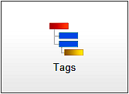The Personal Settings Tags screen contains the tags specified by the administrator and their values. Here the user can uncheck the values that are not needed, for example tasks that this customer never performs.

Unchecked values will not be shown in the *TimeCard* dropdowns in the appointments for this user. This way each user will have fewer alternatives to select from when tagging the appointments with time reporting data.

When the box for “Write tag values in the subject” is checked, the values this user selects for each appointment will be entered in the subject of the appointment also.

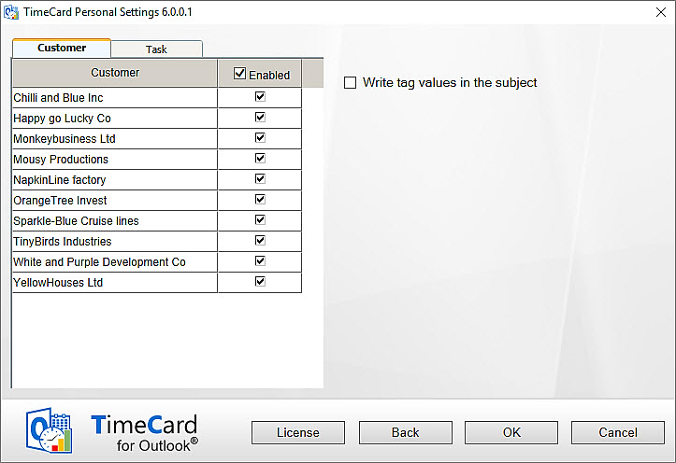

## General Settings

In the Personal Settings, General Settings screen, users can define some other settings that will only apply to the individual user.

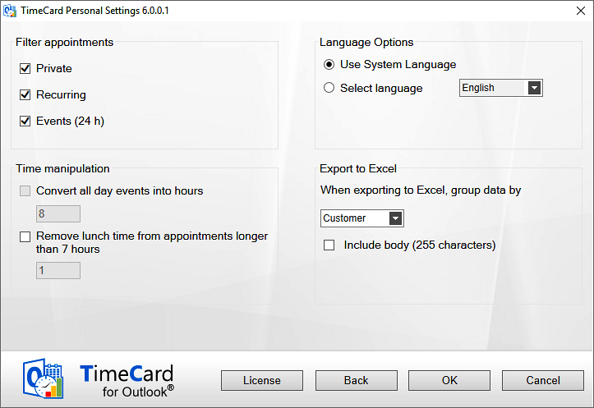

### Filter Appointments

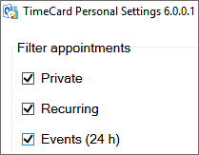Users may decide what types of **appointments should be excluded from reporting**. These appointments will *not* be displayed in the reporting summary even if they exist in the calendar, and they will *not* be entered into the database. Not even if they are tagged with *TimeCard* values will they be reported.

This way users don’t have to use a separate calendar for their work time tracking.

By default private, recurring and all day appointments are excluded from the reporting, but you can uncheck the appropriate box(es) to include them.

#### Recurring Appointments

|  |  |
| --- | --- |
|  | Users who want to include Recurring appointments in the reporting should be aware that recurring series of appointments are treated as one group by *TimeCard*. Any changes in the *TimeCard* values of one appointment will be applied to the whole series. |
|  |

#### Private Appointments

|  |  |
| --- | --- |
|  | By default, private appointments will not be included in *TimeCard* reports. |

#### All Day Appointments

|  |  |
| --- | --- |
|  | When this box is unchecked it is possible to manipulate the time for all day events. If the time is *not* manipulated, all day appointments are considered to be exactly 24 hours work time in the *TimeCard* reports. Therefore, users should set another number of hours in the Time manipulation checkbox, see below. |

### Time Manipulation

When the all day events are set to be reported with *TimeCard* it is possible to **convert all day events into hours**, so that fewer hours than 24 are reported for that day.

It is also possible to **remove time from appointments** that are longer than seven hours.

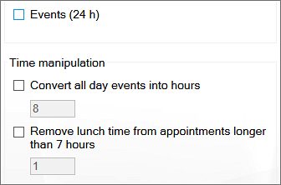

### Language Selection

By default, *TimeCard* takes the system language, but when a database is used for sharing, users may select another one of the supported languages.

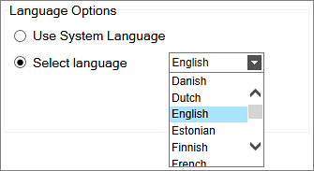

### Export to Excel Options

|  |  |
| --- | --- |
| When you press the Export to Excel button in the Reporting dialog, the data shown in the dialog will be exported to an Excel sheet.  Each user can select by which *TimeCard* tag the data should be grouped in the Excel sheet.  They may also select to include the first 255 characters of the appointment body in the export. |  |

### Rate

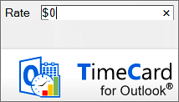If the administrator has specified that costs should be calculated by person and that this rate should be defined in the Personal Settings, this screen will have an additional field for rate.

The currency will be the one specified in the system settings, so you just have to fill out the figure.

## Report To

In the “Report To” dialog you can switch option for reporting and shared settings, if you for example move to another department that uses another option.

The reported appointments will not be migrated to the new option, but tags and other settings will be migrated.

# Work with TimeCard in the Outlook Calendar

Use your Outlook Calendar to plan your day with meetings and appointments. You have to select the appropriate **tag values** (or value) for each appointment; otherwise you can handle them just as you normally would. You can, for example, extend the appointments or move them without the *TimeCard* properties being disturbed.

When the week (or any other preferred period) is done, you can review the existing data and send them directly to the database. You may also export the data of each reporting to an Excel sheet, and when you have reported time with TimeCard for a while you can study your data in the Excel statistics reports.

## The *TimeCard* Ribbon Group

*TimeCard* creates a new ribbon group in the calendar view. It may look in two ways, depending on if an appointment is selected or not.

This is how the ribbon group looks when no appointment is selected – the calendar ribbon group. The group has three buttons, and by clicking them you will reach your Personal Settings, your Reporting dialog and your statistics.

In Outlook 2007 this group looks a bit different:

Replace9

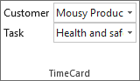When an appointment is selected, the ribbon group will change and instead show the tag values for that appointment – the appointment ribbon group. This way you can select or change values of an appointment without even opening it.

The same ribbon group is shown in the open appointment.

Below you can see how the appointment ribbon group looks when the Expenses feature has been enabled by the administrator.   
  
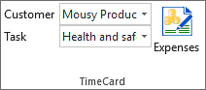

## Create New Appointments with *TimeCard* Values

Create a new appointment as usual, but to use your calendar with *TimeCard*, select the extra information (the *TimeCard* tag values) from the dropdown list or lists in the appointment.

You can handle the appointments just as you normally would. For example, you can extend or copy your appointments without losing the *TimeCard* properties.

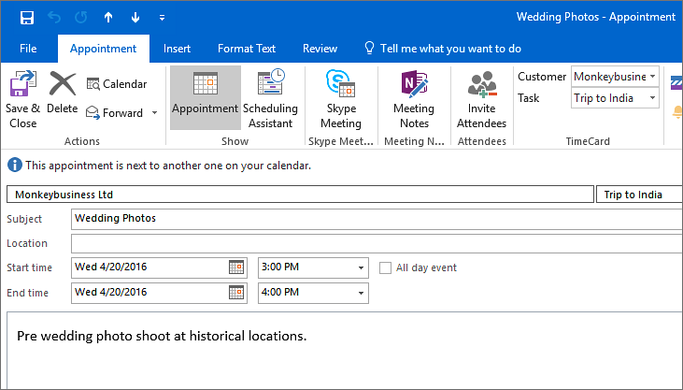

## Set *TimeCard* Values on Existing Appointments

You can add or change *TimeCard* values in an existing appointment two ways:

* Open the appointment and then select or change the *TimeCard* values in the ribbon group.
* Select the appointment in your calendar (by clicking on it once). The *TimeCard* appointment group is now activated in the ribbon. Select or change the *TimeCard* values, and the changes will be applied to the selected appointment.

## Copy appointments

A very fast way to enter information into your calendar is to **drag & drop** an appointment while holding down the **CTRL** key. That will create a copy of your appointment with all the *TimeCard* properties intact. You may also use **CTRL+C** for copy and **CTRL+V** for paste.

If a *reported* appointment is copied, the “reported mark” is removed so that the appointment can be reported again.

## Categories Field

|  |  |
| --- | --- |
| *TimeCard* uses the Outlook **Categories** field to store *TimeCard* tag values in appointments.  If you use the Categories field for another type of appointment classification, *TimeCard* will not interfere with your existing data. However, if you add *TimeCard* values to an appointment with non-*TimeCard* categories filled out, they will be overwritten.  This means that you have to *first* tag the appointment with *TimeCard* values and *then* add the non-*TimeCard* category.  You can reach the Categories via the Categorize button in the open appointment or by selecting an appointment in the calendar view and right clicking it. |  |

### Color Code Tag Values

To get a quick overview of your appointments you can connect each tag value to a color. In All Categories, rename the colors to your tag values and each color will be applied to all appointments tagged to the specified value.

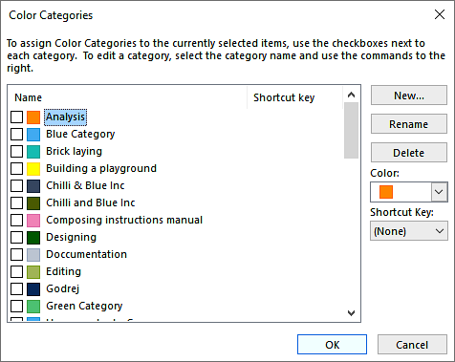

### Remove *TimeCard* Tag Values

To remove *TimeCard* values from an appointment, right click the appointment in the Outlook calendar view and select Categorize and Clear all categories.

Note: if you want to exclude some appointments from the reports you can also mark them as recurring, personal or event, *refer to* **Error! Reference source not found.**.

## Admin Enabled Features

The features below may only be used if they have been enabled in the Global Settings by the *TimeCard* administrator.

### Expenses

|  |  |  |
| --- | --- | --- |
| With *TimeCard* you can **report your expenses at the same time as you report your hours**, if this feature is enabled by the *TimeCard* administrator. This is done in the Expenses dialog, which you reach by pressing the Expenses button in the appointment ribbon group. | |  |
| In the Expenses dialog, fill out your expenses and they will automatically follow the appointment when you report your hours. |  | |

You can see the Expenses button in two ways:

* In the calendar, **select** an appointment and the Expenses button will be visible in the *TimeCard* ribbon group. This method is especially convenient if you want to add or edit expenses, as you can do it without having to open the appointment.
* **Open** an appointment to reach the *TimeCard* appointment group in the ribbon.

### E-mails/Domains Settings

The E-mails/Domains settings is a useful feature when you often get work orders via e-mail. If the administrator has enabled this feature and mapped e-mail or domain settings with tag values, you can drag e-mails to your Outlook calendar and make appointments of them, and those appointments will be tagged automatically with the values the administrator has specified.

When you drag an e-mail to the calendar in the same window, the appointment will be created at the currentdate and time.

When you drag an e-mail in one window to a calendar open in another window you can drop the e-mail on the date and time you prefer. Open the calendar in a new window by right clicking the Calendar label and selecting “Open in New Window”.

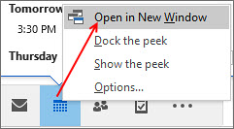

# Report with TimeCard

|  |  |
| --- | --- |
| Open the reporting dialog by pressing the Report button in the *TimeCard* calendar ribbon group. |  |

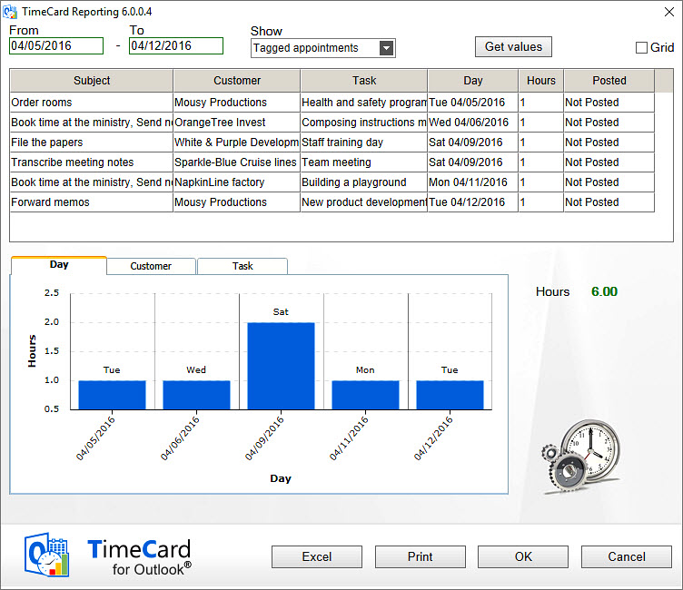

## Reporting Dialog – Main Purpose

The Reporting dialog lets you select a time period, view and edit a summary of your work time and report the work time to a database. Also the expenses are reported if your administrator has enabled that feature and you have used it.

In order to get the best possible data input, you can verify the data in *TimeCard* three times:

* When you enter the appointment in your calendar.
* In the *TimeCard* Reporting dialog, where you get an overview of the data that is about to be entered into the database.
* When you click on OK in the Reporting dialog, you are asked to confirm that you want to report the time.

## Choose Date Ranges

Choose your date range by selecting a start and end date for the report. The Reporting tool will summarize all appointments within that date range and include them in the report.

Standard view:

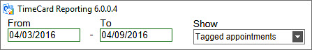

Grid view:

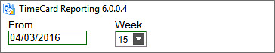

## Display Options

For the time period you have defined, you can select which appointments you wish to show. These are the alternatives:

* all appointments tagged with *TimeCard* values
* all partially tagged appointments
* both tagged and partially tagged appointments
* not tagged appointments
* all appointments.

This makes it easy to verify that you have not missed tagging an appointment in your calendar. If you did, you can easily select *TimeCard* tag values for that appointment in the Reporting dialog.

## Change Appointments Within The Reporting Dialog

You can change the *TimeCard* tag values and other properties within the Reporting dialog by selecting a row in the list and changing one or more values. All changes will be written back to your calendar.

Thus, if you change the duration of an appointment from 2 to 3 hours in the Reporting dialog, the corresponding appointment in the calendar will become one hour longer.

## Grid

If you check the box for Grid, you will get a possibility to **add appointments directly in the Reporting dialog**. For tag values that already exist in the dialog you can quickly change the time period or add more hours in empty cells. Click Save when you are finished with each week, to save the changes to the calendar.   
  
When you are only adding hours for one week, you can click OK directly without saving. Then the additions will be saved to the calendar and your hours for that week will be reported to the database.

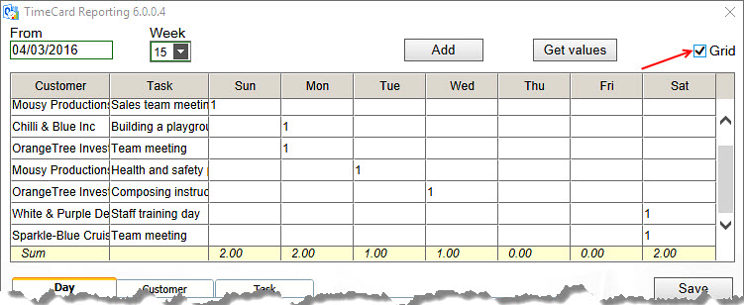

For tag values that are not present in the reporting grid, click the Add button to open a new dialog where you can add tag values. Then click OK to add the appointment to the reporting summary. Enter the number of hours in the cell for the actual day, and click Save to save the new appointment to the Outlook calendar or click OK directly to save and report.

When you have created a new appointment you will be informed about that, either you click the Save button or the OK button. The new appointment will be saved to an empty period of the correct day, but if you want to specify the hour you have to go into the calendar and do that.

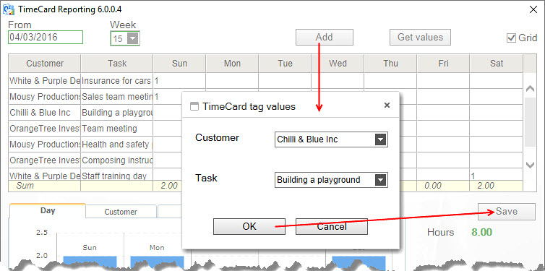

## Report on behalf of

If the feature “Report on behalf” of is enabled in the Global Settings, users who has the right to share another person’s calendar may report the appointments in it and get the name of the person who made the appointment into the database.

The report on behalf of feature works like this:

1. Select the other person's calendar
2. (Tag appointments if this is not done)
3. Click the *TimeCard* Reporting button in Outlook to open the Reporting dialog
4. (Make changes if necessary)
5. Select the right name from the TimeCard user dropdown. The selected calendar owner is shown as default.
6. Report time and expenses by clicking the OK button

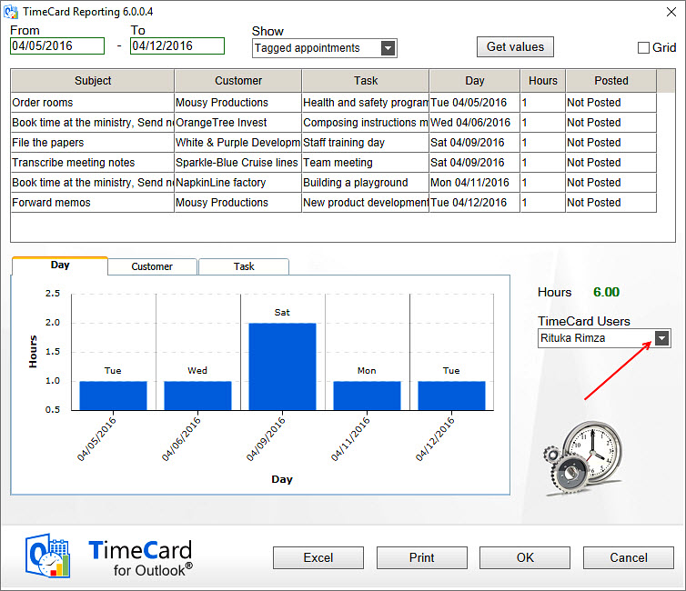

(Reporting for another person is possible even if the box is not checked in Global Settings, but then no choice is shown in the Reporting dialog and the name of the logged in person will be entered into the database instead of the calendar owner’s name.)

## Export to Excel

The Export to Excel button produces an editable Excel sheet with data about all the appointment listed in the *TimeCard* Reporting dialog, where hours (and expenses) are summarized.



In the Personal Settings you can select which *TimeCard* tag the data should be grouped by and if you should include the appointment body or not, *refer to* **Error! Reference source not found.**. To use this feature you must have Microsoft Excel installed.

This Excel report is opened automatically when the button is pressed. The report is saved as **TCExcelReport.xlsx** under '(My) Documents\My TimeCards'. The file can be printed for signatures, if that is needed before the reporting.

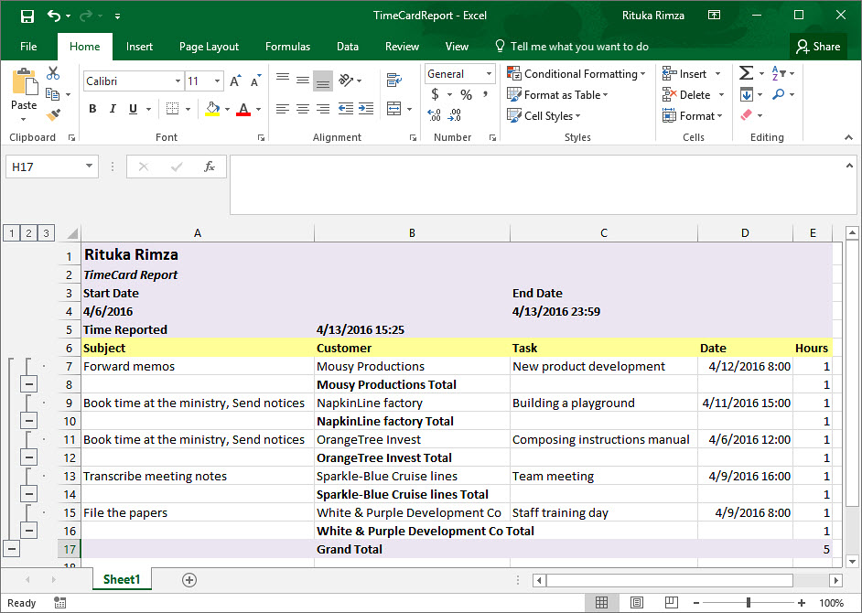

## Customization of the Excel template

The Excel sheet can be customized according to your own needs. When the data is exported to Excel, make the changes you wish and save them. Then the changes will be preserved and available for subsequent reports. You can for example:

* insert a company logo at the left top of the report
* add rows on top and bottom, but *not* in the default exported report area
* change colors, fonts or number format in newly added rows.

We **don’t** recommend inserting any columns, as they can spoil the layout of the report. In the image above the appointments are grouped by Customer, and the box for adding max 255 characters from the appointment body has been checked in the Other Settings dialog.

## Print Report

When you press the Print button the reporting period and the two panels in the Reporting dialog will be printed.



## Send Report

When you click **OK** to post your report you will get a warning that the data cannot be changed once it has been posted.

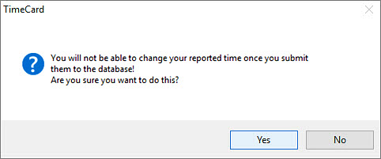

If you decide to post your report, you are asked if you want to send another report.

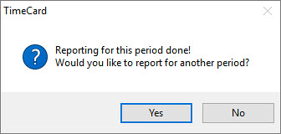

# Statistics

|  |  |
| --- | --- |
| When you press the Statistics button in the *TimeCard* calendar ribbon group, *TimeCard* will create Excel reports with statistics on all reported data. The statistics reports will be stored on your PC at My Document(s) >My TimeCard. |  |

Each time you run the statistics tool the statistics reports will be refreshed with any new data.

When the Statistics button is used by anadministrator,statistics forall userswill be shown.

When another user presses the Statistics button, he or she will only see his/her **own** statistics.

The reports themselves are the same. The only difference is what data is fetched from the database – all data or just data for one user. Therefore, the description below will be the same for both administrators and users.

You can use all the Excel features with these reports, so you can select to study any time period or detail in the data.

The image below shows the first tab of the Excel workbook.

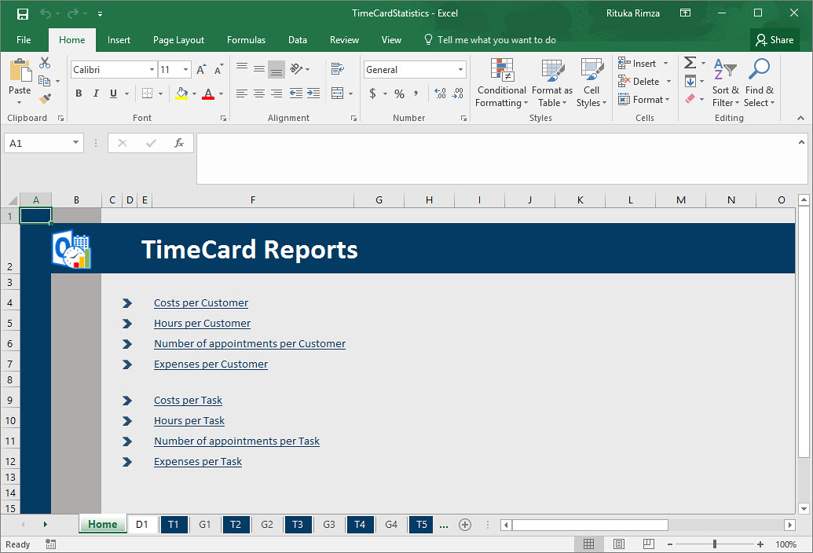

## Default Reports

The default reports are grouped by tag, and there are three statistics reports for each tag: Hours per Tag, Cost per Tag and Appointments per Tag.

When the Expenses feature is enable there will be one more default report per tag. This is shown in the image above.

You can drill down from tags to values to appointments by clicking on the plus signs. If your organization uses category and type for the tag values, you can drill down from category to type to tag to tag value to appointment subject.

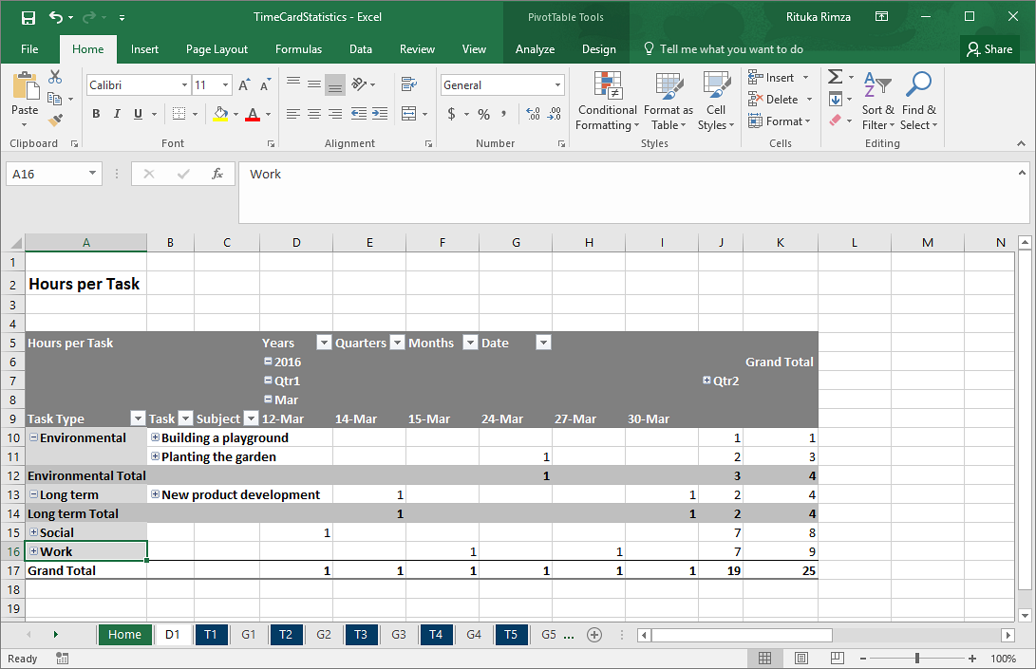

Each report is shown as a pivot table and as a chart.

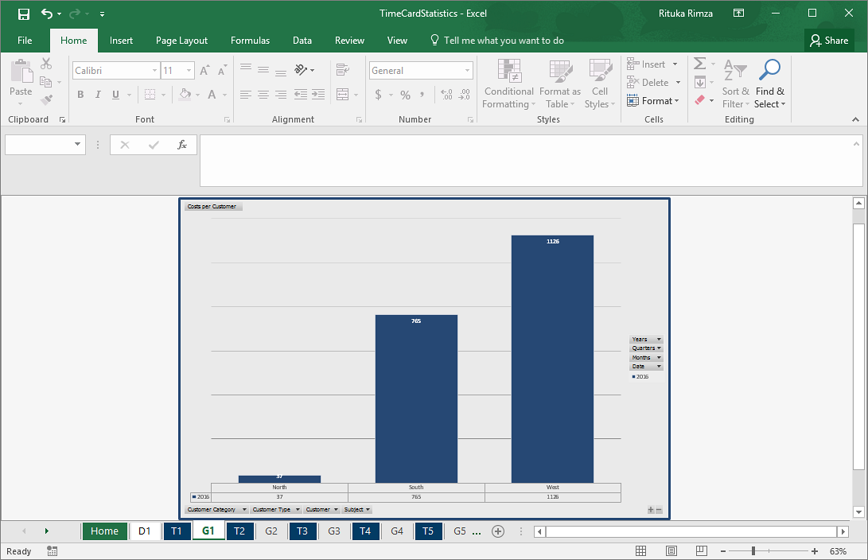

Under the first tab, D1, you can find all info from the database.

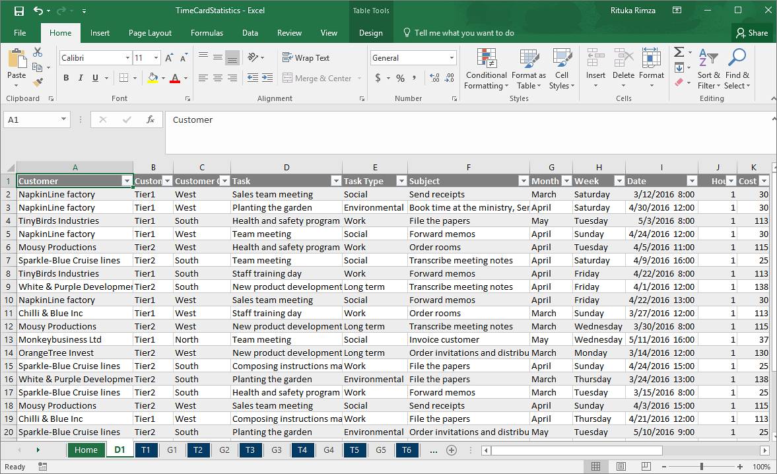

## Custom Reports

All the standard Excel features may be used with the default reports, so it is easy to modify these reports. If the changes are saved, the modified reports will be used instead of the default one.

To create **a totally new report**, open the D1 tab and insert a new pivot table. It is often best to select a new worksheet for it. Then customize the sheet as you like before you save the report.

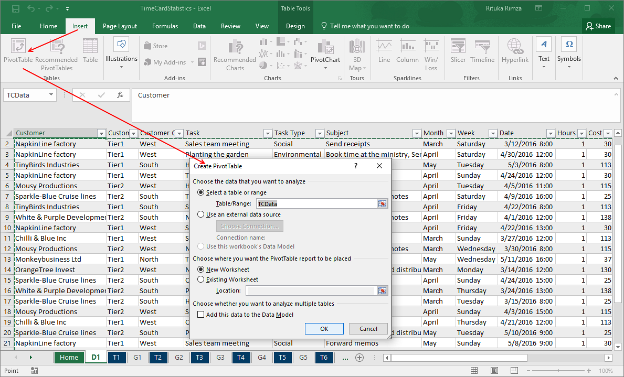  
  
Next time you run the statistics tool, your modified or custom report will be refreshed with the new data just like the default reports.

# Upgrade

When the Administrator has upgraded *TimeCard* the User installations also have to be upgraded, with the file **TimeCardUserSetup.msi**. This upgrade may be performed centrally, using Active Directory.

Each user may also use the file and run it to upgrade his/her own installation.

# Remove TimeCard

*TimeCard* is uninstalled from the Control Panel, Add-Remove programs / Programs and Features.

