TimeCard Workgroup Administrator Manual

Content

1 Introduction 3

1.1 Language 3

2 Requirements 3

2.1 Permissions 3

3 TimeCard Workgroup – Idea 3

4 User Roles 4

5 Administrator Installation 4

5.1 Start installation 5

5.2 Destination 6

5.3 Actual installation 7

5.4 Sharing Options 9

5.4.1 Time 10

5.4.2 Access Database 11

5.4.2.1 Permissions 11

5.4.3 SQL Server Database 12

5.4.3.1 Permissions 12

6 Example Data 13

6.1 Generate Example Data 13

6.2 Remove Example Data 13

7 Global Settings 14

7.1 Tags 14

7.1.1 TimeCard properties – Type and Category 15

7.1.2 Allow Auto-Add of Tag Values 17

7.1.3 Enable and Disable Data 17

7.1.4 Importing Data by Copy and Paste 18

7.1.5 Copying Data from an Outlook Contact Folder 19

7.1.6 Delete TimeCard Properties 19

7.2 Costs and Rates 19

7.3 General Settings 22

7.3.1 Planning Information 22

7.3.2 E-mail/Domain Settings 23

7.3.3 Add Tags in the Appointment Body 23

7.3.4 Mandatory Tags 24

7.3.5 Default Tag Values 24

7.3.6 Report on behalf of 25

7.3.7 Departments 25

7.3.8 Expenses 25

7.4 Report To 26

8 User installation 27

8.1 Start installation 27

8.2 Database Selection 30

8.3 User Installation via AD 31

9 Personal Settings 32

9.1 Tags 33

9.2 General Settings 34

9.2.1 Filter Appointments 35

9.2.1.1 Recurring Appointments 35

9.2.1.2 Private Appointments 35

9.2.1.3 All Day Appointments 35

9.2.2 Time Manipulation 35

9.2.3 Language Selection 36

9.2.4 Export to Excel Options 36

9.2.5 Rate 36

9.3 Report To 36

10 Work with TimeCard in the Outlook Calendar 37

10.1 The *TimeCard* Ribbon Group 37

10.2 Create New Appointments with *TimeCard* Values 37

10.3 Set *TimeCard* Values on Existing Appointments 38

10.4 Copy appointments 38

10.5 Categories Field 39

10.5.1 Color Code Tag Values 39

10.5.2 Remove TimeCard Tag Values 39

10.6 Admin Enabled Features 40

10.6.1 Expenses 40

10.6.2 E-mails/Domains Settings 40

11 Report with TimeCard 41

11.1 Reporting Dialog – Main Purpose 41

11.2 Choose Date Ranges 42

11.3 Display Options 42

11.4 Change Appointments Within The Reporting Dialog 42

11.5 Grid 42

11.6 Report on behalf of 43

11.7 Export to Excel 44

11.8 Customization of the Excel template 45

11.9 Print Report 45

11.10 Send Report 45

12 Statistics 47

12.1 Default Reports 47

12.2 Custom Reports 49

13 Upgrade 50

13.1 Administrator 50

13.2 User 50

14 Subscription 50

14.1 Registration 51

15 Support 51

15.1 Contact 51

16 Remove TimeCard 52

# Introduction

With *TimeCard* users both plan and report their time inside the Outlook Calendar. We hope that you will get a good understanding of *TimeCard* by studying this manual and the online video demonstrations. You are welcome to print the manual or parts of it and use it within your organization. You may also change or add text or images so that the manual better suits your needs.

All screen shots in the manual are taken from a PC with Microsoft Windows 10 and Office 2016, English versions, but *TimeCard* also works with lower Office versions, from 2010, and with the operative systems Windows Vista and above. To use *TimeCard* it is also necessary to have Internet Explorer 9 or higher installed.

Sections 7-11, which are the sections of this manual that concerns all users, are also gathered in a separate edition, which may be downloaded from the [*TimeCard Workgroup* Manual page](https://bizsolutions365.com/our-products/timecard/timecard-workgroup/tcwg-manual/).

## Language

The language of *TimeCard* automatically defaults to the same as the Office language of the user’s actual PC. We currently support Danish, Dutch, English, Finnish, French, German, Italian, Norwegian, Portuguese, Spanish and Swedish. When a database is used for reporting and shared settings, each user has the option of selecting any one of these languages instead of the default system language in his/her Personal Settings.

# Requirements

This must be installed on each PC where *TimeCard* should be used:

* Microsoft Windows 10 and above (32 or 64 bit)
* Outlook 2010 and above (32 or 64 bit)
* Internet Explorer 9 and above
* Excel 2010 and above (32 or 64 bit) – only for the Excel reports.

## Permissions

Users need to have Editor permission or higher on the calendar where they tag appointments, otherwise the reporting will fail. This is normally only relevant for shared or secondary mailbox calendars.

To report appointments which are already tagged with *TimeCard* data in a shared calendar, the user also needs to have the same selection of Tag values as that of the mailbox owner (calendar owner).

Certain permissions are also necessary on the database that users report to, *refer to* Sharing Options.

# TimeCard Workgroup – Idea

With *TimeCard* installed in Outlook users can both plan and report their time inside the Outlook Calendar. *TimeCard* can be used with any calendar, including shared ones or secondary mailbox calendars. The *TimeCard* toolbar will be visible in all calendars. To report appointments of a particular calendar, just run the reporting dialog from that calendar. It is as simple as that!

By avoiding free form text, *TimeCard* makes time reporting quicker and virtually error free. All the users have to do is select the appropriate values for the *TimeCard* tags (one, two or three) for each of their appointments. This will enable easy reporting and follow up.

When users regularly send time reports into the database, each post will contain information about the date, start time, end time, duration, subject, body and the *TimeCard* properties. This data can then be examined in the statistics Excel reports.

*TimeCard Workgroup* should be installed in each PC where it should be used. The common settings are shared via the same database as users report time to.

# User Roles

*T*here are two different installation files for *TimeCard Workgroup*, depending on what role the user has when it comes to *TimeCard*:

* 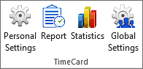**Administrators** can see and manage the Global Settings – settings that are common for all users.   
  The first database selection or creation must be done by an administrator.  
  When an administrator presses the statistics button, statistics reports built on data from all user reports will be shown.

You become an administrator by installing *TimeCard* with the file **TimeCardAdminSetup.msi**. When you report, you must be added as an admin in *before* you install the Workgroup admin setup.

* 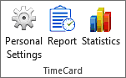**Users** *cannot* see and manage the Global Settings, and they can only see their own statistics.

Users cannot decide about what database should be used for sharing and reporting but must select the database configured by the administrator.

You become a user of *TimeCard Workgroup* by installing *TimeCard* with the file **TimeCardUserSetup.msi**. When users report, they must be added, *before* they install the Workgroup user setup.

Both administrators and users can manage their own Personal Settings. This means that the administrators have two Configure buttons in the *TimeCard* ribbon group, one for Global Settings and one for Personal Settings.

# Administrator Installation

TCWG1 *TimeCard* is designed to be easy to install and distribute, and the administrator installation and configuration takes care of almost everything.   
  
There are two installation files, and the administrator should use the **TimeCardAdminSetup.msi** file. Save the file you downloaded from the bizsolutions365.com website to any location on your computer.

By default the *TimeCard* files are placed at C:\Program Files (x86)\bizsolutions365.com\TimeCard Workgroup Admin\. After the installation is finished, the *TimeCard* installation folder will have content similar to that in the picture below. A screenshot of a social media post

## Start installation

Click the file **TimeCardAdminSetup.msi** to start the installation.

If you click Next, you are asked to accept the License Agreement. If you don’t do that the installation will be cancelled.

When you check the box for the License Agreement it will be possible to click Next again.

## Destination

The default installation folder is **Program files/bizsolutions365.com/TimeCard Workgroup Admin**, but you can change it to another path if you so wish.

## Actual installation

When you have chosen or accepted the installation folder, click Next and then Install to start the installation. Now the actual installation takes place.

When you have clicked Install you will probably be asked by your computer’s User Account Control to allow the installer to make changes to your computer. Note that the Publisher name is Biz Solutions 365.

When you have allowed the installation it will be quick, and after the installation a new screen will be shown. Click Finish to exit.

## Sharing Options

When you start Outlook after the installation is finished, a Sharing Options dialog will be displayed. Here you should decide what medium *TimeCard* should use for reporting and shared settings.

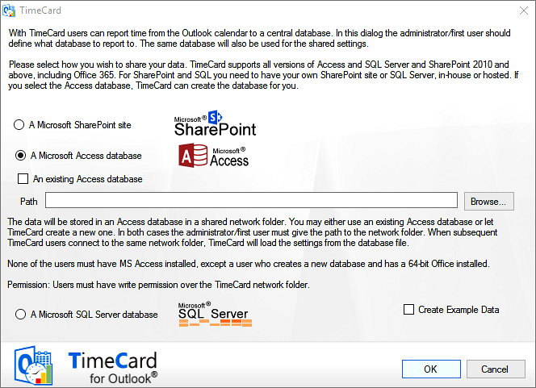

*TimeCard* supports three alternatives for sharing and storing, and each has its benefits. If you select the SQL Server option, you need to have your own SQL Server, in-house or hosted. If you select the Access database, *TimeCard* can create the database for you, but you need a shared network folder to place it in.

If the Access or SQL Server alternative is selected, there will be an option to “Create new” or “Use existing”. When you select one of the “new database” options, the installation program will create the database in a few seconds. The Access database will be stored in the shared file folder to which you have to specify the path.

#### Time

For the synchronization to work, each PC connected to *TimeCard* must have the correct local time and date.

### Access Database

With the Access alternative the time reports and shared settings will be stored in an Access database in a shared network folder. When you select this option, you may either use an existing Access database or let *TimeCard* create a new one for you. In both cases the admin/first user must give the path to the network folder, by pasting it or browsing to it.

The Access database is suitable for evaluation and for a small organization with few users, but for a large number of users and reportings we instead recommend a an SQL server database. These options are easily scalable and support large numbers of users without affecting performance, and they also give better control over the access to data.

Subsequent *TimeCard* users of *Kanban Task Manager* will have to use the “Existing database” option and give the path to the same network folder. Then *TimeCard* will load the settings from the database file.

None of the users need to have MS Access installed, because the ability to read and write Access databases is included in Office. However, if the admin/first user who creates the new database has a 64-bit Office, he needs to have Access installed.

#### Permissions

Users need to have write permission over the .mbd file as well as over the workgroup folder (where the .mbd file is placed) for reporting and statistics to work.

### SQL Server Database

To use a SQL Server there are two alternatives:

1. The administrator enters the SQL Server connection information in the sharing option dialog, and then *TimeCard* creates a new database.
2. If you already have an existing database setup, you can configure it from the *TimeCard* Global Settings, “Report to”, by selecting your reporting option and then configuring it.

Either way, enter the SQL server details, such as server name and user credential. To verify that the entered information is correct, press the ‘Test’. Click OK to continue to the next step.

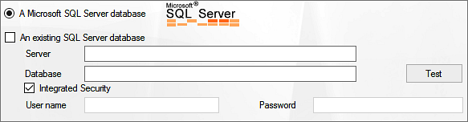

|  |  |
| --- | --- |
| If you open SQL management studio (or other SQL client), you will see there is a new database created (The name is “TimeCard3SQL”) with 10 (or more) tables. These tables will be used for saving settings and reported appointments data. |  |

#### Permissions

SQL‒users need to have DB Write and Read permission over the SQL server database used with *TimeCard*.

# Example Data

The example data is intended for evaluators who don’t want to bother with creating appointments and tagging them with *TimeCard* values for the evaluation of *TimeCard*. The example data quickly gives you a set of tagged appointments to test the various *TimeCard* features with.

## Generate Example Data

When you select to use one of the database options, there is a checkbox for Example data at the bottom of the screen. Check the box if you want to evaluate *TimeCard* with this data, before you click OK to the database choice.

Should you want to use your own appointments and tags, please continue to the next section of this manual, Global Settings.

These are the default example data settings. You can change the periods and the number of appointments as you wish. By default, the example data is created in the default calendar, but you may also browse to another calendar than the default one, to create the example data there.

Click OK to start the creation of example data.

## Remove Example Data

When you have created a new calendar for the *TimeCard* Example Data, you can just delete that calendar when you don’t need them anymore.

If you have generated the Example Data in a calendar you want to keep, open the Calendar List view. Sort the data by category and delete the *TimeCard* Example Data categories.

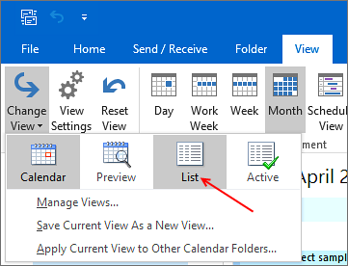

# Global Settings

When you have clicked **OK** in the database dialog, the **Global Settings** dialog will be shown. Here you can define what *TimeCard* properties your organization needs. In other words, decide what extra information needs to be gathered from each appointment beside the date, start time, duration, body and subject and add these properties in the dialog.

There are also various other settings that can help you adapt *TimeCard* to the needs of your organization. The Report To button is used when the database needs to be changed.

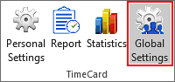The settings can be changed any time. The Global Settings can be reached via the Global Settings button in the *TimeCard* ribbon group.

## Tags

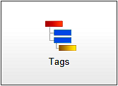By default, *TimeCard* is configured to work with two tags, Customer and Task. This means that for each appointment, the people reporting time will have to select both a certain customer and a certain task for that specific appointment. However, you can easily modify the tags so that they fit your needs.

Write the Tag names you need under **TimeCard Properties**, and the columns to the right will automatically change to reflect what you have entered.

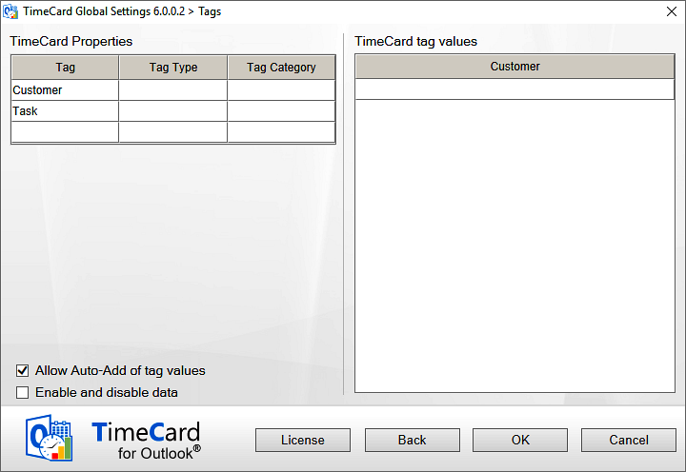

It is possible to add an extra tag, but keep in mind that doing so makes the procedure of tagging appointments more complicated.

You can also remove one tag so that only one remains to work with. This will save time for all users tagging appointments. Choosing the appropriate tags to report on is an important step, and they can easily be edited if the needs of your organization change. It is often best to start with a simple reporting scheme and extend it later (if needed).

Note: You cannot have the same name in more than one tag. If a Task is called "ABC" you can NOT have a Project also called "ABC". You can call the project "ABC_P" (or something similar), but not exactly the same.

You cannot use the characters colon and semicolon (: and ;) in the metadata names. If you enter them in Global Settings the application will remove them automatically, but if you add the data directly into the database instead you have to think about this.

### *TimeCard* properties – Type and Category

The image below shows the *TimeCard* Global Tag settings when example data has been installed. In the example data each Customer tag value has a Type and a Category, and the Task tag has a Type.

These extra properties are not shown in the appointment dropdowns, in the users’ Personal Settings or when users report time. That way the users will never have to bother with the higher levels of categorization. For the management they might be very useful, though, as they are used to group and filter data in the Statistics.

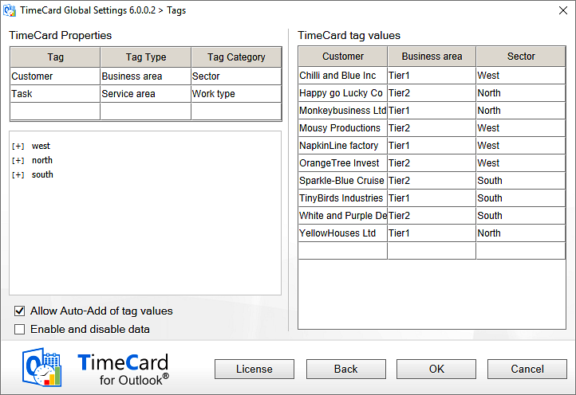

When you have entered the name of a Tag Type and a Tag Category on the left side of the screen, the type and category will be shown in the right panel also, so that you can enter type and category values for each tag value. A hierarchy tree will be shown to the left, under the properties.

You may very well use only a type, but you cannot use just a category.

Below is an example of how the tag Tasks can be sorted in types and categories in the same way. Here the Tag Type is called Service area and the Tag Category is Worktype. The category only has two values – billable time and internal work.  
  
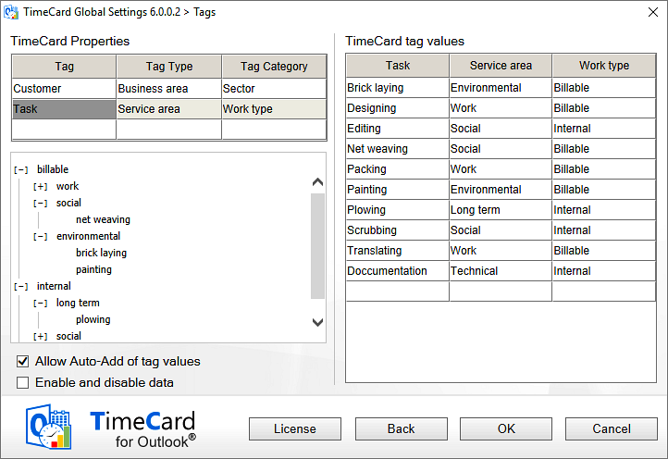

### Allow Auto-Add of Tag Values

If you enable this feature, *TimeCard* will download newly added tag valuesas soon as there is a connection to the database. Each user automatically gets every new value that is added. They of course have the option of de-selecting them if they don't want to use them. When this option is enabled, the tag values in each user’s Personal Settings are not saved but continuously updated with the data from the Global Settings.

When the box is *not* checked, the users have to open the Personal Settings to get the new tag values from the workgroup database.

### Enable and Disable Data

The checkbox “Enable and disable data” lets the administrator hide a tag value from the users without having to delete it. Disabled data will be shown everywhere except in the users’ Personal Settings. As the users cannot select this tag value anymore they cannot report on it.

When the box is checked a new column will be displayed in the right part of the screen. All tag values with their types and categories are enabled by default, but you can uncheck the rows whose tag values you wish to hide to the users.

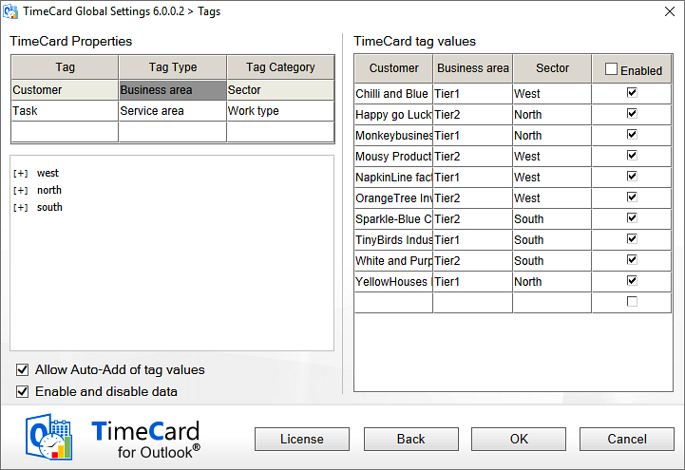

### Importing Data by Copy and Paste

It is quite easy to copy and paste information into the settings grid. If you already have an Excel list or similar with existing values that you want to use, the copying procedure should be very straightforward.

Copy and paste using CTRL + C and CTRL + V, or right click in a cell to show the copy/paste options.

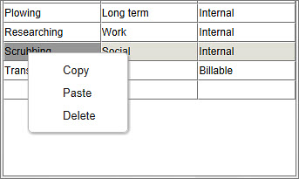

When you click OK or Back after pasting the data, it will be sorted alphabetically if a database is selected for reporting and shared settings. Any blank rows and duplicates will be removed.

You can also import or copy and paste your datadirectly into the *TimeCard* database.

### Copying Data from an Outlook Contact Folder

If you already have some of the data you want to use as a *TimeCard* tag values in an Outlook folder, it is quite easy to transfer the data into *TimeCard*.

The most common scenario is that you have some customers in the Outlook Contacts/People and you want to copy those customer names into the Customer grid of the Tags dialog. These are the required steps:

1. Create or choose an Outlook View that has all the data you need to copy.
2. Select all the data from the Edit menu or by CTRL+A.
3. Copy the data to the clipboard via the Edit menu or CTRL+C.
4. Paste the information into the *TimeCard* Tags dialog. Press OK or Back to get the data properly sorted and all duplicates removed.
5. If necessary, reset your view in the Outlook Contacts folder.

### Delete *TimeCard* Properties

When you want to delete *TimeCard* properties you must do it in a certain order. If you do it in the wrong order, you will be given a message telling you how to do instead.  
  
Delete **tags** from the bottom up, so that you for example delete the second tag before you delete the first one. If your tags are Customer and Task and the Customer is on top, remove the Task tag before you remove the Customer tag.  
  
Do like this if you want to keep the second Task tag but not the first Customer tag:

1. Copy all the Task values from the right side of the screen.
2. Remove the second tag, Task.
3. Rename the first tag to Task instead of Customer.
4. Paste the Task values over the old Customer values.

To delete **category** and **type**, delete the category before you can delete any types.

Tag **values** can be deleted in any way you wish.

When you delete a tag, a type or a category from the *TimeCard* settings, they will not be shown in the statistics but they will be kept in the database. Deleted tag values will still be seen in old appointments in the statistics.

The list of values for a deleted tag will be kept, and if the same tag is added to the settings again the values for that tag will be restored.

## Costs and Rates

*TimeCard* is designed to be very flexible, so that you can set it up to fit the way you want to track costs and time. Thus it is important that you consider how to set up the cost calculating options.

Either you can specify that one of your *TimeCard* properties should be the cost carrier, or you can trace the cost after each person’s hourly rate.

When entering the rates you do not need to enter the currency. It will follow your Windows settings.

The default setting calculates the costs by the first tag. The tag name and the tag values entered in the Tags screen are automatically displayed in the Costs and Rates screen too.

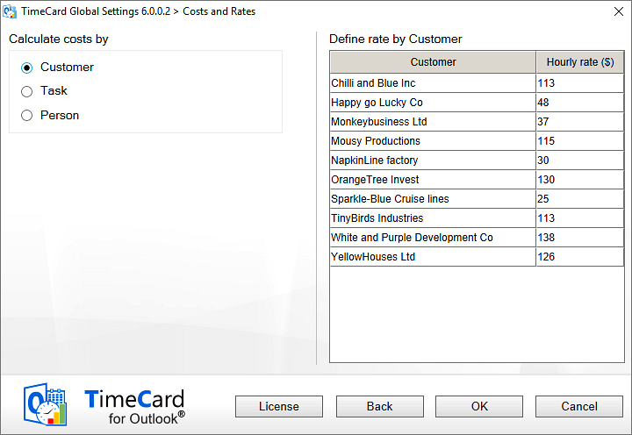

The costs may also be calculated by the second (or third) tag.

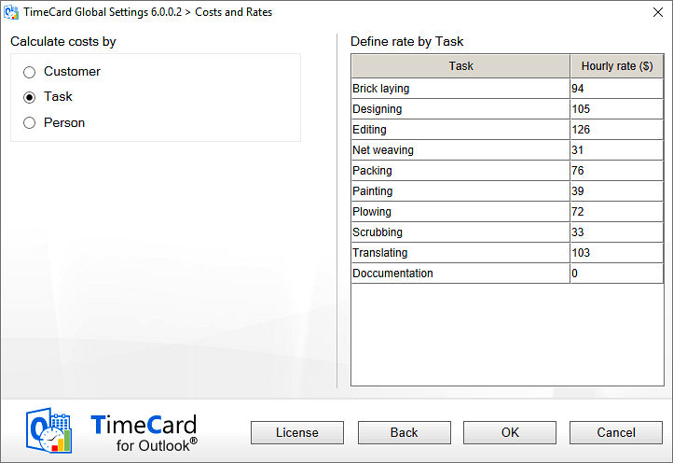

**Example** on calculation by the tag “Task”:

A task value called “Meeting” have been created, and the hourly rate of that value is set to $75. Therefore a two hour appointment tagged with “Meeting” will have a cost of $150 reported into the database.

Likewise, if you choose to calculate costs by the tag “Customer”, your reported time for each individual customer is multiplied by the hourly rate for each customer.

When the costs are counted by person, there are two options:

* The administrator sets the rates in **Global Settings**. When this option is selected, a column for persons and rates will be shown in the right panel. Category may also be added, for example department. Only the category and rates fields are editable. The persons are loaded from the database (tblPersons) after the first time the users have reported time.

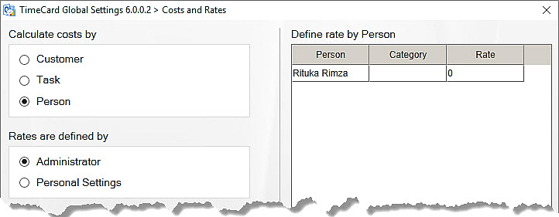

* Each user defines her/his rate.

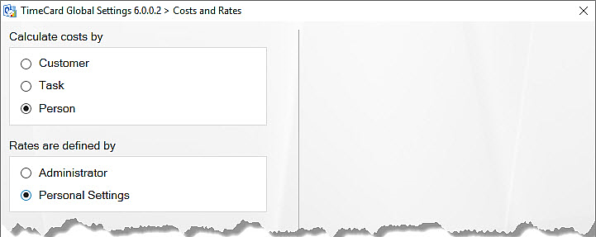

In that case the user sets his/her rate in the Personal Settings.

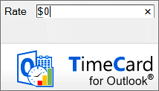

## General Settings

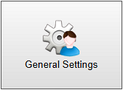In the General Settings screen the *TimeCard* administrator can enable several extra features that may enhance *TimeCard* for the organization. None of these features are enabled by default.

**Sharing option is an Access Database/SQL Server Database**

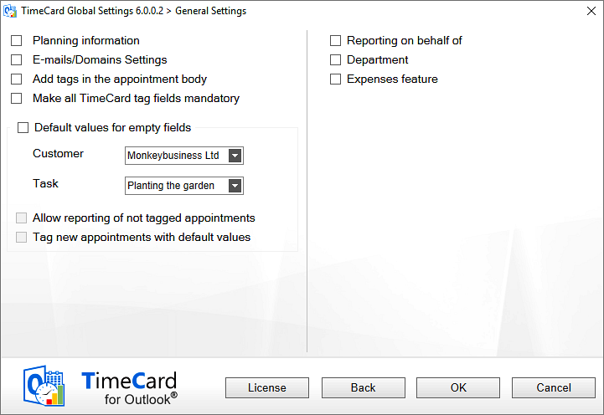

### Planning Information

When Planning information is enabled, the management can study the end users’ future appointments that have not been reported in the **tblPlanning** in the database.

This is how the **Planning information** works:

When a user reports time, all future calendar appointments for one year after the latest reported appointment is added to the planning table in the database.

The next time the same user reports appointments, his/her old future appointments are removed from the database, and the new future appointments are entered instead. Therefore, every time a user reports time, the **Reporting Tool** enters the upcoming meetings fresh, from the last unreported meeting and one year ahead.

Settings are based on what was entered by each user in the **Personal Settings**, which gives the users options such as excluding private appointments.

The Planning reporting is done automatically at the same time as the other reporting. Users can change their future appointments in the calendar, just as they normally would.

This is how the **Planning information** works when it is enabled:

1. When a user reports time, all future calendar appointments for one year after the latest reported appointment is added to the planning table in the database.
2. When the same user reports the next time, the old future appointments are removed from the database, and the new future appointments are entered instead.

### E-mail/Domain Settings

The E-mail/Domain settings is a useful feature when users often get work orders via e-mail. Then they may drag the e-mails to their Outlook calendars and make appointments of them, and those appointments will be tagged automatically.

When the box is checked a Configuration button will be displayed:



Click the button, and a new dialog will open. In this dialog you can enter e-mail addresses or domains and select values from one or two tags to map it with.

The selected tag value will be filled out automatically in the appointments users create by dragging an e-mail to the calendar.

*TimeCard* will understand what e-mail address is relevant, so it will take the "To" address for mapping with the specified tag value if you drag the e-mail from the Sent folder. Otherwise it will take the "From" email address.

You can map either a whole e-mail ID or only the domain. *TimeCard* will first look if you have set a default tag for the whole e-mail address. If there is none, *TimeCar*d will look for the domain.

### Add Tags in the Appointment Body

This feature adds a tag in the appointment body, and it must be checked if you want the *TimeCard* tag values to be added to the appointment automatically after a meeting request has been accepted.

When the “Add Tags in the appointment body” box is checked, a settings icon will be shown. Click it, and a dialog opens where you can add the domains for which you want to have the *TimeCard* values added automatically. This way you can avoid showing *TimeCard* values, for example to people outside the organization.

When the option "Add tags in the appointment body" is enabled, the tag values will be automatically added to the appointment body like this: [TC1:Tag1|| Tag2||Tag3||TC] – when the meeting organizer tags the appointment using the *TimeCard* dropdowns and the meeting request is sent to a specified domain.

This means that if the person who is inviting has set 2 tag values:  
The Customer value “Biz Solutions 365”  
The Task value "Coding"

then the tag in the appointment body will be [TC1: Biz Solutions 365||Coding||TC]

If the invitation is accepted, the two *TimeCard* dropdowns will show " Biz Solutions 365" and "Coding" for the person who has accepted the invitation also.

### Mandatory Tags

When this box is checked, values for the number of *TimeCard* tags (1, 2 or 3) defined by the administrator **must** be selected for each appointment. If the user does not select values for all the tags, *TimeCard* will prompt him/her to try again. Else the changes to the appointment are discarded.

There is one exception: if a user marks an appointment as **private**, he will still be able to save it without defining *TimeCard* tag values. That way a user can have for example a dentist appointment in his calendar without having to tag it with *TimeCard* data.

### Default Tag Values

When users don’t select values from all the *TimeCard* dropdowns (1, 2 or 3) in an appointment, that appointment cannot be reported. But the administrator can define a tag value that will be used automatically if the user has left a field empty when reporting.

When a default value is set for a tag, it will be entered **instead of an empty field.** Selected values will of course stay unchanged.

The default values are not connected to each other but are used separately.

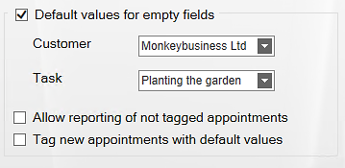

**Example**  
The *TimeCard* tags are “Car” and “Year”. The values are:

Car: Ford, Daewoo, Honda.   
Year: 2010, 2011, 2012, 2013.   
The default values are set to: Honda, 2011.

When an appointment is tagged with <Ford, --> it will be reported to the database as <Ford, 2011>, as the default value is used only for the missing tag.

An appointment tagged with <--, 2012> will be reported as <Honda, 2012>

You may permit reporting if all fields are empty, which might be useful if users often report on the same properties. The checkbox "Allow Reporting of not tagged appointments" means that appointments with all *TimeCard* fields empty will be reported with the default values.

You cannot report appointments with empty fields if default values are not set for them, so the checkbox "Allow Reporting of not tagged appointments" is active only when the checkbox “Default values for empty fields” is enabled.

**Example**  
The appointment <--, --> will be reported as <Honda, 2011> if the checkbox "Allow Reporting of not tagged appointments" is checked and those are the default values.   
(The untagged appointment will not be reported at all if the “Allow” box is unchecked.)

If you check the box “Tag new appointments with default values”, users will see the default tag values when they create a new appointment, and they can either change them or leave them as they are. **This is the best option for most users**.

If you do **not** check this box, the default tag values will be added at reporting. To post appointments users need to select “All appointments” from the right hand dropdown and click "Get Values". When they report all appointments, the not tagged appointment will be saved with the default tag values.

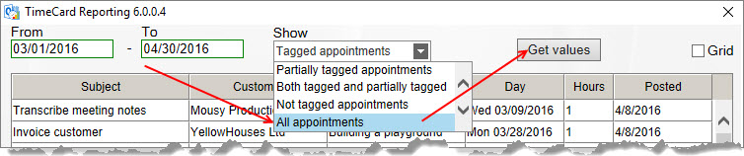

### Report on behalf of

If one person has the right to edit another person’s calendar, he/she can always report from that calendar also, but the logged in name will be entered in tblPersons in the database.

When “Report on behalf of” is enabled, an extra dropdown with names of all *TimeCard* users will be shown in the Reporting dialog, and the reporting person can select the correct name from it. *Refer to* Report on behalf of in the section about reporting. The names will be added when users report time for the first time, but they may also be added manually in the database, tblPersons.

If the person who is reported on behalf of does not use *TimeCard*, you can still report for him. He only needs to be added to the *TimeCard* database to show up in the dropdown list. This may be done manually or with a tool that will be sent to Community Members on request.

### Departments

When the **Departments** box is checked, each user will be asked for his/her department when reporting for the first time.

### Expenses

If the Expenses Feature is enabled, users can add expenses to each appointment and then report these expenses when reporting hours.

The reported expenses will be saved in the table tblExpenses in the database, intReportID as foreign key for tblReports, and they will be shown and summarized in the Excel reports, both in the statistics reports and in the Export to Excel data sheet.

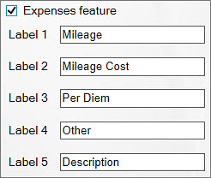

When you check the box to enable the Expenses feature, five fields are shown. Here you can edit labels for the expense costs that users should be able to report. We suggest that all the fields except the Description field should be numeric, to be easy to summarize.

The default values are Mileage, Mileage Cost, Per Diem, Other and Description.

Once you change the caption of an Expense Label in the Global Settings, it will also be changed in the *TimeCard* statistics, in the Export to Excel sheet and in the Add/Edit Expenses dialog box in the users’ appointments.

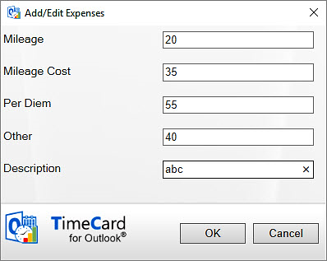

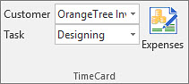

## Report To

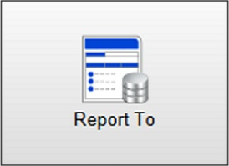In the “Report To” dialog you can switch option for reporting and shared settings for everyone who uses the installation.

The reported appointments will not be migrated to the new option, but tags and other settings will be migrated.

# User installation

TCWG2Once the administrator has performed the administrator installation, *TimeCard* must also be installed on all the user machines. This is done with the **TimeCardUserSetup.msi**, which can be downloaded from [the bizsolutions365.com website](https://bizsolutions365.com/our-products/timecard/timecard-workgroup/tcwg-try/). The person installing the Client Tool needs to have Administrator rights over the workstation.

The file **TimeCardUserSetup.msi** may also be used for a central installation of the client tools, via Active Directory.

The Client Tool installer will install the same files on the client machines as on the administrator machine – except the files for the Global Settings.

**TimeCardUserSetup.msi** also creates a My TimeCards folder under (My) Documents. Here the Excel files for the user’s own statistics reports and Reporting sheets will be saved.

## Start installation

Click on the file **TimeCardUserSetup.msi** to start the installation.

Now you are shown a Welcome dialog.

Then you are asked to accept the license agreement. When you do that you will be able to click Next.

By default, the *TimeCard* is installed in Program files/bizsolutions365.com/TimeCard Workgroup User, but you can choose another folder by pressing the Change button.

Click **Next**, and then **Install** to start the installation.

When the installation is over, click Finish to exit the installation wizard.

## Database Selection

Once the installation of the client tool is finished, the user is asked to specify the *TimeCard* database that the administrator has created and configured.

When that is done and the user has clicked OK, the *TimeCard* Personal Settings of that machine will be populated with the tags and tag values entered in the Global Settings.

What is left to be done is for the user to select their tag values and define some other personal settings, *refer to* Personal Settings. Then he/she is ready to tag appointments with tag values and report time to the database.

## User Installation via AD

When a database is selected as reporting and sharing option, the user installations may be performed centrally, via Active Directory.

When the administrator has done the Administrator installation and the database configurations, first propagate the database option to all users like this:

**SQL Server database:**

The Admin needs to set the SQL connection string to the registry. The Registry should be set on the path: "Software\\bizsolutions365.com\\TimeCard\\Settings"  
Key - DBConnections  
Value - SQL Connection string

(Example: "Provider=SQLOLEDB;Password=Biz@123;User ID=sa;Data Source=192.168.150.111\\SQLBIZLABS;initial catalog=az")

**Access database**:

The Admin needs to set the Access database file path to the registry. The Registry should be set on the path: "Software\\bizsolutions365.com\\TimeCard\\Settings"

Key - DBConnections  
Value - Access database path

(Example - \\BIZLAB\Internal Shared\)

When the database has been propagated, the administrator can deploy the user setup for all users. For more info about how to do that, please refer to <https://bizsolutions365.com/other-faq/> (How do I deploy your products to each user in an automated fashion?)

Both steps described above may also be done in one package.

When a user starts Outlook for the first time after the central deployment, the Personal settings dialog will open directly. The users will never see the Sharing Options dialog.

# Personal Settings

The dialog Personal Settings is shown when the

## Report To

In the “Report To” dialog you can switch option for reporting and shared settings for everyone who uses the installation.

The reported appointments will not be migrated to the new option, but tags and other settings will be migrated.

User installation is finished and the *TimeCard* database has been specified. Here each user selects those common properties that he/she will be working with and needs to report on.

The Personal Settings also contains other choice possibilities. It may be reached anytime via the Personal Settings button in the Outlook ribbon.

Below is the main screen of the Personal Settings.

## Tags

The Personal Settings Tags screen contains the tags specified by the administrator and their values. Here the user can uncheck the values that are not needed, for example tasks that this customer never performs.

Unchecked values will not be shown in the *TimeCard* dropdowns in the appointments for this user. This way each user will have fewer alternatives to select from when tagging the appointments with time reporting data.

When the box for “Write tag values in the subject” is checked, the values this user selects for each appointment will be entered in the subject of the appointment also.

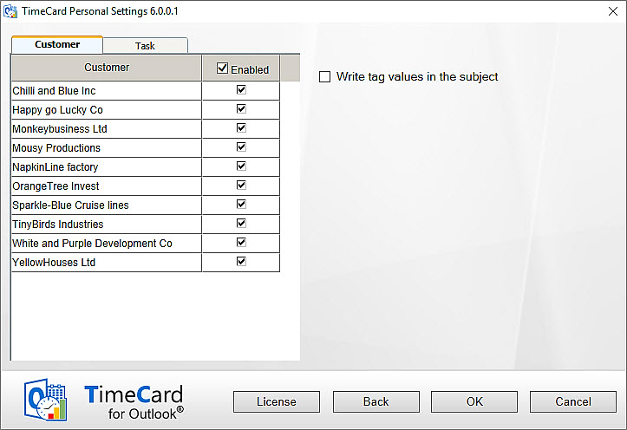

## General Settings

In the Personal Settings, General Settings screen, users can define some other settings that will only apply to the individual user.

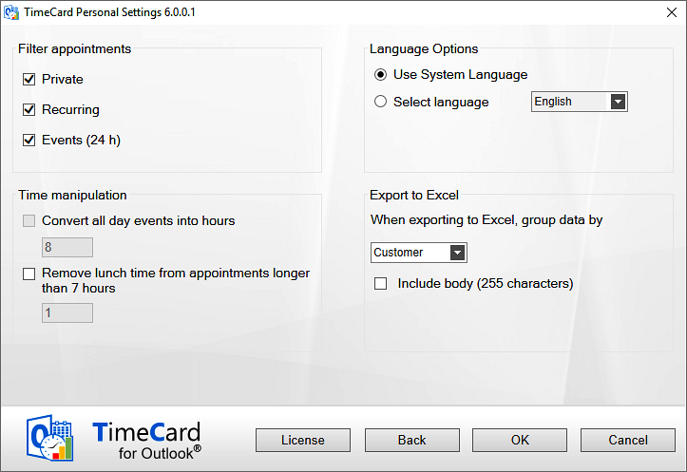

### Filter Appointments

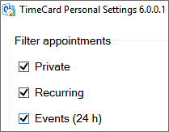Users may decide what types of **appointments should be excluded from reporting**. These appointments will *not* be displayed in the reporting summary even if they exist in the calendar, and they will *not* be entered into the database. Not even if they are tagged with *TimeCard* values will they be reported.

This way users don’t have to use a separate calendar for their work time tracking.

By default private, recurring and all day appointments are excluded from the reporting, but you can uncheck the appropriate box(es) to include them.

#### Recurring Appointments

|  |  |
| --- | --- |
|  | Users who want to include Recurring appointments in the reporting should be aware that recurring series of appointments are treated as one group by *TimeCard*. Any changes in the *TimeCard* values of one appointment will be applied to the whole series. |
|  |

#### Private Appointments

|  |  |
| --- | --- |
|  | By default, private appointments will not be included in *TimeCard* reports. |

#### All Day Appointments

|  |  |
| --- | --- |
|  | When this box is unchecked it is possible to manipulate the time for all day events. If the time is *not* manipulated, all day appointments are considered to be exactly 24 hours work time in the *TimeCard* reports. Therefore, users should set another number of hours in the Time manipulation checkbox, see below. |

### Time Manipulation

When the all day events are set to be reported with *TimeCard* it is possible to **convert all day events into hours**, so that fewer hours than 24 are reported for that day.

It is also possible to **remove time from appointments** that are longer than seven hours.

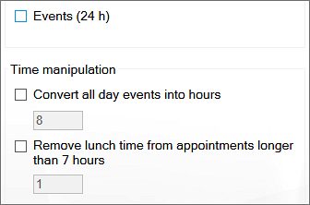

### Language Selection

By default, *TimeCard* takes the system language, but when a database is used for sharing, users may select another one of the supported languages.

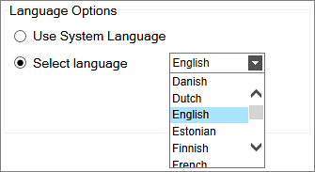

### Export to Excel Options

|  |  |
| --- | --- |
| When users press the Export to Excel button in the Reporting dialog, the data shown in the dialog will be exported to an Excel sheet.  Each user can select by which *TimeCard* tag the data should be grouped in the Excel sheet.  They may also select to include the first 255 characters of the appointment body in the export. |  |

### Rate

If the administrator has specified that costs should be calculated by person and that this rate should be defined in the Personal Settings, this screen will have an additional field for rate.

The currency will be the one specified in the system settings, so you just have to fill out the figure.

## Report To

In the “Report To” dialog you can switch option for reporting and shared settings, if you for example move to another department that uses another option.

The reported appointments will not be migrated to the new option, but tags and other settings will be migrated.

# Work with TimeCard in the Outlook Calendar

Use your Outlook Calendar to plan your day with meetings and appointments. You have to select the appropriate **tag values** (or value) for each appointment; otherwise you can handle them just as you normally would. You can, for example, extend the appointments or move them without the *TimeCard* properties being disturbed.

When the week (or any other preferred period) is done, you can review the existing data and send them directly to the database. You may also export the data of each reporting to an Excel sheet, and when you have reported time with TimeCard for a while you can study your data in the Excel statistics reports.

## The *TimeCard* Ribbon Group

*TimeCard* creates a new ribbon group in the calendar view. It may look in two ways, depending on if an appointment is selected or not.

This is how the ribbon group looks when no appointment is selected – the calendar ribbon group. The group has three buttons, and by clicking them you will reach your Personal Settings, your Reporting dialog and your statistics.

In Outlook 2007 this group looks a bit different:

Replace9

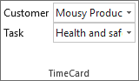When an appointment is selected, the ribbon group will change and instead show the tag values for that appointment – the appointment ribbon group. This way you can select or change values of an appointment without even opening it.

The same ribbon group is shown in the open appointment.

Below you can see how the appointment ribbon group looks when the Expenses feature has been enabled by the administrator.

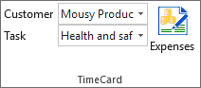

## Create New Appointments with *TimeCard* Values

Create a new appointment as usual, but to use your calendar with *TimeCard*, select the extra information (the *TimeCard* tag values) from the dropdown list or lists in the appointment.

You can handle the appointments just as you normally would. For example, you can extend or copy your appointments without losing the *TimeCard* properties.

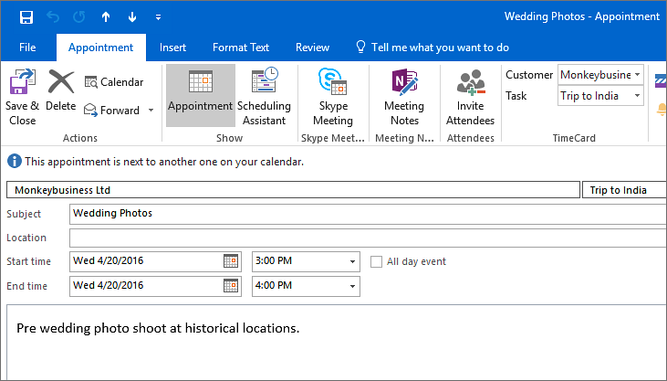

## Set *TimeCard* Values on Existing Appointments

You can add or change *TimeCard* values in an existing appointment two ways:

* Open the appointment and then select or change the *TimeCard* values in the ribbon group.
* Select the appointment in your calendar (by clicking on it once). The *TimeCard* appointment group is now activated in the ribbon. Select or change the *TimeCard* values, and the changes will be applied to the selected appointment.

## Copy appointments

A very fast way to enter information into your calendar is to **drag & drop** an appointment while holding down the **CTRL** key. That will create a copy of your appointment with all the *TimeCard* properties intact. You may also use **CTRL+C** for copy and **CTRL+V** for paste.

If a *reported* appointment is copied, the “reported mark” is removed so that the appointment can be reported again.

## Categories Field

|  |  |
| --- | --- |
| *TimeCard* uses the Outlook **Categories** field to store *TimeCard* tag values in appointments.  If you use the Categories field for another type of appointment classification, *TimeCard* will not interfere with your existing data. However, if you add *TimeCard* values to an appointment with non-*TimeCard* categories filled out, they will be overwritten.  This means that you have to *first* tag the appointment with *TimeCard* values and *then* add the non-*TimeCard* category.  You can reach the Categories via the Categorize button in the open appointment or by selecting an appointment in the calendar view and right clicking it. |  |

### Color Code Tag Values

To get a quick overview of your appointments you can connect each tag value to a color. In All Categories, rename the colors to your tag values and each color will be applied to all appointments tagged to the specified value.

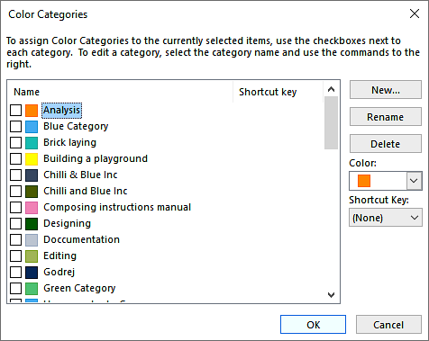

### Remove *TimeCard* Tag Values

To remove *TimeCard* values from an appointment, right click the appointment in the Outlook calendar view and select Categorize and Clear all categories.

Note: if you want to exclude some appointments from the reports you can also mark them as recurring, personal or event, *refer to* Filter Appointments.

## Admin Enabled Features

The features below may only be used if they have been enabled in the Global Settings by the *TimeCard* administrator.

### Expenses

|  |  |  |
| --- | --- | --- |
| With *TimeCard* you can **report your expenses at the same time as you report your hours**, if this feature is enabled by the *TimeCard* administrator. This is done in the Expenses dialog, which you reach by pressing the Expenses button in the appointment ribbon group. | |  |
| In the Expenses dialog, fill out your expenses and they will automatically follow the appointment when you report your hours. |  | |

You can see the Expenses button in two ways:

* In the calendar, **select** an appointment and the Expenses button will be visible in the *TimeCard* ribbon group. This method is especially convenient if you want to add or edit expenses, as you can do it without having to open the appointment.
* **Open** an appointment to reach the *TimeCard* appointment group in the ribbon.

### E-mails/Domains Settings

The E-mails/Domains settings is a useful feature when you often get work orders via e-mail. If the administrator has enabled this feature and mapped e-mail or domain settings with tag values, you can drag e-mails to your Outlook calendar and make appointments of them, and those appointments will be tagged automatically with the values the administrator has specified.

When you drag an e-mail to the calendar in the same window, the appointment will be created at the currentdate and time.

When you drag an e-mail in one window to a calendar open in another window you can drop the e-mail on the date and time you prefer. Open the calendar in a new window by right clicking the Calendar label and selecting “Open in New Window”.

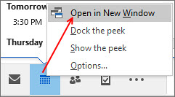

# Report with TimeCard

|  |  |
| --- | --- |
| Open the reporting dialog by pressing the Report button in the *TimeCard* calendar ribbon group. |  |

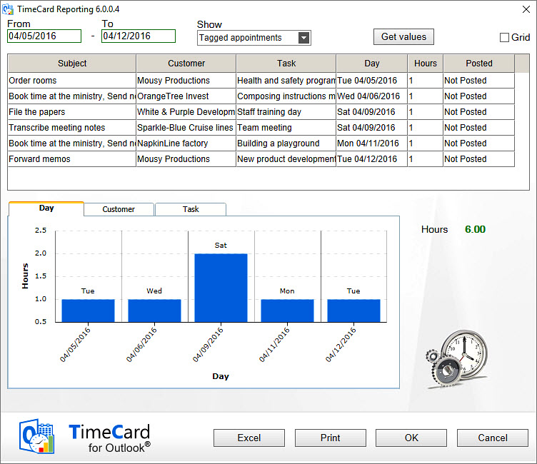

## Reporting Dialog – Main Purpose

The Reporting dialog lets you select a time period, view and edit a summary of your work time and report the work time to a database. Also the expenses are reported if your administrator has enabled that feature and you have used it.

In order to get the best possible data input, you can verify the data in *TimeCard* three times:

* When you enter the appointment in your calendar.
* In the *TimeCard* Reporting dialog, where you get an overview of the data that is about to be entered into the database.
* When you click on OK in the Reporting dialog, you are asked to confirm that you want to report the time.

## Choose Date Ranges

Choose your date range by selecting a start and end date for the report. The Reporting tool will summarize all appointments within that date range and include them in the report.

Standard view:

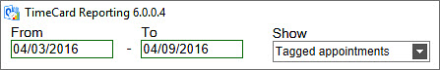

Grid view:

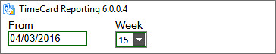

## Display Options

For the time period you have defined, you can select which appointments you wish to show. These are the alternatives:

* all appointments tagged with *TimeCard* values
* all partially tagged appointments
* both tagged and partially tagged appointments
* not tagged appointments
* all appointments.

This makes it easy to verify that you have not missed tagging an appointment in your calendar. If you did, you can easily select *TimeCard* tag values for that appointment in the Reporting dialog.

## Change Appointments Within The Reporting Dialog

You can change the *TimeCard* tag values and other properties within the Reporting dialog by selecting a row in the list and changing one or more values. All changes will be written back to your calendar.

Thus, if you change the duration of an appointment from 2 to 3 hours in the Reporting dialog, the corresponding appointment in the calendar will become one hour longer.

## Grid

If you check the box for Grid, you will get a possibility to **add appointments directly in the Reporting dialog**. For tag values that already exist in the dialog you can quickly change the time period or add more hours in empty cells. Click Save when you are finished with each week, to save the changes to the calendar.   
  
When you are only adding hours for one week, you can click OK directly without saving. Then the additions will be saved to the calendar and your hours for that week will be reported to the database.

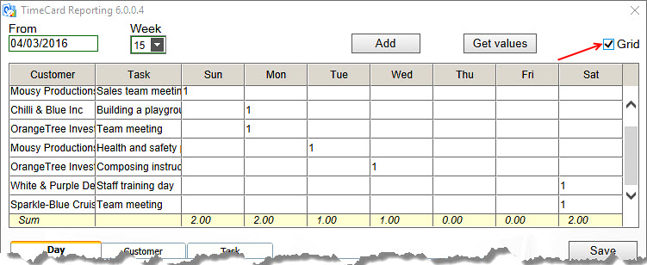

For tag values that are not present in the reporting grid, click the Add button to open a new dialog where you can add tag values. Then click OK to add the appointment to the reporting summary. Enter the number of hours in the cell for the actual day, and click Save to save the new appointment to the Outlook calendar or click OK directly to save and report.

When you have created a new appointment you will be informed about that, either you click the Save button or the OK button. The new appointment will be saved to an empty period of the correct day, but if you want to specify the hour you have to go into the calendar and do that.

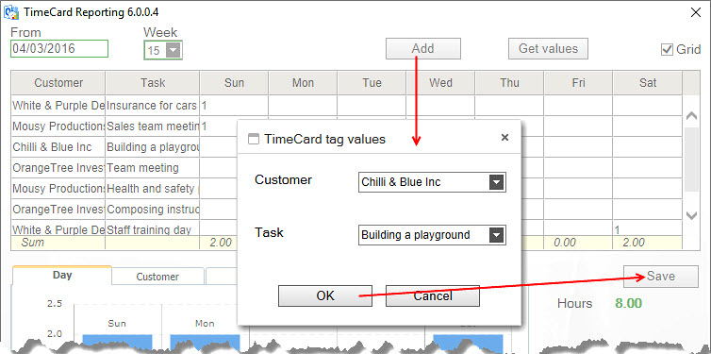

## Report on behalf of

If the feature “Report on behalf” of is enabled in the Global Settings, users who has the right to share another person’s calendar may report the appointments in it and get the name of the person who made the appointment into the database.

The report on behalf of feature works like this:

1. Select the other person's calendar
2. (Tag appointments if this is not done)
3. Click the *TimeCard* Reporting button in Outlook to open the Reporting dialog
4. (Make changes if necessary)
5. Select the right name from the TimeCard user dropdown. The selected calendar owner is shown as default.
6. Report time and expenses by clicking the OK button

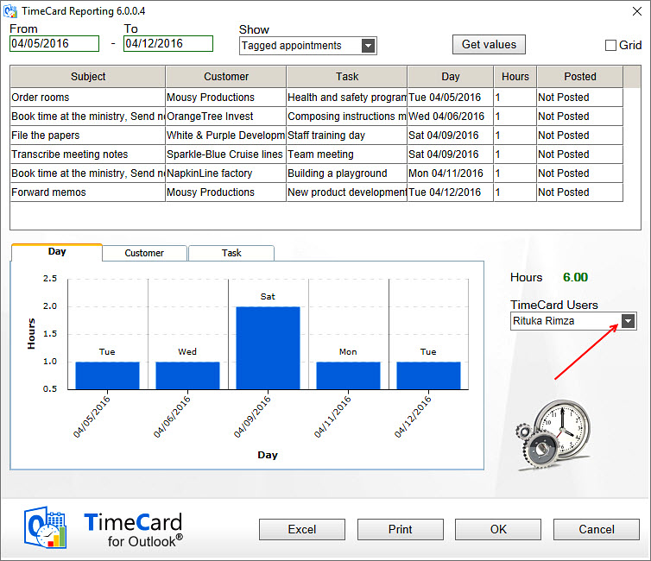

(Reporting for another person is possible even if the box is not checked in Global Settings, but then no choice is shown in the Reporting dialog and the name of the logged in person will be entered into the database instead of the calendar owner’s name.)

## Export to Excel

The Export to Excel button produces an editable Excel sheet with data about all the appointment listed in the *TimeCard* Reporting dialog, where hours (and expenses) are summarized.

  
  
In the Personal Settings you can select which *TimeCard* tag the data should be grouped by and if you should include the appointment body or not, *refer to* Export to Excel Options. To use this feature you must have Microsoft Excel installed.

This Excel report is opened automatically when the button is pressed. The report is saved as **TCExcelReport.xlsx** under '(My) Documents\My TimeCards'. The file can be printed for signatures, if that is needed before the reporting.

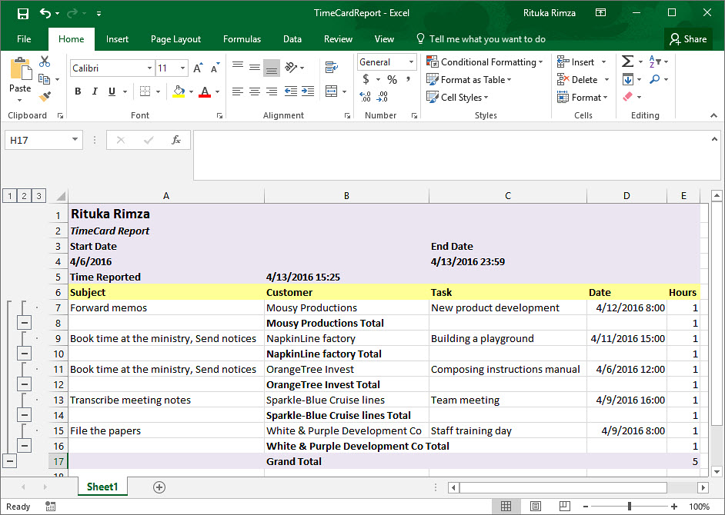

## Customization of the Excel template

The Excel sheet can be customized according to your own needs. When the data is exported to Excel, make the changes you wish and save them. Then the changes will be preserved and available for subsequent reports. You can for example:

* insert a company logo at the left top of the report
* add rows on top and bottom, but *not* in the default exported report area
* change colors, fonts or number format in newly added rows.

We **don’t** recommend inserting any columns, as they can spoil the layout of the report. In the image above the appointments are grouped by Customer, and the box for adding max 255 characters from the appointment body has been checked in the Other Settings dialog.

## Print Report

When you press the Print button the reporting period and the two panels in the Reporting dialog will be printed.



## Send Report

When you click **OK** to post your report you will get a warning that the data cannot be changed once it has been posted.

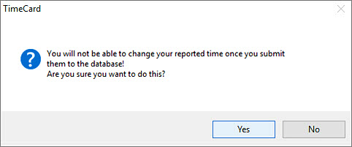

If you decide to post your report, you are asked if you want to send another report.

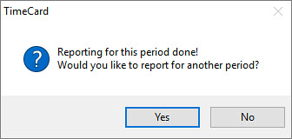

# Statistics

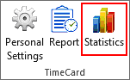When you press the Statistics button in the *TimeCard* calendar ribbon group, *TimeCard* will create Excel reports with statistics on all reported data Each time you run the statistics tool the statistics reports will be refreshed with any new data.

When the Statistics button is used by an **administrator,** statistics for **all users** will be shown.

When another user presses the Statistics button, he or she will only see his/her **own** statistics.

The statistics reports will be stored locally at My Document(s) >My TimeCard.

The reports themselves are the same. The only difference is what data is fetched from the database – all data or just data for one user. Therefore, the description below will be the same for both administrators and users.

You can use all the Excel features with these reports, so you can select to study any time period or detail in the data.

The image below shows the first tab of the Excel workbook.

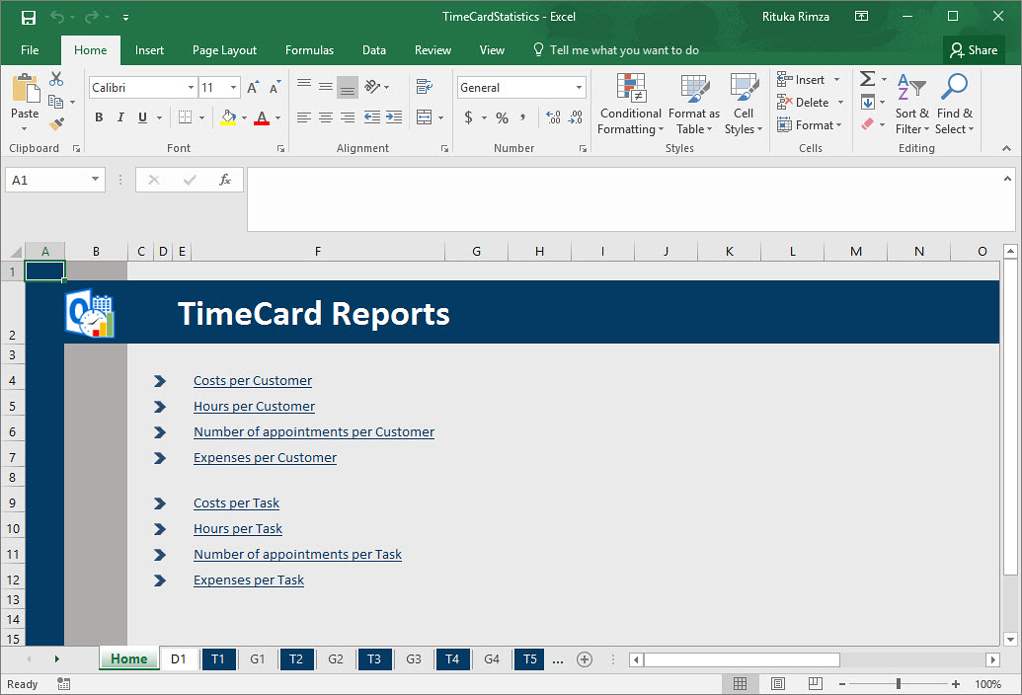

## Default Reports

The default reports are grouped by tag, and there are three statistics reports for each tag: Hours per Tag, Cost per Tag and Appointments per Tag.

When the Expenses feature is enable there will be one more default report per tag. This is shown in the image above.

You can drill down from tags to values to appointments by clicking on the plus signs. If your organization uses category and type for the tag values, you can drill down from category to type to tag to tag value to appointment subject.

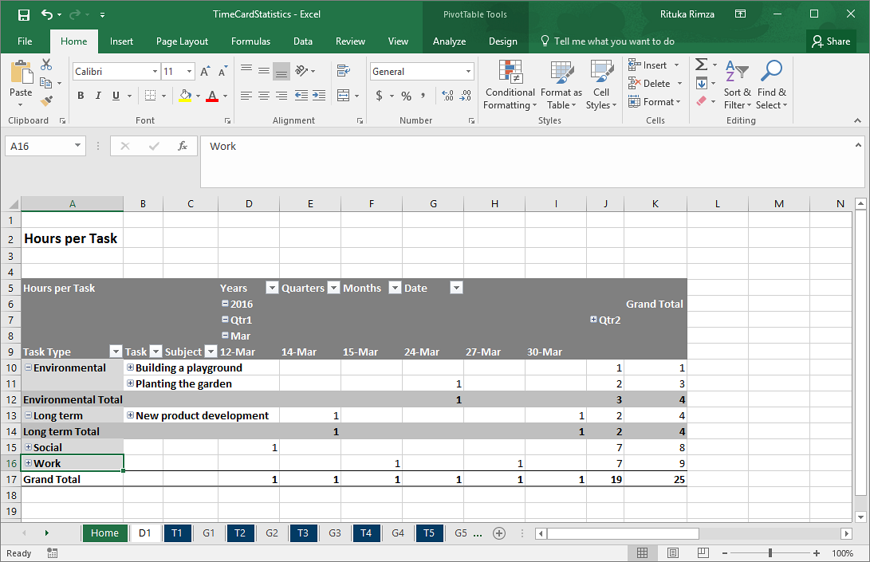

Each report is shown as a pivot table and as a chart.

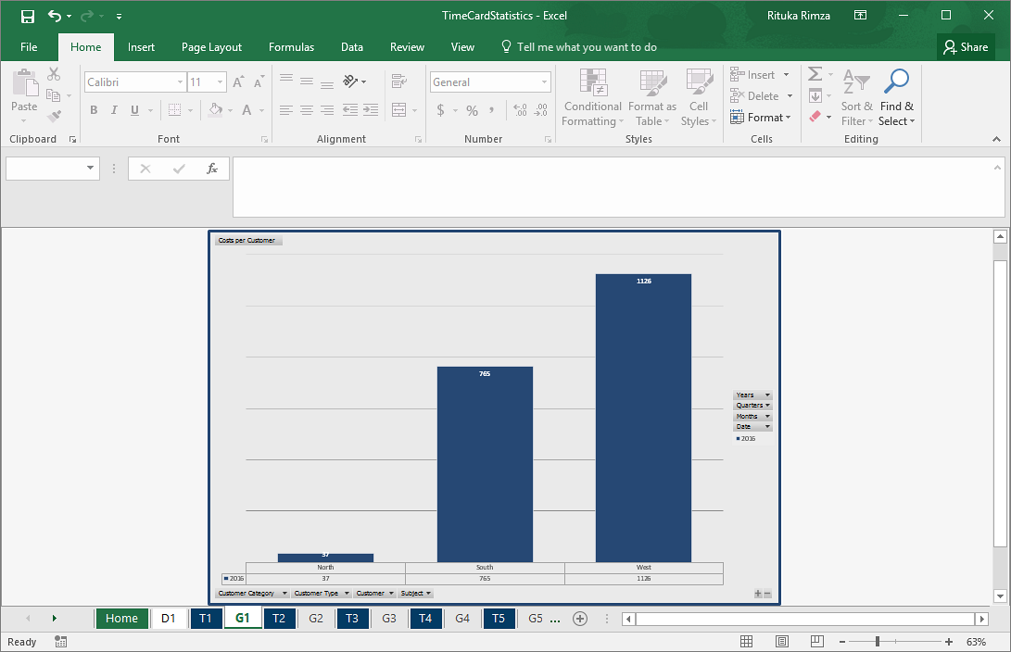

Under the first tab, D1, you can find all info from the database.

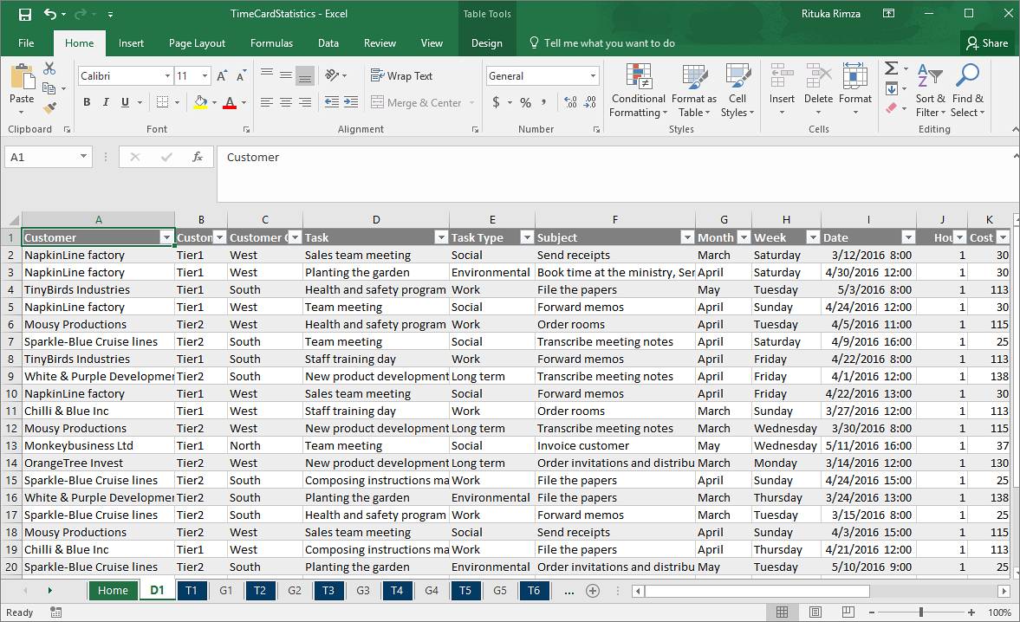

## Custom Reports

All the standard Excel features may be used with the default reports, so it is easy to modify these reports. If the changes are saved, the modified reports will be used instead of the default one.

To create **a totally new report**, open the D1 tab and insert a new pivot table. It is often best to select a new worksheet for it. Then customize the sheet as you like before you save the report.

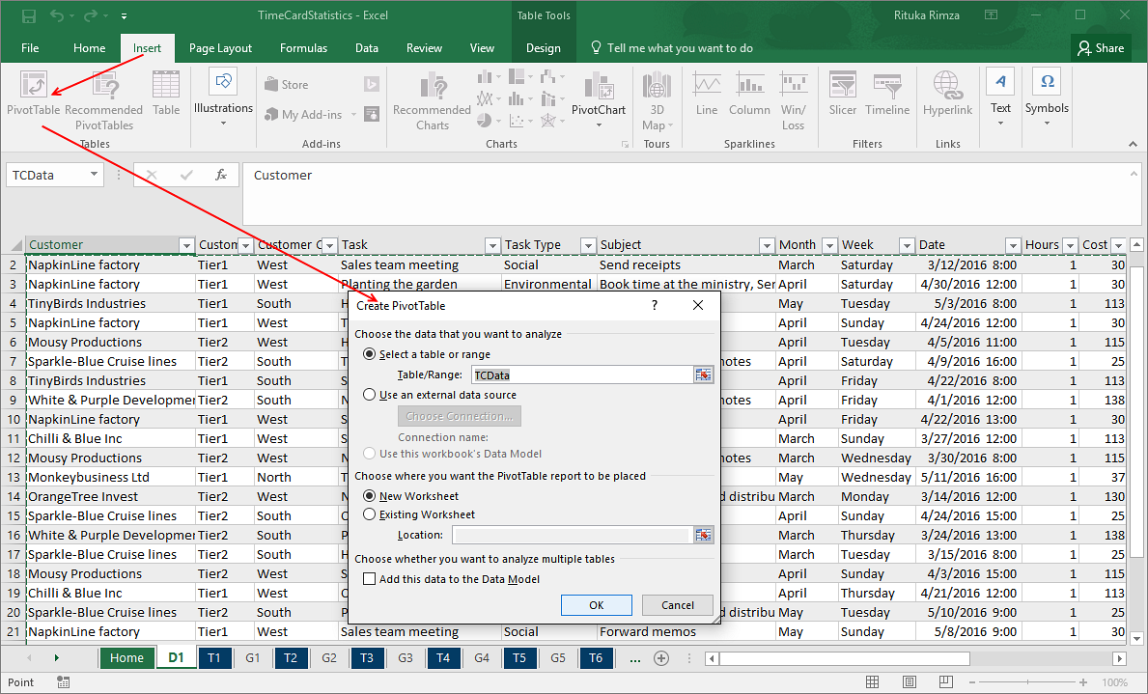  
  
Next time you run the statistics tool, your modified or custom report will be refreshed with the new data just like the default reports.

# Upgrade

Free upgrades are included in the *TimeCard* subscription, and we recommend users to always have the latest – and best! – version.

## Administrator

To upgrade, the administrator will just have to close Outlook and run the file **TimeCardAdminSetup.msi**, downloaded from the [*TimeCard Workgroup* Upgrade page](https://bizsolutions365.com/our-products/timecard/timecard-workgroup/upgrade-tcwg/). Then the upgrade will be quick and automatic.

## User

The User installations also have to be upgraded, with the file **TimeCardUserSetup.msi**. This upgrade may be performed centrally, using Active Directory. *Refer to* User Installation via AD.

Each user may also use the file and run it to upgrade his/her own installation.

# Subscription

The evaluation period for *TimeCard* expires after 30 days. Then you need to start subscribing to *TimeCard* and either register it or order a register free Premium copy of *TimeCard* to be able to continue working with it.

There are three subscription levels, refer to the https://bizsolutions365.com/subscription/*.*

**Support, free upgrades and an unlimited number of users** within the organization are included in all levels.

## Registration

This information is only valid for organizations with a Minimum or Medium subscribers. *Premium subscribers do not have to register their installations.*

The registration is performed inside *TimeCard*, so there is no need to change anything once you decide to subscribe.

The registration is performed by clicking the License button in the Global or Personal Settings. Register with the key you have received from the bizsolutions365.com team and with an e-mail address that has the domain of your company or organization.

No special permissions are needed, and the registration will be performed for all users. When *TimeCard* has been registered, the License buttons in the settings dialogs will be hidden.

# Support

To use *TimeCard,* your organization must have a valid subscription. Free upgrades and the bizsolutions365.com Support Services are included in all subscription levels.

## Contact

The solutions of bizsolutions365.com are designed to be very easy to deploy, use and manage.  However, if you have any kind of problems or questions about our software, there are several ways of contacting us:

|  |  |  |
| --- | --- | --- |
| E-mail | <support@bizsolutions365.com> | Technical issues |
|  | <sales@bizsolutions365.com> | General and sales issues |
| Telephone | +91 780 600 6234 |  |
| Chat online | <www.bizsolutions365.com> |  |

# Remove TimeCard

Both the workgroup and the client versions of *TimeCard* are uninstalled from the Control Panel, Add-Remove programs / Programs and Features.

