*TimeCard Single* Manual

Contents

1 Introduction 3

1.1 Layout of the Manual 3

1.2 Several Calendars 4

2 Requirements 4

3 Language 4

4 Installation 4

4.1 Setup Actions 5

4.2 Start Installation 6

4.3 License Agreement 6

4.4 Installation Path 7

4.5 Install 7

5 Example Data 9

5.1 Create a new calendar 10

5.2 Remove Example Data 10

6 Configuration 11

6.1 The TimeCard Single Settings 11

6.2 Tags 12

6.2.1 Tag 13

6.2.2 Tag Values 14

6.2.3 Type and Category 14

6.2.3.1 *TimeCard* Properties – Tag Hierarchy Examples 15

6.2.4 Importing Data by Copy and Paste 17

6.2.5 Copying Data from an Outlook Contact Folder 18

6.2.6 Delete TimeCard Properties 19

7 General Settings 20

7.1.1 Planning Information 20

7.1.2 E-mail/Domain Settings 21

7.1.3 Mandatory Tags 22

7.1.4 Default Tag Values 22

7.1.5 Expenses 23

7.2 Costs and Rates 24

7.3 Other Settings 25

7.3.1 Filter Appointments 25

7.3.1.1 Recurring Appointments 25

7.3.1.2 Private Appointments 26

7.3.1.3 All Day Appointments 26

7.3.2 Time Manipulation 26

7.3.3 Tag Values in Subject 26

7.3.4 Export to Excel Options 26

8 Working In The Outlook Calendar 27

8.1 The *TimeCard* Ribbon Groups 27

8.2 Adding New Appointments With TimeCard Properties 27

8.3 Copying Appointments 28

8.4 Tag Existing Appointments 28

8.5 Expenses 29

8.6 Categories Field 29

8.6.1 Color Code Tag Values 30

8.6.2 Remove TimeCard Tag Values 30

9 Reporting with TimeCard 31

9.1 Reporting Dialog – Main Purpose 31

9.2 Choosing Date Ranges 32

9.3 Display Options 32

9.4 Change Appointments Within The Reporting Dialog 32

9.5 Grid 32

9.6 Export to Excel 33

9.6.1 Customization of the Excel template 34

9.7 Print Report 34

9.8 Send Report 35

10 Statistics 35

10.1 Default Reports 36

10.2 Custom Reports 39

11 Registration and Trial info 39

12 Support 40

13 Contact 41

14 Upgrade TimeCard 41

15 Move TimeCard 41

16 Repair or Remove TimeCard 41

17 General Architecture 42

17.1 The Files and their Purpose 42

# Introduction

With *TimeCard* you both plan and **report your time inside your Outlook Calendar**. The application is easy to use and can be handled without many instructions, but this manual will help you to get the most out of your investment.

*TimeCard* **adds a ribbon group with two views** to your Outlook calendar:  
  
In the calendar view when no appointment is selected. the ribbon group shows buttons for Configure, Report and Statistics.  
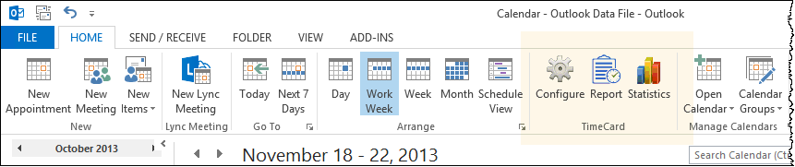

In the open appointment and when an appointment is selected in the calendar view the *TimeCard* ribbon group allows you to tag appointments with time reporting data of your choice (and to report expenses if you have enabled that feature in the settings.) 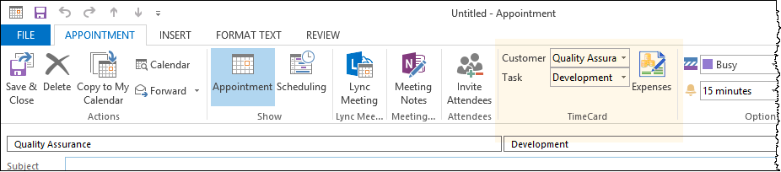

This manual describes what is behind the *TimeCard* ribbon groups, how you can make use of them in the best possible way and how you can adapt *TimeCard* to meet your requests.

## Layout of the Manual

In this manual we will first look at the *TimeCard* **installation and configuration**, because you have to take care of those parts before you can start working with *TimeCard*.

When the configuration is finished, you can create your appointments in the Outlook Calendar just as you normally do, but you should also select one, two or three *TimeCard* tags – depending on your choice in the *TimeCard* settings.   
  
The *TimeCard* tags will give you a lot of useful information about how you use your time. By avoiding free-form text and instead using selection of pre-defined values, we make time reporting quicker and significantly reduce errors. The **daily use** of *TimeCard* is described in the fourth chapter.

Next chapter describes the **reporting**. You report time (and expenses) to an Access database (created by *TimeCard*)after the period you choose. You can then study your data directly in the database or in the Excel reports.

Regularly submitted time reports into the database will contain information about date, start time, end time, duration, subject, body and the *TimeCard* tags you have defined. These data can be used in **statistics**, which is described in the following chapter.

After that comes chapters about registration, upgrade, support, contact and repair and removal of *TimeCard*. In the last chapter we give information about the general architecture of *TimeCard*. By reading it you can get an understanding on how the different parts work together.

In addition to studying this manual, please also watch the [*TimeCard Single* video demonstrations.](https://bizsolutions365.com/our-products/timecard/timecard-single/tcsu-demo)

## Several Calendars

If you only use one calendar, you don’t have to read this section.  
  
The *TimeCard* ribbon group is displayed in **all calendars**. If you have several Outlook profiles, *TimeCard* will work in the calendars for all of them.

When you run the reporting dialog, the **appointment data will be taken from the calendar that is currently selected in Outlook**. That can be your own default calendar, someone else’s calendar or a shared calendar among Exchange public folders.

You do, however, need to have **editor** permissions or higher on the Outlook calendar to report time from it. For more information about the reporting, *refer to* Reporting with *TimeCard*.

# Requirements

This must be installed on your PC if you want to use *TimeCard*:

* Microsoft Windows 7 and higher (32 or 64 bit)
* Outlook 2010 and higher (32 or 64 bit)
* Internet Explorer 9 and higher
* Excel 2010 and higher (32 or 64 bit) – only for the Excel reports.

# Language

The **language** of *TimeCard* automatically defaults to the same as the Outlook language of the user’s actual PC. We currently support Danish, Dutch, English, Finnish, French, German, Italian, Norwegian, Portuguese, Russian, Spanish and Swedish. If you have another language in your Outlook, *TimeCard* will be in English.

# Installation

Download the file **TimeCardSingleSetup.msi** from the bizsolutions365.com website to the desktop or to any folder in your computer. You may also download the file in zipped format. In that case, you need to expand it to reach the .msi file.   
  
If you are not interested in what happens during the installation you can now go directly to section 4 below.

## Setup Actions

The file you download from the bizsolutions365.com website – **TimeCardSingleSetup.msi**  – contains compressed files.During the installation process, it first decompresses those files and then configures Outlook.   
  
The **TimeCardSingleSetup.msi** file creates the folder **bizsolutions365.com** in the **Program Files** or **Program Files (x86)** directory. When you have already downloaded other applications from bizsolutions365.com that also use the bizsolutions365.com folder, the installer will not create it again.   
  
Within the **bizsolutions365.com** folder, the installer creates a folder named **TimeCard Single.**

After the installation is finished, the **TimeCard Single**directory will contain these files:

When you start using *TimeCard* two more folders will be created:   
  
Under the **(My) Documents** *TimeCard* will create a folder named **My TimeCards**. It will contain an Access database, **TimeCard3.mdb**, and your Excel time report, **TimeCardReport.xlsx** and your statistics reports, **TimeCardStatistics.xlsx**.   
  
Under User >AppData >Roaming *TimeCard* will create a bizsolutions365.com folder with a TC subfolder. Here your settings will be stored.

## Start Installation

Click on the downloaded file, **TimeCardSingleSetup.msi**, to start the installation. A welcome screen will be displayed. Click Next.

## License Agreement

You must accept the End-User License Agreement. If you don’t accept it, the installation will be cancelled. Click next when you have check the box and accepted the agreement.A screenshot of a cell phone

## Installation Path

The installer lets you choose where you want *TimeCard* to be installed. Click on **Change..** if you do not want to use the default folder. If you will use the default folder, it will be automatically created on your computer. Click Next.

## 

## Install

Click on **Install** to start the installation.

Now you will probably be asked to allow the installation. Do that, and the installation of *TimeCard* on your computer will start.

A progress bar will show how the installation is proceeding.

You will get a message when the installation is finished. Click Finish to close the installer.

# Example Data

The example data is intended for users who don’t want to bother with creating appointments and tagging them with *TimeCard* values for the evaluation of *TimeCard*. The example data quickly gives you a set of tagged appointments to test the various *TimeCard* features with.  
  
When you open Outlook for the first time after the *TimeCard* installation, the settings screen will be shown with a question if you want to create example data. If you want to evaluate *TimeCard* with this data, click Yes. If you want to use your own appointments and tags, please continue to the next section of this manual, Configuration.  
  
These are the default example data settings:  
  
You can change the periods and the number of appointments as you wish. By default the example data is created in the default calendar, but you may also browse to another calendar than the default one, to create the example data there.

Click OK to start the creation of example data.

## Create a new calendar

Another option is to create a separate calendar for the evaluation of *TimeCard*. You can do that via the “Manage Calendars” ribbon group in the Outlook calendar.

|  |  |
| --- | --- |
|  |  |

## Remove Example Data

To remove the example data, delete the calendar if you are using a separate calendar for the evaluation.  
  
If you have added the example data to your own calendar, you can remove them via the calendar List view.

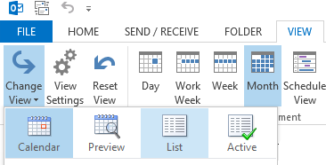

Sort the appointments by category. Now you can easily see what appointments belong to the example data and should be removed.  
  
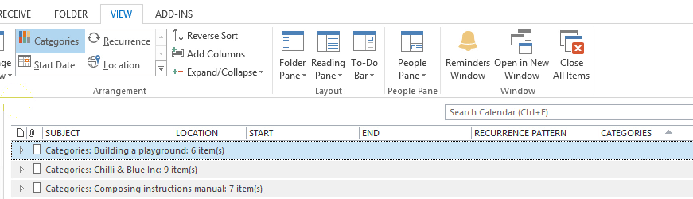

Now, open the *TimeCard* settings and configure *TimeCard* as you want it, see next section below. Then you can start tagging appointments with your own data.

# Configuration

Before you start using *TimeCard* you must configure *TimeCard* so that it behaves as you want it to behave. This is done in the Settings dialogs.

## The TimeCard Single Settings

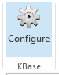Once the installation is finished, the Settings dialog will be shown.

If the Settings dialog does not appear automatically, then re-boot your computer and open Outlook. Now you will see a new Configure button in the Outlook ribbon. Press it, and the Settings main dialog will be shown.  
  
You can also run the Settings tool by clicking the file **TCSingleSettings.exe** in the **TimeCard Single** directory.

The **Settings** **main dialog** has four buttons that will take you to subscreens. These subscreens are described below.   
  
As long as *TimeCard* is not registered, you will also see the License button in the main screen.

## Tags

In the Tags dialog you must define **what info you want to tag your appointments with** when you are using *TimeCard*. In other words, you must decide what additional information you will need to gather besides the standard appointments information of date, start time, duration, body and subject.

You can use *TimeCard* with tag type and tag category and with a maximum of three tags, but you may very well use *TimeCard* with just one tag and no types or categories. It all depends on how much information you need to gather.

Choosing the appropriate tags to report is an important step, but the tags can easily be modified. It is often best to start with a simple reporting scheme and extend it later if needed.

### Tag

By default *TimeCard* is configured with two tags, **Customer** and **Task**. This means that you have to **select one customer and one task for each appointment**.   
  
However, you can **easily modify** the tags so that they fit your needs. Click in the cell and write your own parameters instead of Customer and Task. And remove the text in one of the cells under Tag altogether if you only want to use one tag. Because you must not use two parameters.  
  
You can use one, two or three tags, but if you are considering three, please think it through. Maybe you can manage with only two if you use category and type in a clever way? Keep in mind that three tags make the procedure of tagging appointments considerably more complicated.

NOTE:   
You cannot use the characters colon and semicolon (: and ;) in the tag names. If you enter them in the Tags screen *TimeCard* will remove them automatically, but if you add the data directly into the database instead you have to think about this.

### Tag Values

In the right part of the Tags screen you should write the **tag values you want to select from** in each appointment. When you change the default tags of Customer and Task, your own tag names will be displayed in the right panel instead of the default ones.   
  
Enter the values you want to be able to select between for each tag.   
  
**Example**:   
If one of the tags is “Task”, the values are the different tasks you perform and that you want to include in your time reports.   
  
NOTE: You cannot have the same name in more than one tag value. If a Task value is called "ABC" you can NOT have a project value "ABC" also.

You can call the project value "ABC_P" or some other modification, as long as it is not exactly the same.

### Type and Category

To get more out of your *TimeCard* statistics (*refer to* Statistics) you can make use of Tag Types and Tag Categories. They are only visible in the Tags settings screenand when you view the statistics**,** but they will not appear in the appointments or when you report time.

It is not necessary to use types and categories, but if you have entered some types and categories for a tag, a **hierarchy tree** will be shown in the Tags screen.

When you have entered the name of a Tag Type and a Tag Category on the left side of the screen, the type and category will be shown in the right panel also, so that you can enter type and category values for each tag value.

You may very well use only a type, but you cannot use just a category.

#### *TimeCard* Properties – Tag Hierarchy Examples

**Example:**   
Here is an example on how Customers can be categorized in countries and towns. With this info added to the settings the customers will be grouped by countries and towns in the statistics.

With the customer tag values shown in the example above, the Customer dropdown in the appointment will look like in the image below. The type and category are not shown here.  
  
**Example**:  
Below is another example on how to use Tag Type and Tag Category with the Customers Tag. The relation between the Tag, the Tag Type (Business area) and the Tag Category (Sector) is automatically shown in the tree diagram below.

**Example:**  
Below is an example of how the tag Tasks can be sorted in types and categories in the same way. Here the Tag Type is called Service area and the Tag Category is Worktype. The category only has two values – billable time and internal work.

### Importing Data by Copy and Paste

It is quite easy to **copy and paste information into the settings grid**. If you already have an Excel list or similar with existing values that you want to use for reporting, the copying procedure should be very straightforward.   
  
Copy and paste using CTRL + C and CTRL + V, or right click in a cell to show the copy/paste options.  
  
When you click OK or Back after pasting the data, it will be sorted alphabetically and any blank rows and duplicates will be removed.

You can also **import or copy and paste your data directly into the *TimeCard* database**. In that case you must **first open the settings**, enter a Tag and a Tag value and click OK. Then the Access database will be created automatically in the My TimeCards folder under (My) Documents, and you can open it there and import/paste the rest of your data.

### Copying Data from an Outlook Contact Folder

If you already have some of the data you want to use as a *TimeCard* tag values in an Outlook folder, it is quite easy to transfer the data into *TimeCard*.   
  
The most common scenario is that you have some customers in the Outlook Contacts/People and you want to copy those customer names into the Customer grid of the Tags dialog. These are the required steps:

1. Create or choose an Outlook View that has all the data you need to copy.
2. Select all the data from the Edit menu or by CTRL+A.
3. Copy the data to the clipboard via the Edit menu or CTRL+C.
4. Paste the information into the *TimeCard* Tags dialog. Press OK or Back to get the data properly sorted and all duplicates removed.
5. If necessary, reset your view in the Outlook Contacts folder

### Delete *TimeCard* Properties

When you want to delete *TimeCard* properties you must do it in a certain order. If you do it in the wrong order, you will be given a message telling you how to do instead.  
  
Delete **tags** from the bottom up, so that you for example delete the second tag before you delete the first one. If your tags are Customer and Task and the Customer is on top, remove the Task tag before you remove the Customer tag.  
  
Do like this if you want to keep the second Task tag but not the first Customer tag:

1. Copy all the Task values from the right side of the screen.
2. Remove the second tag, Task
3. Rename the first tag to Task instead of Customer
4. Paste the Task values over the old Customer values.

To delete **category** and **type**, delete the category before you can delete any types.  
  
Tag **values** can be deleted in any way you wish.  
  
When you delete a tag, a type or a category from the *TimeCard* settings, they will not be shown in the statistics but they will be kept in the database. Deleted tag values will still be seen in old appointments in the statistics.  
  
The list of values for a deleted tag will be kept, and if the same tag is added to the settings again the values for that tag will be restored.

# General Settings

Below is the default General Setttings subscreen. Here you can enable several extra features that may enhance *TimeCard* for you. None of these features are enabled by default.  
  
### Planning Information

When Planning information is enabled, **you can study your future, not reported, appointments in the table tblPlanning** in the database. The planning reporting is made automatically at the same time as the other reporting.  
  
This is how the **Planning information** works:

1. When you report time, all future calendar appointments for one year after the latest reported appointment is added to the planning table in the database.
2. When you report the next time, the old future appointments are removed from the database, and the new future appointments are entered instead.

The Planning information follows the report settings in the Other Settings subscreen, which means that you for example can exclude private appointments from being reported.

You can change your future appointments as you like in your calendar, just as you are used to do, because the Reporting tool first removes all existing future appointments from the database. Therefore, every time you report, the **Reporting tool** enters your coming meetings fresh, from the last unreported meeting and one year ahead.

To study the future appointments, go into the folder **My TimeCards** under (My) Documents and open the database file, **TimeCard3.mbd**. You will find all your future appointments in the **tblPlanning** table.

### E-mail/Domain Settings

The E-mail/Domain settings is a useful feature when you often get work orders via e-mail. Then you **may drag the e-mail to your Outlook calendar and make an appointment of it**.   
When the box is checked a Configuration button will be displayed:  


Click the box, and a new dialog will open. In this dialog you can enter e-mail addresses or domains and select values from one or two tags to map it with.

The selected tag value will be filled out automatically in the appointment you have created by dragging an e-mail to the calendar.

*TimeCard* will understand what e-mail address is interesting for you, so it will take the "To" address for mapping with the specified tag value if you drag the e-mail from the Sent folder. Otherwise it will take the "From" email address.   
  
You can map either a whole e-mail ID or only the domain. *TimeCard* will first look if you have set a default tag for the whole e-mail address. If there is none, *TimeCar*d will look for the domain.

NOTE: When you drag an e-mail to the calendar in the **same window**, the appointment will be created at the **current** date and time.

When you drag an e-mail in one window to a calendar open in **another window** you can drop the e-mail on the **date and time you prefer**. Open the calendar in a new window by right clicking the Calendar label and selecting “Open in New Window”.  
  
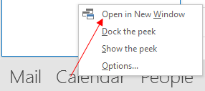

### Mandatory Tags

 When you want to prevent yourself from saving an appointment unless values are selected for all *TimeCard* tags, you can check the box for making them mandatory. If you don’t select a tag value when this box has been checked, *TimeCard* will prompt you to try again. Else the changes to the appointment are discarded.

There is one exception: when you mark an appointment as private, you will still be able to save it without selecting *TimeCard* tag values. That way you can have for example a dentist appointment in your calendar without having to tag it with *TimeCard* data.

### Default Tag Values

You can define a *TimeCard*-property that will be used automatically if you leave a field empty when reporting. If you have selected at least one *TimeCard* tag value, the appointment will be reported, and **if a default value is set for a field, that value will be entered instead of an empty field.**

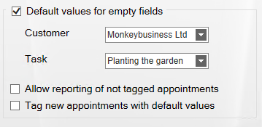  
  
Fields that were filled out will of course stay unchanged. The default values are not connected with each other but are used separately.

You may permit reporting if all fields are empty, which might be useful if you often report on the same properties. The checkbox "**Allow Reporting of not tagged appointments**" means that appointments with all *TimeCard* fields empty will be reported with the default values.   
  
You cannot report appointments with empty fields if default values are not set for them, so the checkbox "Allow Reporting of not tagged appointments" is active only when the checkbox “Default values for empty fields” is enabled.   
**Example**  
The appointment <--, --> will be reported as <Renew Insurance> if the checkbox "Allow Reporting of not tagged appointments" is checked and those are the default values.   
(The untagged appointment will not be reported at all if the “Allow” box is unchecked.)

If you check the box “**Tag new appointments with default values**”, you will see the default tag values when you create a new appointment, and you can either change them or leave them as they are. This is the best option for most users.  
  
If you do **not** check this box, the default tag value will be added at reporting. To post appointments you need to select “All appointments” from the right hand dropdown and click "Get Values". Then report all appointments, and the not tagged appointment will be saved with the default tag value.  
  
### Expenses

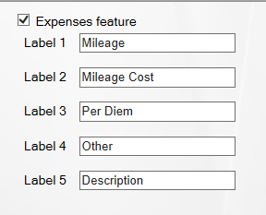If you enable the Expenses feature, you can **add expenses to each appointment** and then report these expenses when reporting hours and *TimeCard* tags. The reported expenses will be saved in the table **tblExpenses** in the database (intReportID as foreign key for tblReports), and they will be shown in the statisticsand in the Export to Excel sheet.

When you check the box to enable the Expenses feature, five fields are shown. Here you can **enter what expense costs you would like to track**.

The default values are Mileage, Mileage Cost, Per Diem, Other and Description. Once you change the caption of an Expense Label it will also be changed in the statistics, in the Export to Excel sheet and in the Add/Edit Expenses dialog box.  
  
We suggest that all the fields except the Description field should be numeric, to be easy to summarize.

## Costs and Rates

*TimeCard* is designed to be very flexible, so that you can set it up to fit the way you want to track costs and time. Thus it is important that you consider how to set up the cost calculating options.

When entering the rates you do not need to enter the currency. It will follow your Windows settings.

You can calculate the costs in two different ways.

* Calculate costs for **one of your** ***TimeCard* tags**. In this case the number of hours for each value of this tag is reported as cost to the database.

**Example** on calculation by the tag “Task”:   
A task value called “Meeting” have been created, and the hourly rate of that value is set to $75. Therefore a two hour appointment tagged with “Meeting” will have a cost of $150 reported into the database.

Likewise, if you choose to calculate costs by the tag “Customer”, your reported time for each individual customer is multiplied by the hourly rate for each customer.

* Calculate costs by **Person**. Then your rate per hour will be multiplied by your reported number of hours.

## Other Settings

In the Other Settings screen we have gathered some more options on how your time can be reported.

### Filter Appointments

You can configure what types of **appointments should be excluded from reporting**. These appointments will *not* be displayed in the reporting summary even if they exist in your calendar, and they will *not* be entered into the database.

Even if you tag the appointments with for example customer and task they will not be reported to the database.  
  
By default private, recurring and whole day appointments are excluded from the reporting, but you can uncheck the appropriate box(es) to include them.

#### Recurring Appointments

|  |  |
| --- | --- |
|  | You can work with recurring appointments together with *TimeCard*. Just add *TimeCard* properties to your recurring appointment.  Recurring series of appointments are treated as one group by *TimeCard*, so that any changes in the *TimeCard* properties in one appointment will be applied to the whole series. |
|  |

#### Private Appointments

|  |  |
| --- | --- |
|  | By default, private appointments will not be included in *TimeCard* reports. Uncheck the box if you want to include them. |

#### All Day Appointments

|  |  |
| --- | --- |
|  | Uncheck this box if you want to work with all day appointments in *TimeCard*. All day appointments are considered to be exactly 24 hours work time in the *TimeCard* reports, so use the Time manipulation checkbox if you want another number of hours to be reported, see below. |

### Time Manipulation

When the all day events are set to be reported with *TimeCard* it is possible to **convert all day events into hours**.

It is always possible to **remove time from appointments** that are longer than seven hours

If you want to check one of these boxes you can accept the suggested time in the field to the right or fill out your own preferred time.

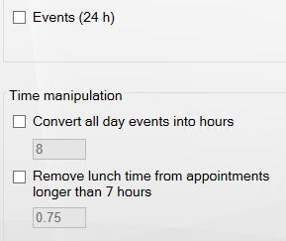

### Tag Values in Subject

If you check the box for tag values in the subject, the Subject field in each tagged appointment will automatically be filled out with the *TimeCard* tag values you selected for that appointment.

### Export to Excel Options

|  |  |
| --- | --- |
| If you want to use the Export to Excel button in the Reporting dialog, refer to  Export to Excel, you should select here **by what *TimeCard* tag the data should be grouped** in the Excel sheet.   You may also select to include the first 255 characters of the appointment body in the export. |  |

# Working In The Outlook Calendar

You can start working with *TimeCard* as soon as you have configured thesettings.

Use your Outlook Calendar to plan your day with meetings and appointments and select the appropriate *TimeCard* tag values (or value) for your *TimeCard* appointments. Otherwise, you can handle your appointments just as you normally would.   
  
For example, you can edit, extend, copy or move appointments without interfering with the *TimeCard* properties.   
  
When the week (or any period you choose) is done, you can review your data in the Reporting dialog or in an Excel sheet and then send them directly to your database.

## The *TimeCard* Ribbon Groups

Once *TimeCard* is installed and configured a new **ribbon group** will be visible in all calendars. The image to the right shows this calendar group.  
   
In Outlook 2007 it looks like this:

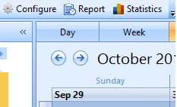

The **appointment group** becomes active when you select an appointment in the calendar view. In the screenshots below the Expenses feature is used, so that button is shown also.

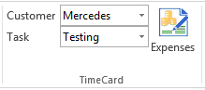

The appointment group will also be visible when you open a new or old appointment.

## Adding New Appointments With TimeCard Properties

Create a new appointment like you normally would.   
  
The ***TimeCard* group** will appear in the ribbon of the appointment, so that you can select the suitable tag values.  
  
## Copying Appointments

A very fast way to enter information into your calendar is to **drag & drop** the initial appointment while holding down the CTRL key. This will create a copy of your appointment with all of your *TimeCard* properties intact.   
  
**CTRL+C for copy and CTRL+V for paste** also works in the same way. If a *reported* appointment is copied, the “reported mark” is removed so that the appointment can be reported again.

## Tag Existing Appointments

There are two ways to add or change *TimeCard* tag values on an existing appointment.

One way is to **open** the appointment and then select or change your tag values in the *TimeCard* ribbon group.

The other way is to **select** the appointment in your calendar view (by clicking on it once). The *TimeCard* ribbon group will then be changed to the appointment group, so that you can select or change the *TimeCard* tags. The change will be applied to the selected appointment.

You now know the basics of how to use *TimeCard.* If you’re not interested in any advanced features, you may go directly to the chapter Reporting with *TimeCard*.   
  
However, in order to get the most out of your *TimeCard* application, it is recommended that you continue reading the rest of this chapter.

## Expenses

|  |  |
| --- | --- |
| With *TimeCard* you can report your expenses at the same time as you report your time. Add your expenses in the Expenses dialog, which you reach by pressing the Expenses button in the *TimeCard* ribbon group. |  |
| In the Expenses dialog, fill out your expenses and they will follow the appointment when you report time. |

You can see the Expenses button in two ways:

* In the calendar, **select** an appointment and the Expenses button will be visible in the *TimeCard* ribbon group. This method is especially convenient if you want to add or edit expenses, as you can do it without having to open the appointment.
* **Open** an appointment to reach the *TimeCard* appointment group in the ribbon.

## Categories Field

|  |  |
| --- | --- |
| *TimeCard* uses the Outlook **Categories** field to store *TimeCard* tag values in appointments.   If you use the Categories field for another type of appointment classification, *TimeCard* will not interfere with your existing data. However, if you add *TimeCard* values to an appointment with non-*TimeCard* categories filled out, they will be overwritten.  This means that you have to ***first* tag the appointment with *TimeCard*** **values** and *then* add the non-*TimeCard* category.  You can reach the Categories via the Categorize button in the open appointment or by selecting an appointment in the calendar view and right clicking it. |  |

### Color Code Tag Values

To get a quick overview of you appointments you can connect each tag value to a color. In All Categories, rename the colors to your tag values and each color will be applied to all appointments tagged to the specified value.

### Remove *TimeCard* Tag Values

To remove *TimeCard* values from an appointment, right click the appointment in the Outlook calendar view and select Categorize and Clear all categories.

Note: if you want to exclude some appointments from the reports you can also mark them as recurring, personal or event, *refer to* Filter Appointments.

# Reporting with TimeCard

|  |  |
| --- | --- |
| Open the reporting dialog by pressing the **Report button** in the *TimeCard* ribbon group. |  |

## Reporting Dialog – Main Purpose

The Reporting dialog lets you select a time period, view and edit a summary of your work time and report the work time to a database. Also the expenses are reported if you have enabled that feature.

In order to get the best possible data input, you can verify the data in *TimeCard* three times:

* When you enter the appointment in your calendar.
* In the *TimeCard* Reporting dialog, where you get an overview of the data that is about to be entered into the database.
* When you click on OK in the Reporting dialog, you are asked to confirm that you want to report the time.

## Choosing Date Ranges

Choose your date range by selecting a start and end date for the report. The Reporting tool will summarize all appointments within that date range and include them in the report.   
  
Standard view:

Grid view:

## Display Options

For the time period you have defined, you can select which appointments you wish to show. These are the alternatives:

* all appointments tagged with *TimeCard* values
* all partially tagged appointments
* both tagged and partially tagged appointments
* not tagged appointments
* all appointments.

This makes it easy to verify that you have not missed tagging an appointment in your calendar. If you did, you can easily select *TimeCard* tag values for that appointment in the Reporting dialog, see below.

## Change Appointments Within The Reporting Dialog

You can change the *TimeCard* tag values and other properties within the Reporting dialog by selecting a row in the list and changing one or more values. All changes will be written back to your calendar.

Thus, if you change the duration of an appointment from 2 to 3 hours in the Reporting dialog, the corresponding appointment in the calendar will become one hour longer.

## Grid

If you check the box for Grid, you will get a possibility to **add appointments directly in the Reporting dialog**. For tag values that already exist in the dialog you can quickly change the time period or add more hours in empty cells. Click Save when you are finished with each week, to save the changes to the calendar.  
  
For tag values that are not present in the reporting grid, click the Add button to open a new dialog where you can add tag values. Then click OK to add the appointment to the reporting summary. Enter the number of hours in the cell for the actual day, and click Save to save the new appointment to the Outlook calendar.   
  
The appointment will be saved to an empty period of the correct day, but if you want to specify the hour you have to go into the calendar and do that.   
  
## Export to Excel

The Export to Excel button produces an editable Excel sheet with data about all the appointment listed in the *TimeCard* Reporting dialog, where hours easily can be summarized.

In the settings you can select which *TimeCard* tag the data should be grouped by and if you should include the appointment body or not, *refer to* Export to Excel Options. To use this feature you must have Microsoft Excel installed.

The Excel report is opened automatically when you have pressed the Excel button in the Reporting dialog. Click the + signs to the left to see more information. The report is saved as **TCExcelReport.xlsx** or **TCExcelReport.xls** (depending on Excel version) under '**(My) Documents** >**My TimeCards'**, but you can of course save it in any folder and with any name you like.

### Customization of the Excel template

The Excel sheet can be customized according to your own needs. When the data is exported to Excel, make the changes you wish and save them. Then the changes will be preserved and available for subsequent reports. You can for example:

* insert a company logo at the left top of the report
* add rows on top and bottom, but *not* in the default exported report area
* change colors, fonts or number format in newly added rows.

We **don’t** recommend inserting any columns, as they can spoil the layout of the report. In the image above the appointments are grouped by Customer, and the box for adding max 255 characters from the appointment body has been checked in the Other Settings dialog.

## Print Report

When you press the Print button the reporting period and the two panels in the Reporting dialog will be printed.

## Send Report

|  |  |  |
| --- | --- | --- |
| When you click **OK** to post your report you will get a warning that the data cannot be changed once it has been posted. |  | |
| If you decide to post your report you are asked if you want to send another report. | |  |

# Statistics

|  |  |
| --- | --- |
| When you press the Statistics button in the *TimeCard* ribbon group, *TimeCard* will create Excel reports on with statistics on all data you have reported to the database.  Each time you run the statistics tool the statistics reports will be refreshed with any new data. |  |

You can use all the Excel features with these reports, so you can select to study any time period or detail in the data.

The image below shows the first tab of the Excel workbook.

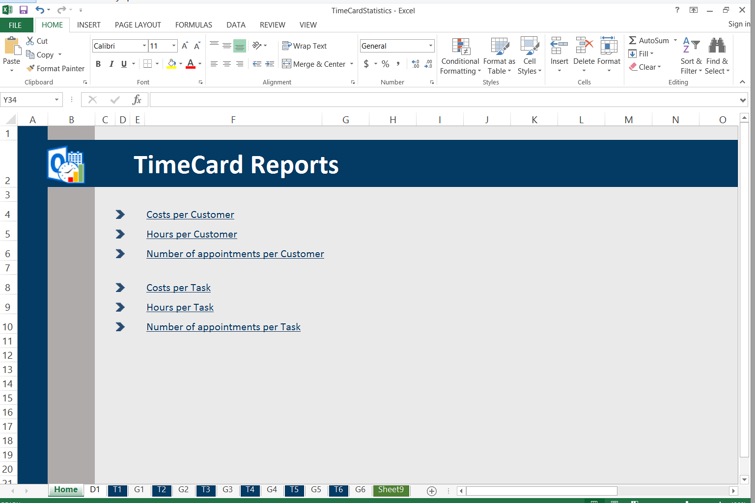

## Default Reports

The default reports are grouped by tag, and there are **three statistics reports for each tag**: Hours per Tag, Cost per Tag and Appointments per Tag.   
  
When the Expenses feature is enabled there will be one more default report per tag.  
  
You can **drill down** from tags to values to appointments by clicking on the plus signs. If you have used category and type you can drill down from category to type to tag to tag value to appointment subject.

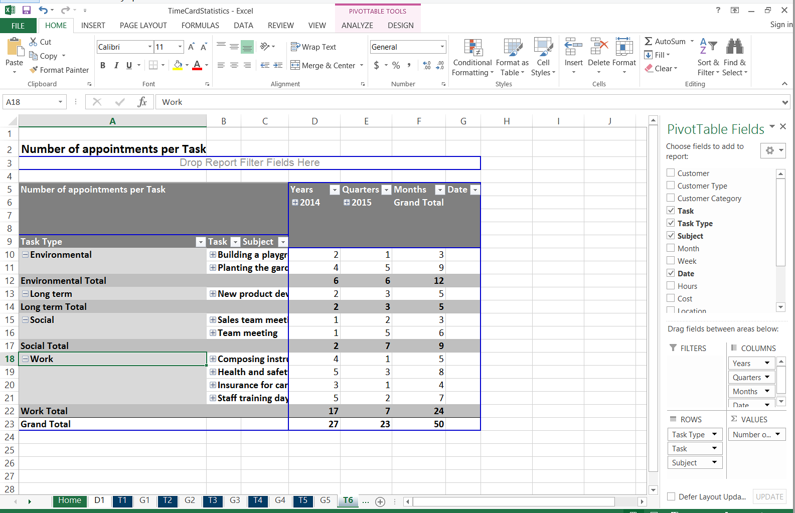

Each report is shown as a pivot table and as a chart.

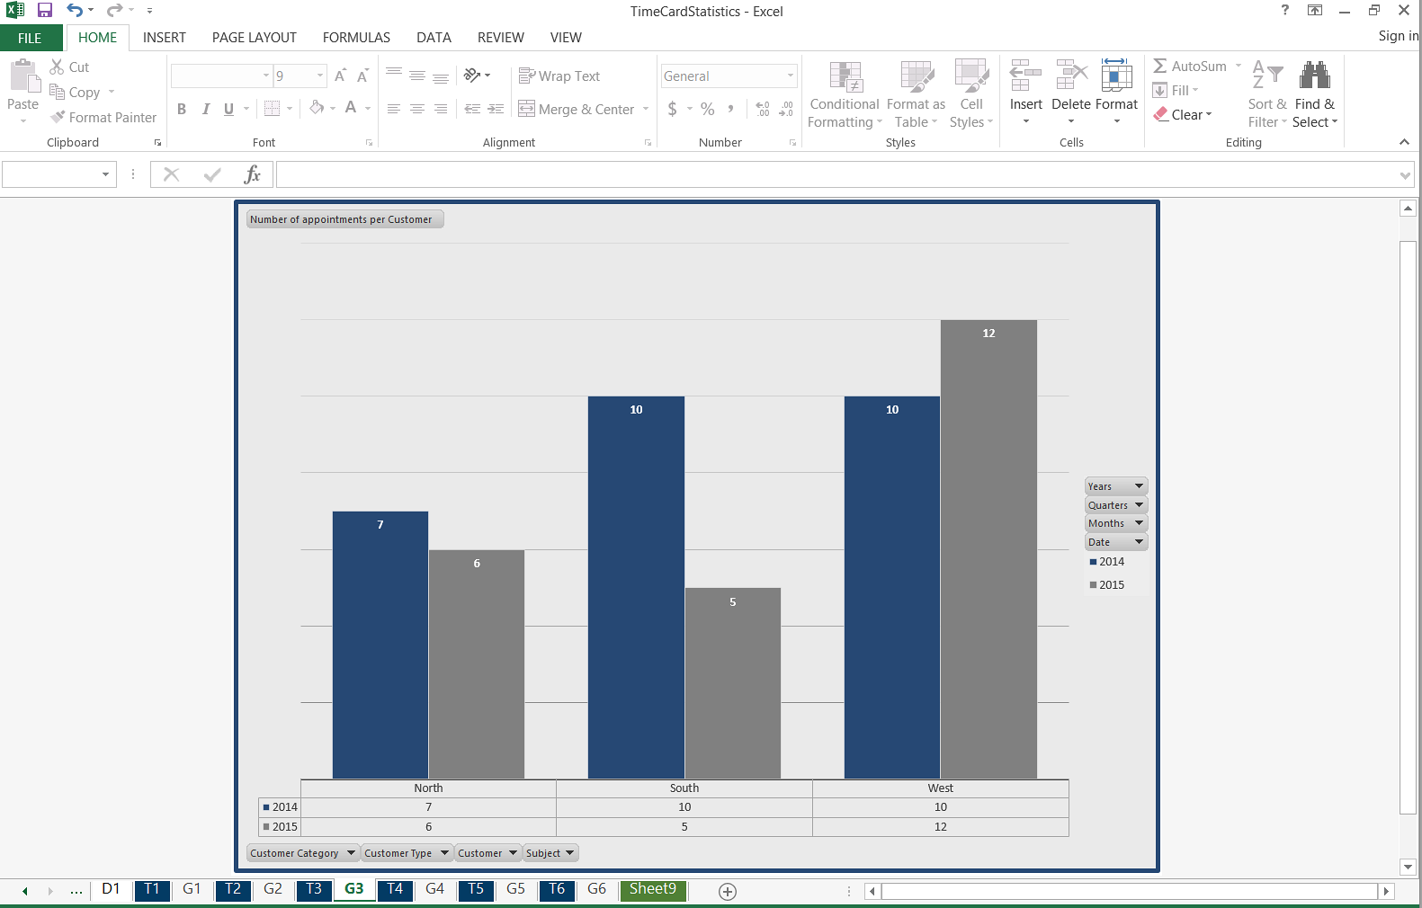

You can change the look of the chart as you wish.

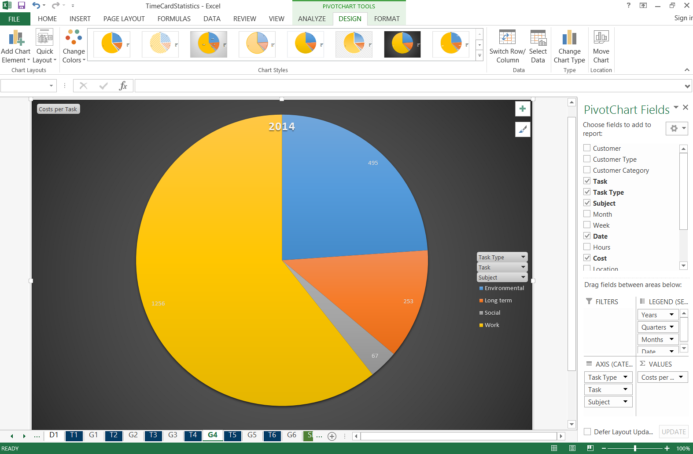

Under the first tab, D1, you can find all info from the database.

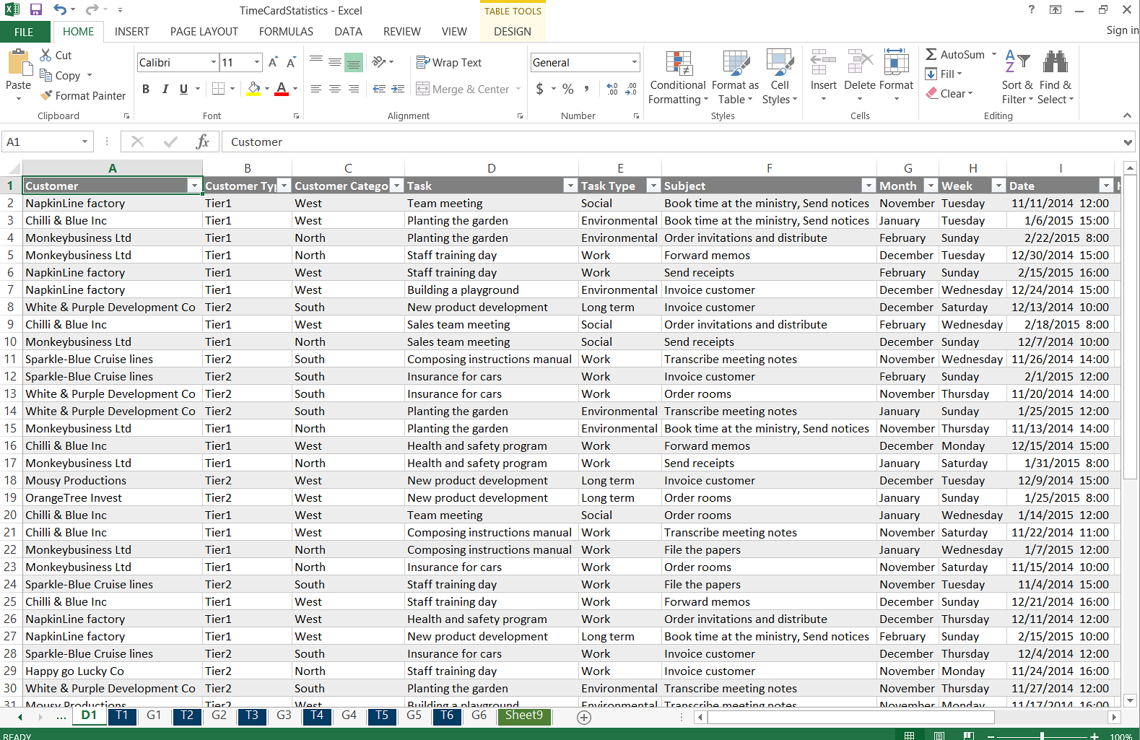

## Custom Reports

All the standard Excel features may be used with the default reports, so it is easy to modify these reports. If the changes are saved, the modified reports will be used instead of the default one.   
  
To create **a totally new report**, go to the D1 tab and insert a new pivot table. It is often best to select a new worksheet for it. Then customize the sheet as you like before you save the report.

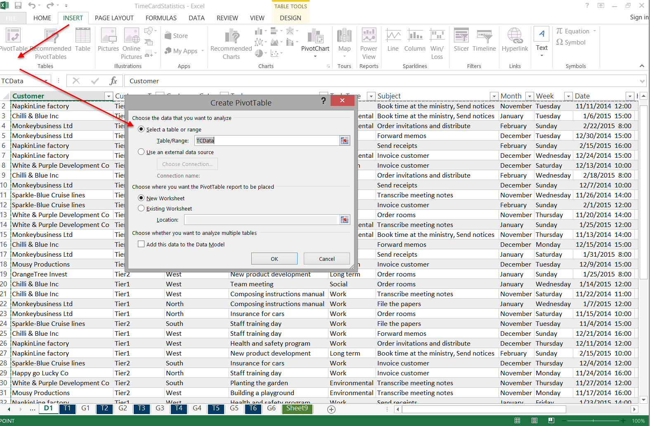  
  
Next time you run the statistics tool, your modified or custom report will be refreshed with the new data just like the default reports.

# Registration and Trial info

*TimeCard* is a shareware, with a free **trial period of 30 days**. If you want to continue using the program after the trial period has expired, you must buy a license and register *TimeCard*. Registration is done in place, so there is no need to change anything once you decide to buy.

The registration is performed by clicking the **License** button in the main screen of the **Configure** dialog. Then the registration dialog will open.

Enter the registration key and your e-mail address in the License dialog. *TimeCard* needs access to internet to verify the key.

After registration you can continue working on the same data as before. No re-installation is needed.

# Support

Three months of support and free upgrades are included in the purchase price of *TimeCard*. We recommend that you buy more support when the three months period has expired. The ***bizsolutions365.com Single Support*** gives the following assistance:

* Free upgrades of the applications you have purchased licenses for – never worry about upgrades.
* Your e-mails answered within 24 hours* – you ask, we answer.
* A scheduled IM conference within 36 hours* – let us be a part of your virtual team.
* A scheduled telephone or Skype conference within 36 hours* – speaking is an often underestimated form of communication.
* Remote connection services – sometimes solving the problem on your computer is the best. We can help you set up the software or solve problems.
* Influence on future versions and features – we will listen to our paying customers first.  
    
   *during Western Europe working days

# Contact

If you have problems or questions about our software, e-mail is the best way to contact us:

|  |  |  |
| --- | --- | --- |
| E-mail | <support@bizsolutions365.com> | General and Technical issues |
| <sales@bizsolutions.com> | Sales issues |
| Telephone | +91 780 600 6234 |  |
| Chat online | <www.bizsolutions365.com> |  |

# Upgrade TimeCard

Upgrades are free for customers who have a valid support contract.

For upgrade or repair of the application, close Outlook and run the setup file you have downloaded from the bizsolutions365.com website, **TimeCardSingleSetup.msi**.   
  
*TimeCard* will know that you have an older version installed and upgrade it instead of creating a new installation.   
  
If you run a setup file with the same version as the one you have installed, you will get the options in chapter 15 below.

# Move TimeCard

Please follow this procedure:

1. Download and install *TimeCard Single* on the new machine: <https://bizsolutions365.com/our-products/timecard/timecard-single/tcsu-try/>
2. Copy the database file TimeCard3.mdb in (My Documents > MyTimeCards on the old machine and paste it in the same place on the new one.
3. Open the *TimeCard* settings on the new machine and configure *TimeCard*. All your tag properties and values will be there, as they come from the database, but if you don't use the default TimeCard settings you have to make your choices again.
4. Click OK to save the settings.

Now you can start using *TimeCard* on the new computer.

# Repair or Remove TimeCard

If you run a setup file of **the same version** as the one you have installed, a dialog will be displayed where you can choose to either repair or remove *TimeCard*.

You can also repair or remove *TimeCard* from the **Control panel**. The *TimeCard* installer adds an entry under the title *TimeCard Single* under Add/Remove Programs / Programs and Features.

At removal the Uninstaller will ask if you want to remove the database as well, so if you want to keep it you have the option to do so.

# General Architecture

## The Files and their Purpose

*TimeCard for Outlook* consists of several compressed files. During installaion they are automatically extracted and placed in a **TimeCard Single** folder under **Program Files/bizsolutions365.com**. The most important files are mentioned below.  
  
The *TimeCard* .exe files creates two more folders, a **My TimeCards** folder under **(My) Documents** and a **TC** folder under User >AppData >Roaming >bizsolutions365.com.

**TimeCard Single folder**

|  |  |
| --- | --- |
| TCSingleSettings.exe | The **TimeCard Settings** application is activated when you press the **Settings** button, or when you run this file manually. Here you can customize the *TimeCard* properties you want to use and define other settings too.   This file reads from the database and writes to the system registry for offline access. The TCSingleSettings.exe permits you to change personal settings. The license information can also be accessed from this file. |
| TCReporting.exe | The reporting application is executed when you click the **Reporting** button in the *TimeCard* ribbon group, or when you run this file manually. Its main purpose is to sum up the data and give you a chance to do a final review of them before you post it to the database. The 64-bit version of Outlook uses the TCReporting64.exe instead. |
|  |
| TCClientTool.dll | This file adds a ribbon group with two views to Outlook, so that you can manipulate items in your calendar. |
| TCStatistics.exe | This application creates an **Excel file with statistics reports on all the data** in your database. Run it by pressing the statistics button in the ribbon group. You can also run it manually directly from the folder. |

**My TimeCards folder**

|  |  |
| --- | --- |
| TimeCard3.mdb | This is the **Access database** where your time reports are stored. The Access database is not downloaded with the rest of the files but is created automatically the first time you run the TCSingleSettings.exe file. |
| TimeCardReport.xlsx | This file is created if you use the **Export to Excel** button in the Reporting dialog. |
| TimeCardStatistics.xlsx | This file is created when you press the statistics button in the ribbon group to generate statistics reports. |

**TC folder**:TCGlobalSettings.txt and TCPersonalSettings.txt