Kanban Task Manager Single Manual

1 Introduction 3
1.1 Languages 4
1.2 Requirements 4
1.3 Systems 4
2 Installation of Kanban Task Manager 5
2.1 Process 5
2.2 Files 8
2.3 The Convert E-mail button in Outlook Mail Folder 9
2.4 Show Kanban View Button in Outlook Tasks Folder 9
2.5 Hide Kanban View Button in Outlook Task Folder 9
3 Configuration 10
3.1 Extra Field 11
3.2 Checklist 11
3.2.1 Checklist templates 11
3.3 Time Logging 12
3.4 Categories 12
3.4.1 Colors 12
3.5 Status/Phase 13
3.5.1 Columns Per Phase 14
3.5.2 Phase for Closed Tasks 14
3.6 Hide a Phase or Category 14
3.7 Lanes 15
3.8 WIP Limits 16
3.9 Default Values 16
3.10 Tasks Converted from E-mails 17
3.11 Show Tasks After A Specific Date 17
3.12 Default Task Folder 17
4 Use Kanban Task Manager 18
4.1 Convert Button In Outlook Mailbox View 18
4.2 Kanban Board 18
4.2.1 Move Tasks 19
4.2.2 Details Pane 19
4.2.3 Filter and Search Tasks 22
4.2.4 Create New task 23
4.2.5 Completed Indicator 27
4.2.6 Open and Edit a Task 27
4.2.7 Delete a Task 27
4.2.8 Priority 27
4.2.9 Task Overdue Indicators 27
4.3 Convert E-mails into Tasks 27
4.3.1 Open Converted Task 29
4.4 Other Views 30
4.4.1 Month View 31
4.4.2 Year View 31
4.4.3 Timeline Categories 32
4.4.4 Month and Timeline Category Features 33
4.5 Categories View 33
4.6 Daily Trend 34
4.7 Day Report 34
5 Statistics 36
6 Upgrade 38
7 Registration and trial info 38
8 Subscription 38
9 Contact 39
10 Uninstallation 39

Introduction
Kanban Task Manager Single helps you to visualize, categorize and manage tasks inside Outlook.
The traditional kanban board uses cards that tell what and how much should be produced and when it should be done. When you get such a visual picture of the work process, you can quickly reveal bottlenecks and blockers. Less time is spent on trying to sort out how tasks are coming along, because everything is visible on the kanban board.
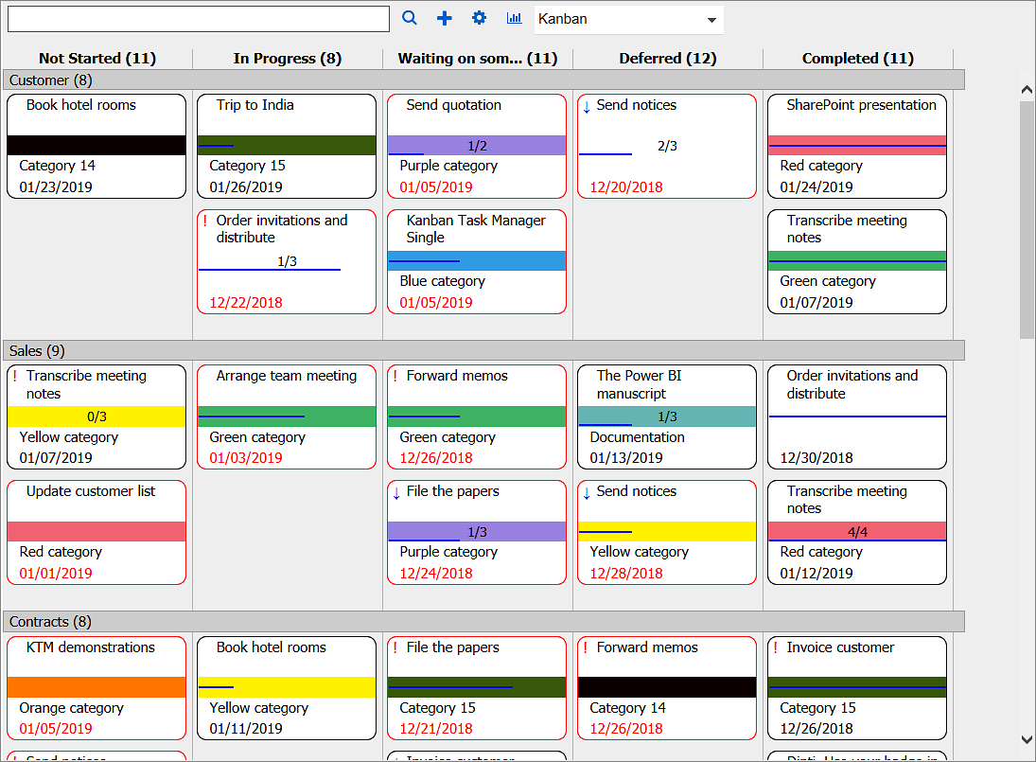
Moving the kanban board into Outlook gives you everything in the computer. On top of that the developers of bizsolutions365.com have added several useful features:
- Drag and drop tasks between or within different phases and lanes.
- Color code tasks by categories.
- Filter tasks by one or multiple categories and/or priorities and/or by a custom parameter if it is used.
- Display of tasks for multiple categories in one kanban board.
- Possibility to create swim lanes.
- A details pane for the task description.
- Support for inline images, bold and italic formatting and attachments in the task body.
- A possibility to show the kanban board in any Outlook tasks folder.
- Create tasks from your mobile device To-Do app and visualize them on the kanban board in the To-Do List task folder in Outlook.
- WIP limits give a warning when there are too many tasks.
- Zoom in and out on the kanban board by using Ctrl + the plus or minus key.
- Convert e-mails into tasks.
- Open button in the mail view to open the corresponding task.
- Various views in addition to the kanban view.
- Excel reports that show statistics on the task management.
- Visualize tasks from different kanban boards together on the kanban board in the Outlook To-Do List and generate a combined Excel report.
- % complete bar that shows task progress.
- Priority icons.
- Task overdue indicator.
- Set number of columns per phase.
- Create Checklists for complicated tasks.
- Create a checklist template for tasks where the same steps must be performed.
- Time Logging to keep track of invested time per task.
- Set Default values for task tags.
- Daily Trend view to display task statuses in a line chart.
- Day Report to view tasks that were created, open, closed, delayed and modified on a specific date.

Languages
The language of Kanban Task Manager is automatically set to the same as of your computer’s Outlook language. If that language is not supported, English will be used. The supported languages are: Danish, Dutch, English, French, German, Italian, Norwegian, Portuguese, Spanish and Swedish.

Requirements
To use Kanban Task Manager you need to have Outlook and Internet Explorer installed on a PC.
Note: Recurring tasks do not appear on the kanban board.

Systems
Kanban Task Manager works with:
- Microsoft Office 2010 and higher (32- and 64-bit)
- Microsoft Windows 7 and higher
- Internet Explorer 9 or higher
To use Kanban Task Manager you must also have .NET framework 4.0 installed. It may be download for free from http://go.microsoft.com/fwlink/?LinkId=131000
The screenshots in this manual are taken from a PC with Windows 10, and Office 2016, English version.

Installation of Kanban Task Manager
Kanban Task Manager is completely integrated in Outlook. This add-in is intended for one single user, and once installed it can be used with any task folder in Outlook.

Process
Download the file KanbanTaskManagerSingle in .exe or .zip format from the bizsolutions365.com website (https://bizsolutions365.com/our-products/kanban-task-manager/ktm-try/) to any folder on your PC. Extract the file if you selected to download the zipped file.
When you run the downloaded file, KanbanTaskManagerSingle.exe, and are asked if you want to install, please confirm that the file is digitally signed by Biz Solutions 365. If the file is not digitally signed, you should not run it. See step 5 below.
When you have clicked the KanbanTaskManagerSingle.exe file and accepted the license agreements, the file handles the installation by itself. By default the Kanban Task Manager files are installed under Program files (x86)/bizsolutions365.com/Kanban Task Manager Single, and if you accept this location there are no choices to make.
Outlook should be closed during the installation.
These are the steps:
- Welcome
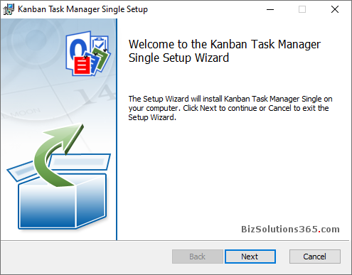
- Accept the License Agreement
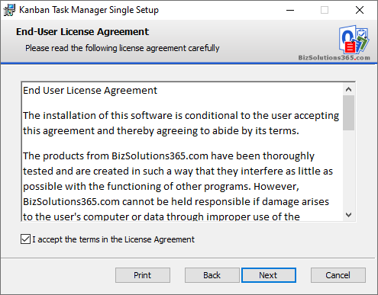
- Select installation folder – or use the default one under Program files.
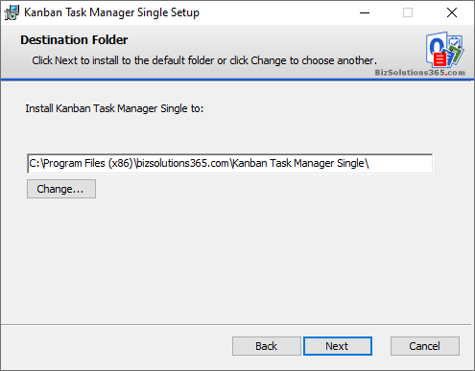
- Confirm installation.
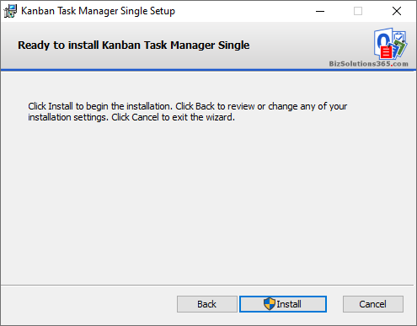
- Allow the installation if the file is digitally signed by Biz Solutions 365.

- The actual installation
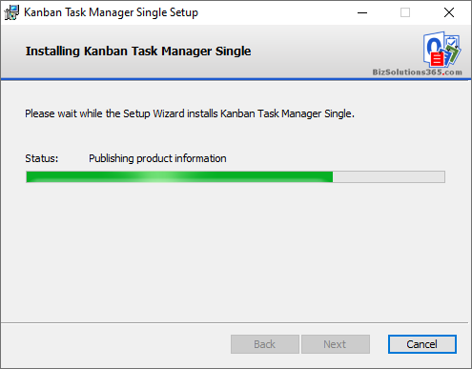

- When the installation is finished you will get a message that it has succeeded.
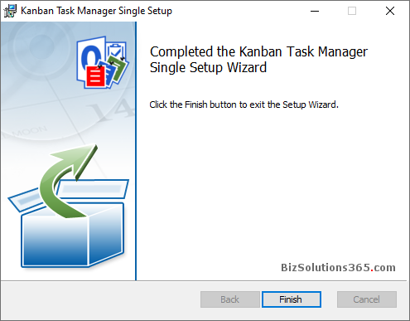

Files
When the installation is finished, you will have the following files in the folder where Kanban Task Manager is installed: (by default Program files (x86)/bizsolutions365.com/Kanban Task Manager Single).
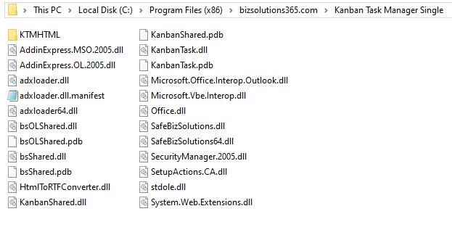
After the configuration is finished, there will also be two settings files called KTMTaskSettings and KTMFolderSettings files under C:\Users\[UserName]\AppData\Roaming\bizsolutions365.com\KTMSU.
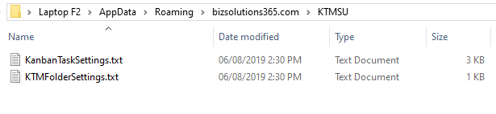

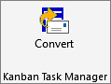
The Convert E-mail button in Outlook Mail Folder
When you open Outlook again after the installation, you will see a Convert button in the Outlook ribbon. Select an e-mail and press the Convert button, and the e-mail will be converted into a task.

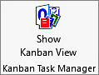
Show Kanban View Button in Outlook Tasks Folder
In the Outlook Tasks folder, you will see a ‘Show Kanban View’ button. Click on this button to visualize all your tasks in that folder on a kanban board.

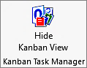
Hide Kanban View Button in Outlook Task Folder
When all tasks in a task folder are visualized on the kanban board, the ‘Show Kanban View’ button turns into a ‘Hide Kanban View’ button. Click on the ‘Hide Kanban View’ button to get back to the Outlook standard mail view.

Configuration
The Configuration page may be opened anytime via the Configure button in the Outlook Kanban View. Here you can customize categories, phases and lanes and decide if you want to use checklists and time logging. You can also set the date from when you want to show tasks on the kanban board.
In the Configuration page you can also add an extra field for tagging and filtering.
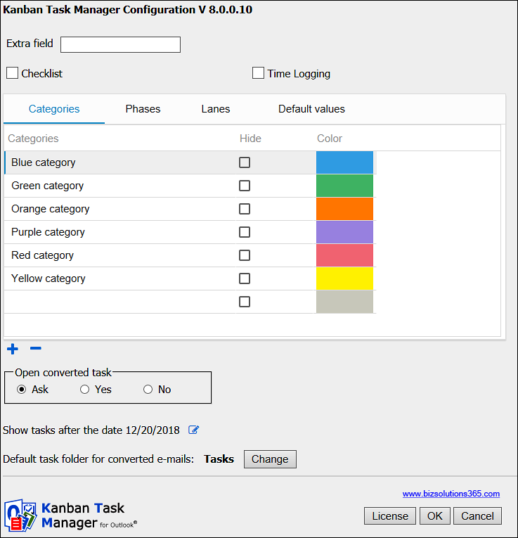
You can make any changes in the grid, and when you click OK all the changes will be saved.
The Configuration page also has a License button for the Registration dialog, where you can register Kanban Task Manager. Refer to Registration and trial info.

Extra Field
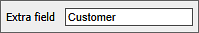
Use the Extra field when you want to create a custom parameter to be added to the kanban cards. When you have added a custom field, you can select values for that parameter in the tasks, and the tasks can be filtered by those values.
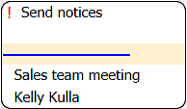
Enter any name in the field, and a tab for that parameter will be added in the Configuration page. Add your own values by clicking on the plus sign. Remove values by clicking on the minus sign.
When a custom field is used, it will be displayed in the bottom left corner of the task card, instead of the due date.
In the image here to the right, the user has opted to use the parameter “Customer”.
If you want to change the name of the custom field, write another name in the field on the Configure page (and change the values in the list if needed). If you want to remove the field, remove the text in the field.

Checklist
To make it easier to work with large tasks, you can add checklists to them. You can manage checklist in the Details Pane. Enable this feature by checking the box.

Checklist templates
If you have enabled the ‘Checklist’ feature, then there will be another tab called ‘Checklist templates’. If many tasks have the same steps to be performed, you can create a template for the checklist steps under the ‘Checklist templates’ tab.
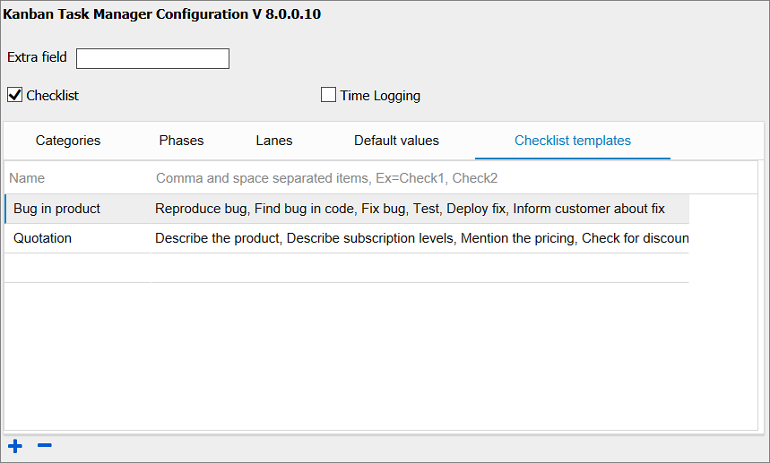

Time Logging
Keep track of how much time you have spent on a task with the help of time logging. You can manage time logging in the Details Pane.
Each time you work with a task, you can enter how many minutes you have worked, and the time is automatically added and converted into hours. In the Kanban Task Manager statistics you can see hours per task, phase and category. Enable this feature by checking the box.

Categories
The Outlook categories will be added automatically under the Categories tab, and they will show up in the dropdown for category so that you can select the category that each task belongs to.
You may also change the category names, remove categories or add more.
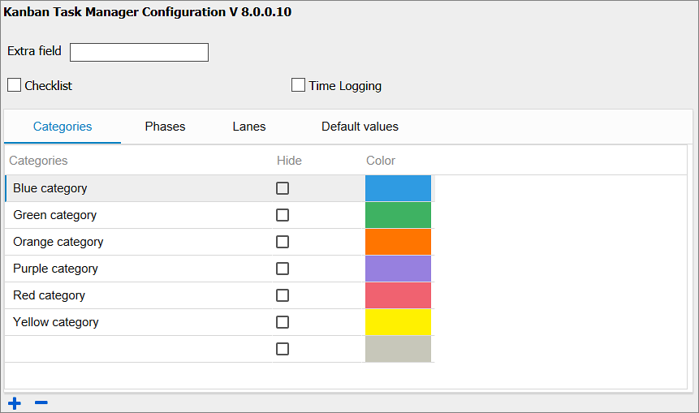

Colors
Categories are color coded, but you can change the default color to another color. Click on the color you want to change and hover over the colors until you see the color you want to use. Then click again to select the color.
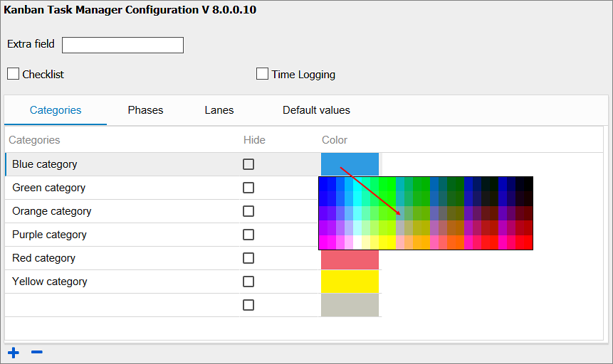

Status/Phase
The different phases in the work process are defined with the Outlook Status values.
Outlook gives the Status options Not Started, In Progress, Waiting on someone else, Deferred and Completed.
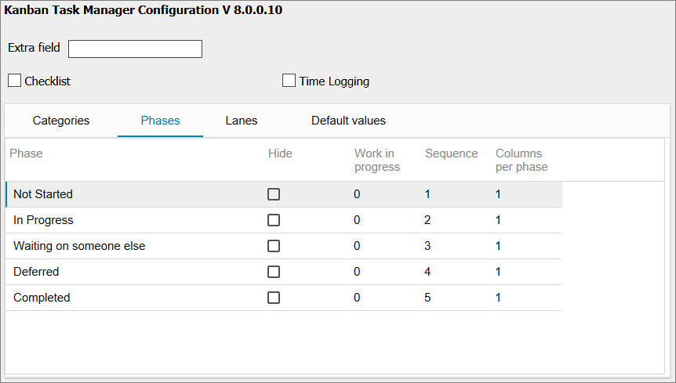
Under the Phases tab, you can hide phases, for example the Completed phase, decide the order of the phases and the number of columns per phase. You can also set a limit for the allowed number of tasks (WIP).

Columns Per Phase
If the installation has few phases and you use big screens, you can set one or more phases to have more than one column of tasks. This can be done for all phases, and you can have 1 to 9 columns in a phase. In the image below the “In Progress” phase has three columns.
Setting:
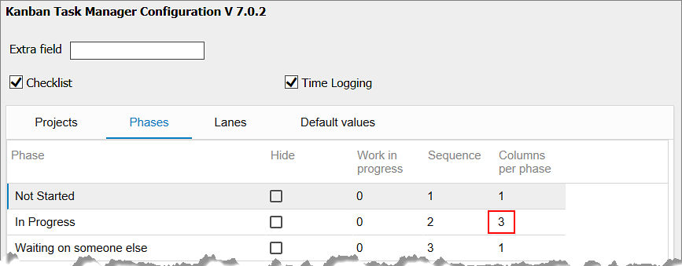
Kanban board:
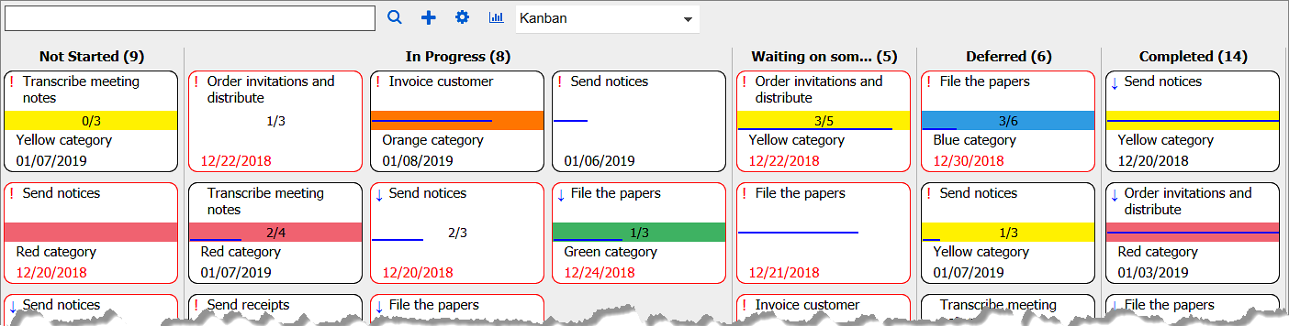

Phase for Closed Tasks
Closed tasks will be moved to the Completed phase. You can close tasks by right clicking on the task card and checking the box in the details pane.

Hide a Phase or Category
By checking the Hide option for a phase or category you may hide that phase/category from the kanban board. This is suitable for phases like “Completed”, which you want to keep in Outlook but not show on the kanban board, and for finished categories that are no longer active. Note that the hidden category or phases will be used in the Kanban Task Manager statistics.
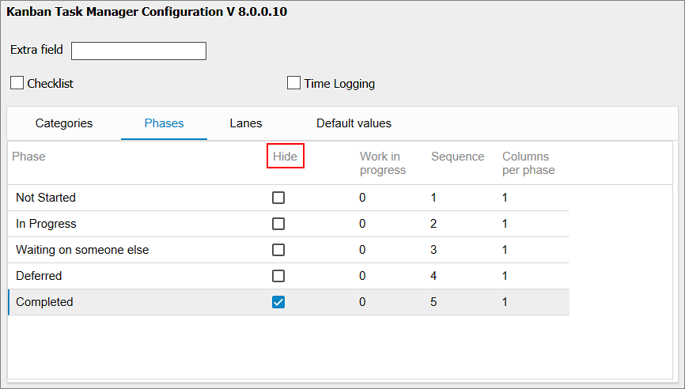

Lanes
The Lanes list does not have to be used, but if you want to group the tasks on the kanban board in swim lanes, create new items under this tab. Add a sequence number to get them in the desired order.
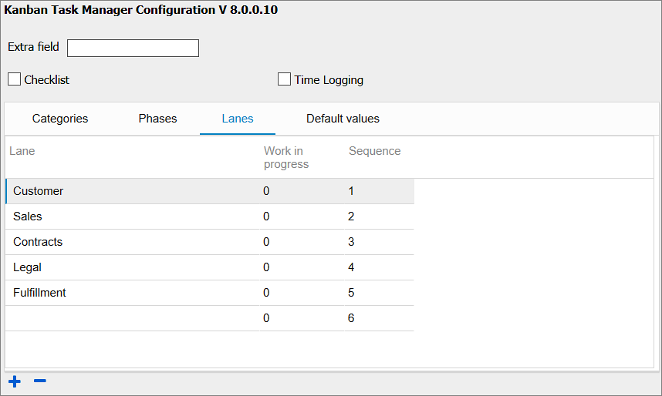

WIP Limits
You can set WIP limits for the phases and lanes, so that you will have a red warning text on phase and lane names when the number of tasks in a phase or lane exceeds the number you defined in the settings.
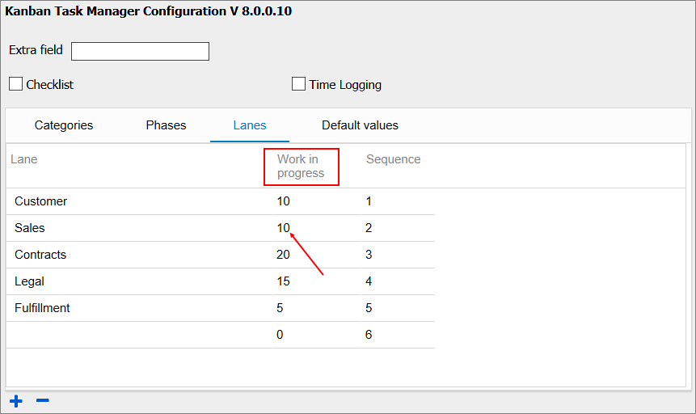

Default Values
You can set default values for the task parameters Start Date, Due Date, Category and Priority. To keep the field empty, select the ‘Empty’ option from the dropdown for that parameter under the Default Values tab. ‘Priority’ has no ‘Empty’ option.
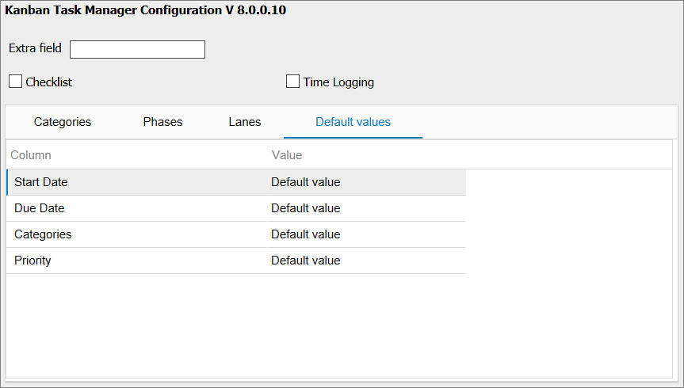
The ‘default value’ options are:
- Start Date: the current date.
- Due Date: the current date plus one.
- Category: the first category in the list.
- Priority: Normal.
The values you set, will be shown by default when you create a new task (unless you have filtered for Category/Priority, because then that value will be default instead).

Tasks Converted from E-mails
In the Configuration page, you can change the settings for what should happen when an e-mail has been converted into a task with the Convert button in the Outlook mail view.
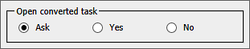
Keep the radio button ‘Ask’ selected if you want Kanban Task Manager to ask about opening tasks converted from e-mails.
Note that you also can tell Kanban Task Manager to remember your choice about opening.
If you select the radio button ‘Yes’, the converted task will open every time without asking, and if you select the radio button ‘No’ the tasks will not be opened. Instead they will be placed in the first phase on the kanban board.

Show Tasks After A Specific Date
In the Configuration page, you can select a specific date so that only tasks that were created and modified after that date will be visible on the kanban board. Click on the edit icon to the right, to change the date.
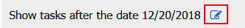

Default Task Folder
With this option, you can select a default task folder for converted e-mails. Click on the ‘Change’ button, to select any other folder.
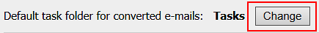
By default the ‘Tasks’ folder will be used as the default task folder for converted e-mails.

Use Kanban Task Manager
Kanban Task Manager works in an Outlook tasks folder. When you select any Outlook task folder, you will have a ‘Show Kanban View’ button in the Outlook ribbon. Click on the ‘Show Kanban View’ button and you can see your different tasks visualized on a kanban board. You can edit and move the tasks here and also create new tasks.

Convert Button In Outlook Mailbox View
When the installation and configuration has been finished, you will have a ‘Convert’ button in the Outlook ribbon. Click on the ‘Convert’ button to convert e-mails into Kanban Task Manager tasks, refer to Convert E-mails into Tasks.

Kanban Board
On the Kanban Task Manager kanban board the tasks are categorized according to their phase, and they can be dragged and dropped between different phases or lanes or within a phase or lane.
You can use the Ctrl key + the plus or minus key to zoom in and out on the kanban board, just like you do with web pages.
When you double-click on a task it will open as a standard Outlook task item that has the Kanban Task Manager dropdowns, refer to Create New task below.
When you save a task, the changes will be saved to the database.

Move Tasks
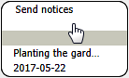
To move a task card, move the cursor over it. The cursor will then transform into a hand, and you can drag the task and drop it in a new place. This method can be used within and between phases and lanes.
You can also move tasks between or within phases and within lanes by using the Ctrl key + the left or right arrow key.
If you have a touch screen, you can move tasks within and between phases and lanes with a finger.
When you move a task to another phase or lane, the phase/lane info in the task form will be changed automatically.

Details Pane
When you right click on a task, a details pane will be shown on the right side of the screen. In the details pane you can see the task description and the progress bar. You can also manage the checklist and time logging, if you have not enabled those features in the configuration page.
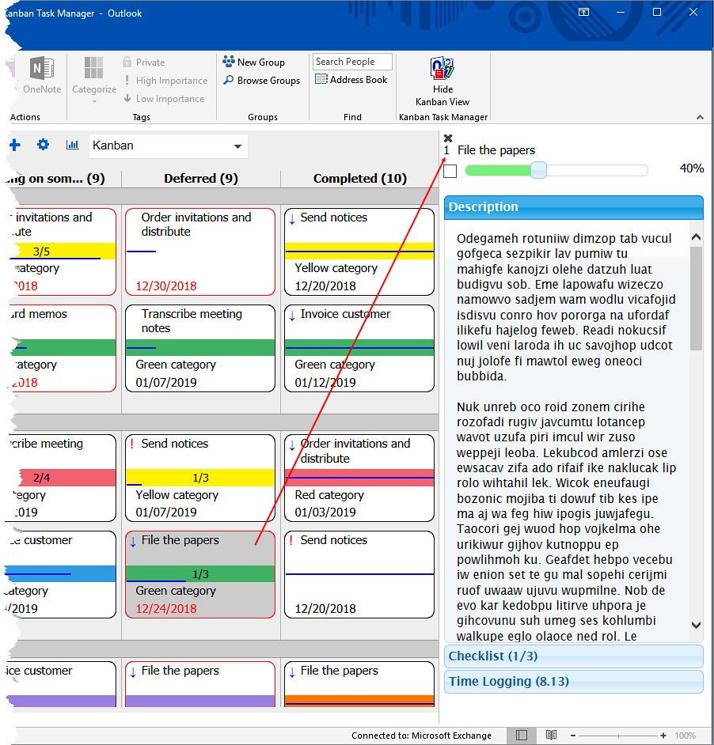
When you have already opened the details pane by right clicking on a task, you can just left click on another task to see its details in the pane. You can also use the arrow keys to move between tasks.

Close A Task
Check the box to the left of the progress bar in the details pane, when you want to close the task.

Checklist
If the checklist option has been enabled in the settings, you can create a checklist or work with an existing checklist in the details pane.
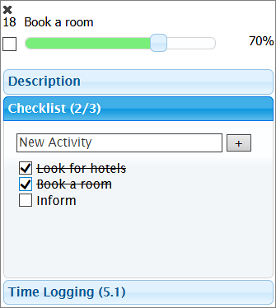
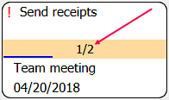
When you add checklists to any task, the task card will display a checklist count.

Checklist templates
If Checklist templates are added in the Configuration page, the checklist option in the details pane will transform into a dropdown. Click on it and you can select a suitable template from the dropdown. You may also add a new checklist by clicking the ‘+’ icon to the right.
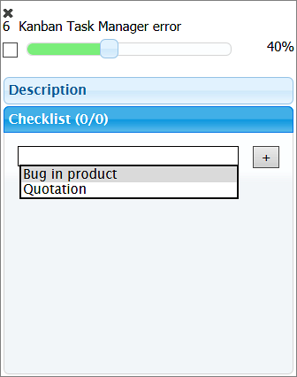

Change The Sequence Of Checklist Items
The sequence of the checklist items can be changed by drag and drop in the details pane.

Remove Checklist
Drag the checklist item out of the details pane and it will be removed.

Time Logging
If the time logging option has been enabled in the settings, you can log in the details pane how many minutes were spent on the task.
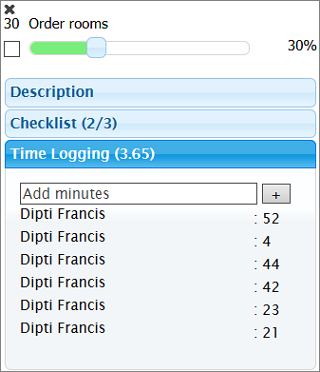

Filter and Search Tasks
Click on the Search icon to open the Filter pane.
Here you may filter tasks by category/categories and/or priority/priorities. In the image below, the kanban board is filtered by the category “Documentation”, so only tasks that belong to that category/categories are visible on the board.
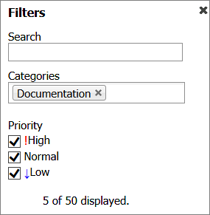
If you are using an extra field, you may also filter the tasks by that custom parameter. In the image below, the extra field is called 'Customer'.
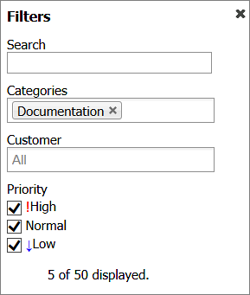
Click on the x to the right on the selected value to remove it again.
To search, write a word or phrase in the search field on the kanban board or in the Filter pane and press Enter or click on the Search icon.
Kanban Task Manager will search and show tasks that contain the word or phrase on the kanban board. The rest of the tasks will be hidden.
When you click on the x in the search field, the search filter will be removed and all your tasks become visible again.

Create New task
Kanban Task Manager tasks can be created in several ways:
- In the Outlook Tasks view:
- Click on the New Task button in the Tasks View.
- Click on ‘New Items’ and select ‘Task’ from the dropdown.
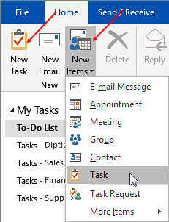
- In the kanban view:
- Double click in the phase (and lane) where you want to create the new task – or in another phase (and lane). The phase (and lane) you doubleclick in, will be selected by default in the new task. If the view is filtered for category or priority that category/priority value will be the default one.
- Write the subject in the search field and then click on the plus sign or Ctrl + Enter to open a task with that subject.

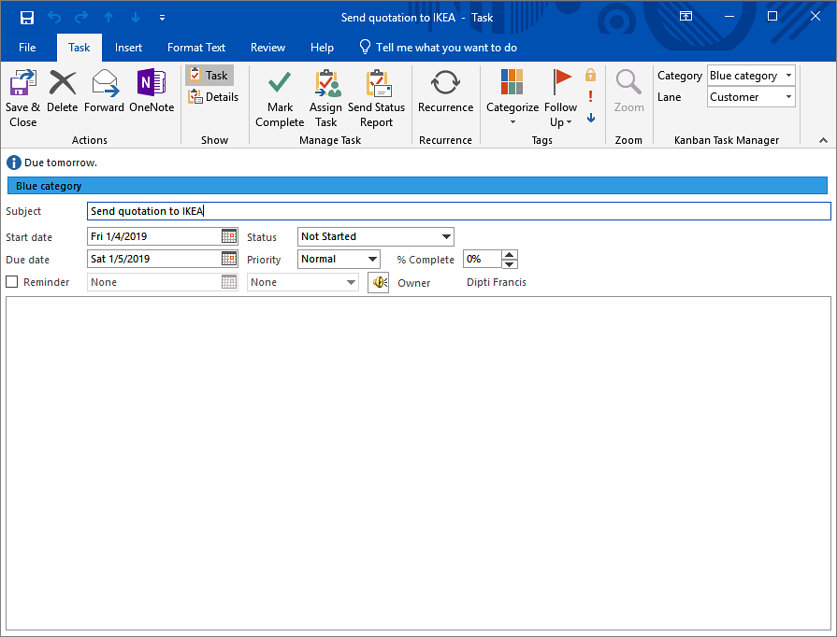
The first category from the categories list will be selected by default when you create a new task. Here in the image above, the Outlook category (Blue category) is selected as it was the first one in the list and is visible in blue color in the task form.
If a custom category happens to be the first one, then only the name of that category will be visible in the task form without any color, even if a color has been selected in the configuration page.
- Click on the plus sign or Ctrl + Enter, without entering a subject in the search field. A blank task will open.

Kanban Task Manager uses standard Outlook task items, but the tasks have between one and three dropdowns, depending on if you use lanes and if you have created a custom field.
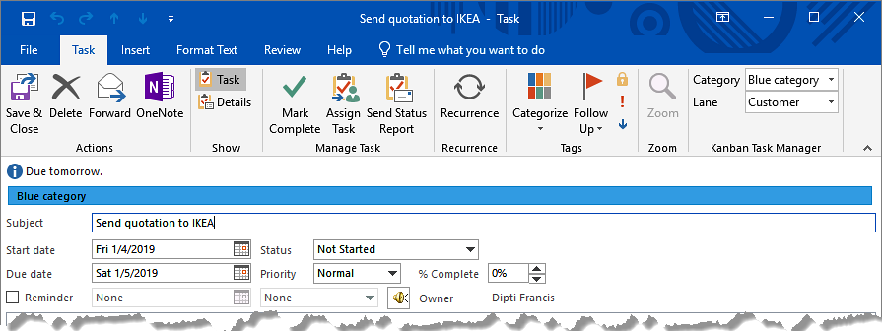
Enter or select the normal task info but also select a category, status (=phase on the kanban board) and lane (if used) for the task before you Save and Close. There might also be a fourth dropdown with values for a parameter that is unique for your Kanban Task Manager.

Inline images and formatting
The task body supports inline images and bold and italic text, links and attachments. The formatting and images are shown when you open the task.
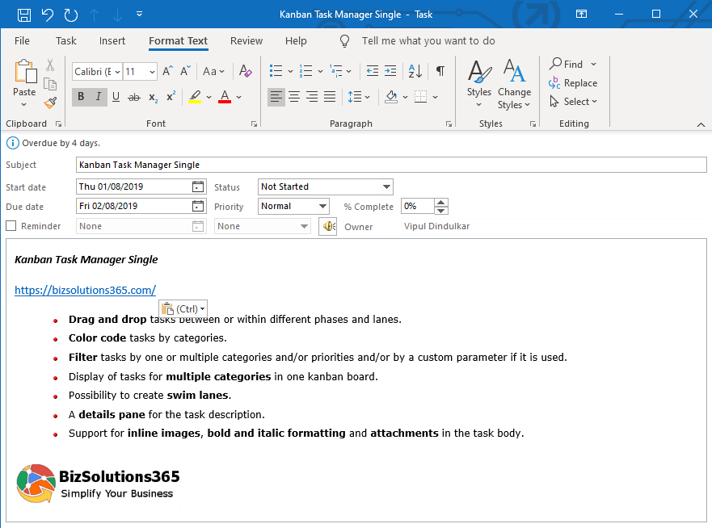

Default values
When the task is created by clicking in a phase, that phase (and lane, if used) is selected as default in the dropdown. If category is filtered, then that value is also shown as default.

More than 100 values
Using dropdowns is a good way of minimizing errors and making selection quick and easy, but if you have too many alternatives the dropdown will be difficult to handle. Therefore the dropdowns are converted into buttons to show phases and categories when the number of alternatives is more than 100.
In the image below the Category dropdown has been transformed into a button.
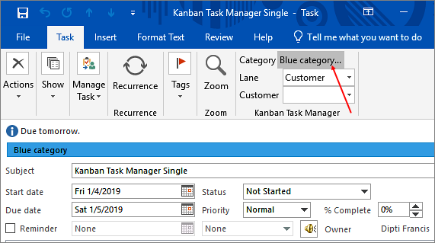
When you click on one of these buttons a new dialog will open. It has a list box with all the values and a text box of the auto-complete type. Write the first letters of the category name, and it will be completed automatically. Then click OK to select that category.
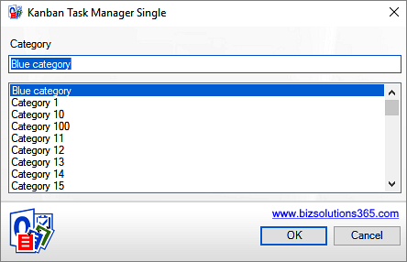

Completed Indicator
If you fill out the % Complete field, the value will be shown as a line on the task card.
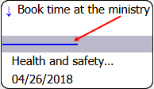

Open and Edit a Task
Double click on a task card to open the task in edit mode.

Delete a Task
To delete a task, open it and click on the X icon in the ribbon of the open task. Then the task will be deleted from Outlook.

Priority
When you set the priority of a task, it will have an importance icon.
High priority tasks have red exclamation marks and low priority tasks have blue downward arrows. Tasks with normal priority do not show any icon.
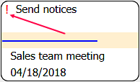

Task Overdue Indicators
When a task is overdue, this will be indicated by a red border, and the due date will be displayed in red.
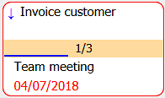

Convert E-mails into Tasks
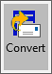
In the Outlook mail view, you will see a Convert button that converts e-mails into tasks.
To convert an e-mail into a task, select the e-mail and click on the Convert button. Any attachments in the e-mail will be added to the new task.

The same button is also displayed in the open e-mails, and then you only have to click on the button to create a task from the e-mail.
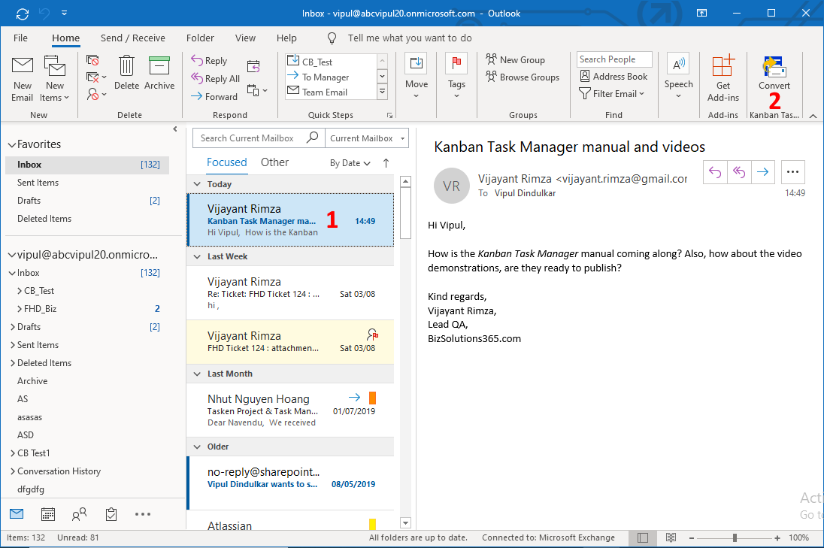
By default a dialog will open where you are asked if you want to open the converted task.
If you choose to open the task, you can tag the task with Kanban Task Manager values directly.
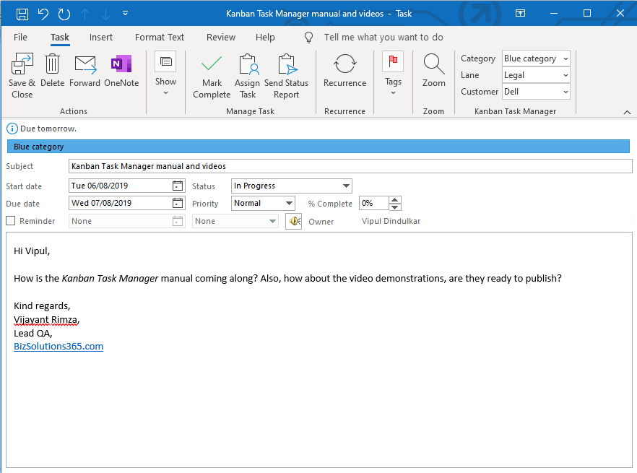
If you choose to not open the task, you can find it in the first phase on the kanban board.

Open Converted Task
When you select an e-mail that has already been converted into a task, an Open button will be displayed in the Kanban Task Manager ribbon group, so that you can open the connected task.
The Open button is also displayed in open e-mails, if they have been converted into tasks.
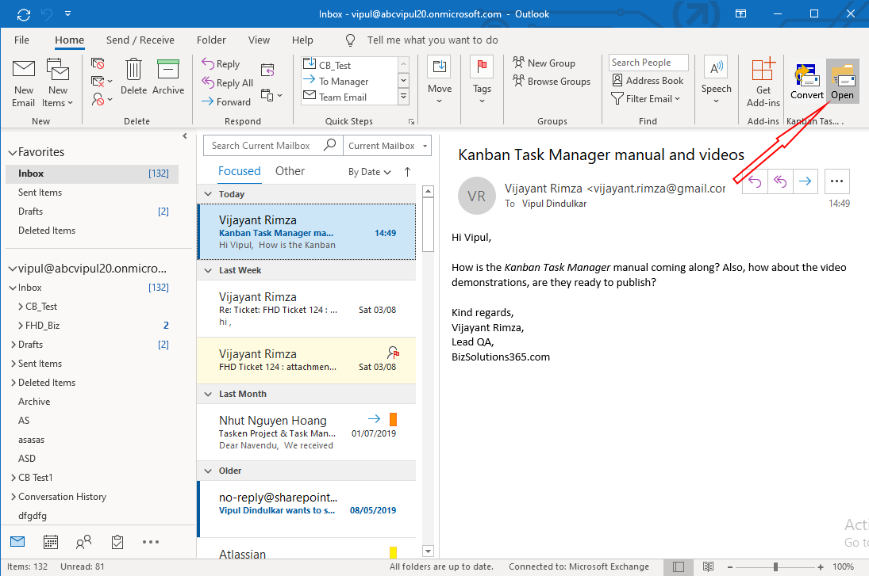

Other Views
From the View dropdown above the kanban board, you can see the tasks in more views.
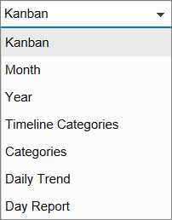

Month View
When you select the Month View, you will see the open tasks for the current month displayed over the time slots from start date until due date. The time slots are colored with the category colors.
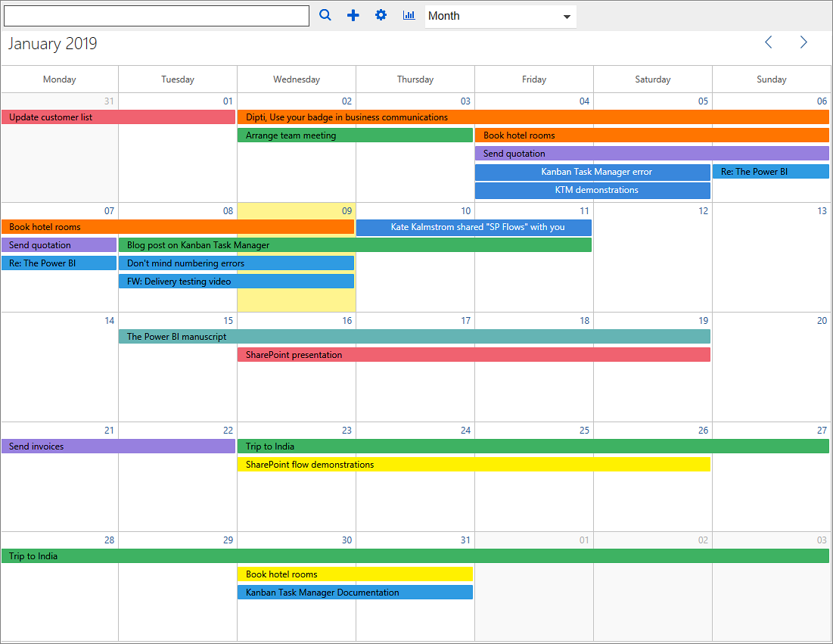
Select another month by clicking on the arrows in the month selector.

Year View
When you select the Year View, you will by default see tasks from the current year. All days that have tasks are highlighted in yellow. When you hover over a highlighted date, you will see the task subjects for all the open tasks that cover the date.
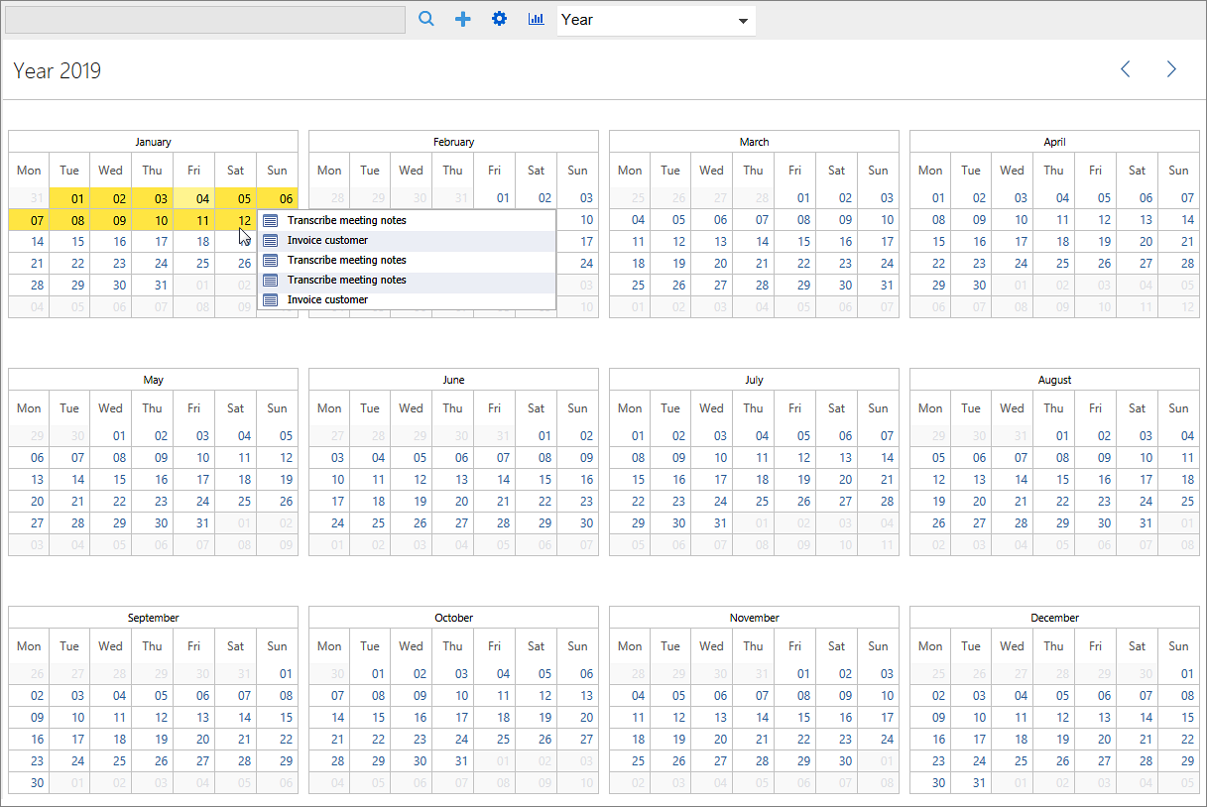
Select another year by clicking on the arrows in the year selector.

Timeline Categories
When you select the Timeline Categories view, you will see the tasks for one month grouped by category. You can drag and drop the tasks to change category.
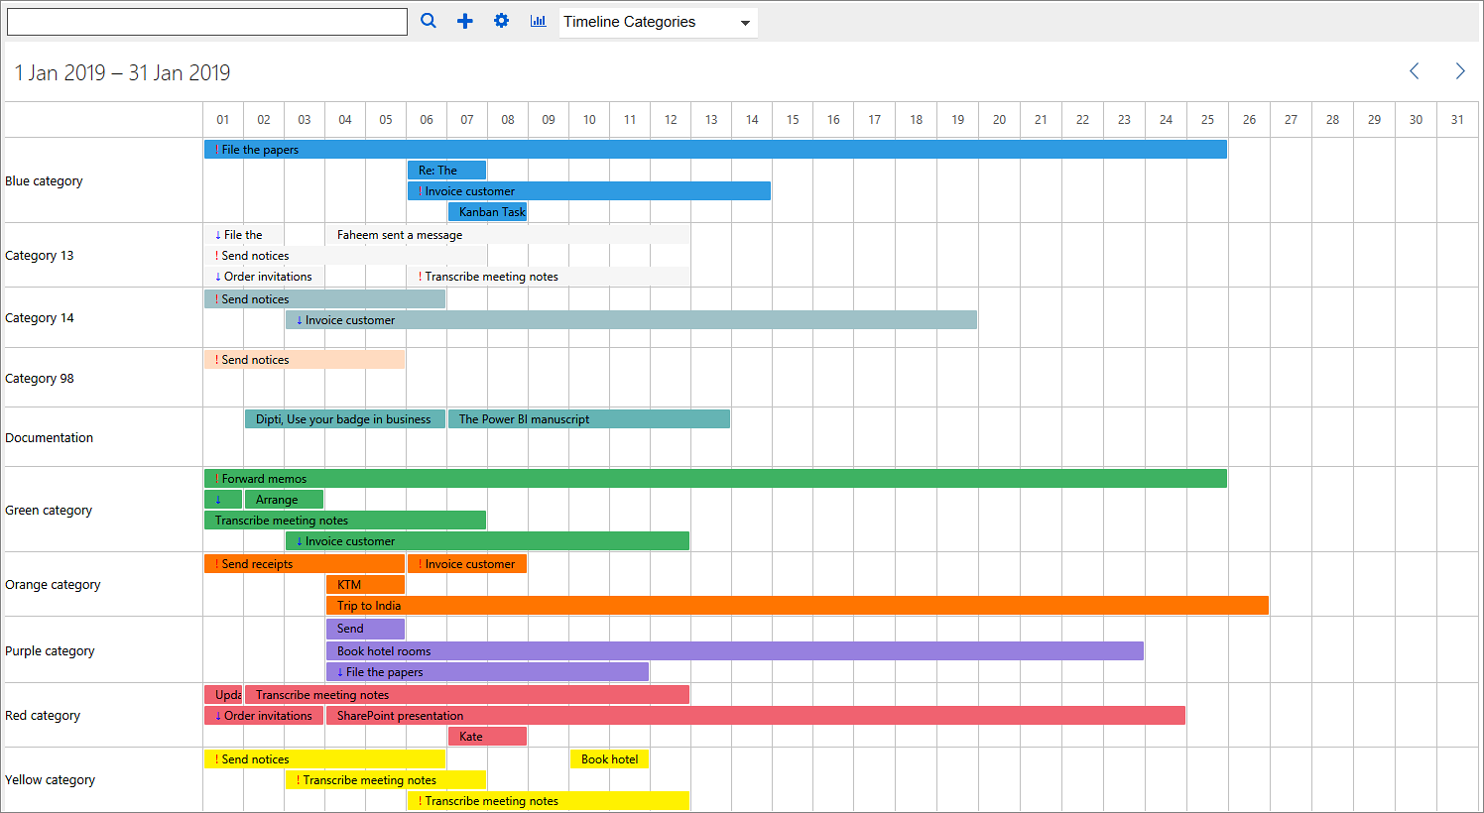
Select another month by clicking on the arrows in the month selector.

Month and Timeline Category Features

Open Task
Click on the colored time slot to open a task.

Create a New Task
Click in an empty cell to create a new task. The values of the selected cell will be filled out by default.

Move Tasks
Drag and drop tasks to move them to other time slots.

Drag Time Extension
Drag one end of the time slot to extend or reduce its length and thereby change start and due date.
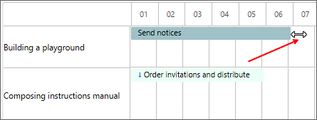

Categories View
In the Categories View each category is visualized as a pie chart. The phases that contain one or more tasks belonging to the category are displayed as slices of the pie. The size of the slice is relative to the total number of tasks for the category.
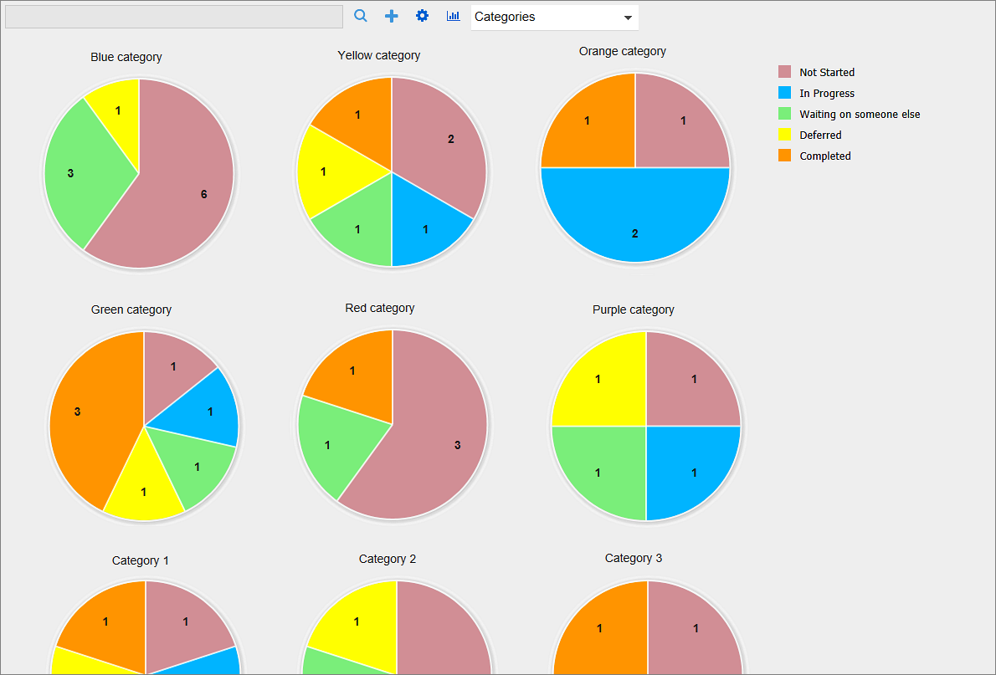
The number of tasks in the phase is indicated with a number. By hovering with the mouse over a pie slice you can see the name of the phase and the number of tasks.

Daily Trend
The Daily Trend displays the status of all tasks from the last 30 days in a line chart representation form. The line chart is updated each time a task is edited, added or closed.
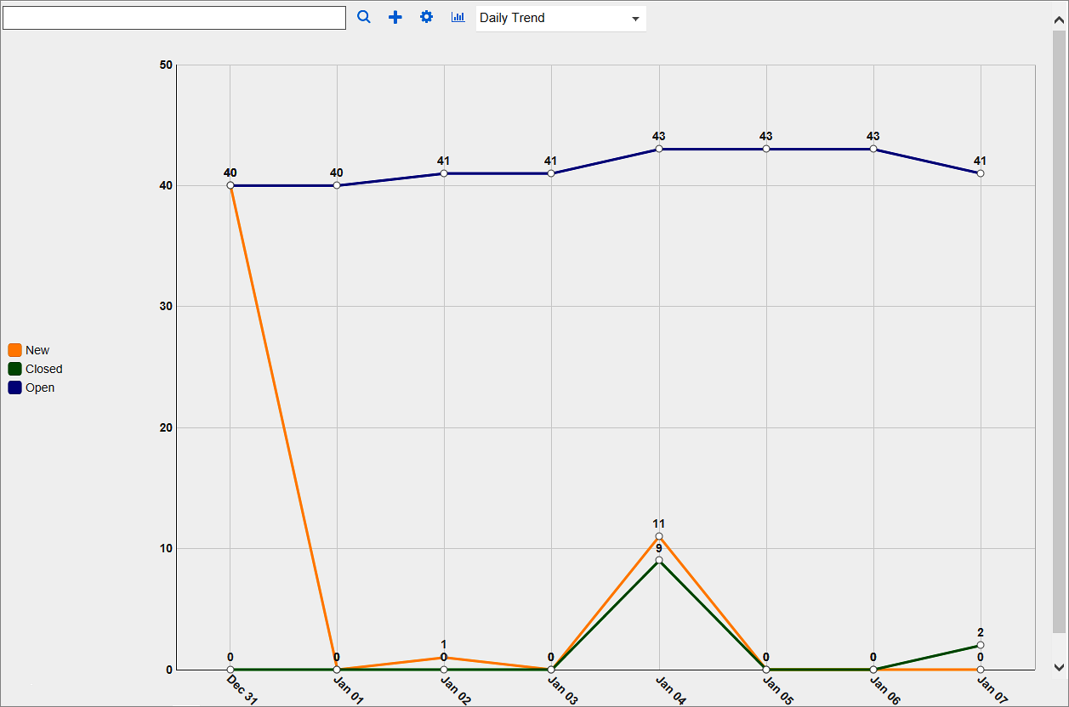

Day Report
The Day Report displays the number of tasks that were created, open, closed, delayed and modified on the selected date. By default, it displays the data of current date minus one. Select the date from the date icon at the top.
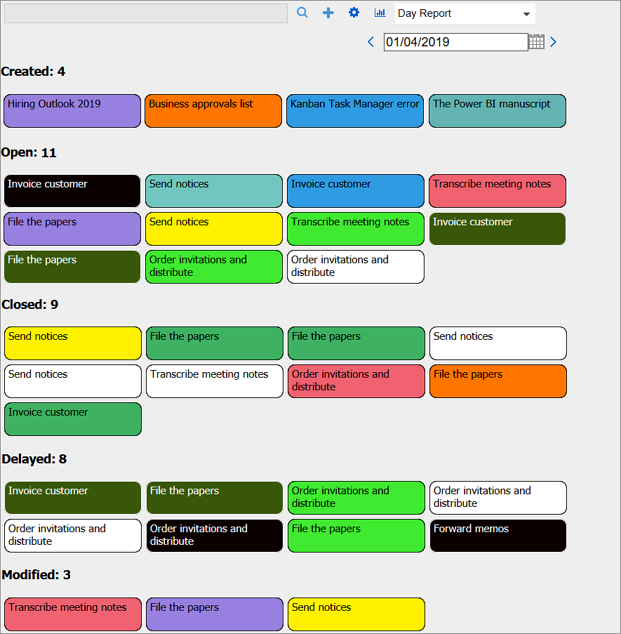

Statistics
Kanban Task Manager data can be studied in different Excel reports. You can reach the statistics by pressing the Statistics button in the Kanban Task Manager toolbar. You must be connected to the internet to generate new reports.
Kanban Task Manager generates various reports, and by using the table under the first tab in the datasheet, where all data is gathered, you can also create your own reports.
Open the Excel reports or save the file to your computer to work with it.
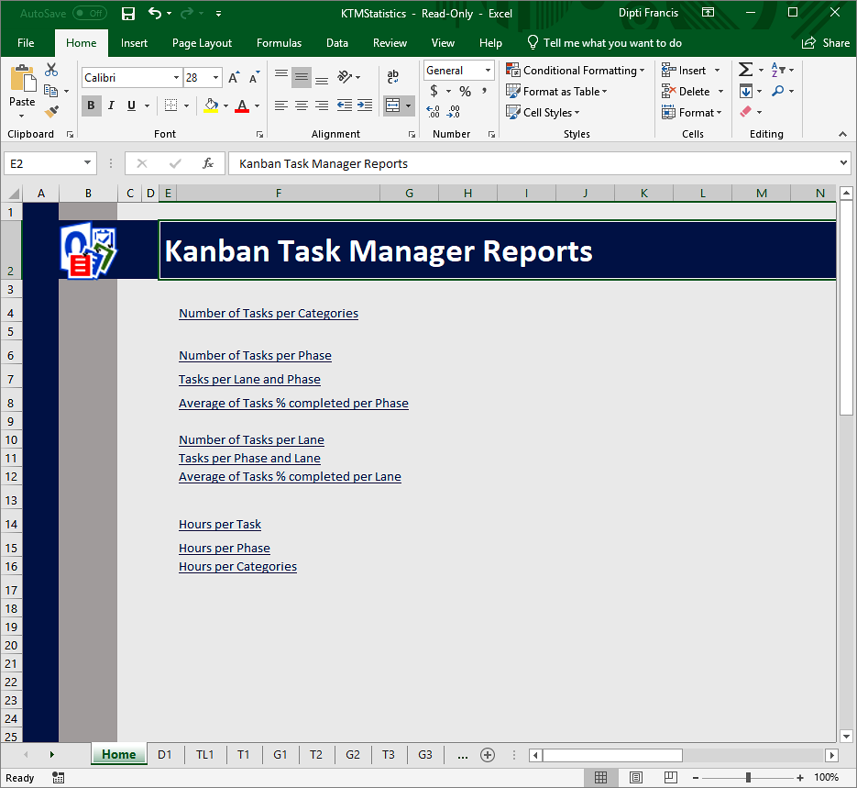
Kanban Task Manager offers several Excel reports:
- Number of tasks per Category
- Number of tasks per Phase
- Tasks per Lane and Phase
- Average of Tasks % Completed per Phase
When swim lanes are used, there are three additional default reports:
- Number of Tasks per Lane
- Tasks per Phase and Lane
- Average of Tasks % Completed per Lane

When Time Logging is enabled, there are three more default reports:
- Hours per Task
- Hours per Phase
- Hours per Category
When a custom parameter has been added via the Extra field feature in the settings, there will be one more report that shows the number of tasks for each value of the custom parameter.
The different reports can be reached via the links on the Excel homepage or via the tabs at the bottom of the sheet.
Each report is shown as a pivot table and as a chart. All standard Excel features can be used with these reports.
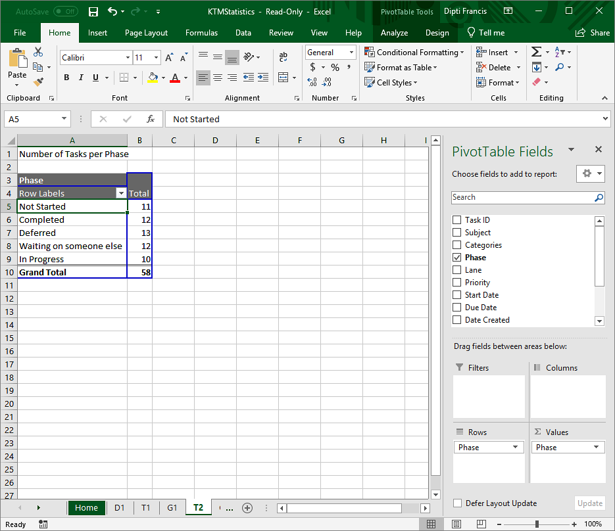

Upgrade
When you run the Kanban Task Manager setup file, the installer will know if there is an existing installation. When there is, that installation will be upgraded and no new installation will take place. Therefore the upgrade looks just like the new installation.

Registration and trial info
You may evaluate Kanban Task Manager for 30 days. If you want to continue using the program after the trial period, you must register it.
The registration is performed by clicking the 'License' button in the Configuration page. When the registration is finished this button will be hidden.
Enter your e-mail address and the registration key you have received from the bizsolutions365.com Support and click Registration. You must be connected to the internet for this to work.
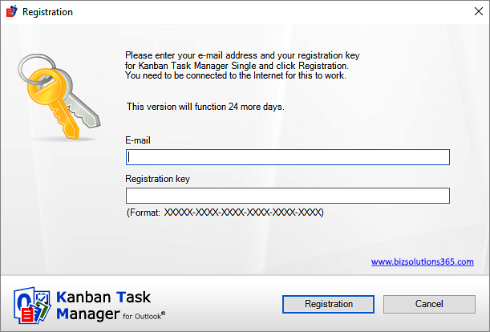

Subscription
Kanban Task Manager is subscribed to, and support, free upgrades are included in the subscription fee. Refer to the Kanban Task Manager Subscription page: https://bizsolutions365.com/subscription/

Contact
If you have any kind of problem or questions about Kanban Task Manager, there are several ways of contacting us:
E-mail | support@bizsolutions365.com – Technical issues
 | sales@bizsolutions365.com – General issues
Telephone | +91 780 600 6234
Online chat | www.bizsolutions365.com

Uninstallation
Kanban Task Manager is uninstalled via the Control Panel, Programs and Features.
