Folder HelpDesk V15 Manual

Content
1 Introduction 5
1.1 Requirements 5
1.2 Languages 6
2 The Folder HelpDesk ticket 7
2.1 Mandatory Fields 7
2.2 Parts 7
2.2.1 The Toolbar Strip 7
2.2.2 The HTML Form 8
2.2.3 The Tab Strip 9
2.2.3.1 The Properties Tab 9
2.2.3.2 The Work Done Tab 10
2.2.3.3 The Sent /Received Tab 10
2.2.4 Ticket body 11
2.3 Open and close tickets 11
3 Support Staff Workflow 13
3.1 Telephone call 13
3.1.1 Caller e-mails 14
3.1.2 Save and Close 15
3.2 E-mail, manual conversion 15
3.3 Convert into a new ticket 16
3.3.1.1 Attachments 17
3.3.2 Add to existing ticket 17
3.3.3 Caller e-mails 18
3.3.3.1 Automatic adding of replies 18
3.4 Web form, manual fetching 18
4 Work with tickets 19
4.1 Search tickets 19
4.1.1 Search open tickets 19
4.1.2 Search and reopen closed tickets 20
4.2 Task conversion 21
4.3 Views 21
4.3.1 Grouped Views 21
4.3.1.1 Sort tickets within a view 22
4.3.2 Customize or create new views 22
4.3.3 HTML Views 23
4.3.3.1 Kanban View 23
4.3.3.2 Month view 24
4.3.3.3 Year View 25
4.3.3.4 Timeline Responsibles 26
4.3.3.5 Timeline Incidents 27
4.3.3.6 Timeline Callers 27
4.3.3.7 Incidents View 28
4.4 Reading pane 29
4.5 Delete tickets 29
4.6 Print tickets 30
5 Install Folder HelpDesk 32
5.1 Permissions for installation 32
5.2 Multiple installations 32
5.3 Installation 32
5.3.1 Create a Folder HelpDesk directory 32
5.3.2 Installation process 33
5.3.3 The Folder HelpDesk Client Tool 36
5.3.4 Select database 39
5.3.4.1 An ACCESS Database 39
5.3.4.2 An SQL Server Database 40
5.3.5 Example data 41
5.3.5.1 Remove Example Data 42
5.3.6 Permissions for users, public folder installation 43
5.4 INSTALLING FOLDER HELPDESK IN A SHARED MAILBOX 43
5.4.1 Permissions for users, shared mailbox installation 44
5.5 The Folder HelpDesk buttons 44
5.5.1 When the Folder HelpDesk folder is not selected 44
5.5.2 When the Folder HelpDesk folder is selected 45
6 Settings 47
6.1 Incidents 47
6.2 Responsibles 48
6.3 Caller categories 49
6.4 Callers 49
6.4.1 Default responsible 50
6.4.2 Exclude callers from automatic e-mails 51
6.5 E-mail folders 51
6.6 Templates 53
6.6.1 Manual e-mail to the caller 54
6.6.2 Manual e-mail to the responsible 54
6.6.3 New ticket 54
6.6.4 Print 54
6.6.5 Automatic e-mails 54
6.6.5.1 Automatic e-mail to Responsible on reply received 55
6.7 FAQ 55
6.8 Status 58
6.8.1 Columns per Status 59
6.9 Advanced: Ticket Form 60
6.10 Advanced: Signature 61
6.11 Advanced: HTML Views 62
6.12 Advanced: Other Settings 62
6.12.1 Send e-mail from 63
6.12.2 Service hours 63
6.12.3 KBase checkbox 64
6.12.4 Web form path and Enable Automatic Tracking 64
6.12.5 E-mail history 64
6.12.5.1 Save e-mails in ticket body 64
6.12.5.2 Save e-mails in subfolders 66
6.12.5.3 Change e-mail history method 67
6.12.6 E-mail notifications 67
6.12.6.1 E-mail to caller when ticket is closed 67
6.12.6.2 E-mail to caller when ticket is created 67
6.12.6.3 E-mail to Responsible on reply received 67
6.12.6.4 E-mail notification when ticket is created 68
7 KBase 69
8 Upgrade or Repair Folder HelpDesk 70
8.1 Permissions 70
8.2 Process 70
8.3 Upgrade of the Folder HelpDesk Client Tool 71
9 Excel Reports 72
9.1 Overview 72
9.2 Default Reports 72
9.3 Custom Reports 74
10 Web form 75
10.1 Files 76
10.2 Setting up the web form 76
10.3 Specify path 76
10.4 Incident types 76
10.5 Monitoring 77
10.6 Created by 77
11 Folder HelpDesk Options 78
11.1 Automatic conversion of e-mails into tickets 78
11.2 Separate Sender E-mail Address 79
12 Customize forms 80
12.1 Customize the Ticket HTML Form 80
12.1.1 Example 81
12.2 Customize the Web Form 82
12.2.1 Example 83
13 Subscription 85
14 Registration 85
15 Remove Folder HelpDesk 86
16 Contact 86
17 Architecture 87
17.1 Files on the network drive 87
17.2 Files for the Web Form feature – FHDOnline folder 87

Introduction
In Folder HelpDesk support cases or other issues that need to be tracked are formalized in tickets, which are filled out automatically or by the people working at the helpdesk.
The tickets are easily distributed among the staff, confirmations are sent out automatically and when a case is closed the ticket can be saved in a knowledge base. The information in the tickets also is automatically saved into a database where it can be searched and used in the integrated Excel Reports. Folder HelpDesk is totally integrated in Outlook.
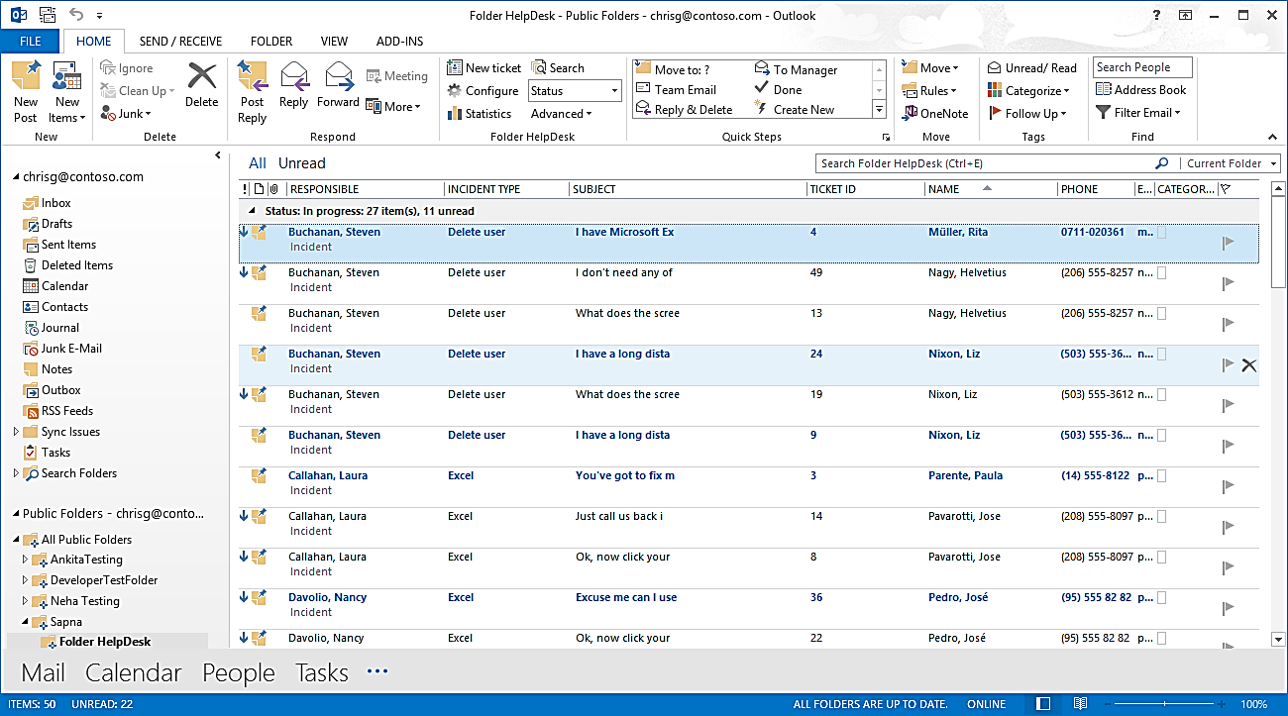
In this manual we have chosen to take support cases as examples, but Folder HelpDesk can be used for all other issue tracking purposes as well.
When we talk about clients in this manual we mean the people who are handling the tickets, for example members of a support team, or the machines used by them.
The screenshots in the manual mostly come from Outlook 2016.
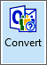
In this manual we talk about e-mail conversion, but tickets may also be created from Outlook Tasks or Appointments by using the Folder HelpDesk conversion button.
Section 4 is useful for all staff working with Folder HelpDesk, while the rest of the manual is intended mainly for the administrator/management.

Requirements
To install and use Folder HelpDesk you need
- Windows 10 or above.
- Microsoft Outlook 2010 or above installed on each client. Both the 32-bit and the 64-bit versions are supported.
- An Exchange server, any version.
- Microsoft Excel 2010 or above for the statistics reports.
- Any version of Microsoft Access or SQL Server.
- .NET framework 4.0 installed. It may be downloaded for free from http://www.microsoft.com/en-us/download/details.aspx?id=17851.There is also a download prompt in the installer, if it cannot find an installation of .NET Framework on the PC.
It is possible to install Folder HelpDesk in any Outlook folder. For sharing the tickets, you must use a shared mailbox or a public folder, which requires access to an Exchange server and a mailbox account, as sharing a .pst file is not supported by Microsoft. Folder HelpDesk supports all versions of Exchange.
Even if it is possible to install and use Folder HelpDesk in an Outlook folder that is not shared, the application is created for sharing and that is what we describe in this manual.
Folder HelpDesk helps you get more out of Outlook and Exchange, but it does not assist you with the general configuring of those programs.

Languages
The language of Folder HelpDesk is set during the installation. The supported languages are: Danish, Dutch, English, French, German, Italian, Norwegian, Portuguese, Spanish and Swedish.

The Folder HelpDesk ticket
The Folder HelpDesk tickets are ordinary Outlook post items that you may customize to suit your organization’s needs. Here the default ticket is described. For customizations, refer to Customize the Ticket HTML Form.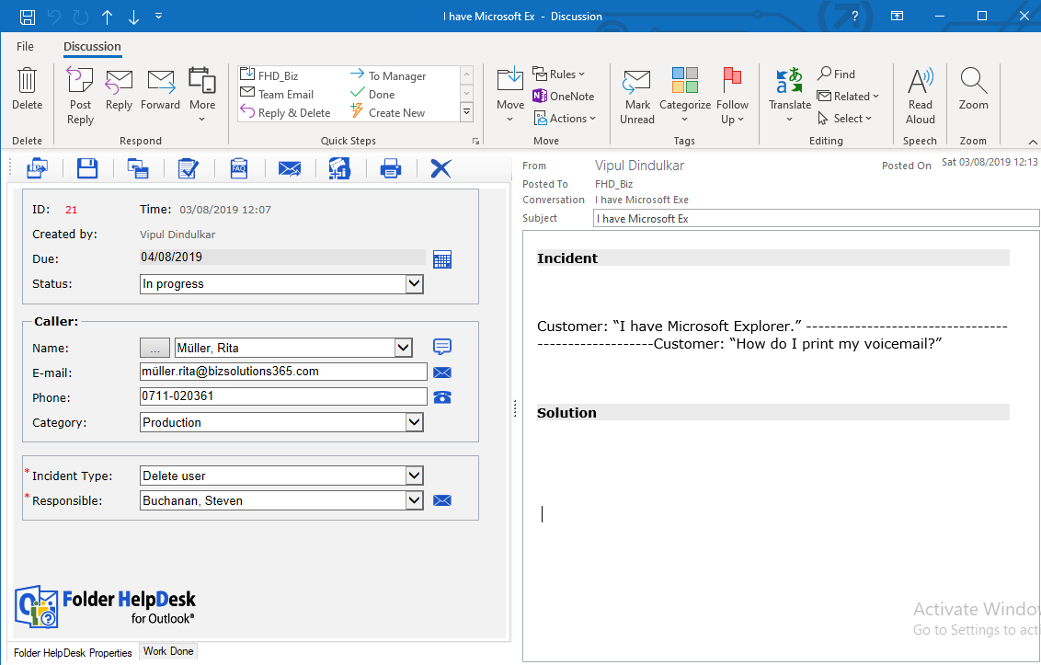

Mandatory Fields
Only a few fields are mandatory in the Folder HelpDesk ticket. The two fields that have to be filled out (by selection) are marked with a red star (*). Tickets can be saved with some of the mandatory fields empty, but tickets cannot be closed until all mandatory fields are filled out.

Parts
The Folder HelpDesk ticket form is divided into four parts. The left side has three parts. The Toolbar Strip is on top and below it comes the main part, the HTML Form with ticket properties. At the bottom we find the Tab Strip. On the right side is the Ticket body.

The Toolbar Strip
The Toolbar Strip contains buttons for different options: Save the ticket and close the window, Save the ticket, Close the ticket, Export ticket data to an Outlook Task, Insert a FAQ Reply, Forward the ticket, Create a KBase article from the ticket, Print the ticket and Delete the ticket.
From left to right the Toolbar buttons are:
- Click Save and Close Window when you wish to save the ticket changes and then close the ticket window.
- Click Save if you wish to save the ticket changes and then continue working with the ticket.
- Click Close when the support case is finished. The ticket is then closed and will be removed from Outlook, refer to Open and close tickets.
- Click Task to create an Outlook Task, which is saved among your personal tasks. The newly created task can be used for synchronizing with a phone or PDA.
- Click FAQ Reply if you want to insert a standard answer in the ticket. For more information, refer to FAQ.
- Click Forward if you want to forward the ticket to another person.
- Click Add to KBase to create an article in the knowledge base from a ticket that should be closed. It will be added to the bizsolutions365.com knowledge base that runs inside Outlook.
- For the Add to KBase button to work there must be an installation of the bizsolutions365.com application KBase, and the checkbox for KBase in the Folder HelpDesk Settings, under the tab Other settings, must be checked, refer to KBase.
- Click the Print button to print the ticket.
- Click the X button to delete the ticket from Outlook and remove it from the database.
For High or Low Importance you can use the normal Outlook Importance icons. The default status is Normal.

The HTML Form
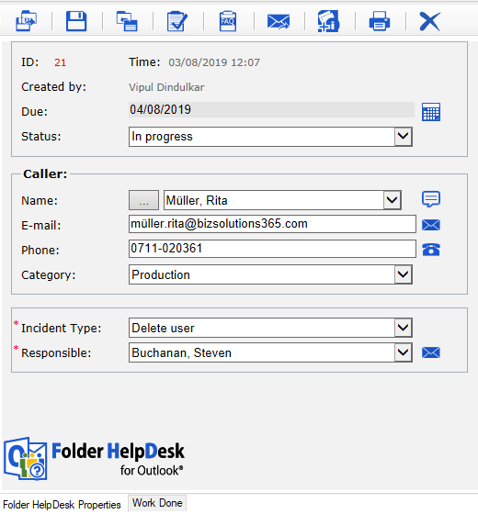
In the HTML Form you can set different ticket properties. You may add your own fields to the HTML Form, refer to Customize the Ticket HTML Form.
To the right is the default form, which is shown when you select the ‘Folder HelpDesk Properties’ tab in the Tab strip at the bottom. When you convert an e-mail to a ticket some of these fields are filled out automatically with details from the e-mail.
Ticket ID, Creation Time and Created by are set automatically and cannot be changed. The Advanced: Ticket Form settings give a possibility to replace creation time with the time when the e-mail was received.
Caller Category, Status, Incident Type and Responsible are easily chosen from dropdown lists that are populated from lists in the Folder HelpDesk Settings. You can also select “New entry” and create a new entry that will be added to the database. In the Settings, Ticket Form, the administrator can select how these new entries should be handled: create new objects, ask or do nothing. Refer to Advanced: Ticket Form .
It is not possible to close a ticket if one of these values does not existing the database.
If a default Responsible is set for the caller, the name will be filled out automatically when the caller is selected. If no default Responsible is set, the Responsible person is selected manually from the dropdown list. Refer to the Settings, Caller tab.
For Due Date, click on the icon and pick the date.
The Caller Name may be picked from the Global Address List or Outlook Contacts, and it may also be chosen in the ticket dropdown. In that case the names come from the Callers list in the Folder HelpDesk Settings. Other known details about that caller are then filled out automatically. E-mail address and telephone number are visible below the Caller name, and more info can be found via the speech bubble to the right.
When a new caller is entered in the caller’s field, the information about this caller can be automatically saved to the database and show up in the Settings under the Caller tab, refer to Advanced: Ticket Form . In this case the selected Caller category will also be entered for this Caller.
E-mails to Caller and Responsible informing them of the ticket can be sent by clicking the e-mail symbol. Refer to E-mail notifications, E-mail notifications.
Manual e-mail to the caller and Manual e-mail to the responsible. These e-mails may also be sent automatically, refer to Templates.
When you have Skype or another desktop calling application installed, you can also make a telephone call to the Caller by pressing the telephone icon in the ticket form. Folder HelpDesk supports all calling applications that supports the callto tag.

The Tab Strip
In the Tab Strip at the bottom of the ticket, you can choose to display the Folder HelpDesk properties of the ticket form or the Work Done information.
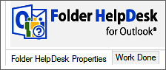
If you have selected to save e-mail history in subfolders there are also tabs for Sent and Received Emails, refer to Save e-mails in subfolders.
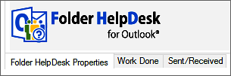

The Properties Tab
Under the Properties Tab you will find the information about the ticket, refer to The HTML Form above.

The Work Done Tab
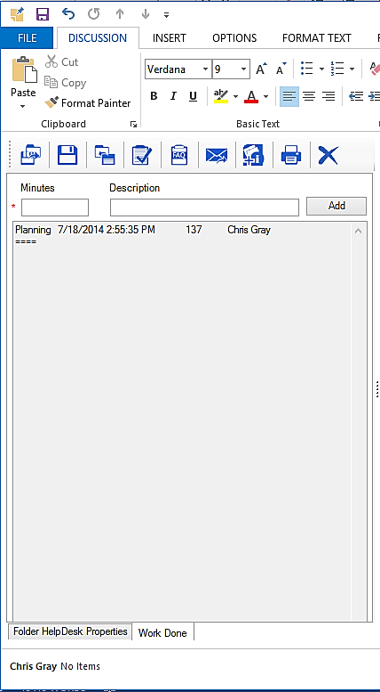
Under the Work Done Tab, enter a work description and a time and click the Add button to move it to the section below the fields.
Once the description is added to the grey field, the text cannot be changed, but there is a possibility to change the time by entering a negative value.
The Work information is especially useful if several people work with a case, or if you work with it on several occasions.
If Minutes worked is not filled out, the standard time stated by the administrator in the Settings is suggested automatically when the user clicks Close to close the case.

The Sent /Received Tab
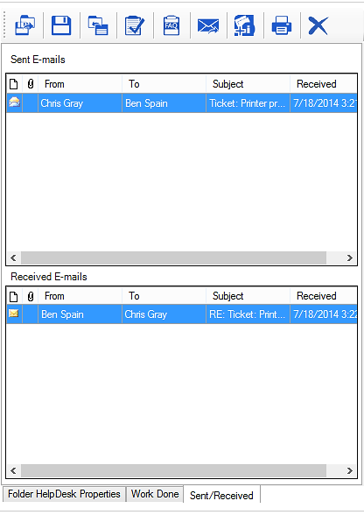
The Sent/Received Tab will be visible if the administrator has checked the option “Save e- mails in Subfolders”, refer to E-mail history. Here you can view all sent and received e-mails for the selected ticket.
Right click to Open, Copy or Delete a converted e-mail. You may also double-click to open the e-mail.

Ticket body
The body text of the e-mail is placed in the ticket’s body.
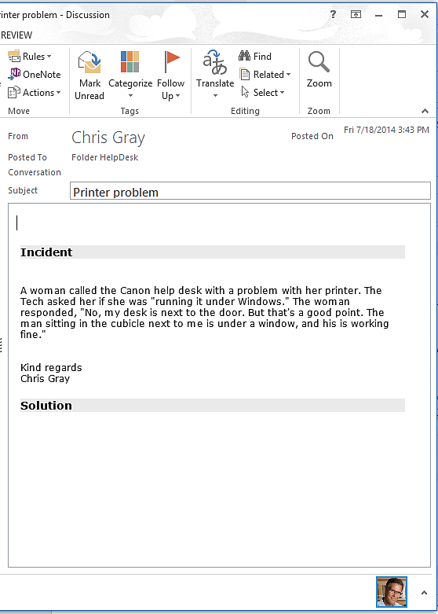

Open and close tickets
Folder HelpDesk tickets that concerns cases which are not finished yet are called open tickets. They are stored both in the database and in the Outlook folder.
Click the Close button in the ticket Toolbar strip when the support case is finished. The ticket will then be closed and removed from Outlook. The ticket is still saved in the database and may easily be accessed and reopened by Search closed tickets.
Also attachments are saved. When an SQL Server database is used with Folder HelpDesk the attachments will be saved directly in the database.
The Access database has a limited capacity, so organizations who use an Access database will instead have their closed ticket attachments stored in a separate subfolder in the Folder HelpDesk server folder, where Folder HelpDesk will fetch them when tickets are re-opened.
When the option " Save e-mails in subfolders" is selected for E-mail history, all sent and received e-mails will also be saved in the same way as the attachments.
If a caller replies to an e-mail sent from a ticket and that ticket has already been closed, Folder HelpDesk will automatically open the ticket again.
If the former ticket has been deleted from the database, a new ticket will be created from the new e-mail.
In the database table tblTickets, field blnClosed, the open tickets are marked “0” and the closed tickets “1” or “-1”.
In the Closed field of the statistics reports you can choose to see data from all tickets, or from only closed or only open tickets. False = not closed (= Open). True = Closed.

Support Staff Workflow
There are basically three scenarios for helpdesk personnel: they receive their cases by telephone, by e-mail or via a web form. E-mails and messages from the web form can be converted into tickets manually or automatically.

Telephone call
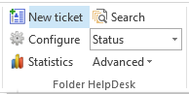
When answering the phone, the support person opens a new ticket by clicking the New ticket button in the Folder HelpDesk ribbon group.
The Caller can be added in three different ways. When a person is picked from one of the registers, point 1 or 2, the form is filled out with the person’s name, e-mail address, telephone number, caller category.
More info can be reached via the speech bubble to the right in the caller entry, if applicable.
These are the three methods to add a caller:
- Picked from the Global Address List or from Outlook Contacts. Use the button to the left of the Name field for this option.
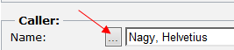

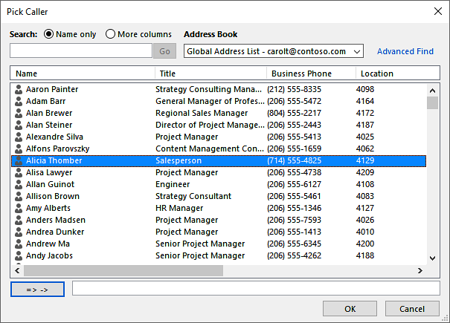

- The Caller may also be picked from a dropdown list of names, which are beforehand specified under the Caller tab in the Folder HelpDesk Settings.
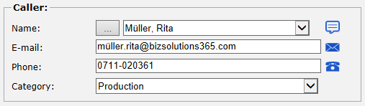

- When the Caller is a new person, you have to write in the details.

If the checkbox for Auto-add new caller is checked in the Folder HelpDesk Settings, this caller’s name and e-mail address will be saved to the database automatically and will thus show up in the Settings under the Caller tab. The next time this caller can be picked according to method 2. For more info about Auto-add Refer to Advanced: Ticket Form .

In the ticket body the creator of the ticket writes a description of the Incident reported by telephone. The body also has room for a description of the Solution to the problem, which is normally written by the Responsible person.
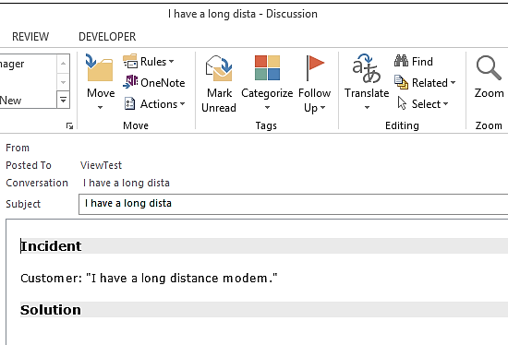

Caller e-mails
An automatic e-mail about the ticket creation can be sent to the caller, refer to Automatic e-mails and E-mail to caller when ticket is created.
If an e-mail with the solution or a request for more information should be sent to the caller, just click the e-mail symbol to the right of the e-mail field and the e-mail is created.
You may also make a telephone call with any desktop calling application. Note that these icons are only shown if an e-mail address / a telephone number or a calling application name is filled out in the field.

Save and Close
If you don’t want to work with the ticket right now but still want to keep it open and at hand in Outlook, click the Save and Close window button.
.
When you Save the ticket it will be saved as an open ticket but the window will not be closed.
Do not click the Close button until the case is finished. When you click Close, the ticket will be removed from Outlook and only saved in the database, but it may be opened via the Search Closed tickets feature, refer to Search and reopen closed tickets.

E-mail, manual conversion
You can convert e-mails to tickets manually with the conversion button that was added to the Outlook toolbar/ribbon when you installed the Folder HelpDesk ClientTool.
One of the dialogs below is shown when the e-mail has been converted. If you check the box for ‘Remember this option next time’, Folder HelpDesk will remember if you clicked on Yes or No to open the ticket and the dialog will not be shown next time. If you want to change the option, click the Configure button in the Outlook ribbon to open the Folder HelpDesk settings and then go to the Advanced: Ticket Form tab.
New ticket:
Existing ticket, refer to Add to existing ticket:
When the e-mail has been converted it is marked with a flag. The e-mail can only be converted again if that flag is removed.
If a mistake has been made, clear the flag (right click and select Clear Flag) and restart Outlook to be able to convert the e-mail again. Note that the first ticket will still be in the ticket list, so if it was a mistake you have to remove it from there also using one of the Folder HelpDesk delete buttons, refer to Delete tickets.

Convert into a new ticket
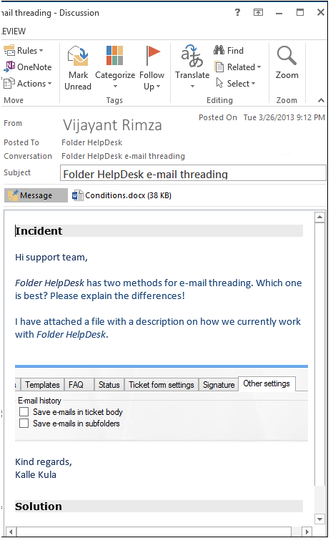If you select to create a new ticket from the e-mail, the title of the e-mail is set as the Subject, the sender of the e-mail is entered as Caller and the E-mail address is also always known.
Further information about the sender is filled out if preset in the Settings, or if information about the sender is available in the Global Address list or in Outlook Contacts.
When the Settings checkbox for Auto-add new caller is checked, and an e-mail from a caller who is not represented in the Settings Caller list is converted to a ticket, this caller’s name and e-mail address is automatically saved to the database and will thus show up in the Settings under the Caller tab. Additional information about the caller might be added there, and next time this caller sends an e-mail that info will be shown.
The body of the e-mail, which describes the problem, event, issue or similar, is added under Incident. The formatting and embedded images from the e-mail will be transferred to the ticket.
The ticket body also has room for a description of the Solution to the problem, which is normally written by the Responsible person.

Attachments
E-mail attachments are transferred to the ticket and shown as in standard Outlook items.
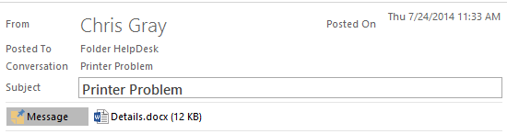
New attachments may be added to the ticket with the Outlook command Insert >Attach File.
When the ticket is posted, the e-mail will be tagged with information about ticket number and the time when the ticket was created. Click the Info button to show related e-mails. The ticket ID is used for the E-mail history feature.
The ticket info might be hidden. If it is, you will see this text instead of the ticket info.

Add to existing ticket
Addition of an e-mail to an existing ticket is only possible if one or both alternatives for E-mail history is enabled under Advanced: Other Settings.
The ticket may be found by filtering or defining ticket ID. You can also just click the “Only Caller tickets” button to see all tickets from the Caller, like in the screenshot below. The caller must be included in the Folder HelpDesk Settings Caller list for this to work.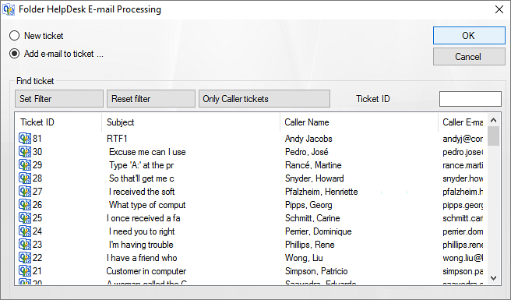

Caller e-mails
An automatic e-mail about the ticket creation can be sent to the caller, refer to Automatic e-mails and E-mail to caller when ticket is created.
If an e-mail with the solution or a request for more information should be sent to the caller, just click the e-mail symbol to the right of the e-mail field and the e-mail will be created.

You may also make a telephone call with any desktop calling application. Note that these icons are only shown if an e-mail address / a telephone number or a calling application name is filled out in the field.

Automatic adding of replies
If you use manual conversion of e-mails into tickets, you must also add replies to the ticket manually. There is however a way to get Folder HelpDesk to automatically add the replies from a caller to a ticket with the same ID: (You must still have one or both alternatives for E-mail history enabled under the Advanced: Other Settings tab.)
- Create an Outlook folder for ticket replies.
- Add this folder under the ‘E-Mail Folders’ tab in the Folder HelpDesk settings.
- Create an Outlook Rule to copy all incoming e-mails with “{“ in the subject to the newly created subfolder under the Folder HelpDesk Outlook folder. These copies will now be added to the ticket that has the same ID as in the e-mail subject.

Web form, manual fetching
The tickets from the web form can be fetched manually, by pressing the third last button in the right side panel of the Folder HelpDesk homepage. Then it will be handled as a ticket converted from an e-mail.  For information about automatic fetching, refer to Web form path and Enable Automatic Tracking. | 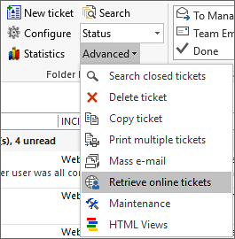

Work with tickets

Search tickets
Folder HelpDesk has two Search functions.

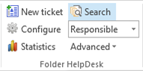
Search open tickets
Search among open tickets in the Outlook folder with the Search button.
Write the search term or number in the search field and click on Search. All text is searched.
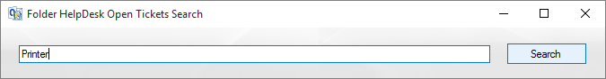
Click on one of the hits to open the ticket.
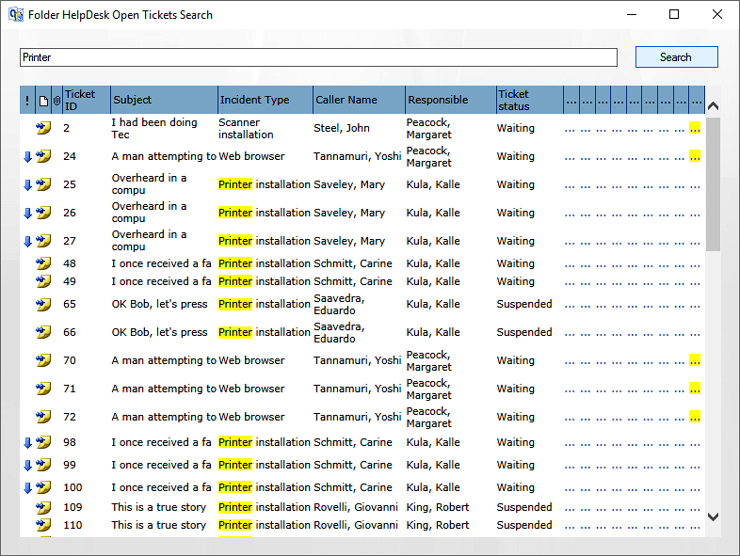

Search and reopen closed tickets
Closed tickets are only removed from Outlook, not from the database. Therefore you can search and reopen the closed tickets. Search among the closed tickets in the database with the Search closed tickets button. This button opens a search form.  You can search by Incident Type, Responsible, Ticket ID and Free text. | 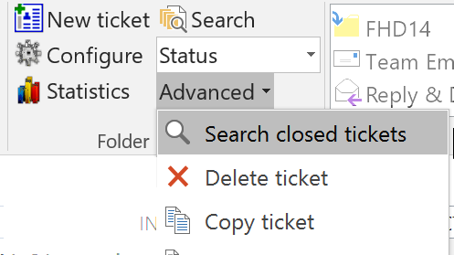
By default the ticket body text is not included in the search of closed tickets. Check the Include body box if you want to include it.
By default the hits are shown in groups of 50, but you can change that figure to anything between 1 and 999.
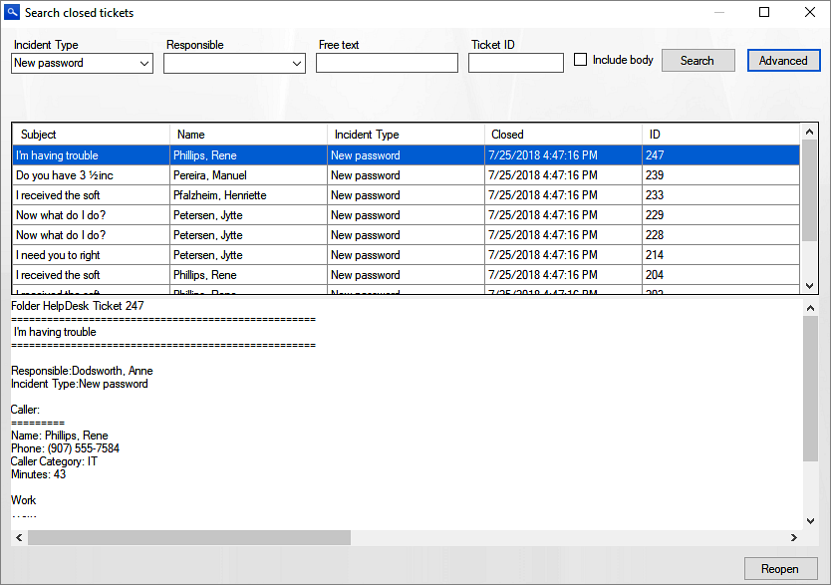
If you click the Advanced button you are shown a dialog with much more search alternatives.  To reopen a closed ticket, click on the Reopen button bottom right in the Search dialog.  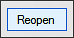  Then this ticket will be shown in the Outlook list again. | 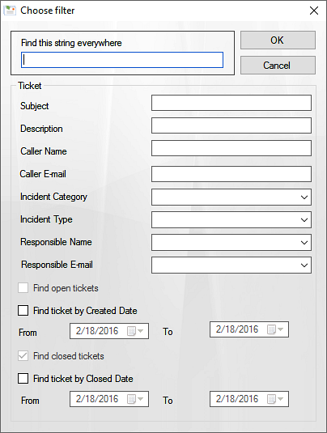

Task conversion
Tickets can be converted into Outlook Tasks. Just click the Task button in the ticket Toolbar Strip, and a Task will be created. Click Save and Close, and the Task will be saved among your other personal Outlook Tasks. This procedure does not change the ticket in any way.

Views
Folder HelpDesk has two kinds of views, the grouped views and the HTML views.

Grouped Views
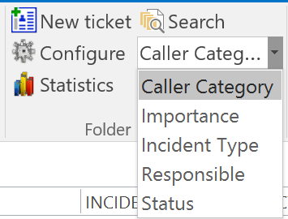
Folder HelpDesk makes it possible to see the open tickets in the ticket list grouped by different ticket parameters: Caller category, Importance, Incident type, Responsible and Status.
The Microsoft Outlook View alternatives can also be used in Folder HelpDesk, so you can very well create more views, refer to Customize or create new views.

Sort tickets within a view
Within the grouped Folder HelpDesk views, tickets can be sorted, for example after importance. This is useful when you have to change responsible person for tickets due to illness or other absence of personnel.
To do this, first choose the Responsible view to see which open tickets the absent person has.
Sort the tickets by clicking the Importance part of the Arrange by field.
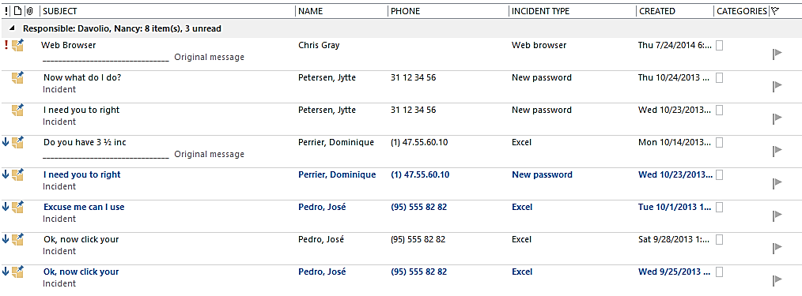
When this is done it is easy to see which of the cases are the most important. Select the tickets you want to move and drag and drop them to the new responsible person.
By clicking the appropriate field in the Arrange by field you may also sort tickets by Date, Subject or whatever you wish within the selected Folder HelpDesk view.

Customize or create new views
To customize the existing views or create new ones: Select Views >Change view >Manage Views
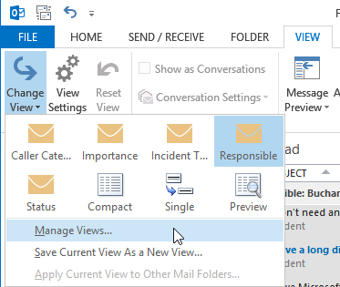
Make a copy of one of the existing views and modify it after your needs.
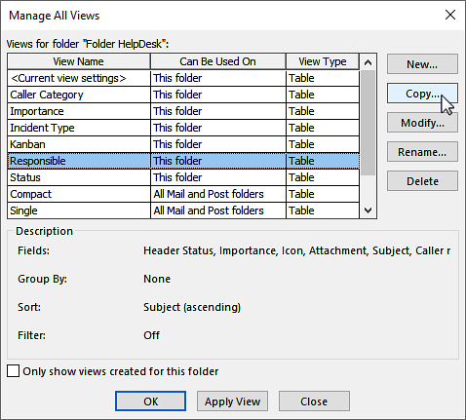

HTML Views
When you select the Folder HelpDesk HTML views in the Advanced dropdown, a new window will open. Here you can visualize open tickets in different HTML views.
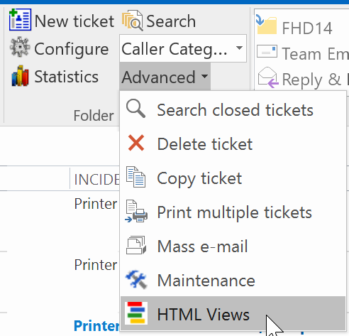

Kanban View
The Kanban View displays the 500 latest created open tickets as cards on a kanban board. The cards can be dragged and dropped between or within the status phases as work proceeds.
You may also use values of a custom field as lanes on the kanban board. In the settings, under the Advanced: HTML View tab, there is a checkbox for such lanes.
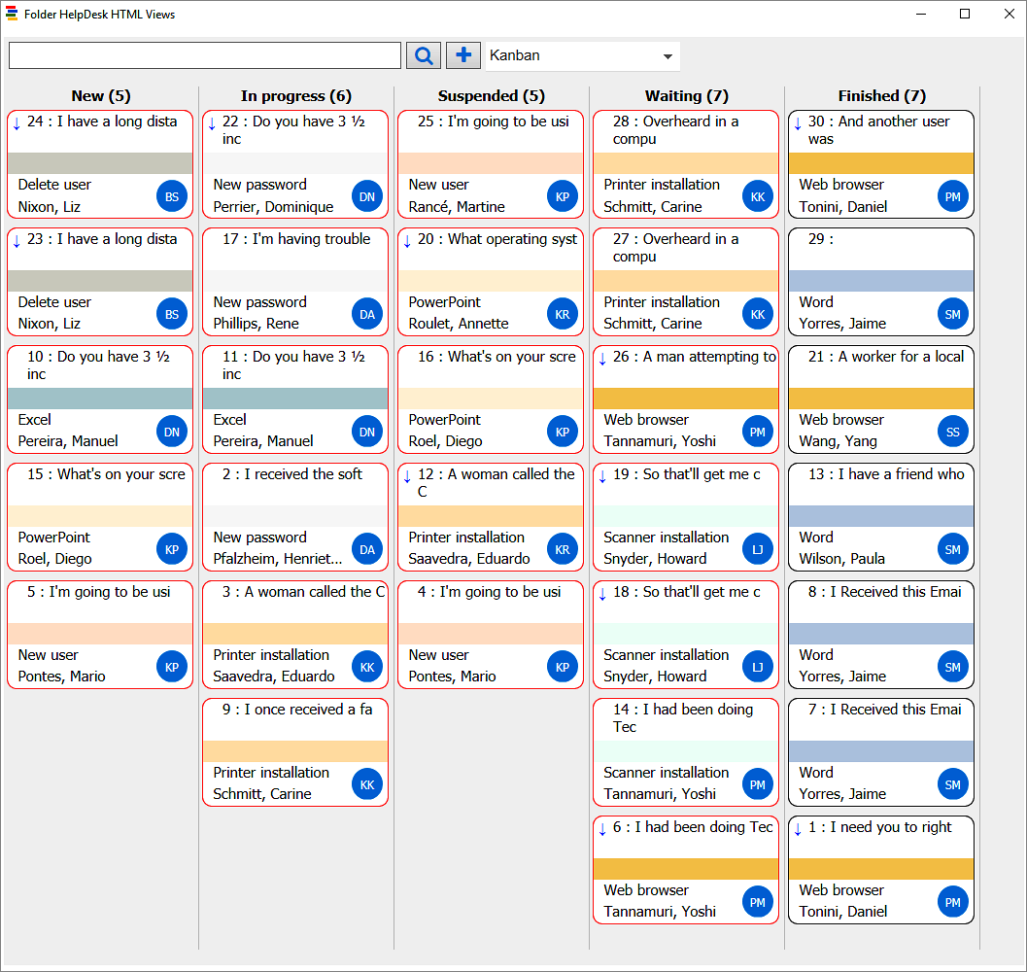
Each card is placed in a status phase, and it shows the ticket's caller, responsible, incident type and subject. It also shows the first lines of the body text.
When you right click on a card details pane will be shown on the right side of the screen. This pane displays more of the ticket body, so you don't have to open the ticket to get an overview of the content.
Double click on the kanban card to open the ticket.
The kanban cards are color coded by either incident type or responsible, and they can be filtered for caller, responsible, priority or incident type.
The kanban board can be zoomed in and out to show more tickets or more details, and there is an instant search of the text in ticket bodies and subjects.

Month view
The Month View shows the open tickets for the current month displayed over the time slots from start date until due date. The time slots are colored with the color for incident type or responsible, depending on which option is selected in the settings.
Click on the colored time slot to open a ticket. Drag and drop tickets to move them to other time slots.
Select another month by clicking on the arrows in the Month selector.
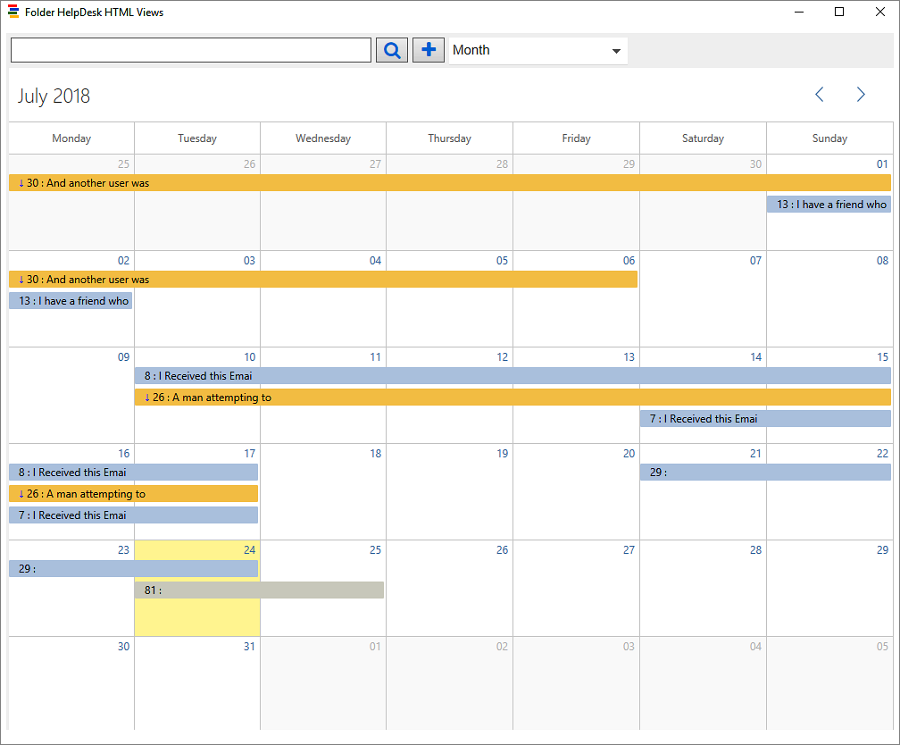

Year View
When you select the Year View, you will by default see open tickets from the current year. All days that have open tickets are highlighted in yellow. When you hover over a highlighted date, you will see the ticket subjects for all the open tickets that cover the date.
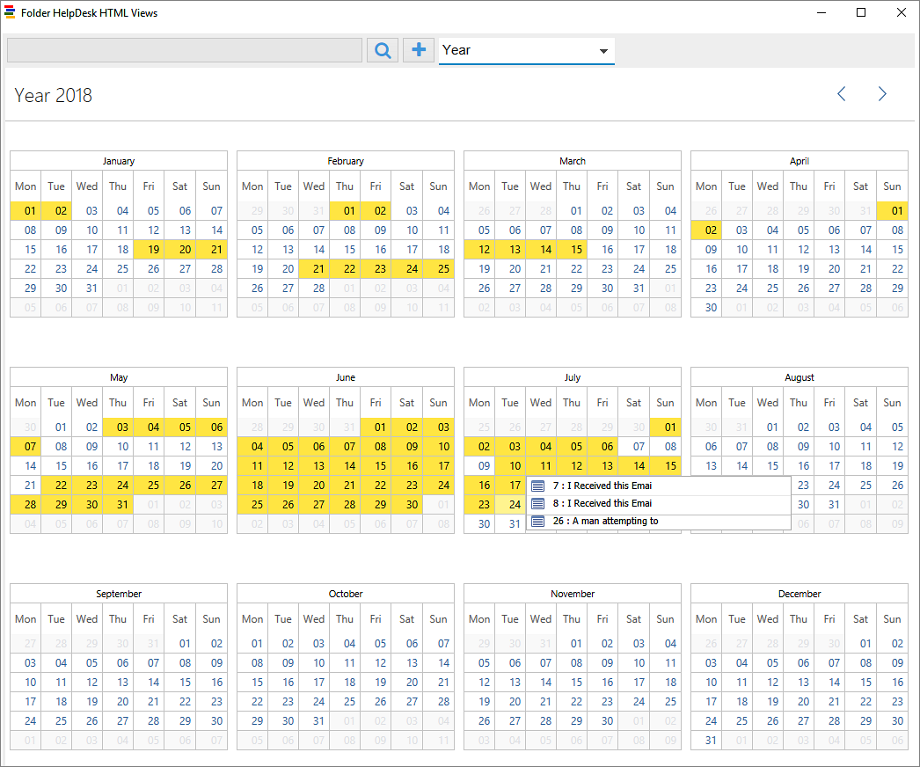

Timeline Responsibles
When you select the Timeline Responsibles view, you will see the tickets for one month grouped by responsibles. You can drag and drop the tickets to change responsible person.
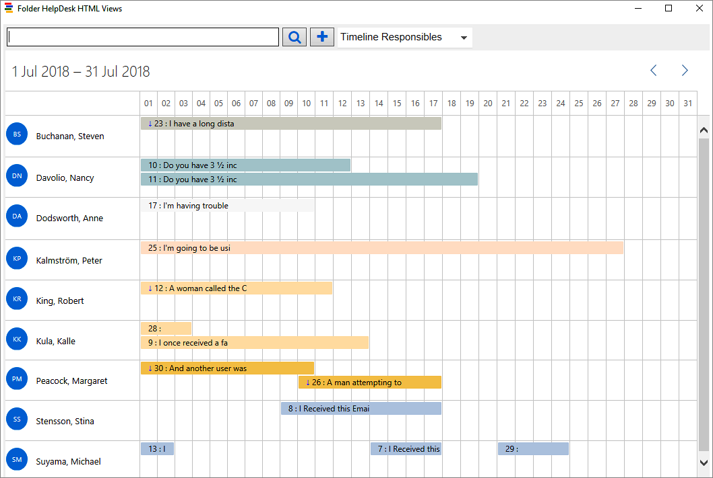

Timeline Incidents
When you select the Timeline Incidents view, you will see the tickets for one month grouped by incidents. You can drag and drop the tickets to change incident.
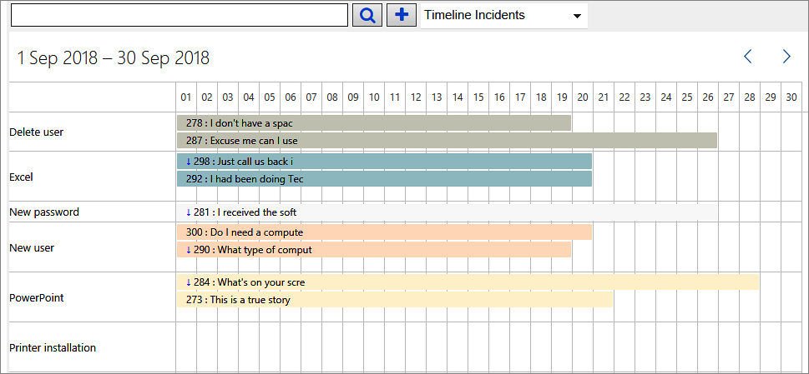

Timeline Callers
The Timeline Callers view, displays the tickets of the e-mails that were recieved in a specific month. These tickets are grouped by caller names.
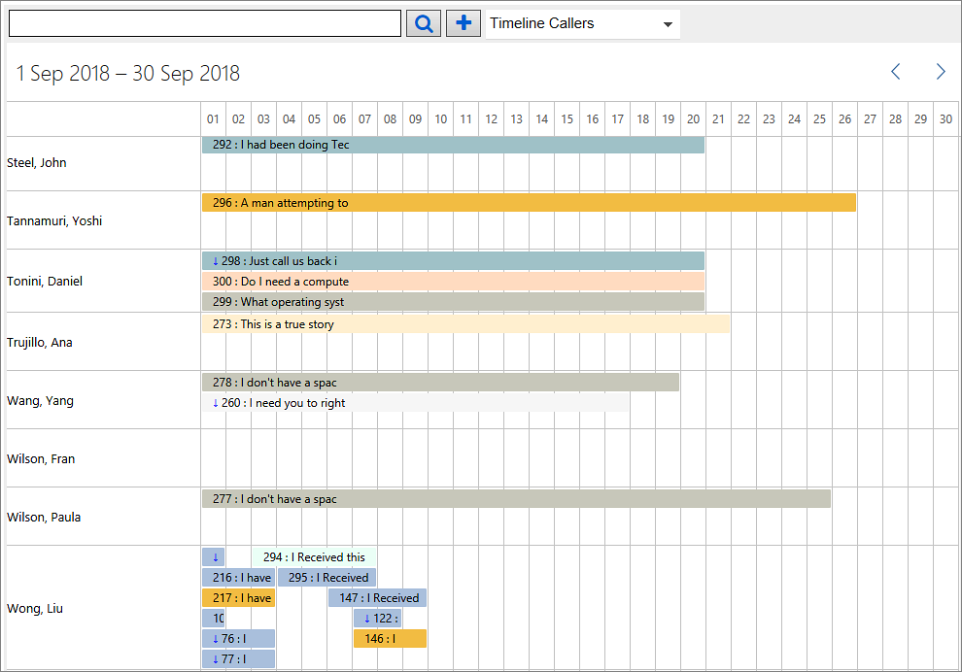

Incidents View
In the Incidents View each incident type is visualized as a pie chart where the tickets are grouped by their status. Each status value is displayed as a slice of the pie. The size of the slice is relative to the total number of tickets for that incident type.
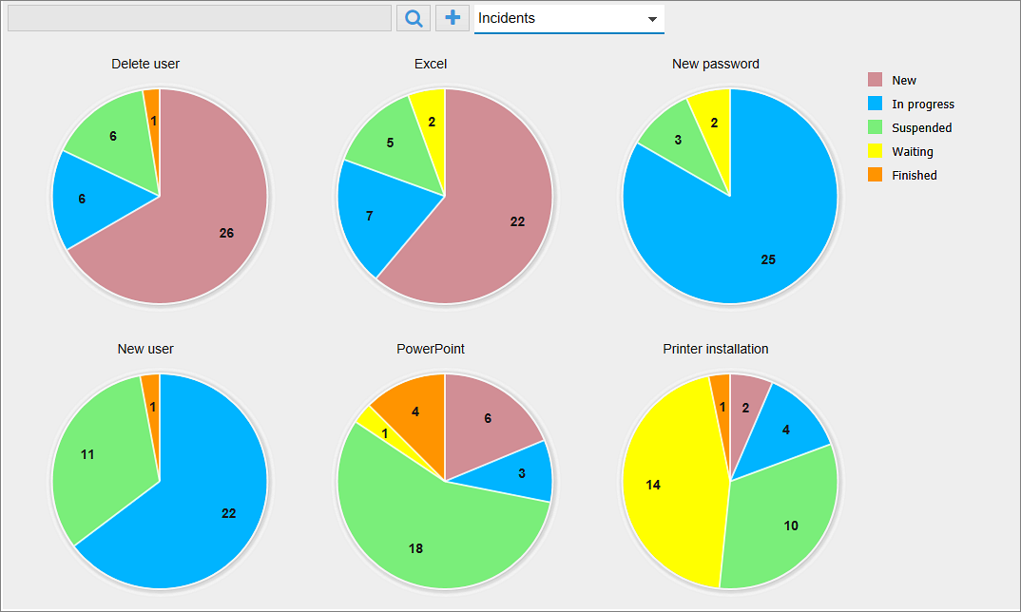
Each status value has a separate color, and you can easily change the default colors in the Folder HelpDesk Settings, Status tab.
The number of tickets in each status is indicated with a number. By hovering with the mouse over a pie slice you can see the status and the number of tickets

Reading pane
To apply a preview window to the ticket list, open the View tab and select the Reading Pane. In the image below the right side option is selected.
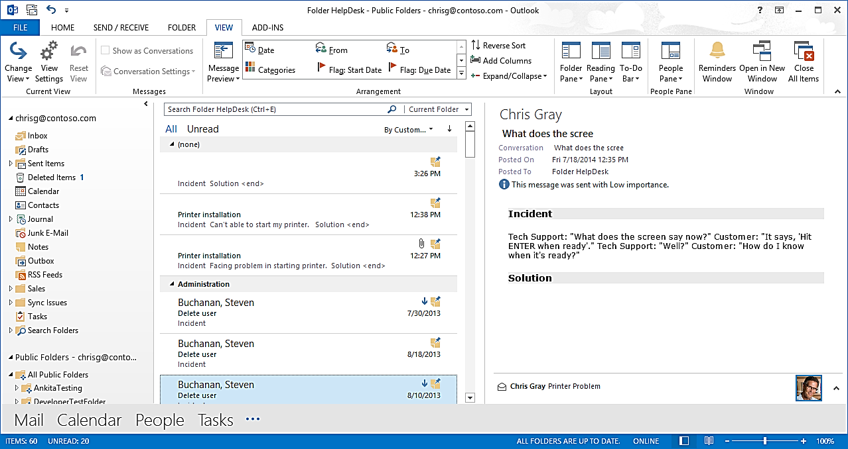

Delete tickets
A ticket can be deleted in two ways:  - To delete a ticket only from Outlook but not from the database, right click it and choose Delete. You may also click on the X button in the Outlook toolbar.  Since these tickets are still kept in the database, they may be seen in the Excel reports. There you can choose to see data from all tickets, or from only closed or only open tickets.  False = not closed (= Open). True = Closed.  Also refer to Excel Reports. | 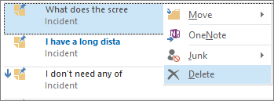  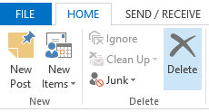
- To delete a ticket from the database too, use the Folder HelpDesk buttons. These buttons are:
The Delete ticket button under Advanced in the Folder HelpDesk ribbon group.
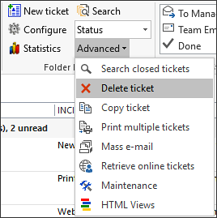

The X to the right in the ticket list.

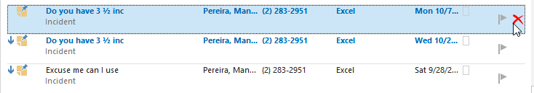

- From inside the ticket you can delete it from Outlook and from the database with the X button in the Toolbar strip.
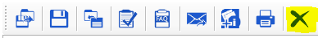

Note that tickets that are deleted from the database cannot be seen in the Excel reports.
If you want to remove tickets directly from the database (tblTickets), closed tickets have blnClosed = “-1” in an Access database and “1” in an SQL database. Use one of these queries:
Access:
Delete from tblTickets where strTicketID="[TicketID]"
Delete from tblTicketMsgs where intTicketID= [TicketID]
Delete from tblWork where intTicketID= [TicketID]
SQL:
Delete from tblTickets where strTicketID=’[TicketID]’
Delete from tblTicketMsgs where intTicketID= [TicketID]
Delete from tblWork where intTicketID= [TicketID]
Replace [TicketID] with the ID of the ticket you want to delete.

Print tickets
Tickets can be printed one or several at a time. If you have selected to save e-mail history in the ticket body, the ticket will be printed with all its history. Refer to E-mail history.
- For printing a single ticket, right click it and select Quick Print. The ticket will then be printed.  You may also press the Print button in the open ticket.  To print several tickets, click the Print Multiple Tickets button. You are then shown a dialog where you can search and select the tickets you want to print.  The tickets are sent to the default printer. In a future version of Folder HelpDesk we will give a possibility to select printer.  If you click the Advanced button in the Print multiple tickets dialog, more filter options will be displayed. | 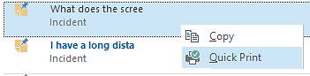  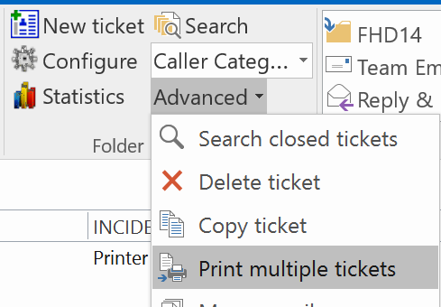
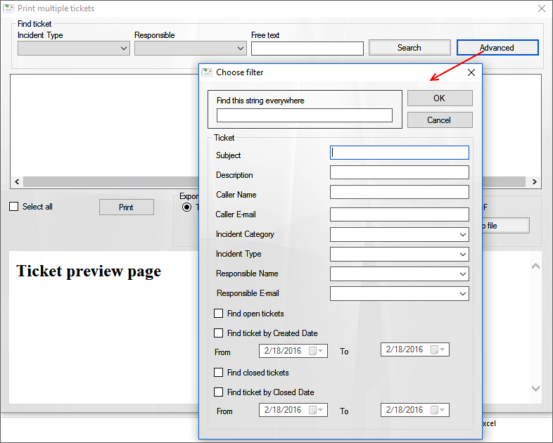
In the Print multiple tickets dialog you may also export tickets to a text, HTML, Word or PDF file.

Install Folder HelpDesk
Folder HelpDesk is a client-server application, designed to be easy to install and distribute, and a central installation and configuration takes care of almost everything. The Client Tool is installed on the client by the file FHDClientSetup.msi and runs as an Outlook add-in. The remaining functionality is supplied by executable files that do not have to be installed, but rather are run directly from the server when they are needed.
Our installer does the following:
- Extracts the files to a network path.
- Configures a new Outlook folder. Adds views and forms to that folder.
- Installs the Client Tool to the local machine by running the file FHDClientSetup.msi.
- Allows the user to create or select a database where tickets and settings will be stored.

Permissions for installation
Installation in a public folder must be done by a person who has Write permission over the shared network folder where Folder HelpDesk should be installed and Owner permission over the Folder HelpDesk folder in Outlook. That person only installs the Folder HelpDesk workgroup files in the shared network folder. To work with tickets the clients will need to install the Folder HelpDesk Client Tool. It is recommended that the user installing the client tool has local administrative rights.
For installation in a shared mailbox, Folder HelpDesk should be installed in the administrator account on the server and by the Owner of the Outlook mailbox.

Multiple installations
It is possible to install Folder HelpDesk in multiple public folders or mailboxes within an organization. You may have any number of Exchange servers, root file folders and databases, but you may not use one Folder HelpDesk shared file network folder for multiple Folder HelpDesk Outlook folders. Each Folder HelpDesk Outlook folder should have its own network file folder.
Note:
- When you have multiple Folder HelpDesk installations you cannot open two Folder HelpDesk Outlook folders in different windows at the same time. You have to first open one of them and then close it before you open the next folder.

- When you convert an e-mail manually, it will go to the folder (among the two Folder HelpDesk Outlook folders) which was last selected.

- The shortcut to Folder HelpDesk will work in the same way as the manual conversion, so it will take you to the installation you used last time.

Installation
The Administrator installs Folder HelpDesk by going through the following steps:

Create a Folder HelpDesk directory
Create a Folder HelpDesk directory in any shared file folder on your server and install the file you have downloaded (FolderHelpDeskSetup.exe) into it. You can use either a UNC-path, such as \\servername\sharename, or a mapped drive, such as Y:.
The server folder may also be created during the installation, refer to
Folder path.
In the .exe file all the installation files are wrapped, and when you run the installation it first unzips those files and then configures Outlook.
After the installation is finished, the Folder HelpDesk directory (the root file folder) will have content similar to that in the picture to the right, where the administrator has made the choices English version and Access database.
The .mbd file will only be there if you at the end of the installation choose to create an Access database. If you choose an SQL or SQL Azure Server there will be a Folder HelpDesk connection .txt file instead.
For a description of the Folder HelpDesk files, refer to Architecture: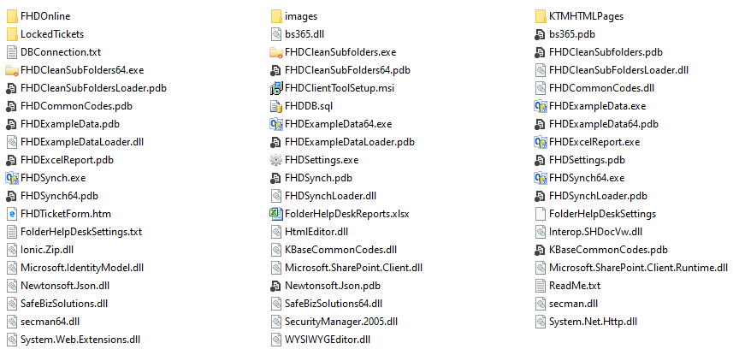

Installation process
The installation is done from a client machine, not directly on the server, so from a client go into the folder where you put the downloaded file, FolderHelpDeskSetup.exe, and run it to start the installation.
Close Outlook before you install Folder HelpDesk. 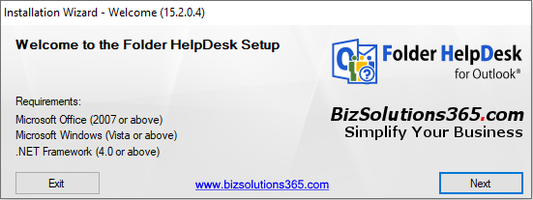

License agreement
Before you can start the installation you have to accept the end user license agreement.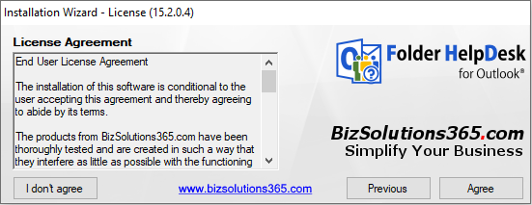

Installation type
The installer lets you choose between a new installation and an upgrade of an earlier Folder HelpDesk installation or repair of the current version. Below the new installation is described. For upgrade and repair, refer to Upgrade or Repair Folder HelpDesk.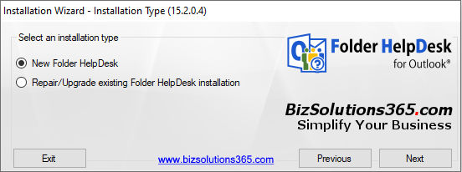

Folder path
When asked for a folder path, browse to or write in the path of, the server folder where you want to install the Folder HelpDesk files. The installer will suggest the folder where you have placed the Folder HelpDesk setup file. If you write the name of a non-existent folder the installer will create this folder automatically.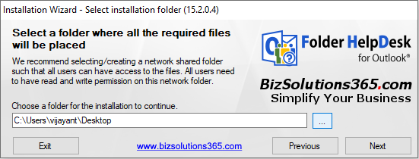

Select language
The next step is to select your language. A number of files, for example the report files, are customized for the different Folder HelpDesk languages, and each language has specific files.
The language selection also determines what language the Outlook form and the Outlook views will have. The language of the operating system is the default choice.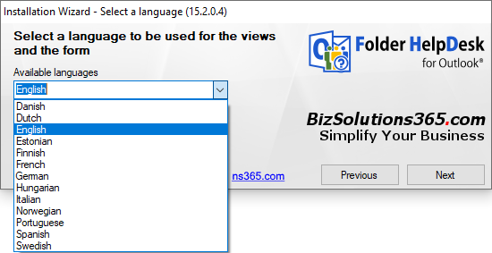

When you have selected language the installation can begin.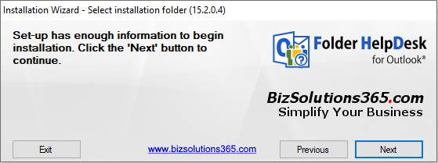

Click Next to start the installation.
Now the Folder HelpDesk Client Tool is also installed on this machine, refer to The Folder HelpDesk Client Tool.
Next step after the Client installation is the Outlook configuration. Select or create a Folder HelpDesk folder of the type Mail and Post Items in Outlook.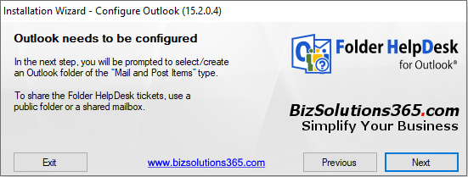

Click Next to create or select a Folder HelpDesk folder.
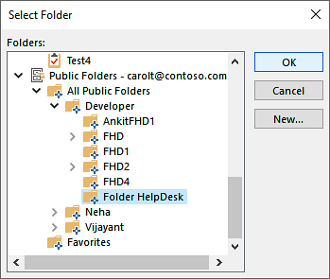
Now the central installation is complete. 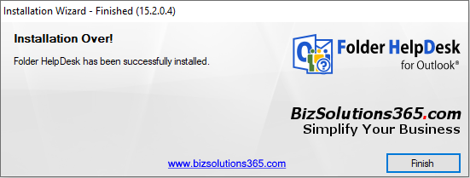

Click Finish. Then Open Outlook and open the new Folder HelpDesk folder to choose database and maybe create Example data. Refer to Select database and Example data.

The Folder HelpDesk Client Tool
During the central installation on the server the Folder HelpDesk Client Tool is installed on the machine that is used for the central installation.
Other users of Folder HelpDesk must install the Folder HelpDesk Client Tool manually the first time, by going into the Folder HelpDesk server folder and running the file FHDClientSetup.msi. This has to be done on each machine used for working with the tickets.
The .msi file may also be used for a central installation of the client tool via Active Directory.
(At upgrades each user will be prompted to upgrade the Client Tool when entering the Folder HelpDesk folder the first time after the central installation has been upgraded. When the user has answered Yes the upgrade of the Client Tool is automatic.)
The Client Tool installation is made with an InstallShield Wizard. 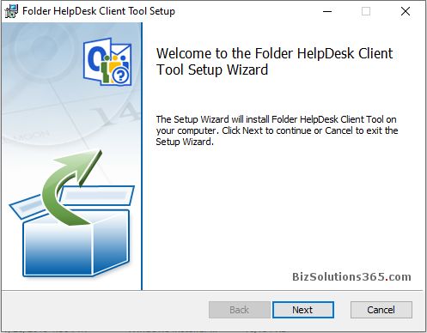

By default the Client Tool is installed in a bizsolutions365.com folder under Program Files.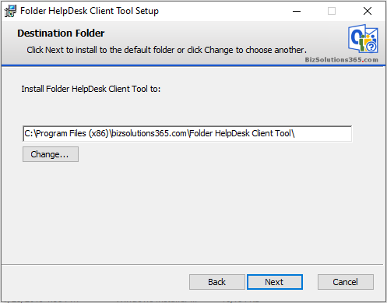

Now you just have to click “Install” and then “Next”.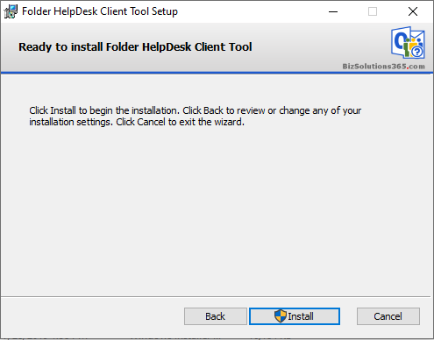

You will get a message when the installation is finished. Click “Close” and start Outlook.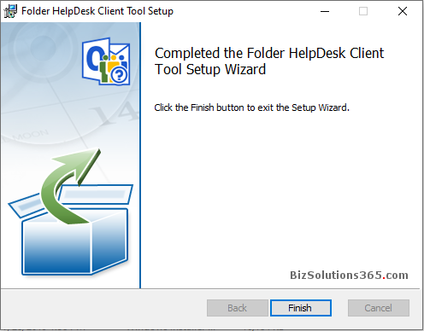

Select database
When you open the Folder HelpDesk folder in Outlook for the first time after the central installation is finished ‒ still on the machine you performed the installation from ‒ you will be asked to choose what kind of database should be used for Folder HelpDesk.
This only has to be done by the person who performs the installation. The other users will automatically be connected to the same database.
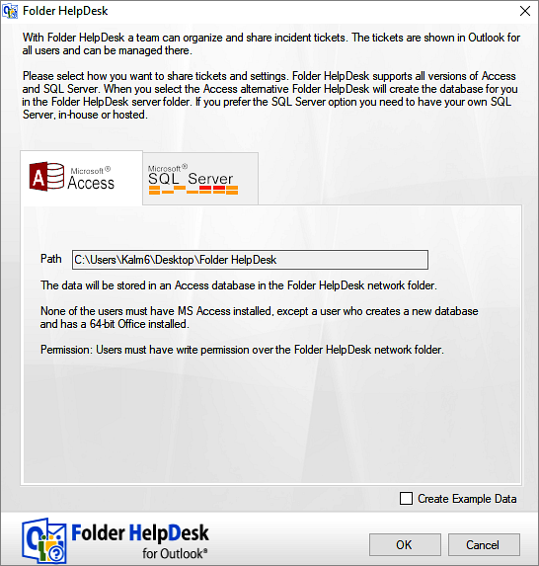

An ACCESS Database
If you prefer creating a new Microsoft Access database the installation program creates it in a couple of seconds. To create an MS Access database you do NOT need to have MS Access installed.
NOTE that the Access database is not a good option if the database goes big. For example, Access 2010, 2013 and 2016 supports only 2 GB and starts creating trouble after that. In that case we recommend an SQL Server database for better performance.

An SQL Server Database
To use the MS SQL option you need to have an MS SQL Server. When you choose to use a database on an SQL Server there will be a Folder HelpDesk connection .txt file in the server folder instead.
You can also use an existing SQL database that you created in advance from the file FHDDB.sql or FHDDB.sql.
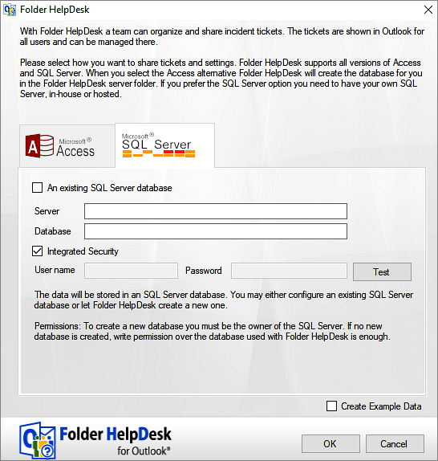

Example data
In the Select database dialog you are also given a possibility to load Example Data. If the software is new to you, it might be a good idea to load the example data. It gives you an opportunity to see how Folder HelpDesk works when you have much data in it, what performance you can expect and so on.
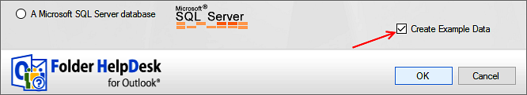
You may of course also choose to not load the example data. In that case you instead insert your own information from the beginning. If you would change your mind later you can always load Example data by clicking the file FHDExampleData.exe in the root file folder on the server.
When you load example data you may choose how many tickets should be open and how many should be closed. The tickets are first stored in both Outlook and the database. When a ticket is closed it is only stored in the database.
Decide the number of tickets you wish to be open and therefore stored in Outlook and in the database and how many should be regarded as closed and stored only in the database. If you wish, you may also change the Start Date.
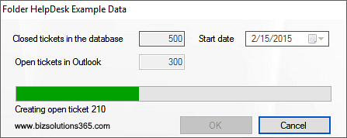
Folder HelpDesk randomizes the desired number of tickets from the starting date. Click OK, and those tickets will be created.
When the Example data are installed you can see the tickets in Outlook, and you can also check them by going into the database and by clicking the Statistics button (for more information about the statistics tool, refer to Excel Reports).
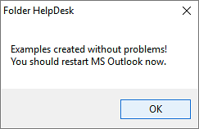

Remove Example Data
The easiest way to remove the Example Data is to first remove all open tickets in Outlook and then remove the whole database. You will be asked to select a new one next time you start Folder HelpDesk. This must be done by the administrator.
For Access, delete the file PFHelpDesk.mdb in the Folder HelpDesk network share. Then open the Folder HelpDesk folder in Outlook and you will be asked to choose a new database.
For SQL Server, remove the DBConnection.txt file from the Folder HelpDesk network share. Then open the Folder HelpDesk folder in Outlook and you will be asked to choose a new database. Choose SQL server again and use the same name as before. That will replace the old existing Folder HelpDesk database with the new one.
When you have added your own settings to the example data and want to keep your own settings but remove the example tickets, delete all tickets from Outlook and then delete all entries of the table tblTickets in the database.
If you already have created your own tickets that you want to keep, you have to remove the Example Data manually from Outlook and the database.

Permissions for users, public folder installation
You need to set the permissions of Folder HelpDesk in two places, in Outlook and in the root file folder. If you are using an SQL database you also need to set the appropriate permissions there.
In Outlook we recommend Publishing Editor permission for the helpdesk staff and None to all others (except the owner, of course).  You may also set the permission to Publishing Author, if you wish that each user should only be allowed to edit his/her own tickets. | 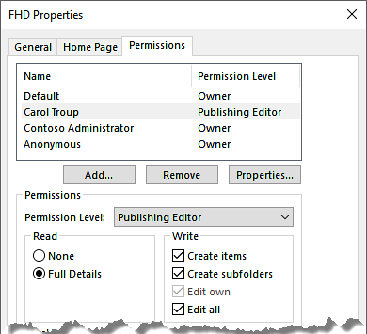
Scripting should be enabled in the root file folder, and the helpdesk staff must have permission to create subfolders and XML documents as well as to upload files. If the web form feature is not used, modifying rights is enough.
When you use an SQL Server, the staff needs to have dataReader and dataWriter permissions over the Folder HelpDesk database.

INSTALLING FOLDER HELPDESK IN A SHARED MAILBOX
The shared mailbox solution is usually suitable for a small team and is probably more resource intensive. It comes handy when you want to use a dedicated support e-mail address to convert incoming e-mails to tickets or send/receive e-mails from Folder HelpDesk (e.g. send on behalf of all your helpdesk staffs).
The shared mailbox must be added to each user’s Outlook. It may be placed under the Inbox or directly under the Outlook Data File.
(A public folder is already available as public within the organization, so it is more suitable for a large user base.)
The installation itself is made as described above. Install Folder HelpDesk in the administrator account on the server.
When you come to the installation step where you should select an Outlook folder, select the shared mailbox folder that you want to use as the Folder HelpDesk folder.

Permissions for users, shared mailbox installation
If you install Folder HelpDesk in your mailbox in Outlook and want other people to access it, you have to give them certain permissions over the Folder HelpDesk folder in your mailbox. We recommend Publishing Editor permission for the helpdesk staff and None to all others (except the owner, of course). You may also set the permission to Publishing Author, if you wish that each user should only be allowed to edit his/her own tickets.
To set permissions on the administrator account on the server, go into Active directory >Administrator account >Exchange advanced >Mailbox Rights >Add, and add the people who will be working with the helpdesk – this is easy if you already have created a group for them. Give them Full mailbox access and of course permission to Read and Change.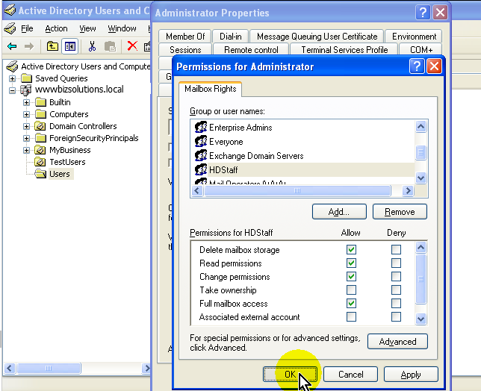

The Folder HelpDesk buttons
When Outlook is started again after the Client Tool installation, it has new Folder HelpDesk buttons in the ribbon. (If you use Outlook 2007 you will instead see a vertical toolbar to the right on the screen.)

When the Folder HelpDesk folder is not selected
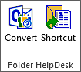
When another Outlook folder than the Folder HelpDesk folder is selected – for example the Inbox – the buttons in the image to the right are shown in the ribbon.
Use the Convert e-mail button when you want to convert an e-mail, an appointment or a task to a ticket manually. Select the item you wish to convert and press this button.
Use the Shortcut to Folder HelpDesk to open the application. You may also open it by selecting the Folder HelpDesk folder in Outlook.
NOTE: The shortcut button will not work if a user tries it before doing anything else with Folder HelpDesk, as no Folder HelpDesk Outlook folder has been mapped on that PC.
Therefore, when a new user has installed the Folder HelpDesk client tool and clicks on the Shortcut or Convert button, there will be a dialog prompting to pick Folder HelpDesk Outlook folder and then go to that folder.
If the user opens the Folder HelpDesk Outlook folder first, no message is needed as the folder will be mapped the first time it is opened.
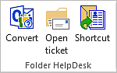
When you have started converting e-mails and then select an e-mail that is already converted, a third button, Open ticket, will be shown:
Use the Open ticket button if an e-mail has been converted into a ticket and you want to open the corresponding ticket. Select the e-mail and press this button. This button will only be shown when a converted e-mail is selected.
The Open ticket button also works with the e-mail notifications sent to admin specified users when a new ticket has been created (refer to E-mail notification when ticket is created) and with e-mails sent to the person responsible for the ticket (refer to Manual e-mail to the responsible and Automatic e-mail to Responsible on reply received).

When the Folder HelpDesk folder is selected
When you open the Folder HelpDesk folder the Folder HelpDesk group is shown in the ribbon.
This ribbon group shows that Folder HelpDesk is actually running, but you can of course also check this in the Task Manager (Press Ctrl + Alt + Del or right click the Task bar and look for the FHDSynch.exe process).
If you don’t see this toolbar, it probably means that the process is not running. Refresh the page or click out of and then into the Folder HelpDesk folder to trigger the file FHDSynch.exe to start running.

In Outlook 2007 there is instead a right hand panel. The buttons in the toolbar for Outlook 2007 are, from top to bottom:
- New ticket – Create a new ticket, refer to Telephone call.
- Settings ‒The Folder HelpDesk administrator settings, refer to Settings.
- Statistics ‒ This button opens the integrated statistics tool, OLAP Reporting Tool. Refer to Error! Reference source not found.
- Search open tickets ‒ Use this button to search among the open tickets, refer to Search and reopen closed tickets.
- Delete ‒ This button deletes a ticket from both Outlook and the database. Refer to Delete tickets.
- Create duplicate copy of ticket ‒ Use this button to copy a ticket.
- Print multiple tickets ‒ Use this button for printing several tickets. You are then shown a dialog where you can search and select the tickets you want to print. Also Refer to Print tickets.
- Mass E-mailing ‒ This button opens up a dialog where you can select callers within a category. By default all the callers in a category are selected, but you may of course uncheck some of them. When you click OK a blank e-mail is opened up, with all the selected e-mail addresses in the BCC field.
- Search closed tickets ‒ Use this button to search among the closed tickets, refer to Search and reopen closed tickets
- Maintenance of Folder HelpDesk. This button opens a dialog with two buttons for fixing ticket issues with one single click:
  - for closing tickets in the database which are set to ‘open’, but don't have a corresponding Outlook ticket.
  - for fixing tickets which are shown in read-only mode when opened, even though they are not already opened by another user.
You can also select view in the Outlook 2010 toolbar.
If the web form is used, a button for manually fetching tickets from the web form will be shown too, refer to Web form, manual fetching.

Settings
The Folder HelpDesk Settings are reached through the Configure button or through the file FHDSettings.exe in the root file folder.  In the Settings dialog, the administrator adapts Folder HelpDesk to the organization’s needs. All Settings data is saved in the database you have created for use with Folder HelpDesk. | 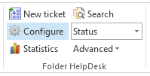
The Settings have default tabs and others which are reached by checking the Advanced box. The tabs described in 7.10‒7.12 below are reached by checking the box Advanced, bottom to the left.
All the Settings lists are ordinary Excel lists, so you can work with them just as you would in Excel.

Incidents
The Incidents tab systematizes the different kinds of incidents that are tracked in the helpdesk system. The incidents are sorted in Incident Types, which are selected in the tickets by the support staff.

You may assign colors for the incident types, to be used in the kanban and month views. If you have chosen to use colors with incident types under the Kanban tab in the settings, a color will be suggested when you enter a new incident type in the grid. You can change it to any color you like by clicking on the color cell.
You may also group the Incident types into Incident Categories, which are useful in the statistics Excel reports. To make work easier for the helpdesk staff, the Categories are not shown in the ticket form.
The values in the Minutes column indicate how many minutes it should take to solve each specific problem, or how many minutes it usually takes.
When a ticket is closed without any minutes worked being filled out under the Work done tab, the minutes defined here will be added to the ticket and shown in the statistics. This way standard minutes may be used for tasks that are performed often.

Responsibles
Under the Responsibles tab you can list the people working at the helpdesk, their e-mail addresses and their hourly rates. The currency will be the one already specified for your system.
In the statistics the rate is divided with 60, so you may easily see the cost for a ticket as the minutes for the tickets are multiplied with the divided rate.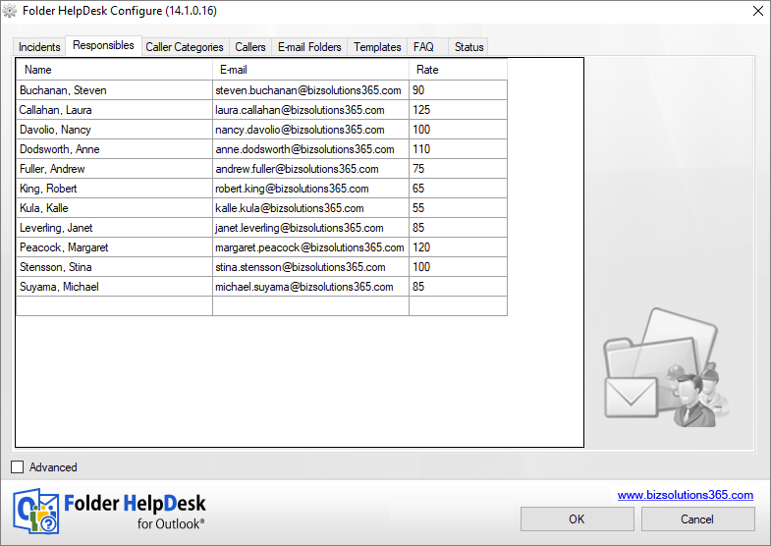

You may assign colors for the responsible persons, to be used in the kanban and month views. If you have chosen to use colors for responsibles under the Kanban tab in the settings, a color will be suggested when you enter a new responsible in the grid. You can change it to any color you like by clicking on the color.
For each caller the admin can set one default Responsible, whose name is automatically filled out in the ticket, refer to Caller below. If no default Responsible is set, the Responsible person is selected manually from the dropdown in the ticket.
It is possible to create and enter a group of several Responsibles. For example, you could create an entry like "Java team" or "Engineering department" etc. Enter the e-mail addresses with a “;” between, just like in an e-mail.
Both Incident Type and Responsible can also be added to the database directly from the ticket. Select New entry in one of these fields and write a nonexistent value.
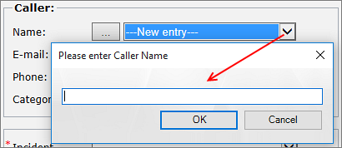

Caller categories
Under the tab Caller Categories the administrator can define different categories to describe the callers. These categories are then used in the ticket and in the statistics. These categories are also shown in dropdowns under the Caller tab, where a Category can be selected for each caller.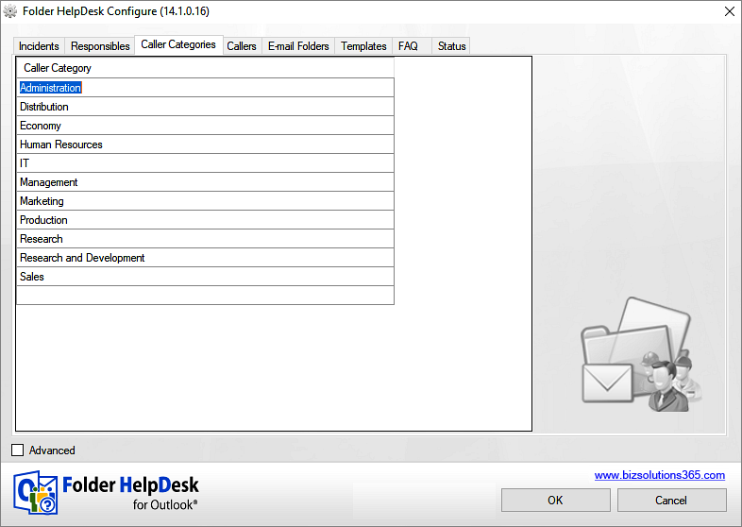

Callers
Information about the people who call or e-mail the helpdesk can be listed under the Callers tab. This is useful when it is known what people would contact the helpdesk but the information about those people is neither stored in the Global Address Book nor in an Outlook Contact folder.
If you want Folder HelpDesk to automatically add a new caller to the Callers list when a new ticket is created and he or she is not already entered there, check the option 'Auto-add new caller', under the tab Advanced: Ticket Form .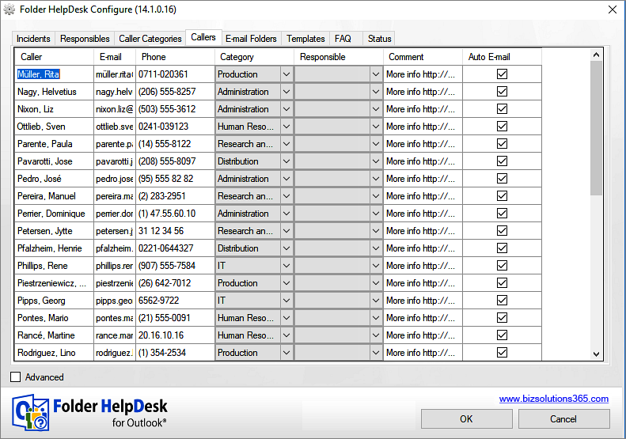

All the entered information is shown in the ticket once the name is selected from the drop down list.
The speech bubble shows where to find more info about the caller.

Default responsible
Under the Caller tab the admin can select one default Responsible for each caller. When an e-mail from that caller is converted, the name of the Responsible is then automatically filled out in the ticket.
(If no default Responsible is set, the Responsible person is selected manually from the dropdown in the ticket.)
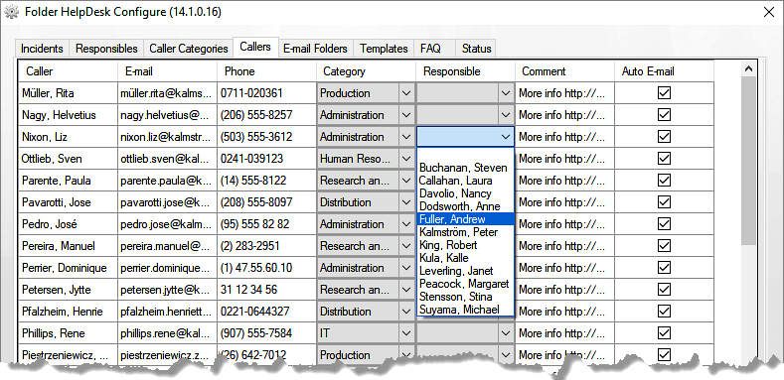
To edit, select a different person from the dropdown. If you want to remove a default Responsible and not select another one, select the option Empty, or remove the default Responsible in the database, tblCallers.

Exclude callers from automatic e-mails
You can choose which callers should have an automatic e-mail when a ticket is created from their e-mails. By default all callers are checked, so uncheck the people you don’t want to send notifications to.
(Note that you must check the box(es) for auto-emails under the Advanced: Other Settings tab for auto-emails to be sent out at all.)
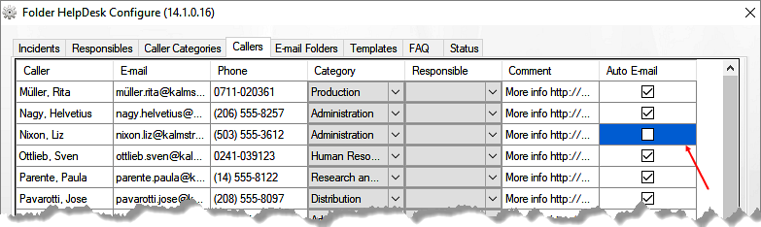

E-mail folders
When you create a special folder for incoming e-mail to the helpdesk, you need to use the tab E-mail Folders to set Folder HelpDesk to monitor this folder. Folder HelpDesk will then automatically pick up all incoming e-mails to that folder and convert them into tickets. Click the plus sign to add a folder.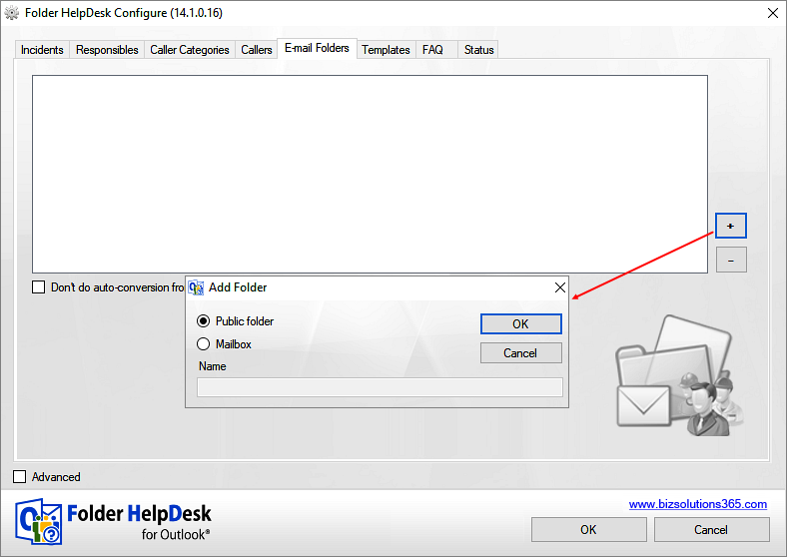

If you wish the folder to be a public folder, click OK and you are asked to select a folder.
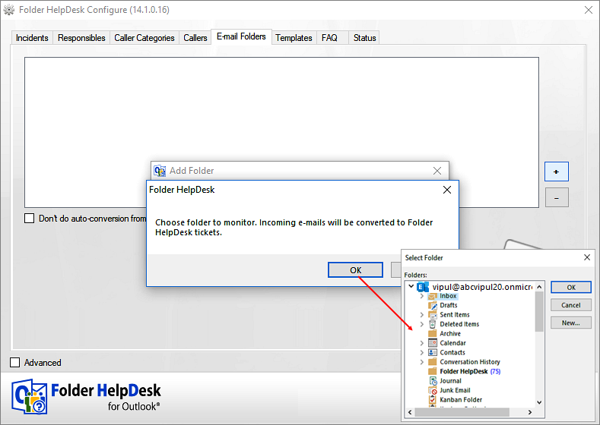
For a shared mailbox the name of the folder must be written in.
Click OK, and the folder will be monitored by Folder HelpDesk.
If you don’t want Folder HelpDesk to monitor the folder under a period, check the box “Do not do auto-conversion …”. Uncheck the box when you want the folder to be monitored again. Note that this box only affects the current user. For the rest of the Folder HelpDesk staff the folder will continue to be monitored, even if the box is checked by one user.
To permanently stop Folder HelpDesk from monitoring the folder, select the folder under the E-mail folders tab and click the minus button. The folder name will then be removed from this dialog.
When a folder is monitored for automatic conversion of e-mails into tickets and the option "Save e-mails in subfolders” is selected under the tab Advanced: Other Settings, a copy of the e-mail will be saved to the received folder of a converted ticket (manual or auto conversion).
To automatically notify callers when tickets are created from e-mails, check the box for this under the tab Advanced: Other Settings. You might also want to change the template for the e-mail under the Templates tab, see below.

Templates
Under this tab you may customize how text should be displayed for certain messages and for new and printed tickets.
Under the list of templates you can see what field info may be included in each of the templates selected from the list. Copy the placeholders you want to include in your template and place them where you want the info to appear in the text. Instead of the placeholder the applicable info will be shown in each e-mail or ticket.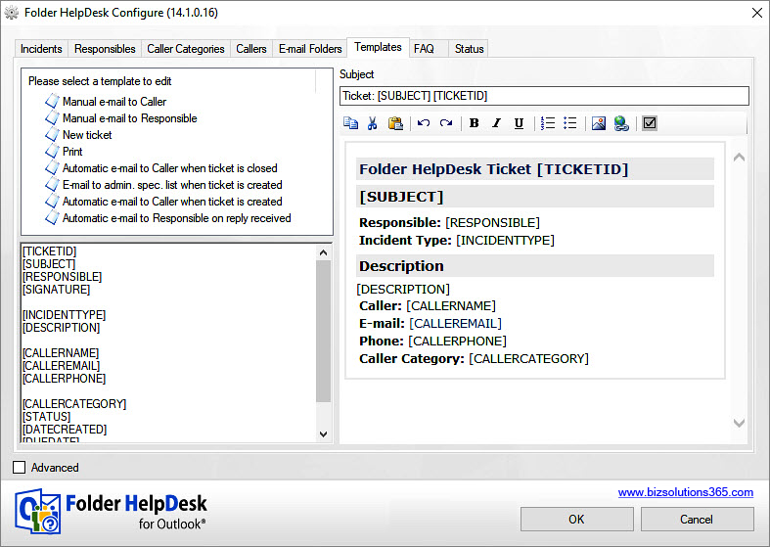

Create a signature for the [SIGNATURE] tag under Advanced: Signature tab.
To help those who are not used to working with HTML code to customize the templates we have added a mini HTML editor to this dialog. You can also copy and paste the code from any HTML editor. Select the template you wish to change and it is shown in the editor. Thanks to the editor you can see if the template looks as you want it.
If you want the default template back, just delete everything in the template, so that it is totally blank. Then click OK. Next time you enter the Settings the template will be filled with the default text again.
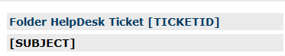
The templates whose top part look like in the image above will take the subject of the ticket (and of the caller e-mail) instead of the place holder [SUBJECT]. If you instead want to have a general subject for all e-mails of the same kind, you may write it instead of the place holder.
NOTE: The automatic e-mails are not sent out unless you check the appropriate boxes under the Other Settings tab, refer to E-mail notifications.

Manual e-mail to the caller
When a ticket is created, an e-mail to the caller can be sent manually by clicking the button to the right of the caller’s e-mail address in the ticket. When you click the button the e-mail is displayed. You may change it if you wish, and then you can send it manually. This template gives a common look to all manual caller e-mails sent from within the ticket.
The default template has a [SUBJECT] field, where the ticket subject will be added in the outgoing e-mail. If you instead want a general subject for all manual e-mails to callers, remove [SUBJECT] from the template and add your general subject here instead.

Manual e-mail to the responsible
The e-mail to the responsible person can be sent manually by clicking the button to the right of the responsible person’s e-mail address in the ticket.

New ticket
The New template gives the administrator of the Folder HelpDesk system a possibility to customize what the body of a new ticket should contain. The default ticket has the headings Incident and Solution, but if that does not suit you, you can modify the html.
NOTE that you should keep the tag [BODY] in the html. When an e-mail is converted into a ticket, the body of the e-mail will be inserted where the [BODY] tag is.

Print
The Print template has HTML code for the look of printed tickets.

Automatic e-mails
Under the tab Other Settings in the Folder HelpDesk Settings there are four checkboxes for automatic e-mails. The e-mail to the responsible person when a reply is received is checked by default, the others are not. Change the template if needed and then check the appropriate box to send out the e-mails – and uncheck it if you want to stop the sending.
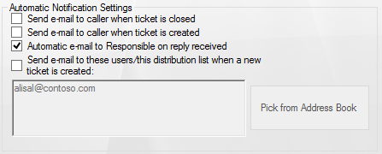

Automatic e-mail to Responsible on reply received
This e-mail is sent to the responsible helpdesk staff when an e-mail reply from the caller is added to a ticket, or when a new e-mail is added to a ticket. The responsible can then open the ticket by simply selecting the notification e-mail and press the Open Ticket button in the Outlook toolbar.
When a new e-mail reply is added to the ticket, the ticket will appear unread.

FAQ
The FAQ editor gives you a possibility to create standard answers. The selected FAQ is inserted in the e-mail you send manually to the caller.
We use the "Manual e-mail to the caller" template for this purpose, and the FAQ is added to the [DESCRIPTION] variable. Also refer to E-mail notifications.
Manual e-mail to the caller.
Click the FAQ Reply button in the ticket Toolbar Strip to include a FAQ in your answer to the caller.
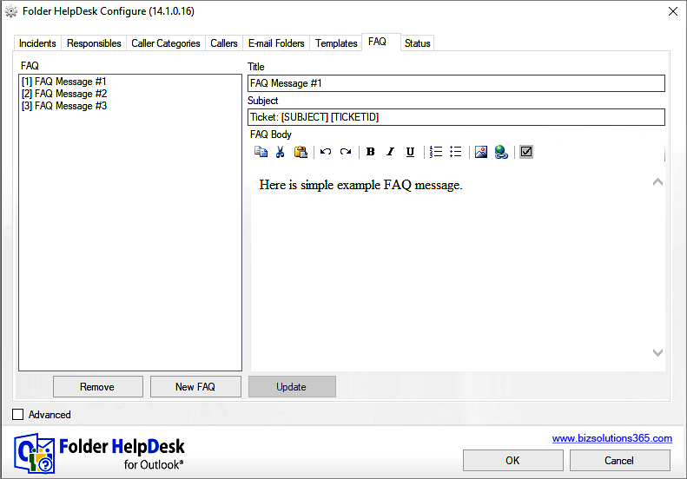

Three example messages have been included in the list to show what the editor can do. Replace them with your own messages and create more. This makes the work easier for the support staff and also ensures that messages that are sent often have the best possible content.
The subject of the FAQ may be either the subject of the ticket + the ticket id or a general subject for all FAQ answers. If you wish to use your own general answer, just remove the place holder(s) [SUBJECT] (and [TICKETID]) and write your own general subject.
Summary:
To create the FAQ:
- Go to the FAQ tab under Settings
- Click the button New FAQ
- Write a title for the FAQ
- Enter the text and images you wish to use in the HTML editor
- Click the button Add to DB
- Click OK
- (You can check in the database, in the tblTemplateMessages, that the new FAQ is really there)
To send the FAQ:
- Create a ticket with the new button or manual conversion - or open an automatically converted ticket.
- Click the FAQ answer button, to open the FAQ list dialog.
- Select the FAQ you want to add.
- Click insert.
- Now a new e-mail is opened automatically, with the FAQ inserted.
- Send the e-mail manually.
Here is an example of how it might look:
The FAQ in the editor might look like this: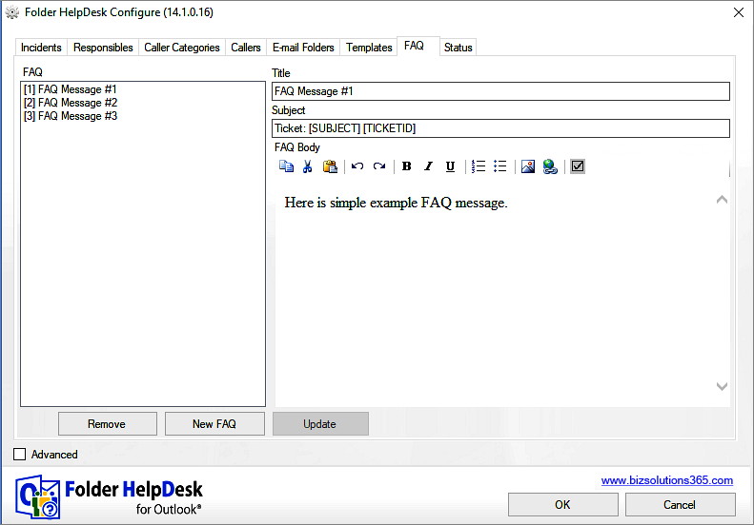

Here the FAQ button in the ticket has been clicked, and the list of standard answers has come up:
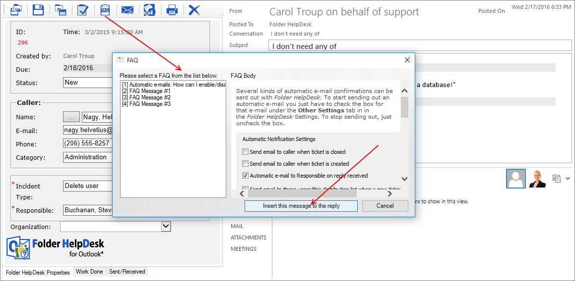
If the support worker selects to insert the FAQ reply, the e-mail to the caller will look like this.
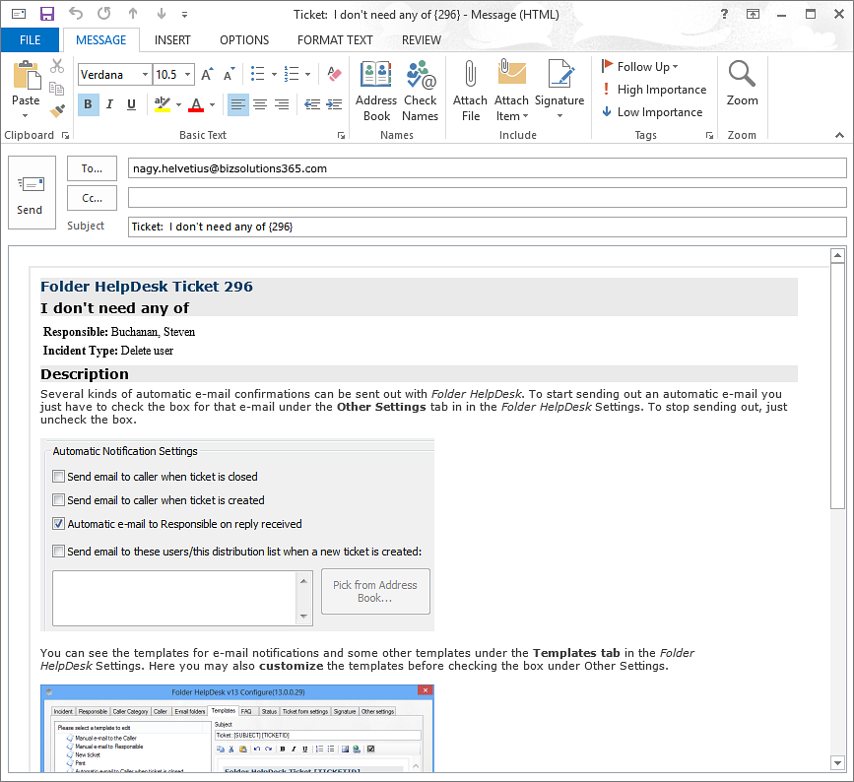

Status
Under the Status tab the administrator can define different status categories to be used in the tickets and in the statistics.
These status values are also used as phases in the kanban and project views, and in the project view they are color coded. When you write in a new value in the grid a color will be suggested, but you can change it to any color you like by clicking on the color cell.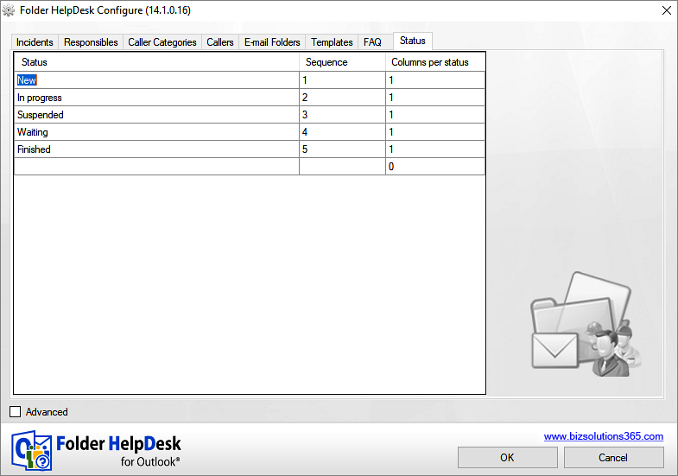

Columns per Status
If the installation has few status phases and you use big screens, you can set one or more status phases to have more than one column of tickets in the kanban view. This can be done for all status phases, and you can have 1 to 9 columns in a status phase. In the image below, “In Progress” has three columns for tickets in the kanban view.
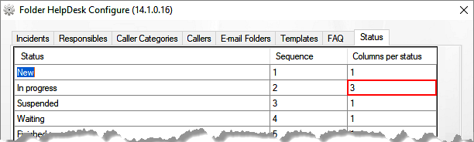
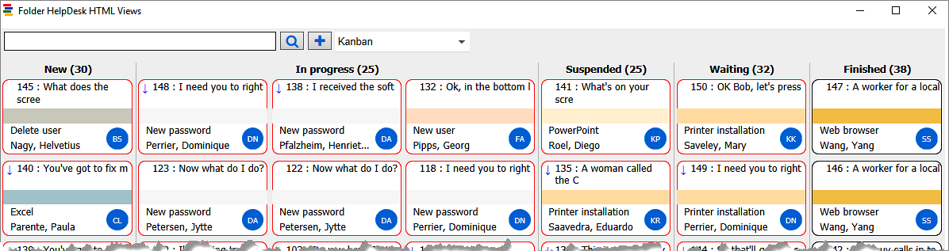

Advanced: Ticket Form 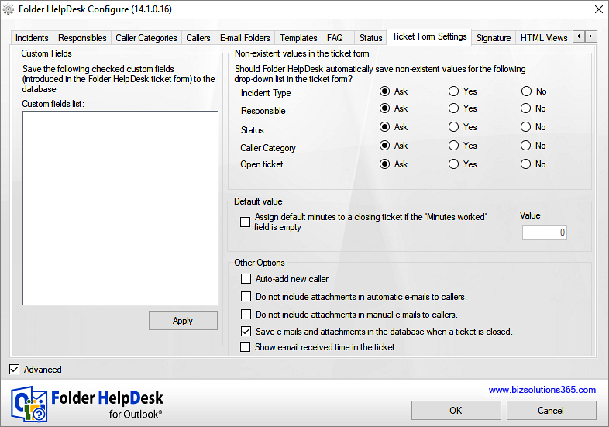

The ticket fields can be customized ‒ Refer to Customize the Ticket HTML Form‒ and the data in the customized fields can be saved to the database. When a ticket field has been added, or a customized field has been changed, it will be shown in the Custom fields list under the Ticket form settings tab. Select it and click Apply, and the data entered in this field will be treated like data entered in the default fields – saved to the database and possible to use in the Excel reports.
It is possible to enter values in the ticket fields that are not found in the Folder HelpDesk Settings. If such non-existent values have been added, you can define under this tab what should be done with them – should they be saved to the Folder HelpDesk Settings automatically, after a question or not at all? You can also select if a new ticket should be opened automatically or not. NOTE that these radio button settings only apply to the local computer.
Under the Ticket form settings tab, a default value for minutes worked can be set for all cases. This value is used if the Minutes worked are neither set by the Responsible under the ticket Work Done Tab when the ticket is closed nor set by the administrator under the Incident tab.
(If the checkbox is not checked and the minutes for the specified Incident are not set, the user will be required to add the number of minutes worked before it is possible to close the ticket.)
When the checkbox for Auto-add new caller is checked and an e-mail from a caller who is not included in the Caller list is converted into a ticket, this caller’s name and e-mail address will be automatically saved to the database. This works for both manual and automatic conversion.
The two check boxes for attachments give a possibility to decide what e-mails should include ticket attachments. One of them is for auto-emails and the other one applies to answers to callers sent from within the Folder HelpDesk tickets. This way attachments may be included in the e-mails to callers sent from the tickets but excluded from the automatic e-mails.
If you want the date and time when an e-mail was received to be shown on the ticket instead of the ticket creation time, check the box for Show e-mail received time in the ticket.

Advanced: Signature
Under the Signature tab a signature for e-mails sent from Folder HelpDesk can be created in a WYSIWYG .html editor. We recommend that you use this signature instead of the Outlook signature.
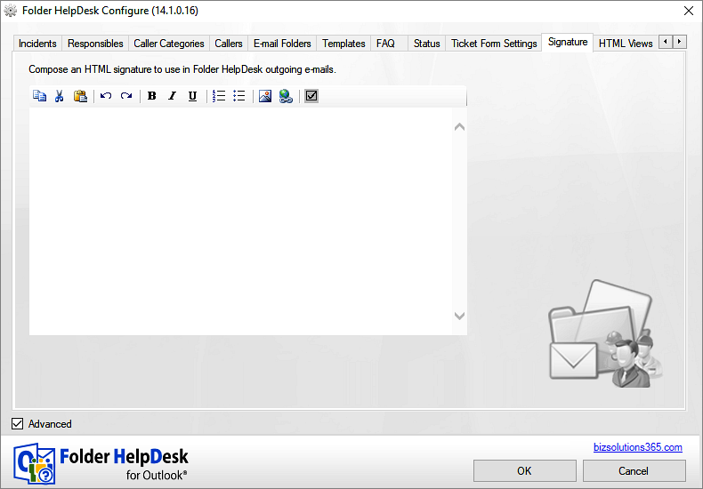
Add the [SIGNATURE] tag to those e-mail templates where you want to include the signature created here.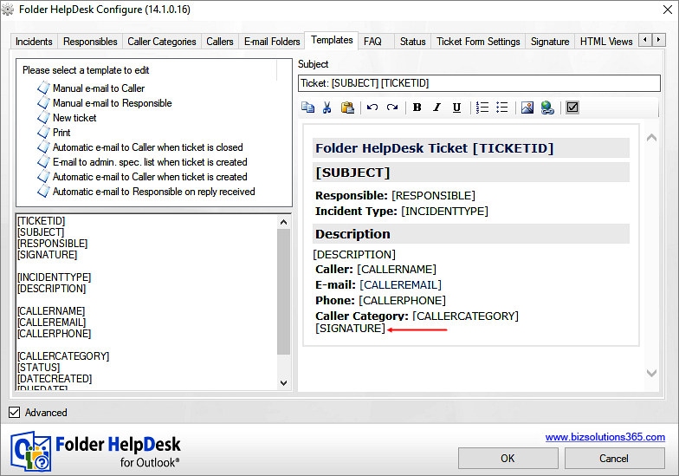

Advanced: HTML Views
Under the HTML Views tab you can decide if tickets in the kanban view should be color coded by Incident Type or Responsible. “Use colors for Incident Types” is the default choice, and when you use it you can select colors under the Incident tab. If you instead select to use colors for Responsibles, the color selection is shown under the Responsible tab.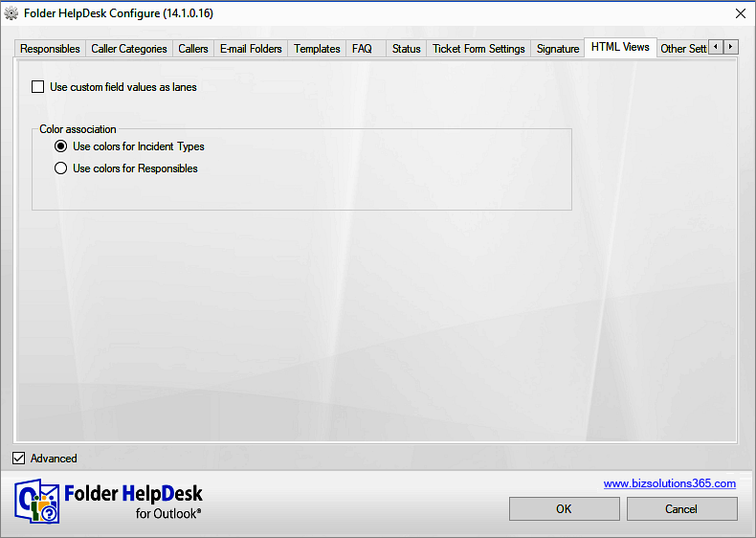

If you are using a custom field in the Folder HelpDesk ticket form, you can use the values in that field as lanes on the kanban board.
Note: Only the 500 latest created open tickets will be shown in the kanban view.

Advanced: Other Settings
The Other Settings tab has a number of functions: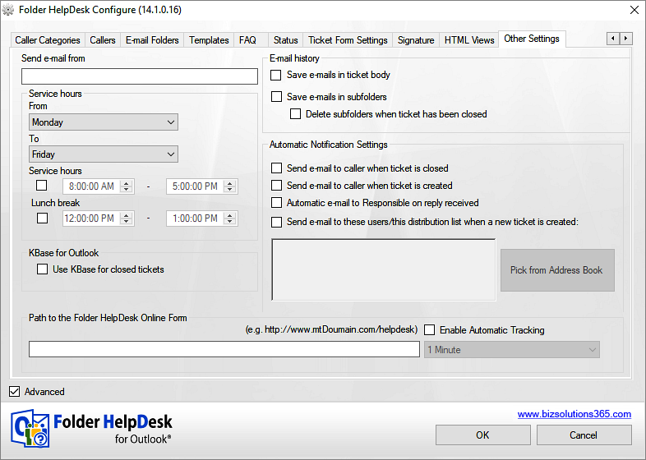

Send e-mail from
By default e-mails which are sent from inside a ticket to the Caller or Responsible are sent from the sender’s personal e-mail account.  If you specify an e-mail address for the e-mails sent from Folder HelpDesk, you will also need to configure Exchange to allow all staff that send messages from Folder HelpDesk to send e-mails from an email address other than their personal one. | 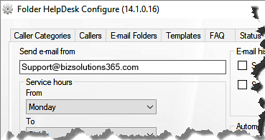

Service hours
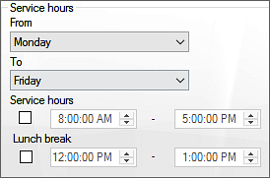
The information about service hours (e.g. the helpdesk’s opening hours) is needed for the statistics. When a ticket is closed Folder HelpDesk calculates how long time it was open, and if the opening hours are set, only time when the helpdesk staff was actually working will be included.
In the example to the right, a ticket opened at 4.50 PM on Friday afternoon and closed at 8.10 on Monday morning will only be counted as being open for 20 minutes – not as the whole weekend.

KBase checkbox
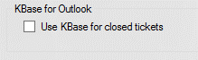
The checkbox for the knowledge base application, KBase, must be checked under Other Settings, if you want to convert tickets with interesting problems and solutions into KBase articles before they are closed. For more info, refer to KBase.

Web form path and Enable Automatic Tracking
Under the Other settings tab you should also set the path to the Folder HelpDesk web form if you are using it. When you check the box for automatic tracking, Folder HelpDesk will fetch tickets from the web form at the specified intervals. The default interval is every minute. Refer to Web form.

E-mail history
There are two ways of saving associated e-mails to a ticket, in the ticket body field or in subfolders. Either one of these or both features can be enabled. | 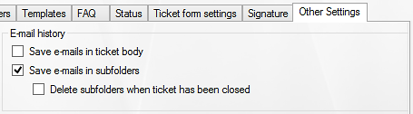
By default these boxes are disabled, and a new ticket is created each time an e-mail is converted. We however recommend you to use the e-mail history feature, as it gives you a much better overview of issues.

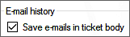
Save e-mails in ticket body
When the box “Save e-mails in ticket body” is checked, all e-mails concerning the same case are added to the ticket. Sent/Received emails will be integrated within the ticket body in chronological order.
Redundant chunks of the e-mails are removed through an intelligent algorithm, and only the required and latest replies are added to the body portion along with the HTML formatting and with a header portion that includes when the e-mail was received, from whom etc.
Attachments from each e-mail are attached to the ticket itself and each attachment name is embedded to the relevant part of the e-mail. An e-mail thread in a ticket could look like this: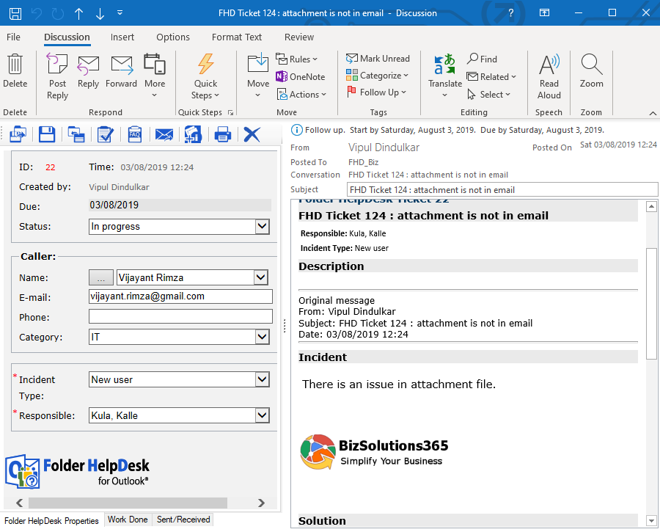

Save e-mails in subfolders
If you want to save connected e-mails in special Folder HelpDesk subfolders, check the box “Save e-mails in subfolders”.  Then subfolders with the ticket id number will be created automatically under the Folder HelpDesk folder in Outlook, and all the e-mails connected to the same ticket ID will be saved in Sent and Received subfolders under the ID folder.  When you use this method to track e-mails you will eventually have a lot of subfolders. To avoid this you can check the box for letting Folder HelpDesk delete the subfolders automatically once the ticket is closed. You can also remove subfolders for closed tickets by running the file PFHDCleanSubfolders.exe in the Folder HelpDesk directory on the server.  All sent and received e-mails and attachments will be saved to the database when tickets are closed, so you can always recover them by re-opening the ticket. | 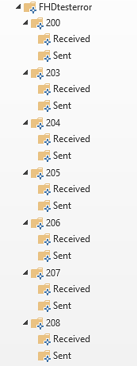
When the option Save e-mails in subfolders is checked, there will be a new tab in the ticket tab strip, Sent/Received, from where the e-mails may be opened. Refer to The Tab Strip.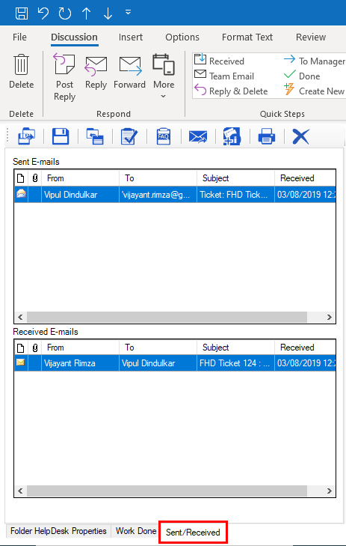

Change e-mail history method
If you have used the subfolder method for saving e-mail history and want to change into the ticket body method, you can get the content of the subfolders added to the earlier ticket bodies. This way you can delete the subfolders and still keep the content in them for future reference and statistics.
When you enable the option Save e-mails in ticket body, Folder HelpDesk will look for subfolders. If they are found, Folder HelpDesk will ask you if you want to add the e-mails in the subfolders into the corresponding tickets. All e-mails in the subfolders are marked with ticket ID of the first ticket, so when you answer Yes the e-mail bodies will be added to the bodies of the tickets with the same ticket ID.

E-mail notifications
Here you can decide which automatic messages should be sent from Folder HelpDesk. To customize these messages, go to the Templates tab in the Folder HelpDesk settings.
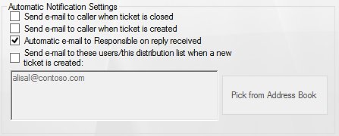

E-mail to caller when ticket is closed
When a ticket is closed, an e-mail can be sent to the caller automatically, confirming that the case is resolved. Enable this feature by checking the first box under Automatic Notification Settings. Callers may be excluded from these e-mails under the Caller tab.

E-mail to caller when ticket is created
When a ticket is created, an e-mail can be sent to the caller automatically, confirming that the case is received. Enable this feature by checking the second box under Automatic Notification Settings. Callers may be excluded from these e-mails under the Caller tab. | 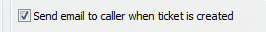

E-mail to Responsible on reply received
This box is checked by default, but it only works if at least one of the checkboxes ‘Save e-mails in subfolders’ or ‘Save e-mails in ticket body’ is enabled. Then an alert is automatically sent to the responsible staff when an e-mail reply from the caller is received to the helpdesk and automatically added to a ticket or when an e-mail is manually added to one of that responsible’s tickets.

E-mail notification when ticket is created
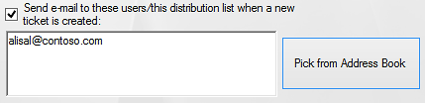
If you need an e-mail to be sent automatically to a person or distribution list each time a new ticket is created, check this box under Automatic Notification Settings and define the e mail addresses. You can also pick the addresses from the Address Book. When there are multiple e-mail addresses, each of them should be separated by a semicolon (;).

KBase
The knowledge base KBase is very helpful when used together with Folder HelpDesk. When you feel that a solution to a problem should be saved into the knowledge base, do this by clicking the KBase button before closing the ticket. The tickets in the KBase can be full text searched, and users can also add information in them, for example if they have a better solution to a problem. When the ticket has attached folders they are automatically saved into the KBase, but attachments may also be added later.
The application can be downloaded from https://bizsolutions365.com/our-products/kbase/kbase-try/. A license for KBase is included in the Folder HelpDesk Medium and Premium subscriptions.
KBase is installed in the same simple way as Folder HelpDesk. Just click the KBaseSetup.msi file and follow the instructions.
If you want to familiarize yourself with KBase, you can make use of the possibility of creating a few example data. This possibility is offered when the installation is over and you are asked to select sharing option.
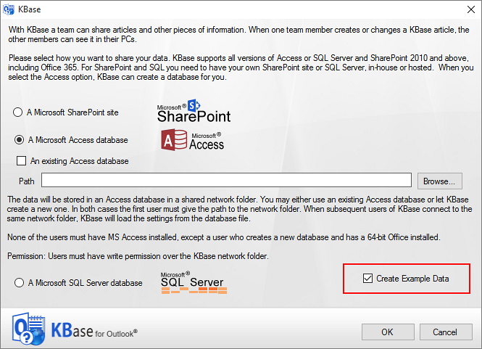
Remember to check the box for KBase in the Folder HelpDesk Settings, Other settings tab, if you want to use KBase. Refer to KBase checkbox.
The articles can be saved as web pages, see example at https://bizsolutions365.com/kbase-faq/ . For more information about KBase, refer to the KBase manual, downloadable from https://bizsolutions365.com/our-products/kbase/. At the KBase home page you will also find links to video demonstrations and a slideshow.

Upgrade or Repair Folder HelpDesk
For upgrade or repair of Folder HelpDesk, run the setup file and select the second option in the installer. Then the installer decides what action needs to be performed.
When the installed version of Folder HelpDesk is earlier than the setup version, the installation will be upgraded.
When the installed version of Folder HelpDesk is the same as the setup version, a repair of the installation will be performed.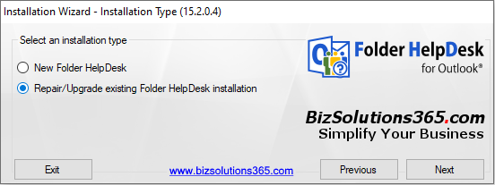

Permissions
The upgrade or repair must be performed by a person who has at least Write permission over the Folder HelpDesk server folder and is Owner of the public folder/shared mailbox.

Process
Make sure that no application of your existing Folder HelpDesk is running during the upgrade. Please follow these steps:
- Save the installation file FolderHelpDeskSetup.exe to your computer and then to the Folder HelpDesk root file folder on your server.
- From a client that has access to the Folder HelpDesk network folder, run the newly downloaded Setup file and accept the License Agreement.
- In the Installation Type dialog, select 'Upgrade/Repair existing Folder HelpDesk' and click Next.
- Specify the Outlook folder of your existing Folder HelpDesk installation.

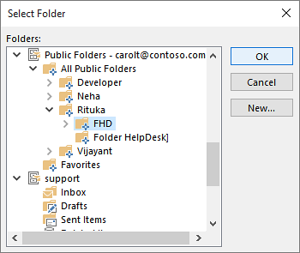
- You will get a message when the upgrade or repair is finished.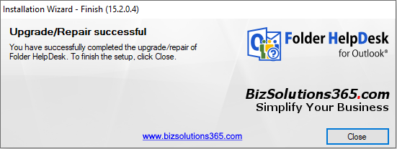

If you have multiple installations, repeat the process for each Outlook folder.

Upgrade of the Folder HelpDesk Client Tool
The Folder HelpDesk Client Tool is not changed so often, but if it has been changed since last update, it will be updated automatically on the installation machine. The other clients will be prompted to upgrade the first time Folder HelpDesk is started after the upgrade of the central installation. Answer Yes, and the upgrade is automatic.
If a client answers No by mistake or is not prompted to install the Client Tool, run the file FHDClientSetup.msi in the Folder HelpDesk root file folder to upgrade the Client Tool manually.

Excel Reports

Overview
The statistics of Folder HelpDesk is very useful for a manager who wants to analyze what kind of problems are reported, how problem solving time is distributed, what problems different staff has been working with, etc. The statistics are based on Excel, and all standard Excel features may be used.
Run the Excel reports tool by pressing the Statistics button in the Outlook ribbon.

Default Reports
The default sixteen reports are grouped by Time (year, quarter or month), Caller category, Incident category and Responsible. For each group the reports show average hours open, costs, total number of tickets and the time spent on tickets.
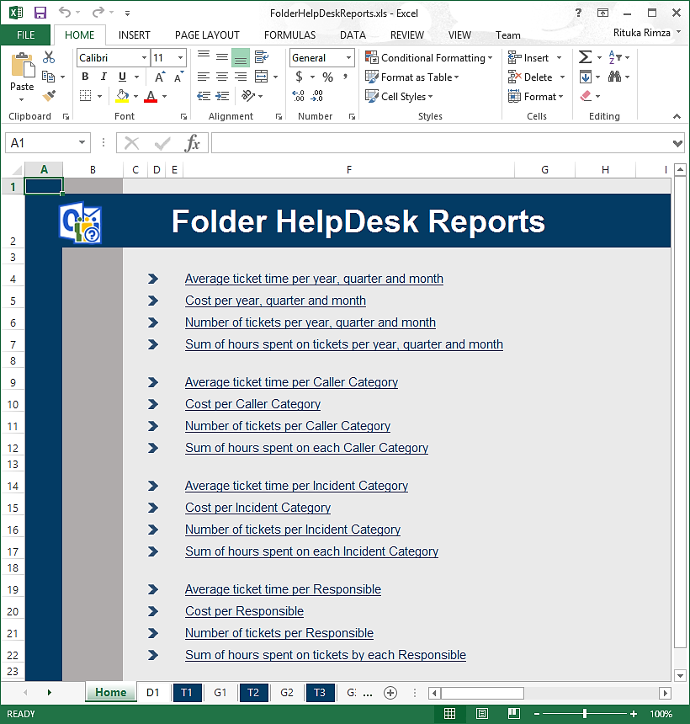
Each report is shown as a pivot table and as a chart.
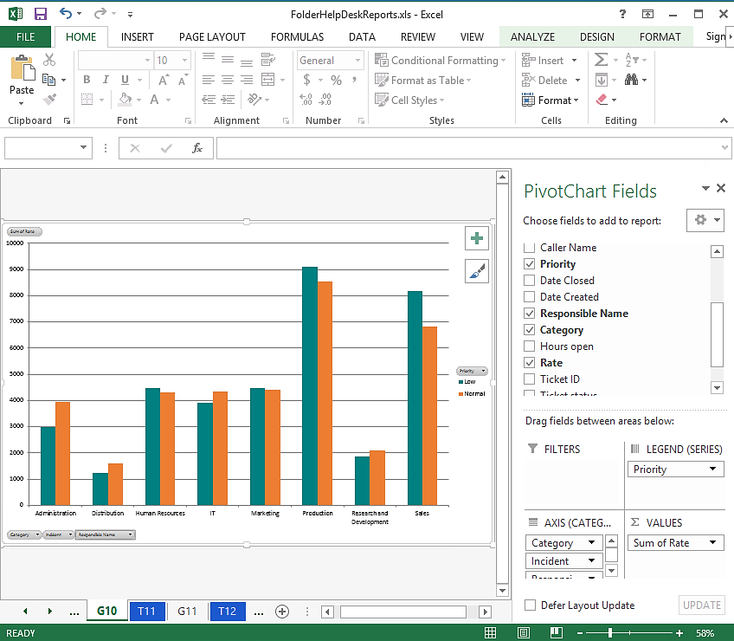

In the pivot tables you can filter by clicking triangles and drill into more detailed figures by clicking the plus signs.
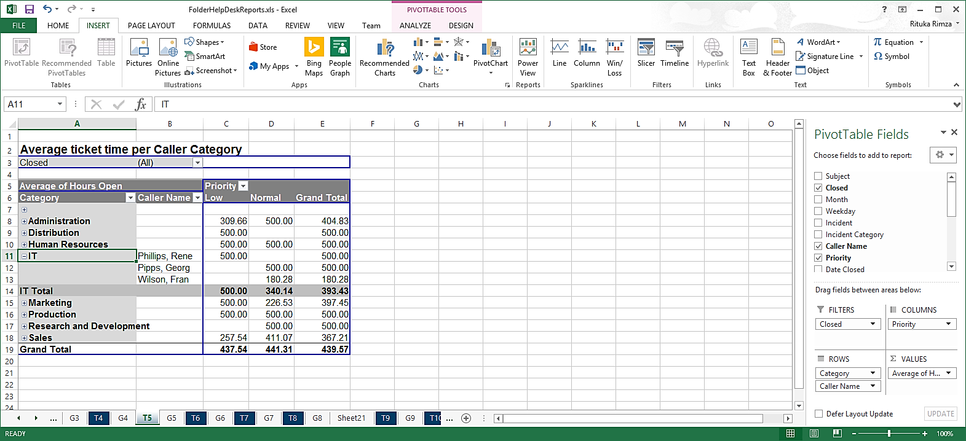
Under the first tab you can find all info from the database. Start from this tab when you want to create a new report.
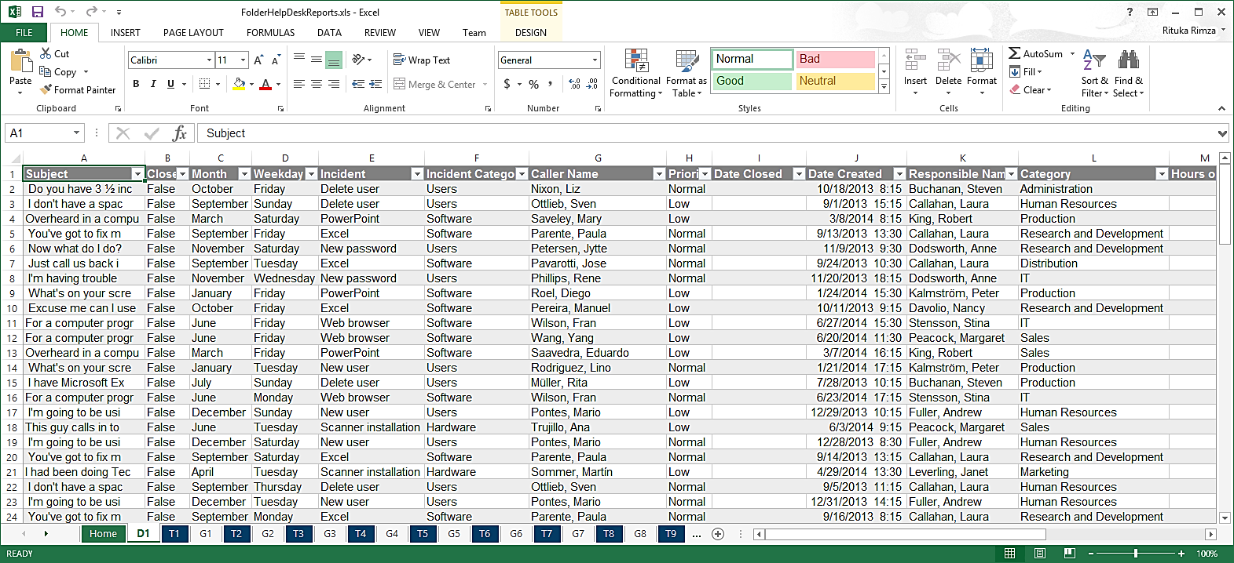

Custom Reports
All the standard Excel features may be used with the default reports, so it is easy to modify these reports. If the changes are saved, the modified reports will be used instead of the default one.
To create a totally new report, open the D1 tab and insert a pivot table. It is often best to select a new sheet for it. Then add parameters as you like before you save the report.
Next time you run the statistics tool, your modified or custom report will be refreshed with the new data just like the default reports.
For more info about the statistics eports, refer to the video demonstration at https://bizsolutions365.com/our-products/folder-helpdesk/fhd-demo/

Web form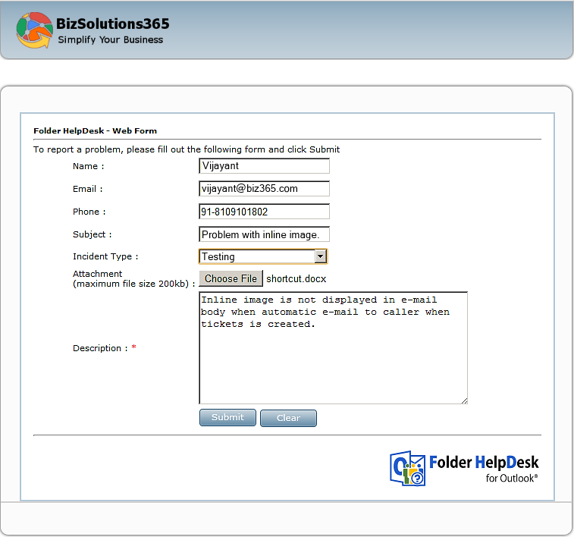

With Folder HelpDesk you can also set up an on-line web form, which creates tickets that go directly into your Folder HelpDesk Outlook folder.
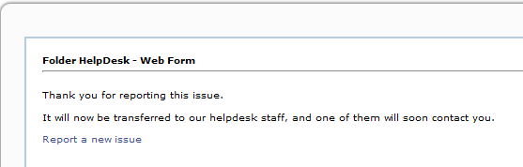

Files
For the web form you should use the folder FHDOnline in the Folder HelpDesk directory. The folder contains various files that should be copied to the webserver where you want to set up the web form. When the form is set up, a subfolder, Uploads, will be created.
The Folder HelpDesk web form folder contains several .aspx files with scripts that write .xml-files and uploaded files into the Uploads folder. You have to allow server scripts to be run at the web folder where you place the Folder HelpDesk web form files.
All files are open source and highly customizable, but of course you should always be careful and make a backup copy before you start changing anything. These files are presented in the section about architecture, Files for the Web Form feature – FHDOnline folder.

Setting up the web form
Copy all files from the FHDOnline folder and put them in a directory on a web server. You also need to set the permissions so that the aspx vb.net code can write .xml-files into this directory and into the Uploads directory.  Give the Internet Guest Account Full Control. | 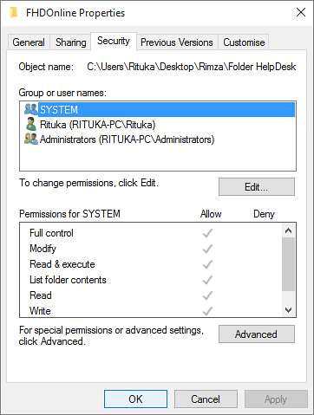

Specify path
In the Folder HelpDesk Settings, the tab Other settings under Advanced, write or paste the path to the web form. Then Folder HelpDesk will monitor your web form and from the .xml files create tickets inside your Folder HelpDesk Outlook folder. Once you do this, a new file PFHDCategories.xml will appear in the Folder HelpDesk web directory (where your web files are stored). Refer to Monitoring.

Incident types
The Incident types in the web form are created from the Folder HelpDesk Settings. When you define an URL where the web files are placed, the Folder HelpDesk Settings tries to call an ASPX page there. This web page creates an XML list on the web server with all Incident types. When default.aspx is opened and the XML file is there, the Incident type will be shown in default.aspx.

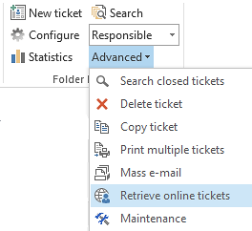
Monitoring
The tickets from the web form can be fetched manually, by pressing the button in the Folder HelpDesk toolbar in Outlook. This button is only shown when the web form has been set up.
You can also enable automatic tracking of the web form and select from a dropdown how often you want the tickets to be fetched. This is done in the Folder HelpDesk Settings, under the Advanced: Other Settings tab.
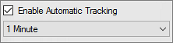

Created by
When an xml file has been created on the web server and when someone after that goes into the Folder HelpDesk folder in Outlook (this could be hours or even days after), the xml file is read and converted into a ticket. The “Created by” field is then automatically filled out with the person running Folder HelpDesk at that time.

Folder HelpDesk Options

Automatic conversion of e-mails into tickets
By default incoming e-mails are placed in the Inbox. From there – or any other Outlook mail folder - they can be converted into tickets with a click on the Folder HelpDesk Convert e-mail icon in the Outlook toolbar, as described in E-mail, manual conversion.
Another way of working with Folder HelpDesk is to automatically convert all e-mails coming to the inbox or to another folder into helpdesk tickets. If you want to use another folder you can specify what e-mails should go there by using Outlook rules.
Add the folder you want Folder HelpDesk to monitor by clicking the Plus sign under the tab E-mail folders in the Settings. You can either monitor a public folder or a shared mailbox for automatic conversion to tickets.
For a mailbox the name of the folder must be written in. If you are using a mailbox, please give the necessary user access permission.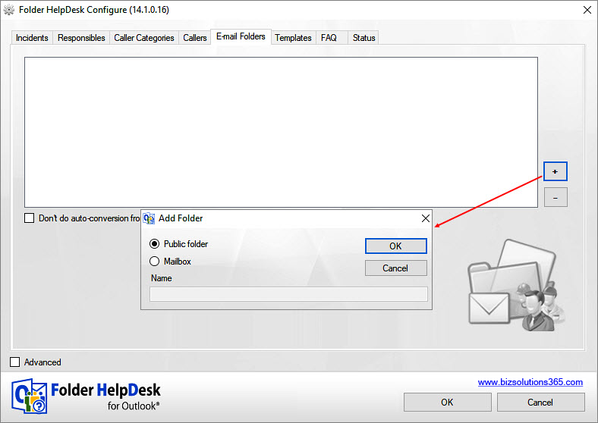

If you want the folder to be a public folder, click OK and you are asked to select folder.

Separate Sender E-mail Address
By default e-mails which are sent from inside a ticket to the Caller or Responsible are sent as from the sender’s personal e-mail account.
If you want to change that, specify an e-mail address for the e-mails sent from Folder HelpDesk under the Advanced: Other Settings tab in the Folder HelpDesk settings. | 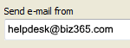
The e-mail address for sent e-mails must be set up on the Exchange server too. It may take some time, up to half an hour, for the server to propagate the changes.

Customize forms

Customize the Ticket HTML Form
If you have some knowledge about HTML code, you can easily add new fields to the Folder HelpDesk ticket form, so that it suits your company’s needs. The new field will be available in every ticket, and the value you enter in it will be saved and available every time you open a ticket.
Make data from your custom fields available in the database and in the statistics by selecting the new field under the tab “Ticket form Settings” in the Folder HelpDesk Settings.
The Title of the ticket form must be {Ticket [Ticket ID]} + Subject.
When modifying the HTML form, never delete a default tag or rename its ID. When adding a new control or tag, its ID should not be same as an existing tag or control ID. If it is, the text users write in that field will not be saved. Please avoid using the IDs below.
These are the default Folder HelpDesk ticket form IDs: | These IDs are used for labels
Subject  Ticket ID  Created at  Caller name  Caller email  Caller phone  Caller category  DatagCaller  Date due  imgCal  Created by  Ticket Status  Problem Type  Responsible  emailresponsible | lblSubject  lblID  lblTime  lblCaller  lblName  lblEmail  lblPhone  lblCategory  lblDue  lblCreatedby  lblStatus  lblProblemtype  lblResponsible
There are also Outlook reserved captions to consider. Do not use an ID for an Outlook item field (e.g. Subject, Company, Conversation, Message, Modified etc.). They are too many to list here, but if you notice that data from your custom field is not saved, try with another ID for it. In a FAQ on the bizsolutions365.com website you can find more Outlook reserved captions. (Ticket custom fields: The values entered in the custom fields are not saved.)
To customize the HTML ticket form, open the file FHDTicketForm.htm in an HTML editor. You will find the file in the Folder HelpDesk server installation folder. Add your organization logo, change colors and move available tags according to your requirement. You may add new fields where ever you want to place them, and you can also create a new table for your custom fields.
Three types of tags are supported for custom fields in the HTML form: Input type Text, Text Area and Select. When adding a tag in the HTML form it should be added inside the form tag.
Newly added tags must have unique IDs (other than the default IDs in the list above). The ID should not have any special characters. This ID will be mapped in the ticket and also to report into the database. The database name of your custom field in the table tblTickets will be “custom” + ID of the tag.
In the Folder HelpDesk Excel reports the ID of the added HTML tag will be the name of your custom field.

Example
Let’s assume that you want to add the Caller’s organization name in the Folder HelpDesk ticket. In this example the new field is added just below the Caller Category.
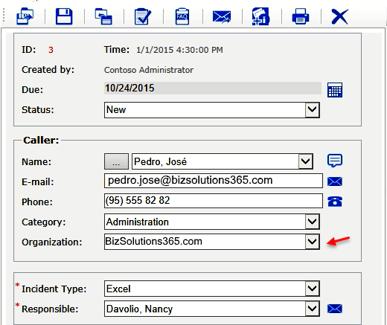
The code can look like this:
<div class="common_row" style="margin-top:5px">
<div class="leftBlock" id="lblOrganization">
Organization:
</div>
<div class="rightBlock">
<select id="Organization" tabindex="0" class="style5">
<option> bizsolutions365.com</option>
<option>Google</option>
<option>Microsoft</option>
<option>Apple</option>
</select>
</div>
</div>
To make data from a customized field available in the database and the Excel reports, open the Folder HelpDesk Settings, check “Advanced” to see all tabs and select the tab Advanced: Ticket Form . 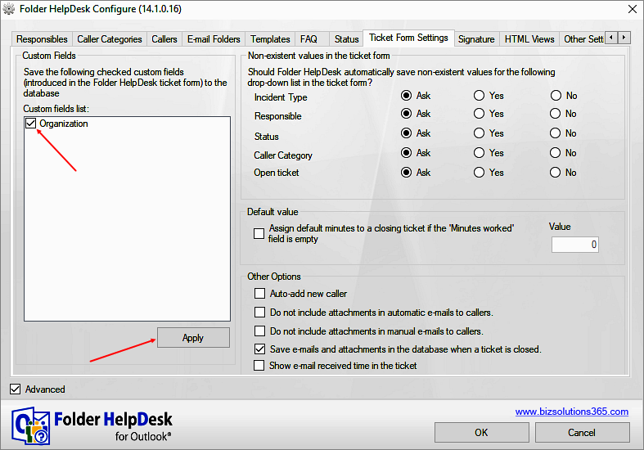
The newly created field with the ID “Organization” is now visible in the Custom fields list. Select it and press “Apply”. Now the database entry for this field will be created, and when this is done, every entry into this custom field in the ticket will be saved to the database.
The Organization name data will also be available in the Excel reports. As the ID of the added HTML tag is “Organization” the data will be shown under that title.

Customize the Web Form
If you have some knowledge about HTML and ASPX, you can easily add new fields to the Folder HelpDesk web form, so that it suits your company’s needs. If you add a new field in the ASPX page, you must also add that field in the HTML Ticket Form with the same ID, refer to Customize the Ticket HTML Form.
Make data from your custom fields available in the database and in the statistics tool by selecting the new field under the tab “Advanced: Ticket Form ” in the Folder HelpDesk Settings.
When modifying the HTML form or ASPX page, never delete a default tag or rename its ID. When adding a new control or tag, their ID should not be same as en existing tag or control ID.
To add a new field you have to modify two ASPX pages “default.aspx” and “default.aspx.vb”. In “default.aspx” you have to get data from the user input and send it to “default.aspx.vb” for processing. The File “default.aspx.vb” will write data into an XML file and save it.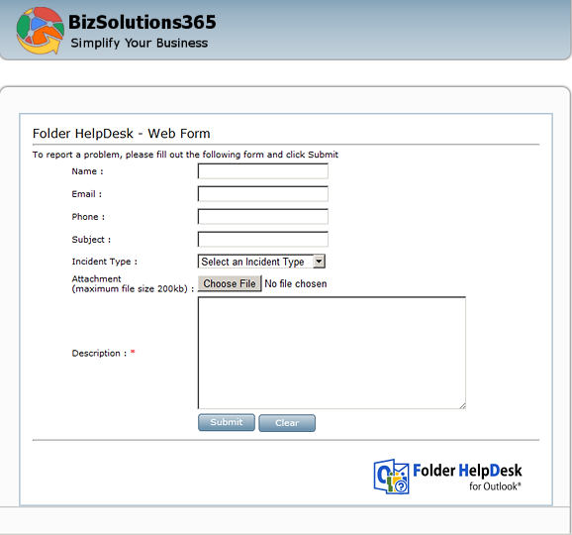

Example
If you want to add the field Company to the web form, you have to add the field to the default.aspx, which is the page that the users see.
<tr>
<td colspan="2" align="right" style="height: 26px">
<span id=" lblCompany " class="PFHDCaptions">Company :</span>
</td>
<td style="width:230px; height:26px; padding-left:2px">
<input type="text" id="companyname" tabindex="4" style="width: 228px" class="style5" name="T6" />
</td>
</tr>

You also have to add the code highlighted by red color below in “default.aspx.vb”.The XML element ID (compayname) should be the same as the ID of the corresponding custom field in the HTML Form.
Always add a new XML element at the end.
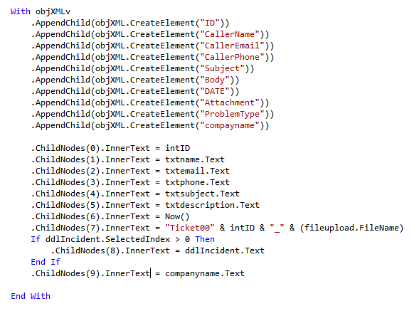

Subscription
Folder HelpDesk is licensed with a subscription. There are three subscription levels, Minimum, Medium and Premium, and support, free upgrades and an unlimited number of users within the subscribing organization are included in all levels.
Refer to the Subscription page: https://bizsolutions365.com/subscription/
If you are already a Premium Subscriber, you may use Folder HelpDesk without paying any extra fees. Just contact the bizsolutions365.com support team at support@bizsolutions365.com and ask for a registration key or a register free Premium copy with your company logotype.

Registration
You have a full 30 days to try out all the functionality in Folder HelpDesk. Then you need to either register Folder HelpDesk or order a register free Premium copy, to be able to continue working with the software.
For the Minimum and Medium Subscriptions, enter the registration key and an e-mail address with your company/organization domain in the License dialog in the Folder HelpDesk Settings. Folder HelpDesk needs access to the internet to verify the key.
After registration you can continue working on the same data as before. No re-installation is needed.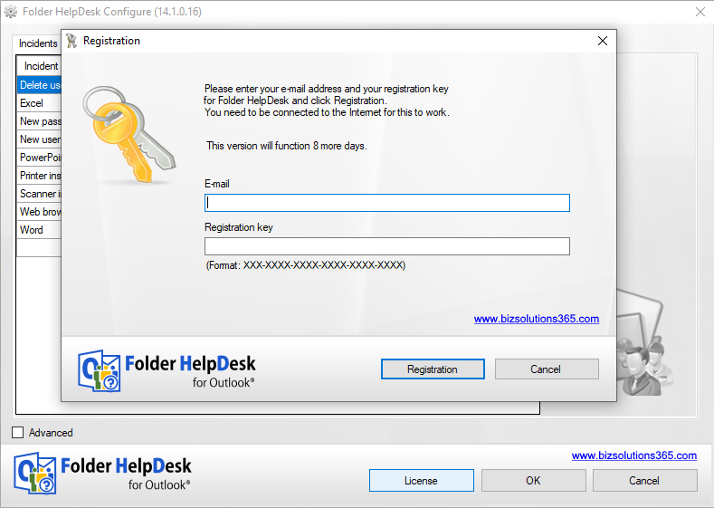

The person who registers Folder HelpDesk must have owner's right over the Folder HelpDesk folder in Outlook. Once registration succeeds, registration is done for all users of the same Folder HelpDesk installation.

Remove Folder HelpDesk
Folder HelpDesk does not appear among Program Files. That way you may have several installations on one machine, but it also means that you cannot remove the application through the Control Panel.
To remove Folder HelpDesk, delete all the Folder HelpDesk folders and files. To continue using the Outlook folder without Folder HelpDesk, go into properties and uncheck the “Show home page by default” checkbox.
Each user should also un-install the Folder HelpDesk Client Tool. This is done from the Control Panel, Add-Remove programs / Programs and Features.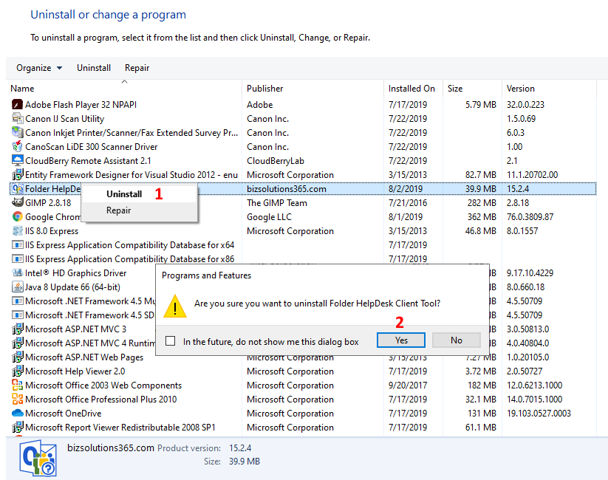

Contact
The solutions of bizsolutions365.com are supposed to be very easy to deploy, use and manage. However, if you have any kind of problem or questions about our software, there are several ways of contacting us:
E-mail | support@bizsolutions365.com | Technical issues
 | sales@bizsolutions365.com | General and sales issues
Telephone | +91 780 600 6234
Chat online | www.bizsolutions365.com

Architecture
Folder HelpDesk consists of several files. These are usually located in a folder on a network drive, where all users of Folder HelpDesk can access and execute them. The following description of the Folder HelpDesk files is provided to give you a general understanding of the functions carried out by each file.

Files on the network drive
FHDSynch.exe and its 64 bit version FHDSynch64.exe – This is the heart of Folder HelpDesk and is running in the background when Folder HelpDesk is active in the public folder. When you step out of the Folder HelpDesk public folder, it is unloaded. This application houses all functions required for interacting with Outlook, forms and database. You can confirm if this application is currently running by:
- checking for ‘FHDSynch.exe’ in the Task Manager
- seeing if the toolbar in the Folder HelpDesk folder is there. (In Outlook 2007 this functionality is instead controlled by the Folder HelpDesk add-in.)
FHDSettings.exe – This is an administrator tool for defining Folder HelpDesk intrinsic settings such as incident type, categories, responsible persons, caller list, ticket email templates, FAQ, signatures and other advance exchange and online web form settings.
FHDExampleData.exe and its 64 bit version FHDExampleData64.exe – This is an application for loading full-fledged demo examples to Folder HelpDesk (usually after a fresh installation) for thorough testing and evaluation.
FHDClientSetup.msi – This is a client installer that must be run from every client system from where Folder HelpDesk will be accessed. This installs several .dll files on the client, by default in a bizsolutions365.com folder under Program Files. The file may also be used for a central installation of the client tools via Active Directory.
FHDCleanSubfolders.exe and its 64 bit version FHDCleanSubfolders64.exe – Run this file if you want to permanently remove closed tickets subfolders. When you do you will be asked to define created date(s) before or between which the subfolders will be removed.
FHDDB.sql – This is pre-defined SQL file used during installation if the user has selected an SQL Server database.
FHDTicketForm.htm – This is the default Folder HelpDesk ticket HTML ticket form. Use this file when you want to customize the ticket form, refer to Customize the Ticket HTML Form.

Files for the Web Form feature – FHDOnline folder
default.aspx – The default page, see screenshot in the section about the Web form.
default.aspx.vb – ASPX script to process the user-entered data from the form. It creates/appends two XML documents - masterTicket.xml, which has listed all the available tickets since it was last read, and actual ticket data XML files (1.xml, 2.xml and so on).
clsField.vb – ASPX class file for the attachment feature. Supplements the clsUpload.vb file.
clsUpload.vb – ASPX class file for the attachment feature.
IncProblemTypes.aspx– Shows the Incident Type dropdown combo inside the default.aspx page. Reads from PFHDCategores.xml (which is created by PFHDSetCategories.aspx)
FHDSetCategories.aspx – Writes the FHDCategories.xml file and is called from the FHDSettings.exe when the settings are saved.
removeMasterXML.aspx – This file is called by the FHDSynch.exe application each time the contents of the masterTicket.xml are read. It tries to remove all read ticket entries from the masterTicket.xml file as well as the attachments related to those read tickets.
setMonitoringFlag.aspx – Monitors which Folder HelpDesk user is currently monitoring the web form, to avoid conflicts.

