E-mail Converter for Outlook and SharePoint – User Manual

Contents
1 Introduction 2
1.1 Languages 2
1.2 Requirements 3
2 The SharePoint site 4
2.1 Permissions 4
3 Installation of E-mail Converter 5
3.1 Process 5
3.2 Files 8
4 First Time Use 9
4.1 Log In 9
5 Configuration of E-mail Converter 11
5.1 List Settings - Define the Connection to SharePoint 11
5.2 The Global Settings list 13
5.2.1 List Edits 13
5.3 E-mail Folders 13
5.3.1 Default lists for different Outlook folders 15
5.4 Credential Store 16
5.5 General Settings 17
5.5.1 E-mail threading settings 17
5.5.1.1 The e-mail thread in the ticket 19
6 Use E-mail Converter 23
6.1 The E-mail Converter Buttons in Outlook 23
6.1.1 Create Ticket from E-mail Manually 23
6.1.1.1 Multiple lists 25
6.1.2 Blank Ticket 25
6.1.3 Statistics 26
6.2 The E-mail Converter Ticket 26
6.3 Merge Tickets 28
6.4 E-mail threading 30
6.4.1 Sent e-mails folder 31
6.4.2 The e-mail 31
6.4.3 Use of E-mail threading + multiple teams and lists 31
7 Report 32
8 Registration and Trial Info 34
9 Subscription 36
9.1 Upgrade 36
10 Contact 36
11 Remove E-mail Converter 36

Introduction
With E-mail Converter for Outlook and SharePoint, users can convert Outlook e-mails to SharePoint list items, here called tickets. New tickets can also be created from Outlook. As the tickets are gathered on a SharePoint site, it is easy to organize and co-operate on them, and they can be reached from everywhere over the internet.
E-mail Converter can also be used in other cases when you need to publish information to SharePoint. As E-mail Converter transfers images from e-mails to SharePoint list items, using E-mail Converter is a smooth way to get images into list items. It is much easier to add images to an e-mail than to add them directly into a SharePoint list item.
The bizsolutions365.com team hopes that you will get a good understanding of E-mail Converter by studying this manual and the online video demonstrations.
When we talk about clients in this manual we mean the people who are handling the tickets, for example members of a support team, or the computers used by them. Each client must have E-mail Converter installed.
In this manual we talk about e-mail conversion, but SharePoint list items can also be created from Outlook appointments and tasks.
The images in this manual are from Outlook 2016 and SharePoint Online, but you may use E-mail Converter with lower versions too, refer to Requirements below.

E-mail Converter combines three parts:
- An Outlook add-on which is installed on every PC where tickets should be created with E-mail Converter.
- One or several SharePoint list(s).
- An integrated statistics tool with an Excel report generator.

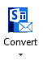
The Outlook add-on has
- A button which allows you to manually create a ticket from the selected e-mail, appointment or task. (The conversion can also be done automatically.) The e-mails are converted into tickets completely with formatting, priority, sender information and attachments.
- A button for creating a blank ticket, for example if you receive a telephone call or simply wish to publish something to SharePoint from your Outlook. Caller information may be taken from the Outlook Contacts or the Global Address List.
- A link to the Report generator and Excel report.
- A Settings form that handles the connection between Outlook and SharePoint.

If you have several Outlook profiles, E-mail Converter will work on all of them.

Languages
The language of E-mail Converter is automatically set to the same as of the computer’s Outlook language. If that language is not supported, E-mail Converter takes the language of the operating system. Should the OS language not be supported by E-mail Converter, English is used. The supported languages are: Danish, Dutch, English, French, German, Italian, Norwegian, Portuguese, Spanish and Swedish.

Requirements
To install and use E-mail Converter, you need to have Microsoft Office 2010 or above installed on each client. Both the 32-bit and the 64-bit versions of Office 2010 and above are supported.
You also need a SharePoint site, version 2010 or above. Office 365 Outlook and SharePoint are supported. E-mail Converter works with all SharePoint lists except libraries and supports all Exchange e-mails, including Office 365 Group e-mails.
(E-mail Converter helps you get more out of Office and SharePoint, but the product does not assist you with the general configuring of these platforms.)
Each client also needs to have .NET Framework 4.0 or higher installed. .NET Framework may be downloaded for free from Microsoft at http://go.microsoft.com/fwlink/?LinkId=131000. If a client without .NET Framework 4.0 tries to open the Configure dialog, a message with a download prompt will be displayed.

The SharePoint site
To use E-mail Converter with SharePoint, you must have a SharePoint site set up and functioning. It does not matter if it is hosted online or in-house. Often the Issue Tracking or the Tasks list is chosen, but you can use any of the list templates provided by Microsoft and customize it as per your needs.
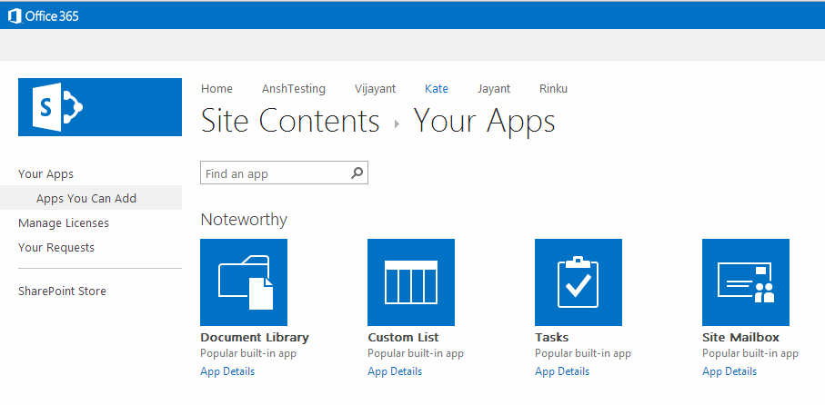
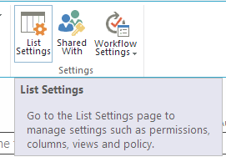
E-mail Converter gives the SharePoint site a connection to Outlook, an e-mail conversion feature, address book integration and automatic information in the ticket about who is calling or having the problem.

Permissions
The admin/first user needs to have Design or Full control permission over the SharePoint site. Subsequent users need to have Contribute permission on the SharePoint lists.

Installation of E-mail Converter
Outlook should be closed during the installation.
Download the Email Converter setup file in.exe or .zip format from the bizsolutions365.com website (https://bizsolutions365.com/our-products/e-mail-converter/ec-try/) to any folder on you PC. Extract the file if you selected to download the zipped file.
When you click on the downloaded file, EmailConverter.exe, and are asked if you want to run it, please confirm that it is digitally signed by Biz Solutions 365. If the file is not digitally signed, you should not run it.
When you have clicked on the EmailConverter.exe file and accepted the license agreement, the file handles the installation by itself.
By default, the E-mail Converter files are installed under Program files (x86)/bizsolutions365.com/E-mail Converter (64-bit operating system) or Program files/bizsolutions365.com/E-mail Converter (32-bit), and if you accept this location there are no choices to make.

Process
These are the installation steps:
- Welcome screen.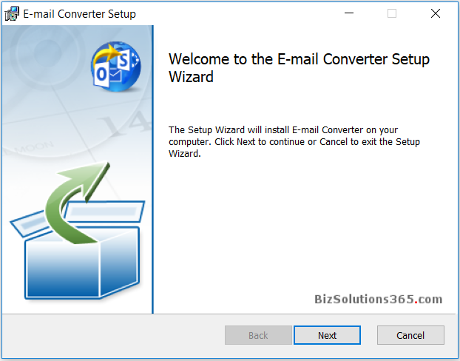

- Accept the License Agreement.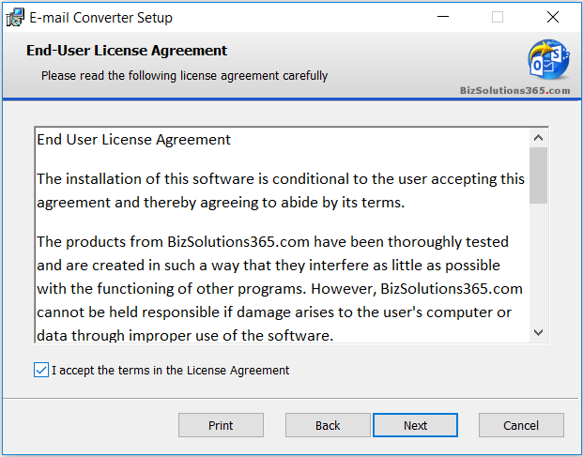

- Select installation folder – or use the default one under Program files.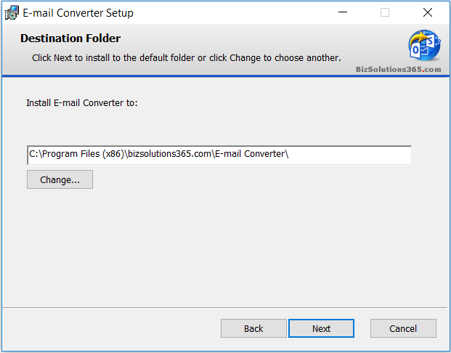

- Confirm the installation.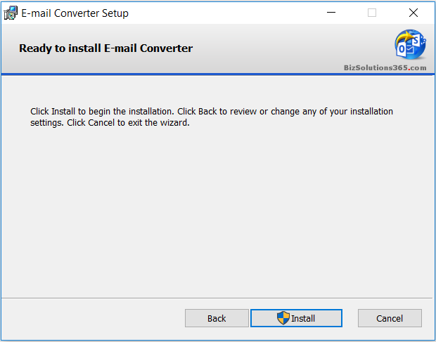
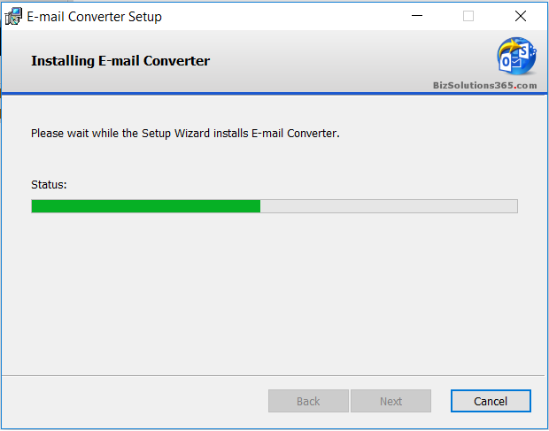
- When the installation is finished you will get a message that it has succeeded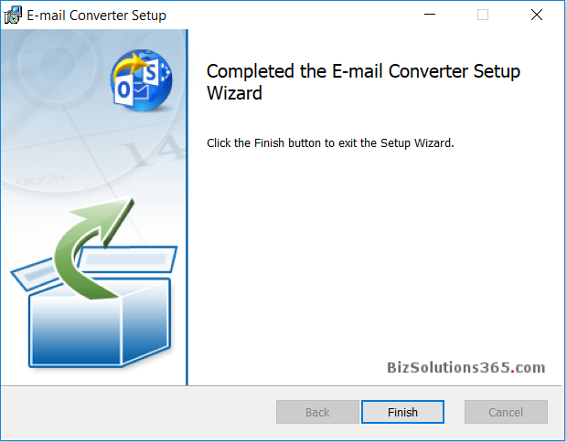

Files
When the installation is finished, you will have the following files in Program files/bizsolutions365.com/E-mail Converter (32-bit Windows) or Program files (x86)/bizsolutions365.com/E-mail Converter (64-bit Windows) – or in the folder you specified, if you changed the default folder.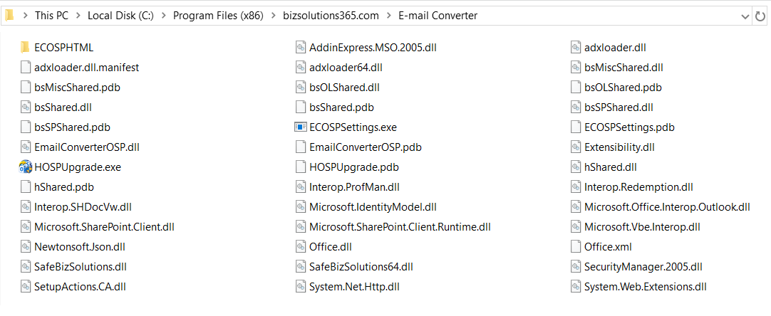

After configuration of E-mail Converter, there will be a settings file called ECOSPSettings.txt under C:\Users\[User Name]\AppData\Roaming\bizsolutions365.com\ECOSP: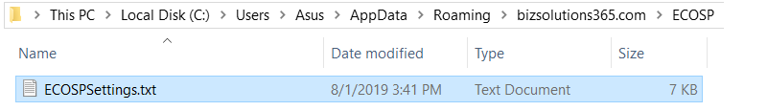

First Time Use
When you open Outlook after the installation, you can see a new Configure button in the Outlook ribbon.
When you click on the Configure button in Outlook for the first time ‒ or run the file ECOSPSettings.exe ‒ after the installation, you will be asked if you want to add a list.
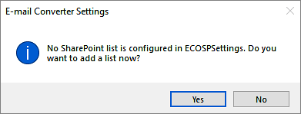
Click Yes, and you will be asked to enter the SharePoint site URL.
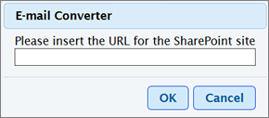
Now you will be prompted to log in to the SharePoint site you have entered.

Log In
When you use E-mail Converter for the first time, you must log in to the SharePoint site that should be connected to E-mail Converter. Your credentials will be saved automatically.
For best security, the password is encrypted when saved to the file ECOSPSettings.txt. The information about username, password and monitored e-mail folder is also stored locally, while information about site and list mapping is stored in the Global settings list on the SharePoint site.
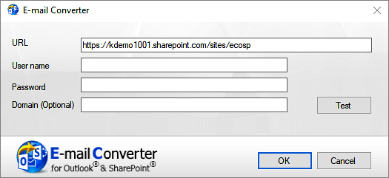
When you have logged in, all the lists of that SharePoint site will be shown. Select one of the SharePoint list and click ‘OK’.
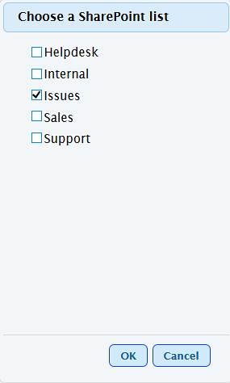
(If you have not added any SharePoint list to the site you have logged in to, this dialog will not appear.)
More SharePoint lists can be added by clicking on the ‘Add List’ button on the Configuration page or on the ‘List Settings’ page.

Configuration of E-mail Converter
After you have added a list, the main Configuration screen opens.
The main screen has four buttons for different settings dialogs and some quick links to features that you can also find in the settings dialogs. The default list is shown here, and you can add lists and enable Live Monitoring (automatic conversion of e-mails).
The two buttons to the top right is for the Merge tickets feature and for the E-mail Converter Manual webpage.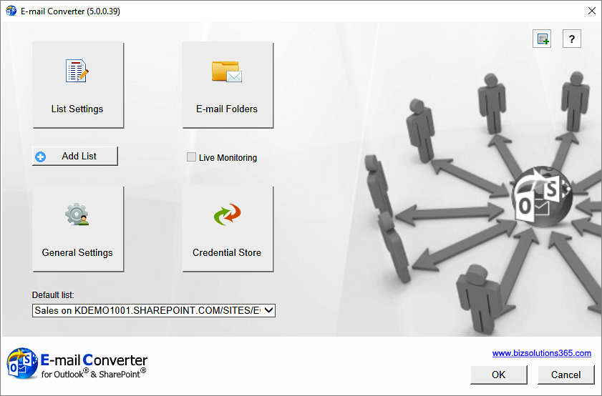

List Settings - Define the Connection to SharePoint
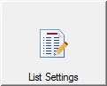
When you have selected a list, the List Settings dialog will open. You can also always open the List Settings using the button in the main Configure screen.
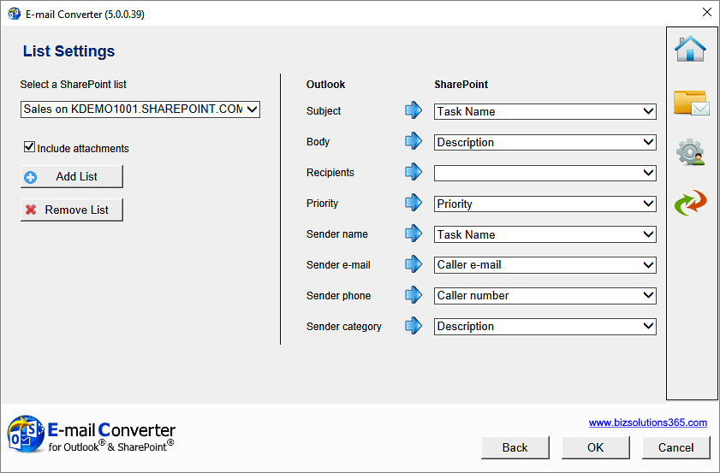
In the List Settings dialog you can define how the connection between Outlook and SharePoint should work. Select to which columns in the list item the different parts of the e-mail should be published.
When you for example want the Subject of the e-mail to be filled out in the Title field of the list item, you select Title from the drop down. The dropdowns are populated with the columns of the list you have chosen to use with E-mail Converter.
You can map multiple e-mail fields to the same SharePoint list column if you so wish.
E-mail Converter supports the SharePoint column types Single line text, Multiple lines of text and Choice.
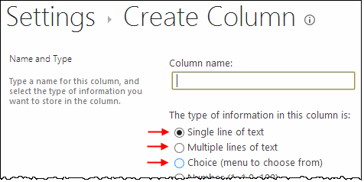
In the List Settings you can also add and remove lists and decide if e-mail attachments should be added to the list items.

The Global Settings list
When the administrator or first user saves the configuration of a SharePoint site in the E-mail Converter Settings, a hidden list, “ECOSPSETTINGS” is created at the selected SharePoint site. In that list an item is created, and in the body of that list item all list info is saved. Such a Global list will be created for each site that has at least one list used with E-mail Converter.
For example, if the user adds a list on “SharePoint Site A” to E-mail Converter, a new Global list will be created on “SharePoint Site A”. Similarly, if the user adds another list to E-mail Converter and that list is on “SharePoint Site B”, a new Global list is created on “SharePoint Site B” as well.
Once the hidden setting list has been created, it is available to all other users. When a user adds a SharePoint list via the Outlook Configuration dialog and the application finds a “ECOSPSETTINGS” list on that site, it loads all the configured lists to the user. This way a new user gets all list settings automatically.
If E-mail Converter finds a “ECOSPSETTINGS” list on the site it overwrites any new settings over previous settings. All the other users get the new settings when they restart their application and connect to the site again.
Each time a user selects a site to connect to E-mail Converter, the application checks if there is Global list with settings for E-mail Converter on that site. If there is, E-mail Converter loads the settings in the Global list from the site. (If there is no Global list, this user is considered to be the first user, and the application will create a Global list with the settings that this user defines and saves.)

List Edits
When a user changes and saves the list settings, the settings in the Global list are also updated. This way all users get the updated settings next time they connect to the site.

E-mail Folders
All users who want to convert e-mails to tickets automatically must configure how it should be done in the E-mail Folders dialog. The checkbox for Live Monitoring will become active after you add an Outlook folder to be monitored, see below.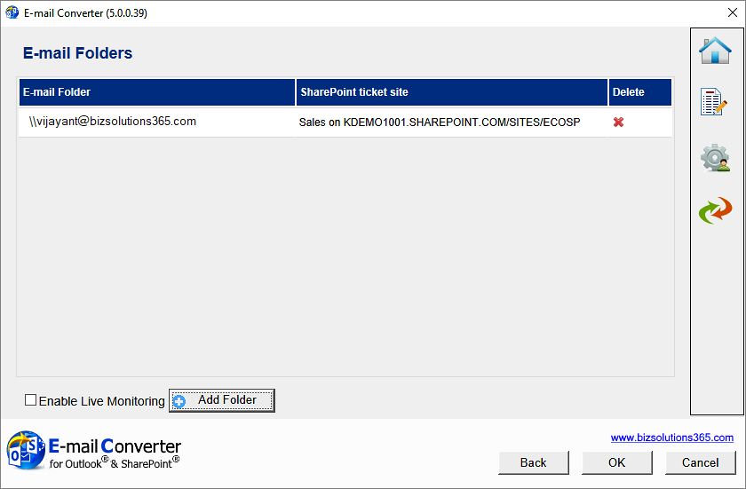

You can Add, Edit and Remove folders to be monitored.
When you click on the Add folder button, an ‘Add folder’ dialog opens. You should first select which folder you want to add, a public folder or a shared mailbox.
You will then be asked to select an Outlook folder to monitor.
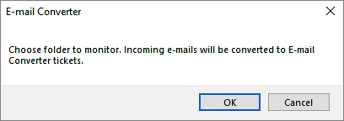
If you choose ‘Public folder’, you can select from the existing public folders or you can create a new folder by clicking on the ‘New…’ button.
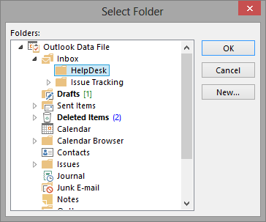
If you choose ‘Mailbox’, you need to enter the name of the mailbox.
When you have selected an Outlook folder to monitor, a small dialog window is launched. It allows you to select a default SharePoint list for that particular folder.
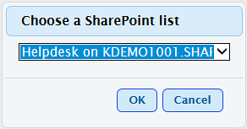
The e-mails from the monitored folder will be placed in a subfolder named Converted, once they have been converted.

Default lists for different Outlook folders
If you have enabled the automatic conversion and several Outlook folders are monitored, you can select different SharePoint lists for different e-mail folders. This is a simple way of distributing the incoming e-mail to different lists.
For example, e-mails to sales@company.com can be converted to list items in the SharePoint-list ”Sales tickets”, while e-mails to support@company.com are converted into list items in the SharePoint-list ”Support tickets”.

Credential Store
When you configure E-mail Converter and have entered the path to the SharePoint site you wish to use, you are prompted to enter your log in details.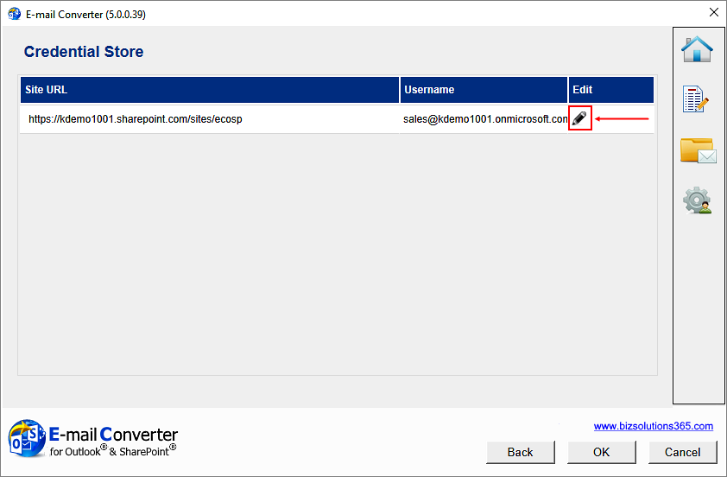

Click on the edit icon to the right of the username to edit the SharePoint site credentials.
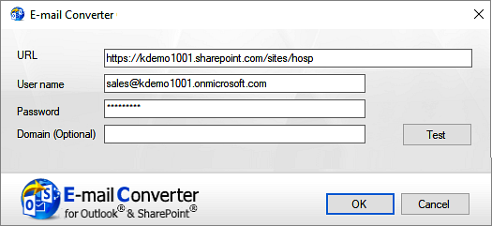
The information about site URL, password and monitored e-mail folder(s) is stored locally on each machine.

General Settings
In the General Settings dialog some general settings are gathered.
The default list is only for manual conversion of e-mails to tickets.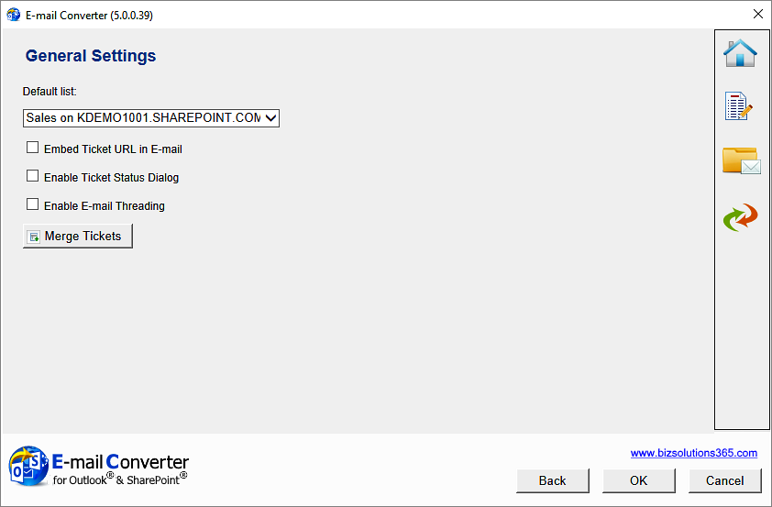

In the General Settings dialog there are three checkboxes. None of them is checked by default:
- If you want an URL to the ticket to be shown in the converted e-mail, check the first box.
- If you want to show a status dialog when a ticket is created, check the second box.
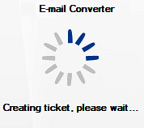
- Use the checkbox for E-mail threading when you want to automatically add e-mails to existing tickets about the same subject, see below.
The Merge Tickets button takes you to a dialog where you can merge several tickets into one, refer to Merge Tickets.

E-mail threading settings
The ‘Enable E-mail threading’ option in the E-mail Converter settings under General Settings must be enabled for the e-mail threading feature to work.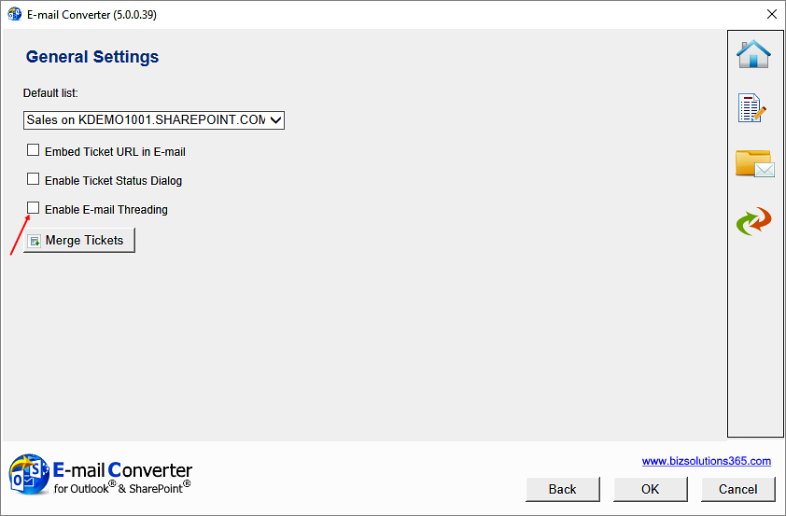

You must also make a setting in the SharePoint list:
- In the SharePoint site, under List Settings >General Settings >Versioning Settings, activate the option Yes for 'Create a version each time you edit an item in this list?'.
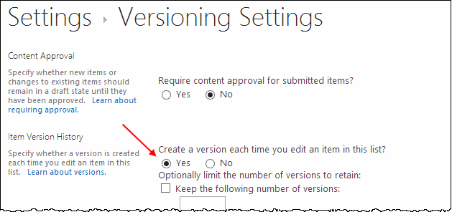
- Create/Use a multi lines of text field with the setting “Append Changes to Existing Text” set to Yes.
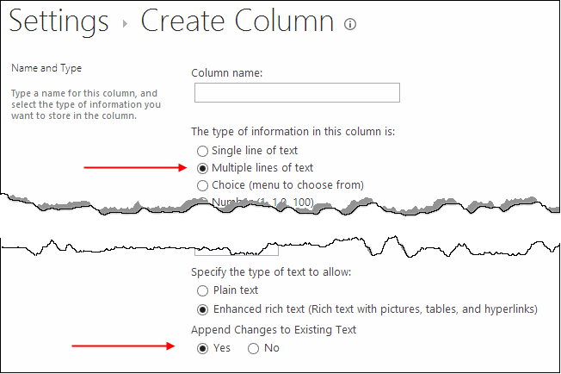
- This multi-line field must be selected as Threading Field in the E-mail Converter List Settings.
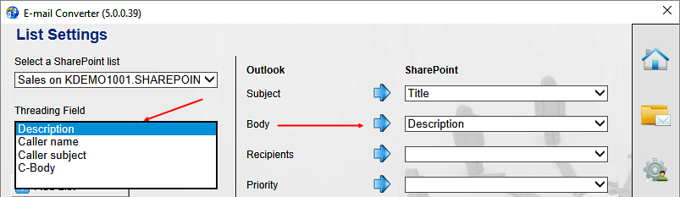
When the checkbox under General Settings is checked and the three settings above are made, every e-mail in a thread will be added to the same SharePoint list item.

The e-mail thread in the ticket
Below is a ticket created from three e-mails of a case. The ticket was first created from the first e-mail, shown at the bottom, and then info from the subsequent e-mails have been added to the same ticket.
The image below shows how the e-mails are entered if you use the description field for both e-mail body and e-mail threading, see above. Then the first e-mail will be at the bottom of the ticket and the subsequent tickets will be added on top of it. This image shows the edit view of the ticket.
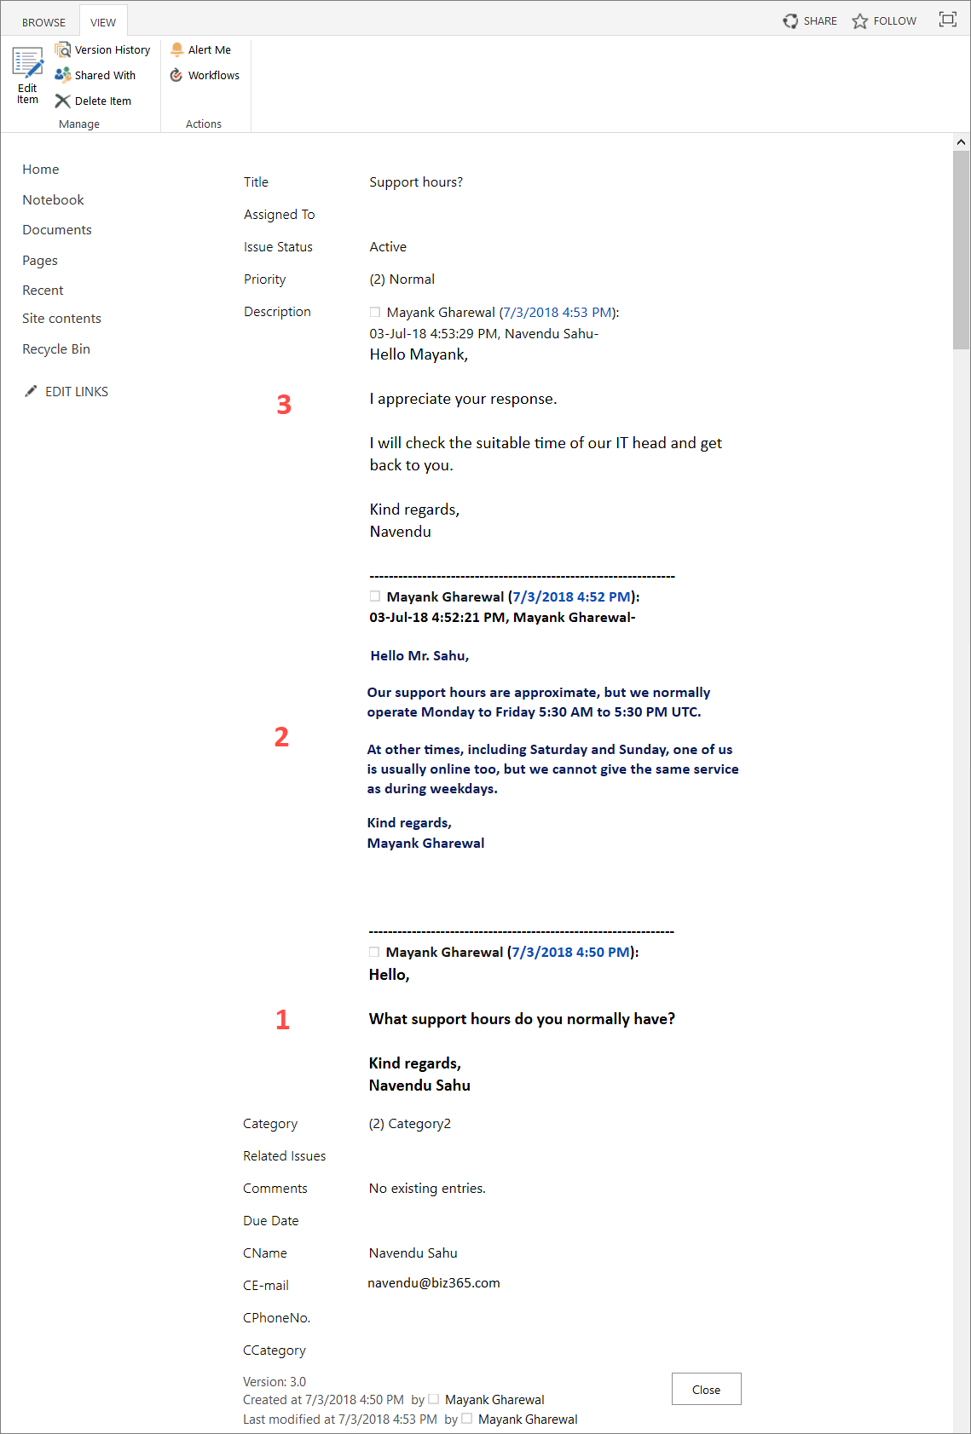

If you want another order between the first and subsequent e-mail, you can use a separate threading field and place it where you want the threading to come in the ticket.
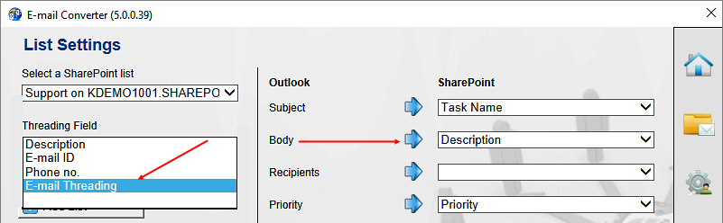
Maybe you want to always have the first e-mail on top, to always see at a first glance what the issue is about? Then you can map the e-mail body with the description field and the subsequent thread with another field that you place below the description field. This mapping will give the first e-mail on top and the subsequent e-mails ordered from the bottom and upwards. The image below shows such an e-mail thread in the ticket standard view.
(Custom SharePoint fields are placed below the default ones by default, so no further customization of the list item is necessary to get the custom threading field below the default description field. For other positions you have to modify the form, for example in SharePoint Designer.)

Use E-mail Converter

The E-mail Converter Buttons in Outlook
When at least one SharePoint list has been configured for E-mail Converter, new buttons are shown in the Outlook ribbon.

Create Ticket from E-mail Manually
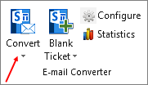
Click on the Convert button in the Outlook ribbon to create a ticket from an e-mail manually. The conversion is quick, and you can work with Outlook as usual while it takes place. See also The E-mail Converter Buttons in Outlook.
If your workgroup or organization uses more than one SharePoint lists, the button converts the e-mail to the default SharePoint list. To get a choice of lists, click the “Convert” text or the little arrow.
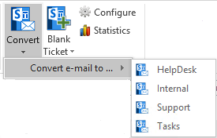 | There is also a conversion button in the ribbon of the open e-mail.
 | 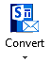
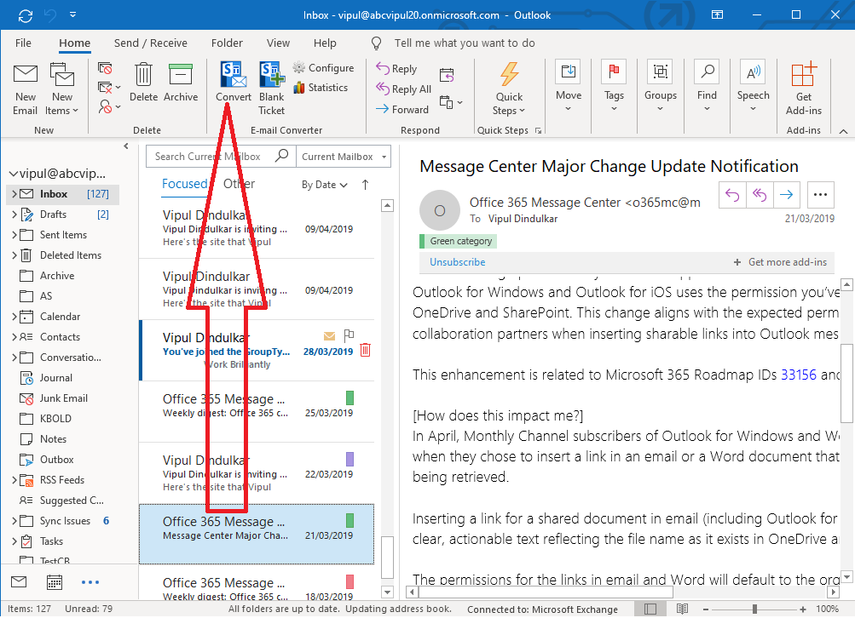
When the e-mail is converted it gets a small icon. The converted e-mail is marked with a ticket number and date and time for conversion.
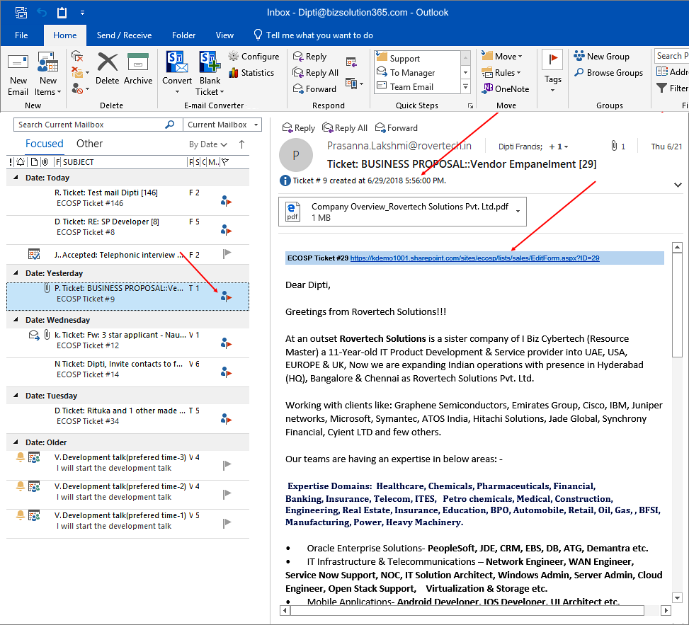
Check the box for ‘Embed Ticket URL in e-mail’ in the General Settings dialog, if you want to get the path to the ticket in the e-mail.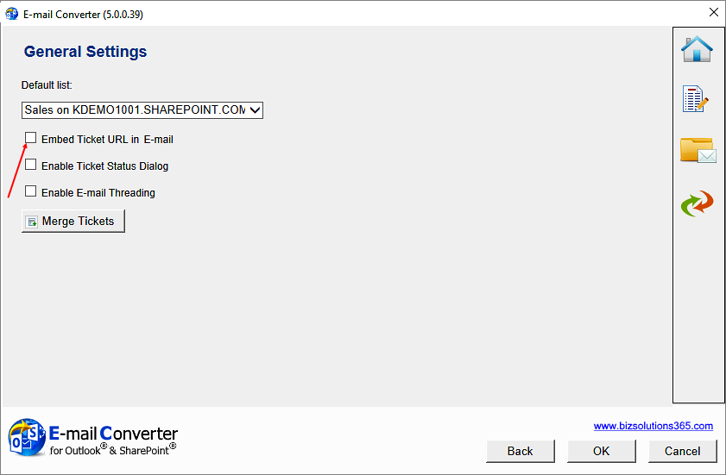

Multiple lists
E-mail Converter only has the two buttons Convert and Blank Ticket even if you use several lists.
When you press the icon on the button, the default list will be selected automatically.
When you press the text on the button, or the little arrow, you will get a choice of lists.
So, if you have a selection of several lists but want the ticket to be placed in the default list, just click on the Convert or the Blank Ticket icon.
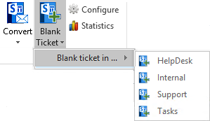

Blank Ticket
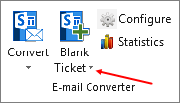
Use the Blank Ticket option if you want to create a SharePoint list item directly from Outlook.
When you use the Blank ticket for an issue report received for example by telephone, you may select the caller from the Contacts or the Global address list or fill out that information manually. In other cases, you can just leave the caller info section empty and click OK.
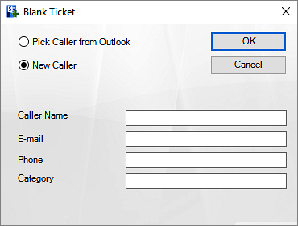
If you want to take the caller info from a contacts list, pick the caller and click OK. Then the information will be entered in the new ticket.
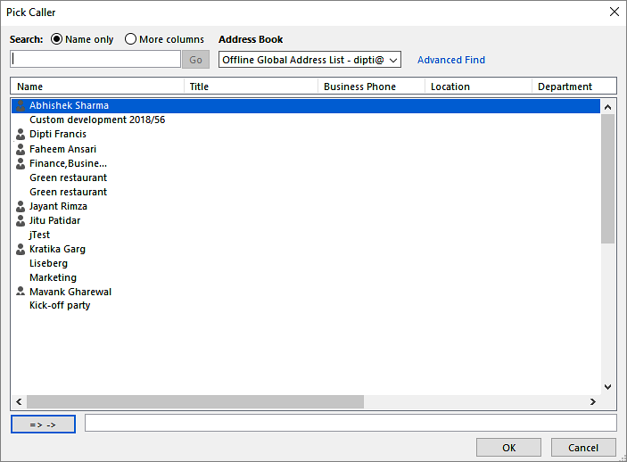
When the new ticket is created it will open in your browser automatically, so that you can fill out the information needed.
Just like with the conversion button the Blank Ticket text and the little arrow will give you a choice of lists when your organization uses several SharePoint lists with E-mail Converter. Please refer 6.1.1.1.

Statistics
The Statistics button takes you to the dialog where you can generate Excel reports from list data. Refer section 7. Report.

The E-mail Converter Ticket
E-mail Converter tickets are regular SharePoint list items. When an e-mail is converted to a ticket with E-mail Converter, the Description field of the ticket will get the same formatting as the e-mail body, and attached files can be included.
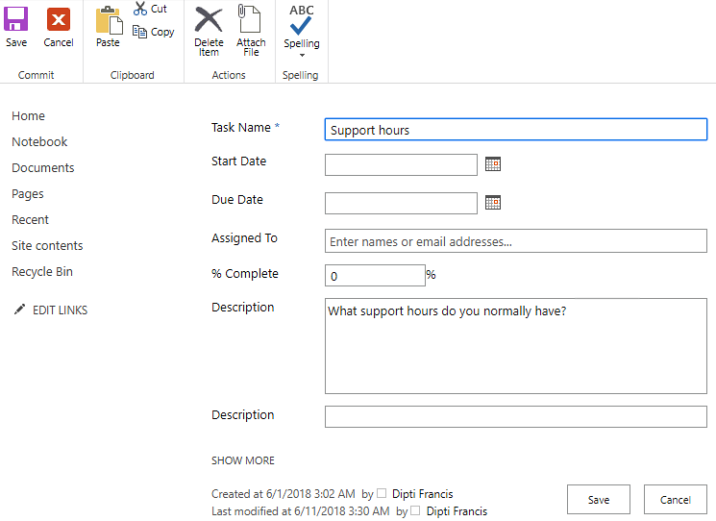
The ticket is shown in the list as a SharePoint list item and can be treated in the same way as any other list item.
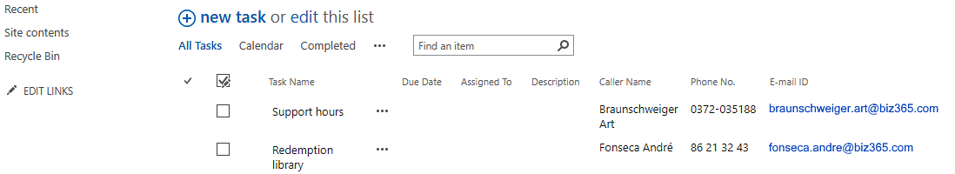
When the e-mail has embedded or inline images, they will appear at exactly the same place when the e-mail has been converted to a ticket. If the image has links they will work in the ticket also. As it is easier to add an image to an e-mail than to add it in SharePoint, E-mail Converter is usable for all situations when you need to add images to SharePoint list items.
NOTE that this only works if the column that is mapped with the e-mail body field (normally the Description column) is set to Enhanced rich text.
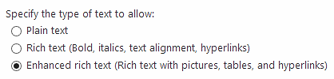
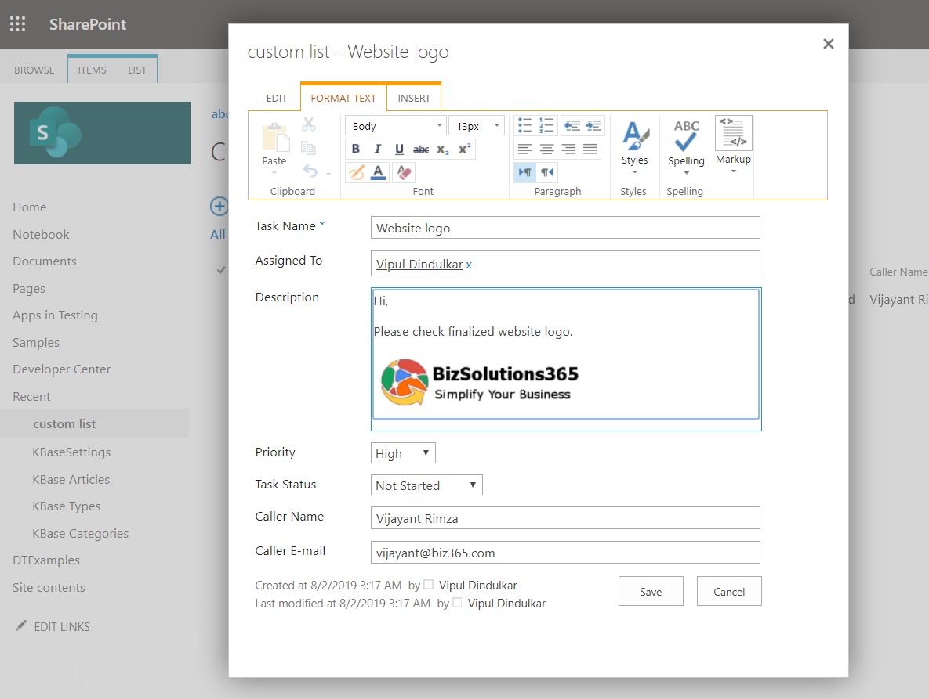

Merge Tickets
If you wish to merge several tickets into one, click on the Configure button in the Outlook ribbon and then the shortcut to the Merge Ticket button in the main screen.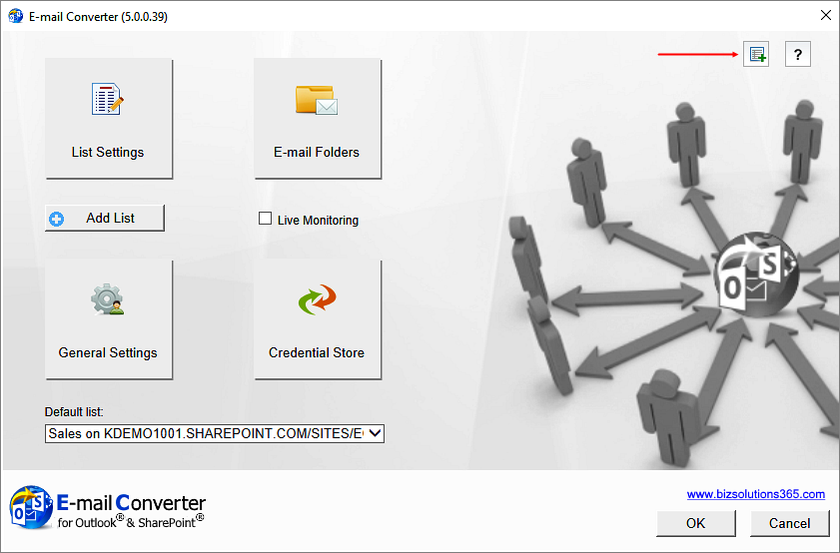

You can also reach the Merge tickets feature from the General Settings dialog.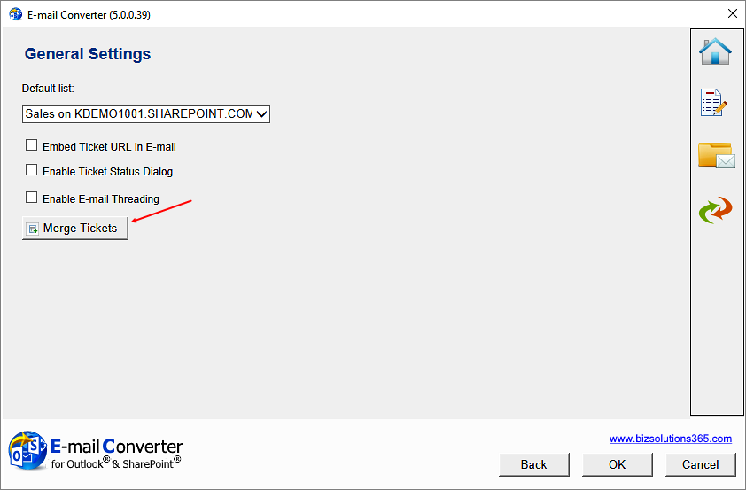

A Merge Tickets dialog will open.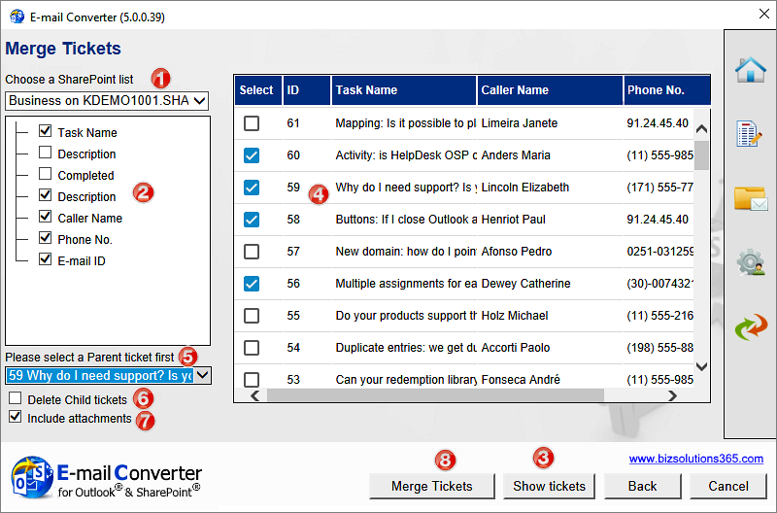

To merge tickets, follow this procedure:
- Select a list where tickets should be merged. If only one list is used for E-mail Converter, that one will be shown. If several lists are used, you can select the required list from the dropdown.
- The Merge Tickets feature supports merging single line texts and multiple line texts. For other fields merging is not possible. Check the fields that should be included.
- Press the Show tickets button.
- Select from the tickets in the grid which tickets should be merged into another ticket.
- Select the Parent ticket. All the selected parts of the selected tickets will be merged into the selected Parent ticket.
- Check the delete box if the tickets that have been merged - the Child tickets - should be deleted after having been merged into the Parent ticket.
- Uncheck the attachments box if you do not want attachments of the Child tickets to be merged into the Parent ticket.
- Click on Merge tickets to start the process.

E-mail threading
The e-mail threading feature in E-mail Converter makes it possible to add each e-mail concerning the same case to the first ticket, instead of creating one ticket for each e-mail. This process gives the responsible staff a chronological listing of all conversation related to that particular problem. The entire process is executed transparent to the user. The e-mail threading feature works for both manual and automatic conversion.
When an incoming e-mail is converted and E-mail threading is enabled, each time E-mail Converter finds a SharePoint item with the same ticket ID as the incoming e-mail, the body of the e-mail will be added to the corresponding field of the list item with the same ID. E-mail Converter will also tag the appended content of the SharePoint ticket with the name of the sender and system time at every update.
If an incoming e-mail is converted and E-mail Converter does not find a SharePoint item with the same ticket ID, a new item will be added to the list.
Note that for manual conversion you must convert the subsequent e-mails just like you did with the first one. They will be added to the earlier ticket, but you must do the conversion step first.
When the tickets are created manually and there are multiple SharePoint lists to choose from, you have to be careful while selecting SharePoint list from the Outlook toolbar dropdown. If you select the wrong list when creating an e-mail thread and there is a ticket with the same ID in that list, the wrong ticket will be updated with the new information.

Sent e-mails folder
All sent e-mails of the e-mail threading will be moved to the subfolder ECOSPSentItems under Sent Items after they have been added into the SharePoint ticket.
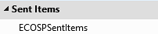

The e-mail
When you create a ticket from an e-mail and the option ‘Enable E-mail Threading’ is checked, E-mail Converter will append the ticket ID in the Subject of the processed e-mail (Ticket: + Subject + [ticket id)) to identify its SharePoint item ID.

When you reply to an e-mail that has been converted into a ticket, make sure the conversion process has finished. Otherwise the Threading feature will not work. To check this, see if the subject line of the email has changed to "Ticket: <Subject> [ ticket #] "

Use of E-mail threading + multiple teams and lists
If you have a situation with several helpdesk teams, A and B, using different mailboxes to monitor incoming mails and different lists, you might want to send a case from one team to another, to ask for help. You then have the following situation:
When a processed e-mail having the ticket ID in the subject field from mailbox A is forwarded to mailbox B E-mail Converter will check if there is a ticket ID tag in the subject. If it is there, E-mail Converter will try to check if that ticket exists under the SharePoint list B.
If a ticket ID does not exist, E-mail Converter will create a new ticket in list B, and this is not a problem. But if it does exist, E-mail Converter will add the newest portion to that ticket. Note that the problem of the ticket with that ID in list B is probably not the same as of the e-mail with that ID that originally was for list A.
To avoid this, when forwarding an e-mail from team A to team B, remove the ticket ID under brackets and then send the e-mail. That way E-mail Converter in team B will process that e-mail as a new ticket in list B.

Report
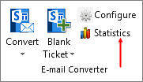
The statistics report is reached via the Statistics button in the E-mail Converter toolbar in Outlook.
When you click the Statistics button, you will get a dialog that lets you select SharePoint list and fields for the statistics. By default, all the fields in the list are selected.
When you have selected fields, click on Display Results.
When you then click on Report, an Excel file with the selected data will be shown. It is a normal Excel sheet, so all the standard Excel features can be used with the E-mail Converter reports.
Below the admin is interested to see what tickets have come in from the different departments in June 2018. The admin first selects the relevant fields: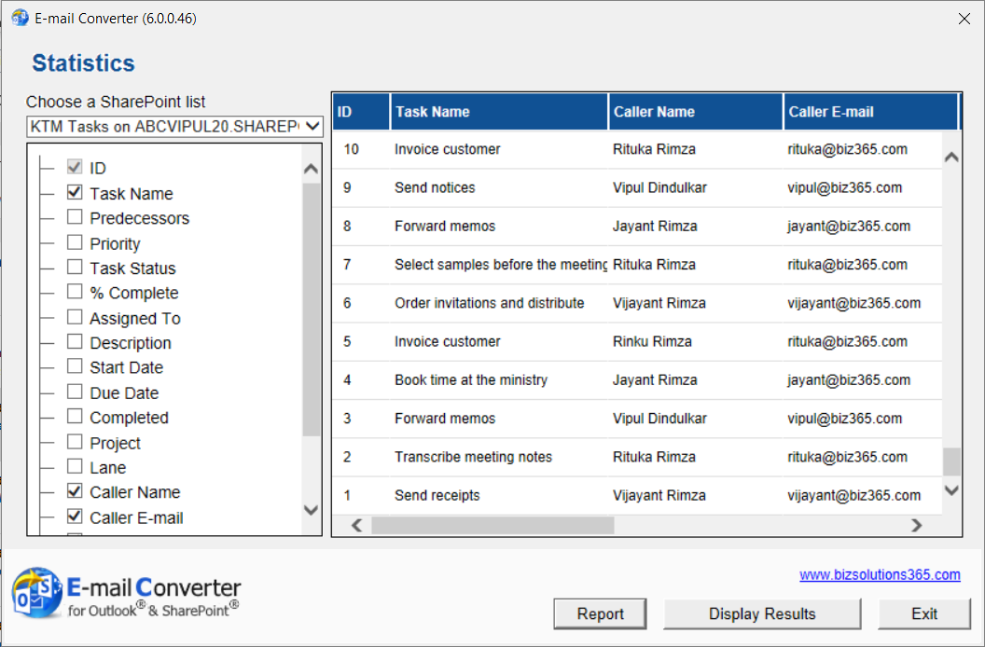

In the Excel report, the admin filters the Created date so that only June 2018 is displayed.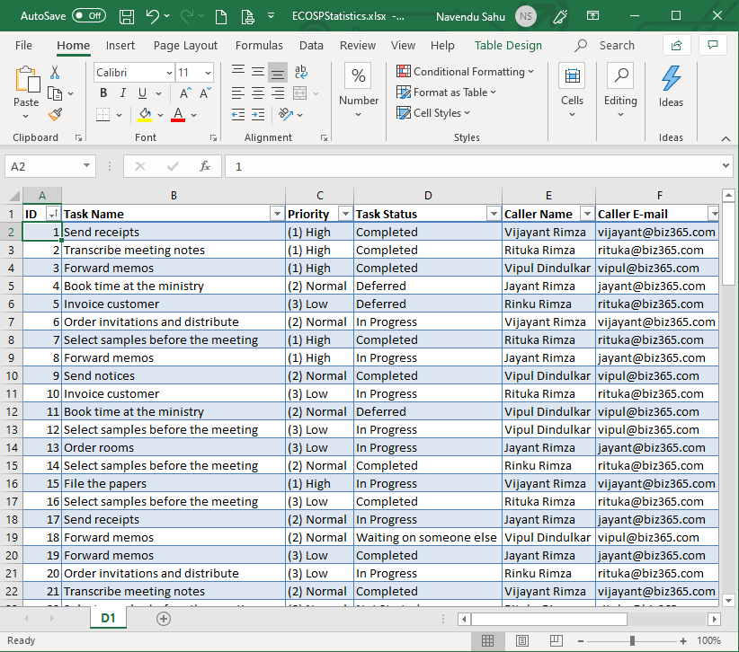

And here is a simple graph on the same data, for June 2018 but with only the caller category and number of tickets included.
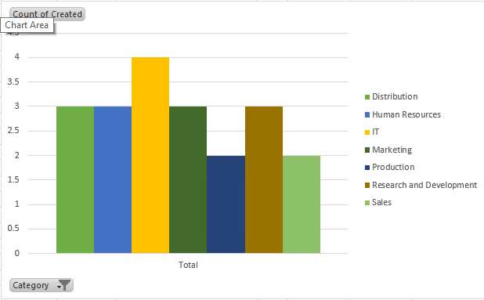

Registration and Trial Info
You may evaluate E-mail Converter without cost and with full functionality for 30 days.
If you want to continue using the solution after the trial period, you must subscribe to the solution. We supply a Premium version, which does not require registration at all, but organizations who select the Minimum or Medium Subscription must register their installations of E-mail Converter.
Minimum and Medium Subscribers will be given a registration key which allows the organization to continue using E-mail Converter for the duration of the subscription.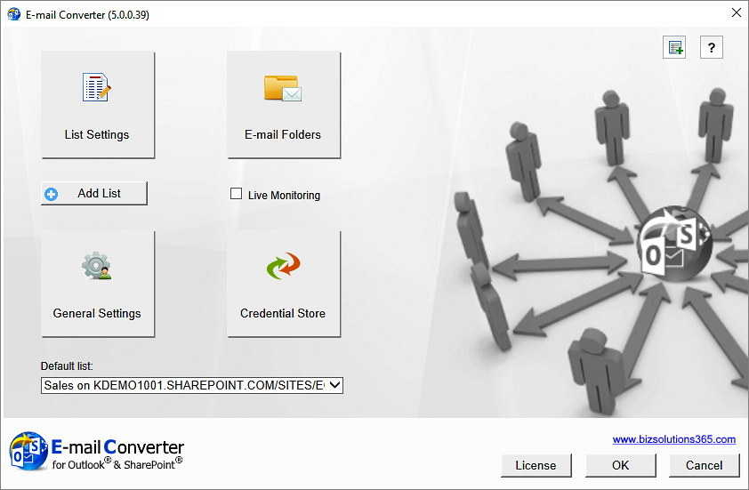

To register, open the Configuration page by clicking on the ‘Configure’ button in the Outlook ribbon. Click on the License button, and a registration dialog will open.
Enter an e-mail address with your company domain and the registration key you have received from bizsolutions365.com. Then click on ‘Registration’. The ‘License’ button will be hidden after the registration.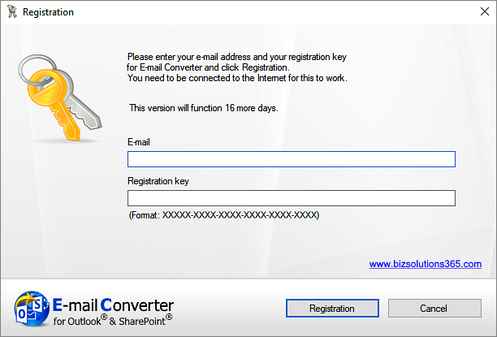

The registration is done by the administrator for all users that are connected to the same SharePoint site.

Subscription
E-mail Converter is licensed with a subscription. There are three subscription levels, Minimum, Medium and Premium. Support, upgrades and an unlimited number of users within the subscribing organization are included in all levels, but the Medium and Premium levels also give other benefits. Refer to the E-mail Converter Subscription page.

Upgrade
When bizsolutions365.com releases a new version of E-mail Converter, you will get an update notification in your PC.
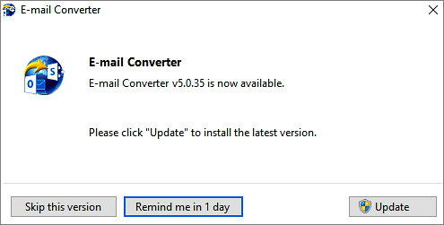
When you click on the ‘Update’ button, your installation will be updated. All your data and settings will be kept. Outlook must be closed during the update. You will get a notification once the new version is installed

Contact
The solutions of bizsolutions365.com are supposed to be very easy to deploy, use and manage. However, if you have any kind of problem or questions about our software, there are several ways of contacting us:
E-mail | support@bizsolutions365.com | Technical issues
 | sales@bizsolutions365.com | General and sales issues
Telephone | +91 780 600 6234
Online Chat | www.bizsolutions365.com

Remove E-mail Converter
Remove E-mail Converter through the Control Panel, Add or Remove Programs / Programs and Features. This will not remove the SharePoint list(s) or the items/tickets. It will only remove the integration between Outlook and SharePoint.

