E-mail Converter for Azure and SharePoint – User Manual

Contents
1 Introduction 2
1.1 Languages 2
1.2 Requirements 2
1.3 Permissions 2
1.4 The SharePoint site 3
2 Converted E-mails and SharePoint Tickets 4
2.1 The converted e-mail 4
2.2 The Ticket 5
3 Install E-mail Converter 7
3.1 Resource Group 10
4 Configure E-mail Converter 11
4.1 First Time Configuration 11
4.1.1 Log in to E-mail Account 11
4.1.2 Log in to SharePoint 12
4.2 The E-mail Converter Homepage 15
4.3 The Main Configuration Page 15
4.3.1 List Settings - Define the Connection to SharePoint 16
4.3.2 E-mail Folders 17
4.3.3 Credential Store 18
4.3.4 General Settings 19
4.3.4.1 E-mail threading settings 20
4.3.4.2 Merge Tickets 26
4.3.4.3 Edit E-mail 28
4.4 Logs 29
4.5 Statistics 30
4.6 The Global Settings list 32
5 Logic App 33
6 Registration and Trial Info 36
7 Upgrade E-mail Converter 38
8 Subscription 38
9 Contact 38
10 Remove E-mail Converter 39

Introduction
With E-mail Converter for Azure and SharePoint, users can monitor multiple E-mail folders and automatically convert e-mails into SharePoint list items 24/7. In this manual we call the SharePoint list items “tickets”. As the tickets are gathered on a SharePoint site, it is easy to organize and co-operate on them, and they can be reached from everywhere over the internet.
E-mail Converter uses the Scheduler in Microsoft Azure, so that users can set the conversion frequency.
The bizsolutions365.com team hopes that you will get a good understanding of E-mail Converter by studying this manual.

Languages
E-mail Converter tries to get the language from the Azure app service localization. In case that language is not supported, English will be selected. User can change the language while logging in to E-mail Converter after installation. The supported languages are: Danish, Dutch, English, French, German, Italian, Norwegian, Portuguese, Spanish and Swedish.

Requirements
To use E-mail Converter, you need to have:
- Exchange Web Service (Office 365, Windows Live or Microsoft Exchange)
- Microsoft Azure
- SharePoint 2013 or above (in-house or hosted) or Office 365 SharePoint Online.
- Supported browsers are Microsoft Edge, Internet Explorer 10 and higher and the latest version of Google Chrome or Mozilla Firefox.
- Supports all Exchange e-mails, including Office 365 Group e-mails.

Permissions
The admin/first user needs to have Design or Full control permission over the SharePoint site.
To create a new resource group, you need to have administrator permission on the Microsoft Azure account.

The SharePoint site
To use E-mail Converter with SharePoint, you must have a SharePoint site set up and functioning. It does not matter if it is hosted online or in-house. Often the Issue Tracking or the Tasks list is chosen for E-mail Converter tickets, but you can use any of the list templates provided by Microsoft and customize it as per your needs. 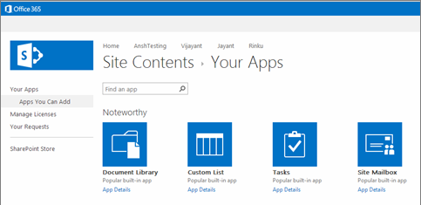

Converted E-mails and SharePoint Tickets
When you use E-mail Converter to convert e-mails into SharePoint tickets, you will still have all e-mails left in the mailbox, but you will also have the e-mail content in one or more SharePoint lists.

The converted e-mail
A red flag on an e-mail shows that it has been converted to a SharePoint ticket. 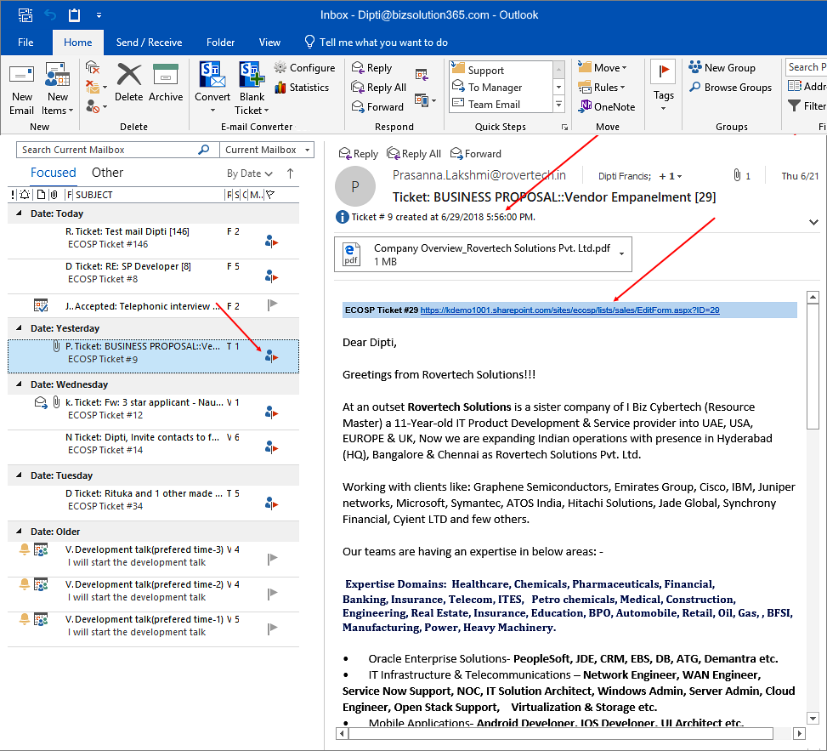

Check the box for ‘Embed Ticket URL in e-mail’ in the E-Mail Converter General Settings page, if you want to get the path to the ticket in the converted e-mail.
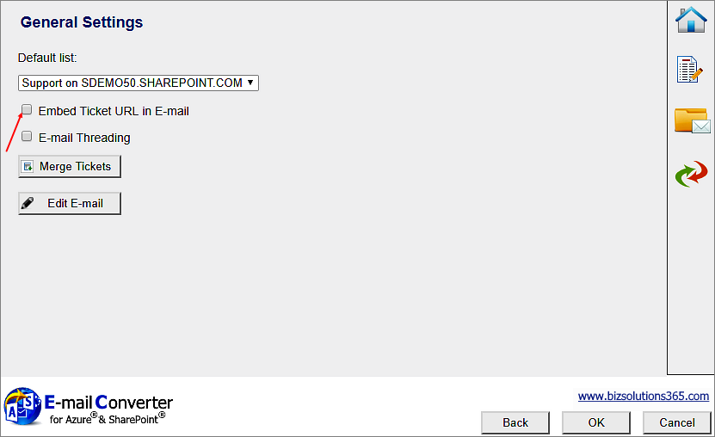
If you have checked the box for ‘E-mail Threading’, the converted e-mail will have a ticket ID.

The Ticket
E-mail Converter tickets are regular SharePoint list items. When an e-mail is converted to a ticket with E-mail Converter, the Description field of the ticket will get the same formatting as the e-mail body and attached files can be included.
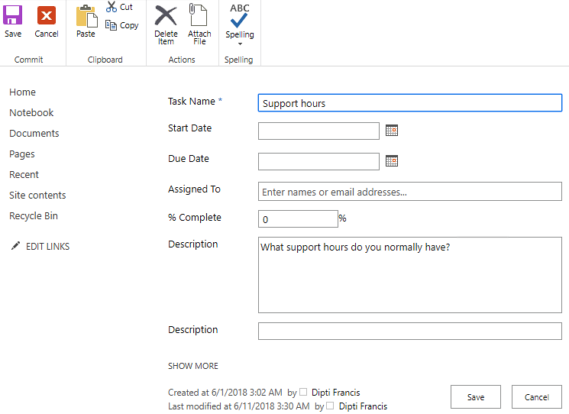
The ticket is shown in the list as a SharePoint list item and can be treated in the same way as any other list item. 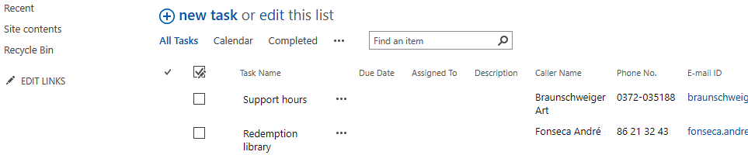

When the e-mail has embedded or inline images, they will appear at exactly the same place when the e-mail has been converted to a ticket. If the image has links they will work in the ticket also. As it is easier to add an image to an e-mail than to add it in SharePoint, E-mail Converter is usable for all situations when you need to add images to SharePoint list items.
NOTE that this only works if the column that is mapped with the e-mail body field (normally the Description column) is set to Enhanced rich text.
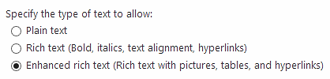
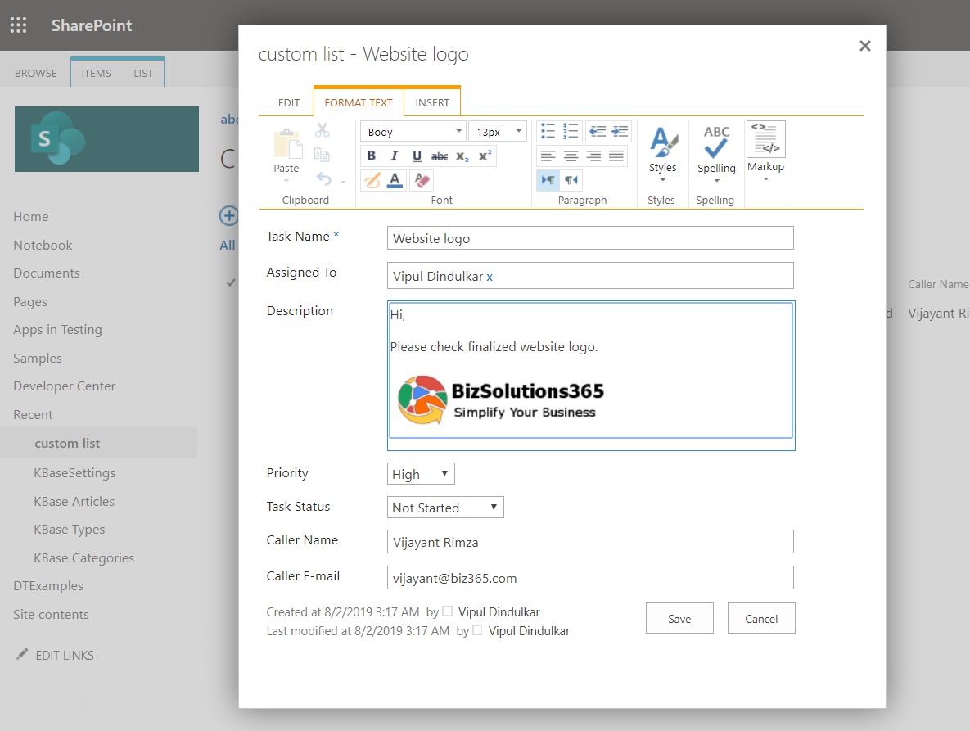

Install E-mail Converter
E-mail Converter for Azure and SharePoint is available on the Azure Marketplace. Below are the steps to install E-mail Converter:
- On the E-mail Converter product page click on ‘Get it now.

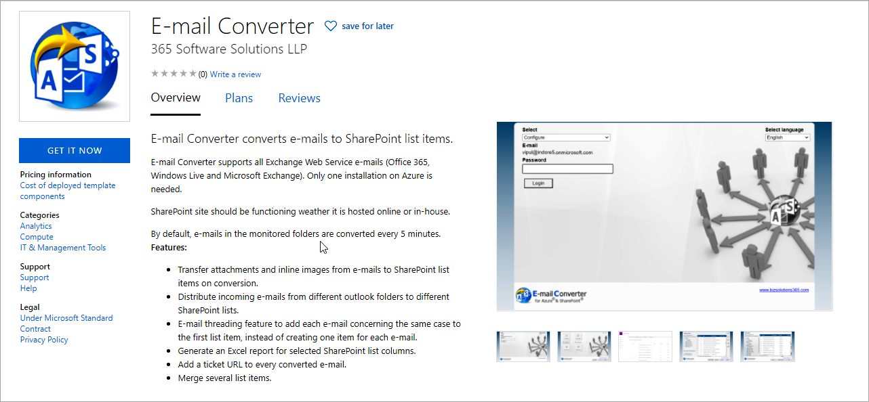

- Click on ‘Continue’.
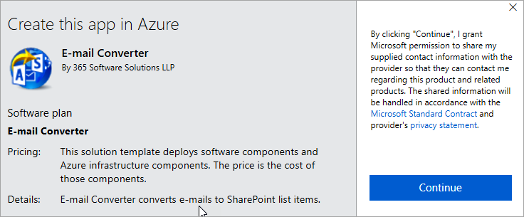

- The Microsoft Azure Dashboard opens. Click on ‘Create’ to deploy the E-mail Converter resources.
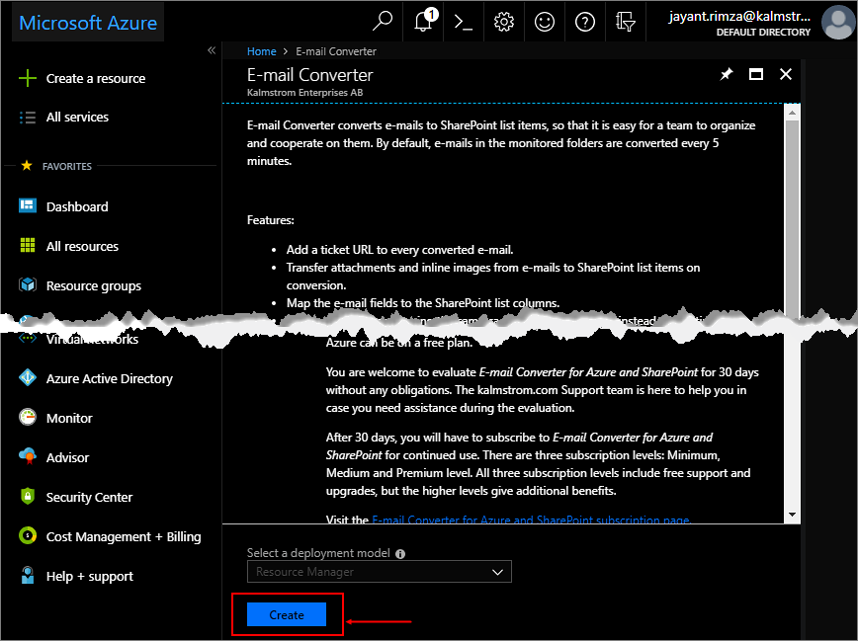
- Fill out the details under the ‘Basics’ tab.
You may select a paid service for the web app service under the ‘Pricing Tier’ dropdown but by default we use a free plan as it doesn’t affect the functionality of E-mail Converter.
Note: By default, we use a minimum subscription for the Scheduler, which is EUR 12 or USD 14 per month. If you wish, you may change the subscription in the future.
For every new installation, it is recommended that you create a new resource group. (By creating a separate resource group for E-mail Converter, you can give permission to another user on that specific resource group, if you want.) However, you may of course select an existing resource group from the dropdown, as well.
Select your location and click ‘OK’.
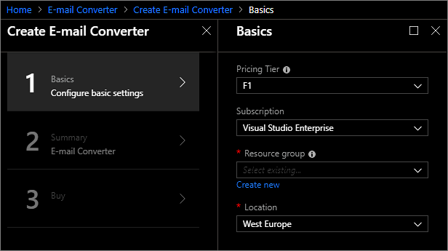
- Click ‘OK’ to confirm the details you filled out under the ‘Basics’ tab.
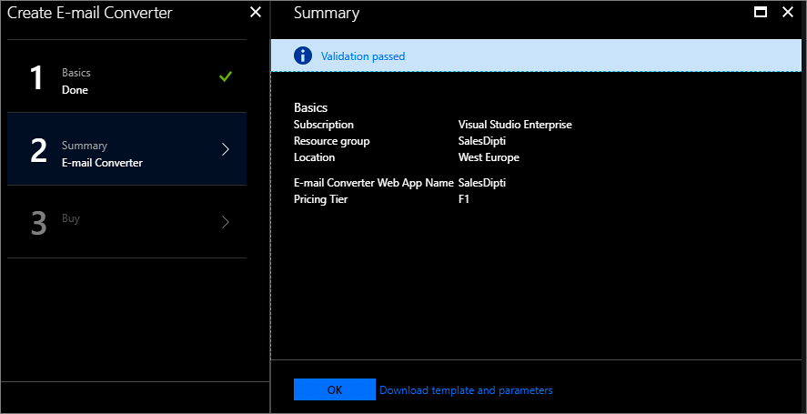
- Accept the ‘Terms of use’ and mention your preferred phone number. Then click on ‘Create’.
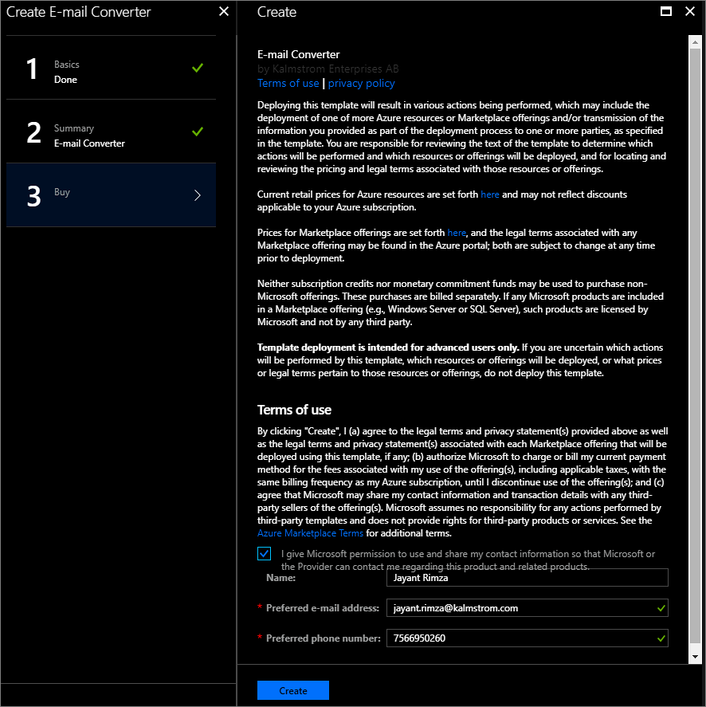

Resource Group
Once a resource group has been created, you will be re-directed back to the Microsoft Azure Dashboard. Click on the ‘Resource groups’ option in the left panel and open the resource group in which E-mail Converter has been installed by clicking on its link.
E-mail Converter deploys three resources to the resource group:
- App Service plan – get the information about the Azure service status, subscription plan and ID.
- Scheduler Job Collection – manage how often e-mails should be converted. Default is every 5 minutes.
- App Service – reach the E-mail Converter Configuration page.

Configure E-mail Converter
When E-mail Converter has been installed in an Azure resource group, the connection between the mailbox folder(s) and the SharePoint list(s) must be configured.

First Time Configuration
E-mail Converter deploys three resources, App Service, Scheduler Job Collection and App Service plan. Open the ‘App Service’ resource and click on the link under ‘URL’.
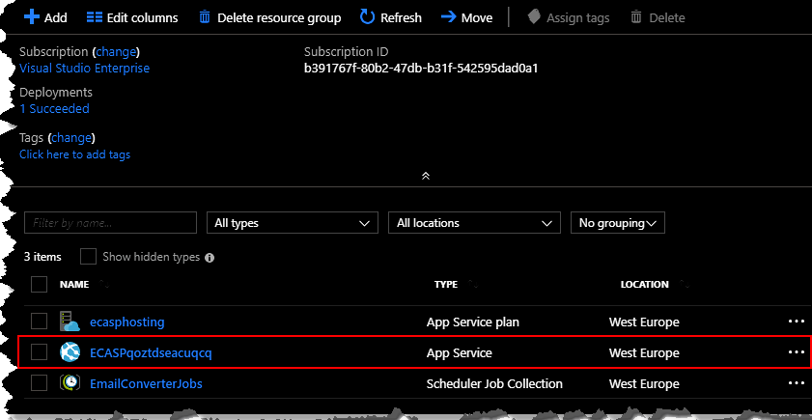
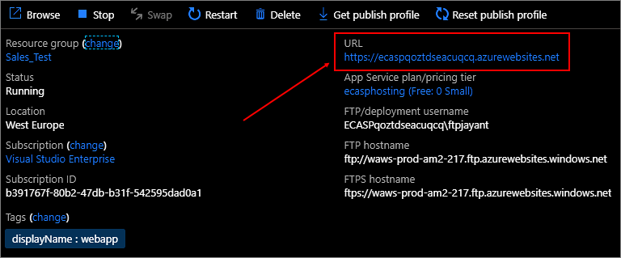

Log in to E-mail Account
When you click on the link inside the ‘App Service’ resource, the E-mail Converter log-in page for E-mail Account will open.
Enter the login credentials of the mailbox that needs to be monitored for the conversion of e-mails. The login credentials can be changed later, refer to Edit E-mail.
E-mail Converter tries to get the language from the Azure app service localization. In case that language is not supported, English will be selected. The language can be changed from the ‘Select Language’ dropdown.

Log in to SharePoint
When you have logged in to the mailbox, the E-mail Converter configuration page will open. This first time, only the ‘Add list’ button and ‘Live Monitoring’ on the configuration page is enabled while the rest is disabled.
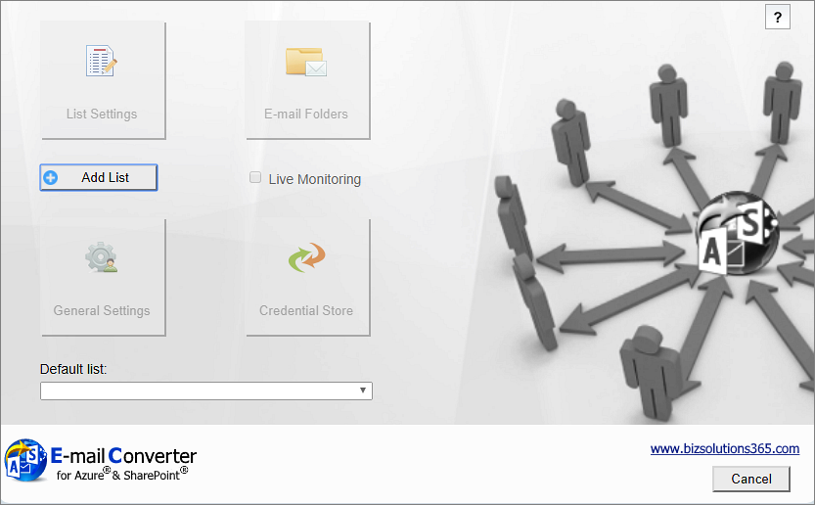
Click on ‘Add list’ to add a list, and you will be asked to enter the URL for SharePoint site where the list you want to use is located.
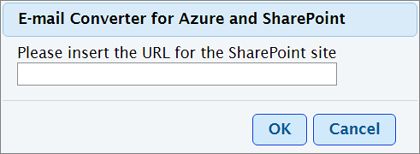
Now you will be prompted to log in to the SharePoint site you have entered.
Your credentials will be saved automatically. 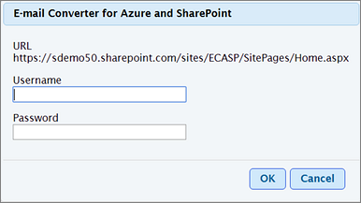

When you have logged in to the SharePoint site, all the lists of that site will be displayed. Select the SharePoint list that should be connected to E-mail Converter and click ‘OK’.
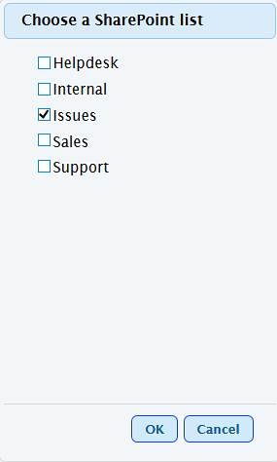
(If you have not added any SharePoint list to the site you have logged in to, this dialog will not appear.)
You can add more SharePoint lists by clicking on the ‘Add List’ button on the Configuration page or on the ‘List Settings’ page.
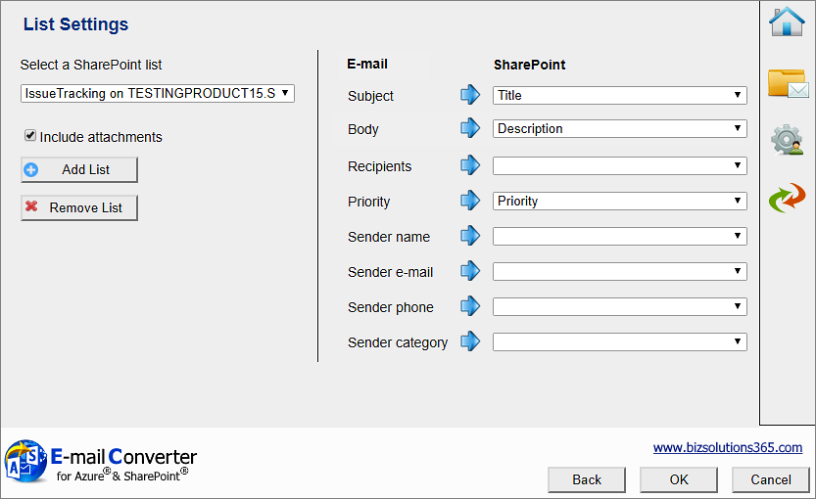
When you have added a list, the List Settings dialog will open.

The E-mail Converter Homepage
After you have added a list and mapped it under the List Settings, click OK to save and the E-mail Converter homepage will open. This page has three buttons: Configure, Statistics and Logs. 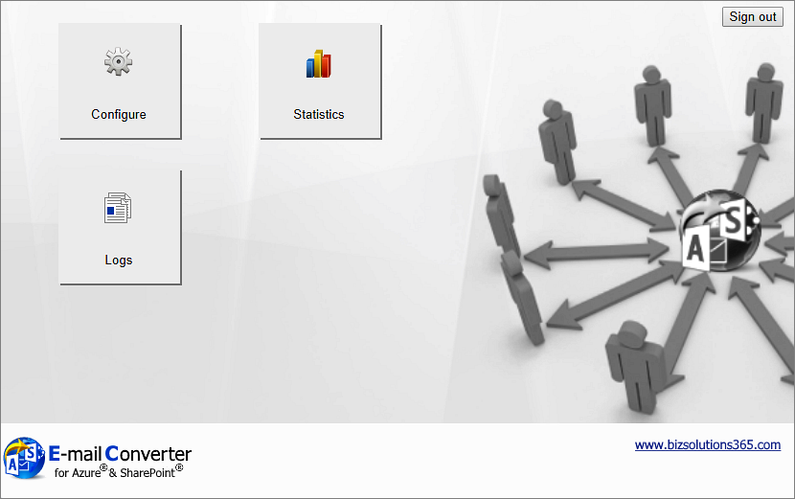

The Main Configuration Page
Click on the ‘Configure’ button to open the main Configuration page.
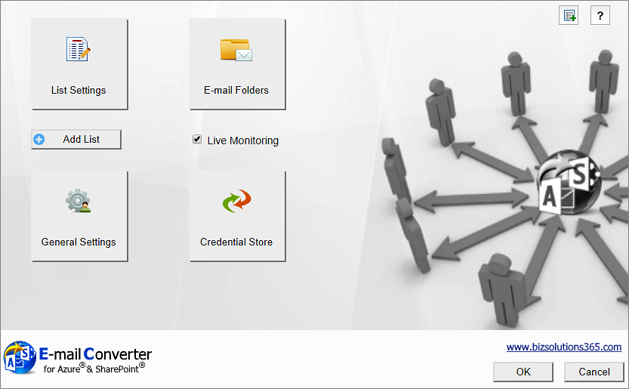
The main screen has four buttons for different settings dialogs and some quick links to features that you can also find in the settings dialogs. You can add lists by clicking on the ‘Add List’ button. The Live Monitoring (automatic conversion of e-mails) option is enabled by default. Uncheck the box if you want to stop the conversion process for some time.
The two buttons to the top right are for the Merge tickets feature and for the E-mail Converter Manual webpage.

List Settings - Define the Connection to SharePoint
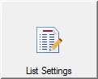
When you have selected a SharePoint list to use with E-mail Converter, the List Settings dialog will open. You can also always open the List Settings using the button in the main Configure screen.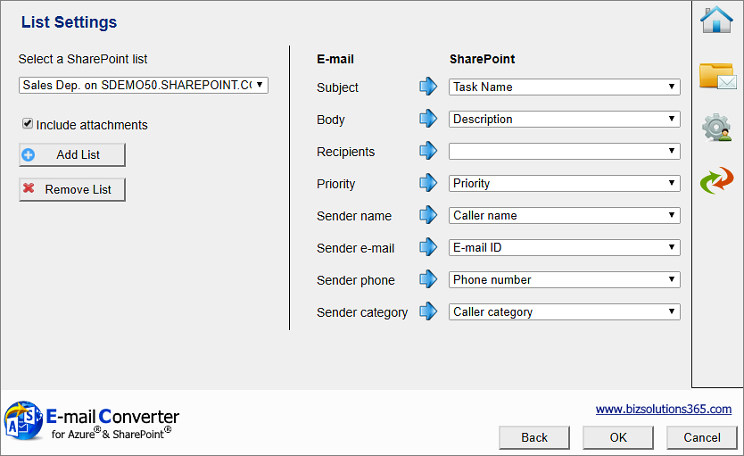
In the List Settings, you can define how the connection between e-mail fields and SharePoint list fields should work. Select to which columns in the list item the different parts of the e-mail should be published.
When you for example want the Subject of the e-mail to be filled out in the Task Name field of the list item, you select Task Name from the drop down at ‘Subject’. The dropdowns are populated with the columns of the SharePoint list you have chosen to use with E-mail Converter.
You can map multiple e-mail fields to the same SharePoint list column if you so wish.
E-mail Converter currently supports the SharePoint column types Single line text, Multiple lines of text and Choice.
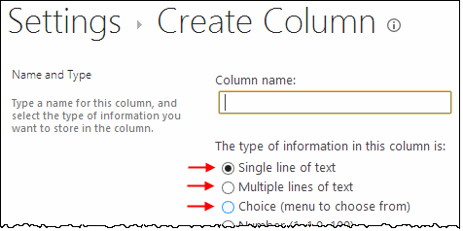
In the List Settings you can also add and remove lists and decide if e-mail attachments should be added to the list items.
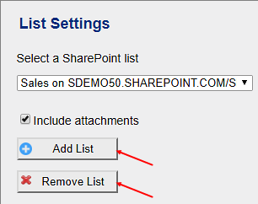

E-mail Folders
When a SharePoint list is added to E-mail Converter and the e-mail fields have been mapped to the list columns, it is time to decide which folder in the mailbox that should be monitored. That is done in the E-mail Folders page.
When you add several e-mail folders to E-mail Converter, you can select different SharePoint lists for different e-mail folders. This is a simple way of distributing the incoming e-mails to different lists.
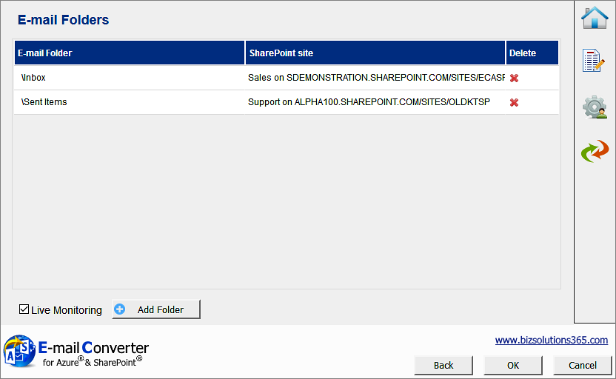
You can Add, Edit and Remove folders to be monitored.
When you click on the Add folder button, you will be asked to select a folder in the mailbox that E-mail Converter is connected to.
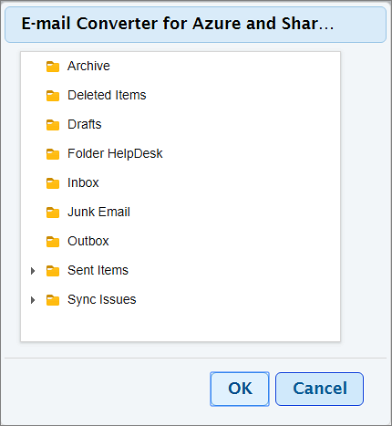
When you have selected a folder to monitor, a small dialog window is launched. It allows you to select a default SharePoint list for that particular folder. 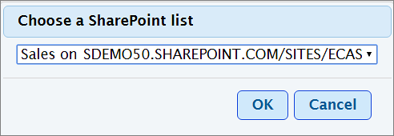

The e-mails from the monitored folder will be placed in a subfolder named Converted, once they have been converted.

Credential Store
When you configure E-mail Converter and have entered the path to the SharePoint site you wish to use, you are prompted to enter your log in details.
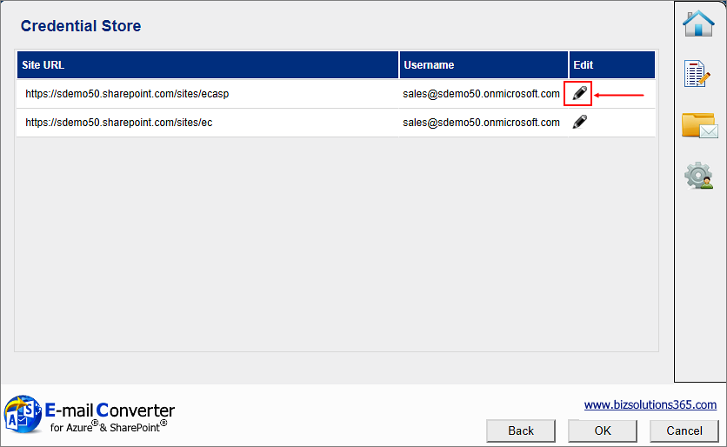
Click on the edit icon to the right of the username to edit the SharePoint site credentials.
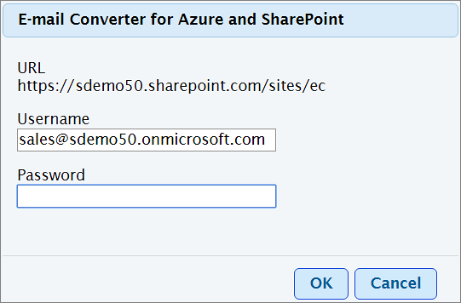

General Settings
In the General Settings page some general settings are gathered. 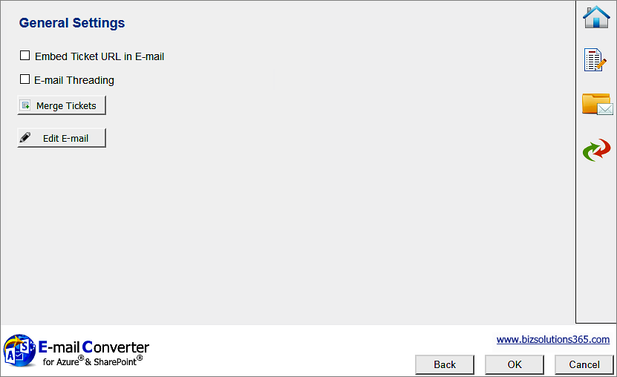

In the General Settings there are two checkboxes. None of them is checked by default:
- If you want the URL to the ticket to be shown in the converted e-mail, check the first box.
- Use the checkbox for E-mail Threading when you want E-mail Converter to add e-mails to existing tickets about the same subject, see below.
The Merge Tickets button takes you to a dialog where you can merge several tickets into one, refer Merge Tickets.
Click on the Edit E-mail button if you wish to change the Exchange login credentials for E-mail Converter, refer to Edit E-mail.

E-mail threading settings
The ‘E-mail Threading’ option in the E-mail Converter settings under General Settings must be enabled for the e-mail threading feature to work.
The E-mail threading feature in E-mail Converter makes it possible to add each e-mail concerning the same case to the first ticket, instead of creating one ticket for each e-mail. This process gives the responsible staff a chronological listing of all conversation related to that particular problem. The entire process is executed transparent to the user.
When an incoming e-mail is converted and e-mail threading is enabled, each time E-mail Converter finds a SharePoint item with the same ticket ID as the incoming e-mail, the body of the e-mail will be added to the corresponding field of the list item with the same ID. E-mail Converter will also tag the appended content of the SharePoint ticket with the name of the sender and system time at every update.
If an incoming e-mail is converted and E-mail Converter does not find a SharePoint item with the same ticket ID, a new item will be added to the list. 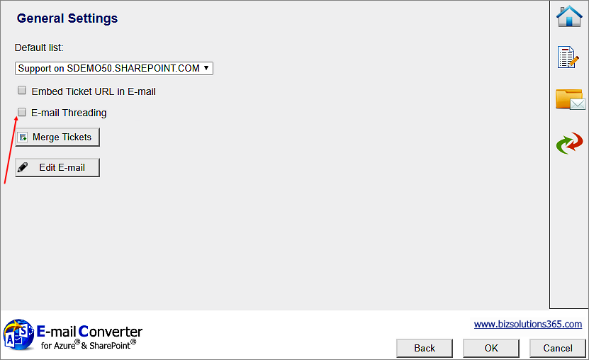

You must also make a setting in the SharePoint list:
In the SharePoint site, under List Settings >General Settings >Versioning Settings, activate the option Yes for 'Create a version each time you edit an item in this list?'.
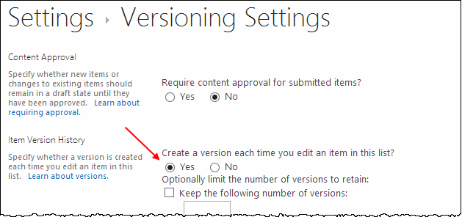
Create/Use a multiple lines of text field with the setting “Append Changes to Existing Text” set to Yes.
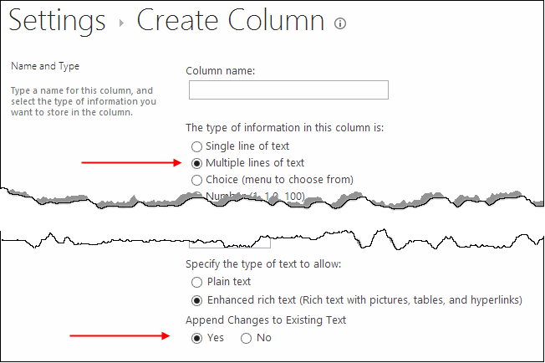
This multi-line field must be selected as Threading Field in the E-mail Converter List Settings. 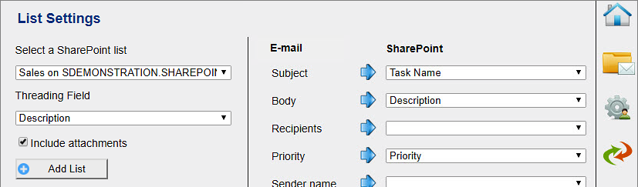

When the checkbox under General Settings is checked and the three settings above are made, every e-mail in a thread will be added to the same SharePoint list item.
Below is a ticket created from three e-mails of a case. The ticket was first created from the first e-mail, shown at the bottom, and then info from the subsequent e-mails have been added to the same ticket.
The image below shows how the e-mails are entered if you use the description field for both e-mail body and e-mail threading, see above. Then the first e-mail will be at the bottom of the ticket and the subsequent tickets will be added on top of it. This image shows the edit view of the ticket.
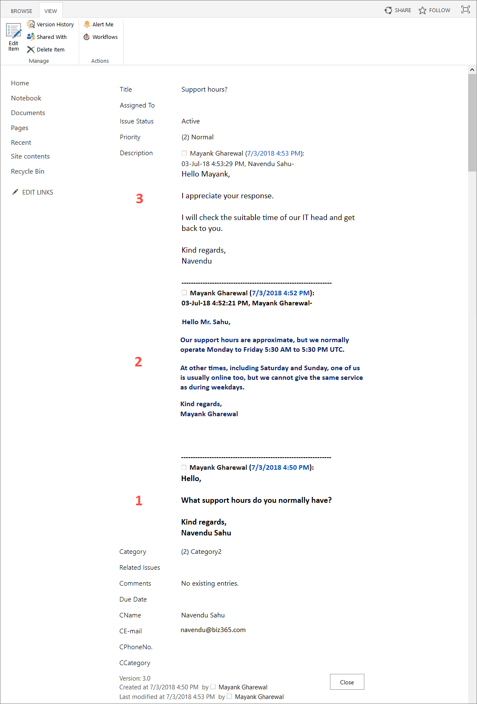
If you want another order between the first and subsequent e-mail, you can use a separate threading field and place it where you want the threading to come in the ticket. 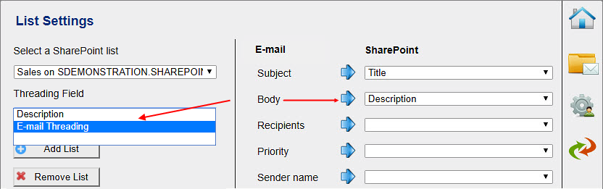

Maybe you want to always have the first e-mail on top, to always see at a first glance what the issue is about? Then you can map the e-mail body with the description field and the subsequent thread with another field that you place below the description field. This mapping will give the first e-mail on top and the subsequent e-mails ordered from the bottom and upwards. The image below shows such an e-mail thread in the ticket standard view.
(Custom SharePoint fields are placed below the default ones by default, so no further customization of the list item is necessary to get the custom threading field below the default description field. For other positions you have to modify the form, for example in SharePoint Designer.)
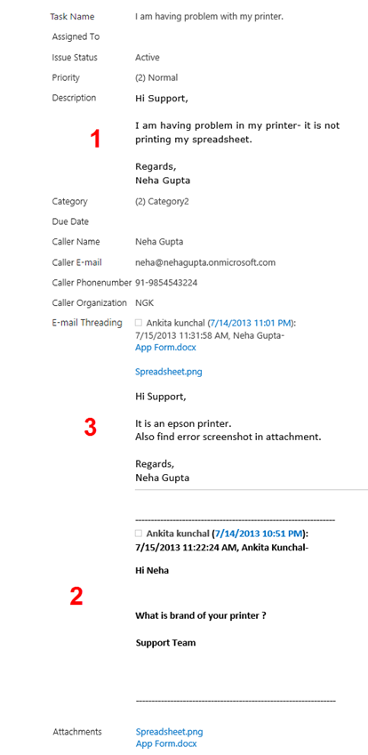

Sent e-mails folder
All sent e-mails of the e-mail threading will be moved to the subfolder ECASPSentItems under Sent Items after they have been added into the SharePoint ticket.

The e-mail
When you create a ticket from an e-mail and the option ‘Enable E-mail Threading’ is checked, E-mail Converter will append the ticket ID in the Subject of the processed e-mail (Ticket: + Subject + [ticket id)) to identify its SharePoint item ID.
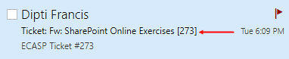
When you reply to an e-mail that has been converted into a ticket, make sure the conversion process has finished. Otherwise the Threading feature will not work. To check this, see if the subject line of the email has changed to "Ticket: <Subject> [ ticket #] "

Use of E-mail threading + multiple teams and lists
If you have a situation with several helpdesk teams, A and B, using different mailboxes to monitor incoming mails and different lists, you might want to send a case from one team to another, to ask for help. You then have the following situation:
When a processed e-mail having the ticket ID in the subject field from mailbox A is forwarded to mailbox B E-mail Converter will check if there is a ticket ID tag in the subject. If it is there, E-mail Converter will try to check if that ticket exists under the SharePoint list B.
If a ticket ID does not exist, E-mail Converter will create a new ticket in list B, and this is not a problem. But if it does exist, E-mail Converter will add the newest portion to that ticket. Note that the problem of the ticket with that ID in list B is probably not the same as of the e-mail with that ID that originally was for list A.
To avoid this, when forwarding an e-mail from team A to team B, remove the ticket ID under brackets and then send the e-mail. That way E-mail Converter in team B will process that e-mail as a new ticket in list B.

Merge Tickets
If you wish to merge several tickets into one, click on the Configure button on E-mail Converter home page and then the shortcut to the Merge Ticket button on the Configuration page. 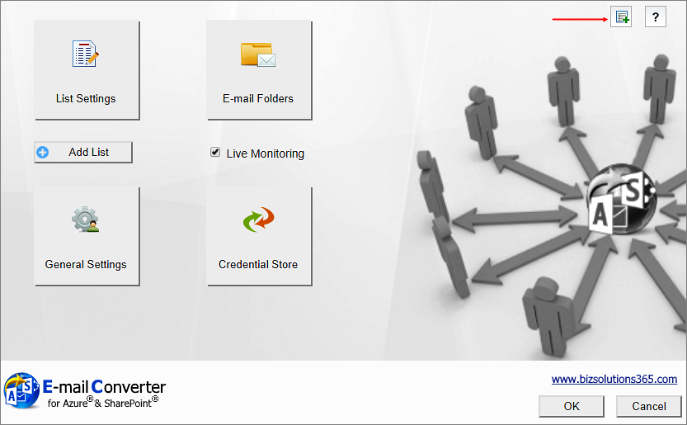

You can also reach the Merge tickets feature from the General Settings dialog. 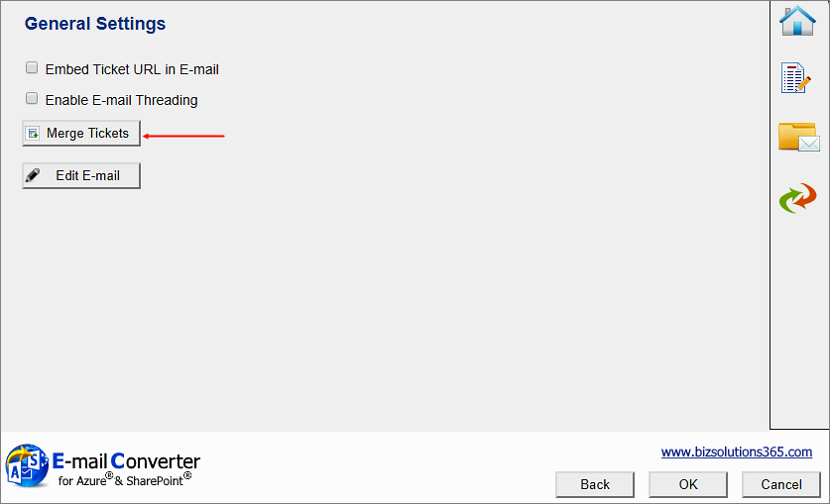

A Merge Tickets dialog will open. 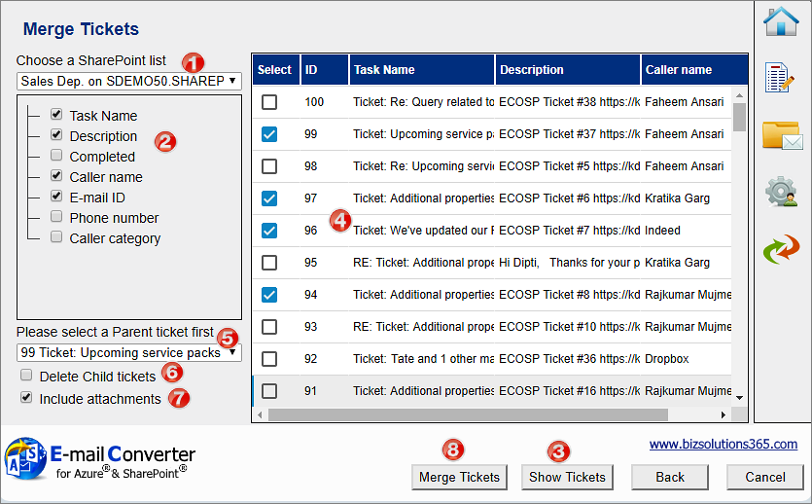

To merge tickets, follow this procedure:
- Select a list where tickets should be merged. If only one list is used for E-mail Converter, that one will be shown. If several lists are used, you can select the required list from the dropdown.
- The Merge Tickets feature supports merging single line texts and multiple line texts. For other fields merging is not possible. Check the fields that should be included.
- Press the Show tickets button.
- Select from the tickets in the grid which tickets should be merged into another ticket.
- Select the Parent ticket. All the selected parts of the selected tickets will be merged into the selected Parent ticket.
- Check the delete box if the tickets that have been merged - the Child tickets - should be deleted after having been merged into the Parent ticket.
- Uncheck the attachments box if you do not want attachments of the Child tickets to be merged into the Parent ticket.
- Click on Merge tickets to start the process.

Edit E-mail
You can change the login credentials to Exchange by clicking the Edit E-mail button in General Settings. Enter the credentials of any new mailbox that you wish to monitor and click on ‘Login’. In this page, you can also change the E-mail Converter language. 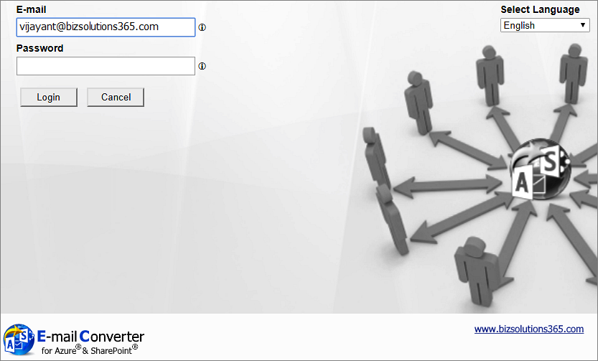

Logs
The Logs button in the E-mail Converter homepage, opens a dialog from where you can get information about ticket conversion messages and error messages from the last 30 days. 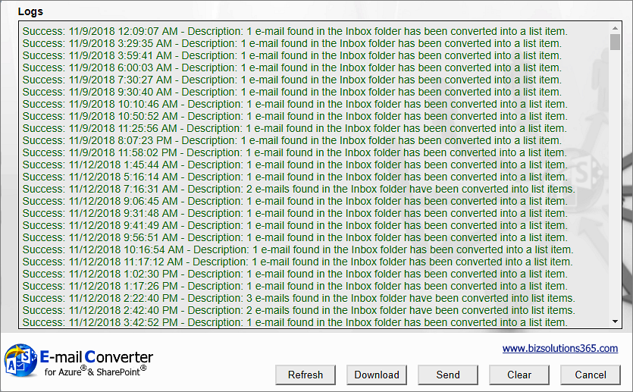

You can refresh, download, send or clear logs.

Statistics
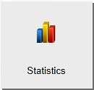
Statistics reports can be created via the Statistics button in the E-mail Converter home page.
When you click on the Statistics button, you will get a dialog that lets you select SharePoint list and fields for the current report. By default, all the fields in the list are selected.
When you have selected fields, click on Display Results.
When you then click on Report, an Excel file with the selected data will be shown. It is a normal Excel sheet, so all the standard Excel features can be used with the E-mail Converter reports.
Below the admin is interested to see what tickets have come in the Sales Department in August 2018. The admin first selects the relevant fields: 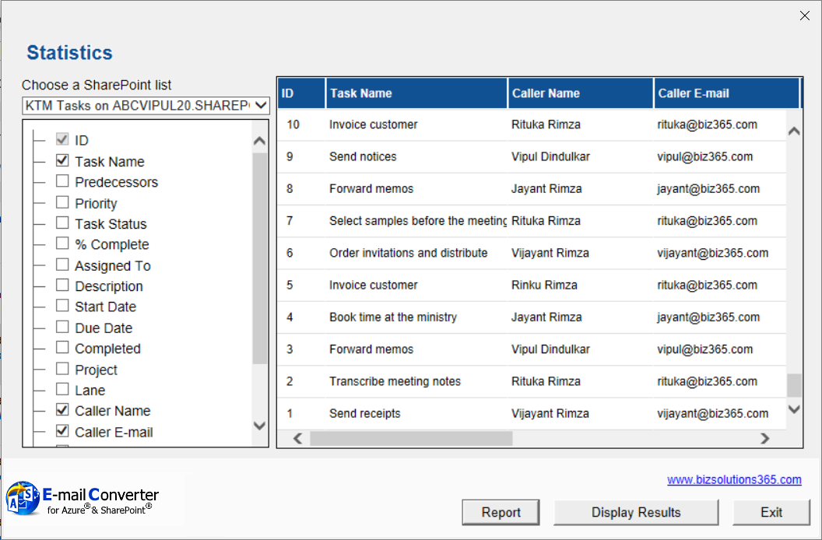

In the Excel report in the image below, the admin has filtered the Created date so that only August 2018 is displayed. 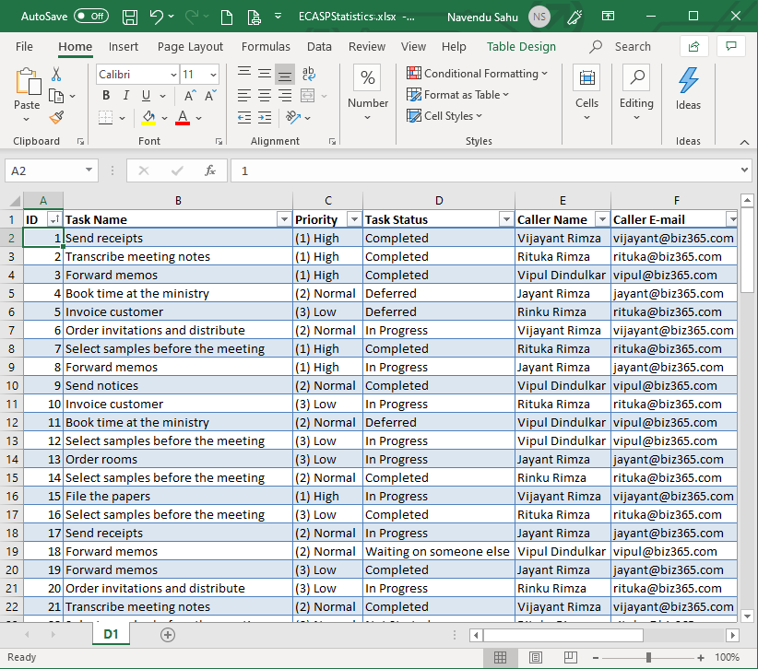

And here is a simple graph on the same data, for August 2018 but with only the caller category and number of tickets included.
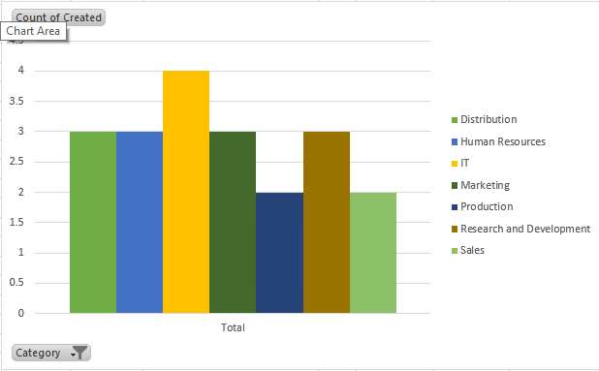

The Global Settings list
When the administrator saves the configuration of a SharePoint site in the E-mail Converter Settings, a hidden list, “ECOSPSETTINGS” is created at the selected SharePoint site. In that list an item is created, and in the body of that list item all list info is saved. Such a Global list will be created for each site that has at least one list used with E-mail Converter.
For example, if the user adds a list on “SharePoint Site A” to E-mail Converter, a new Global list will be created on “SharePoint Site A”. Similarly, if the user adds another list to E-mail Converter and that list is on “SharePoint Site B”, a new Global list is created on “SharePoint Site B” as well.
These hidden lists are helpful when the administrator makes a new installation of E-mail Converter for Azure and SharePoint or has switched from the Outlook edition of E-mail Converter to the Azure edition. When a SharePoint list is added via the E-mail Converter Configuration dialog and the application finds a “ECOSPSETTINGS” list on that site, it loads all the configured lists to the user. This way user gets all list settings automatically.
Each time the user selects a site to connect to E-mail Converter, the application checks if there is Global list with settings for E-mail Converter on that site. If there is, E-mail Converter loads the settings in the Global list from the site. (If there is no Global list, the application will create a Global list with the settings that this user defines and saves.)

Logic App
For periodic conversion of e-mails into tickets, E-mail Converter uses a Logic App in Microsoft Azure which manages how often the conversion process should take place.
By default, e-mails in the monitored folders are converted every 5 minutes.

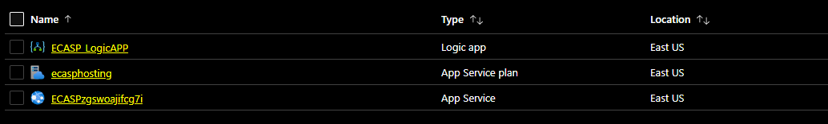

The conversion frequency can be managed under ‘Logic App’ in the E-mail Converter resource group. Follow the steps:

- Click on the “+ Add” under the resource group to create new Logic App.
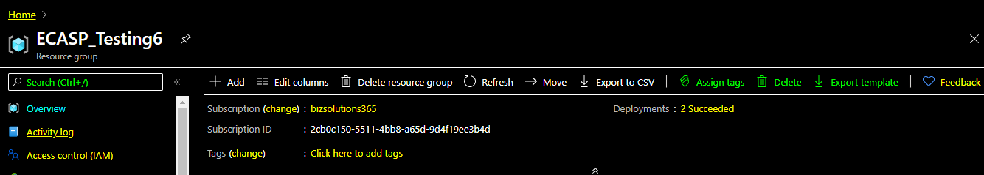

- The Logic App can be searched, or directly found under the Web to create new.
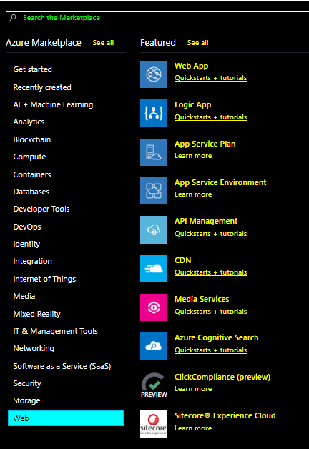

- Enter Logic App name, Select the location and Log Analytics on to monitor workflows. Click Next to proceed.
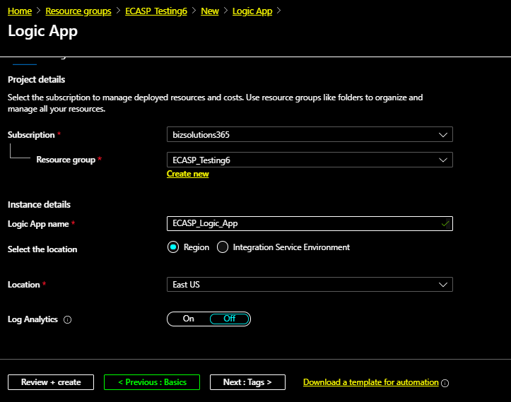

- Enter Name and Value unde the ‘Tags’. It is beneficial to categorize when using multiple resource and resource groups.

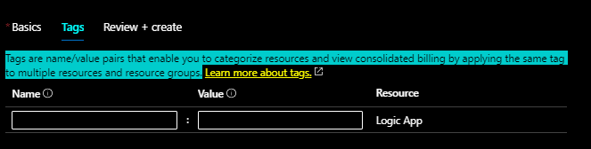
- All details can be reviewed and App Logic can be created. 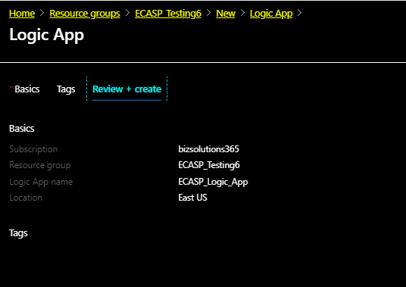
- Set the time interval and frequency at which you want to convert e-mails. To create recurrences of time interval user can select ‘Recurrence’ as 5 minutes with Interval frequency shown below.
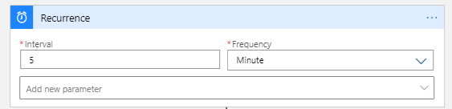

- Set the time interval and frequency at which you want to convert e-mails.
- Click Add an Action and choose an action as HTTP. You need to select ‘GET’ as a method. Enter the URL of Azure Web Service and add “/EWS/TicketProcess” at the end and execute it and save it.

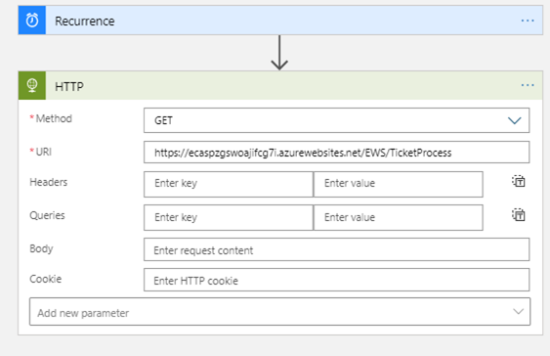

Registration and Trial Info
You may evaluate E-mail Converter without cost and with full functionality for 30 days.
If you want to continue using the solution after the trial period, you must subscribe to the solution. We supply a Premium version, which does not require registration at all, but organizations who select the Minimum or Medium Subscription must register their installations of E-mail Converter.
Minimum and Medium Subscribers will be given a registration key which allows the organization to continue using E-mail Converter for the duration of the subscription. 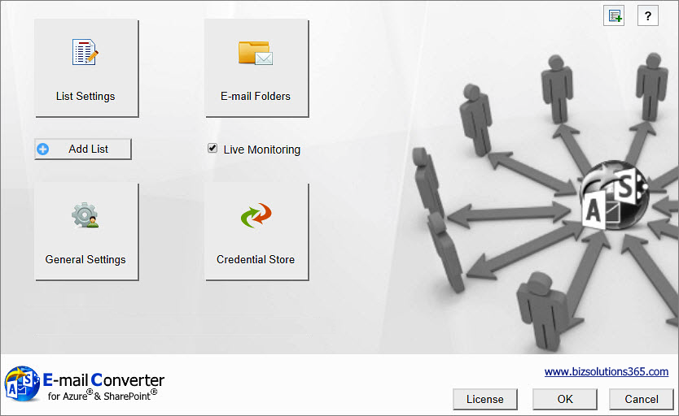

To register, open the Configuration page by clicking on the ‘Configure’ button in the E-mail Converter home page. Click on the License button, and a registration dialog will open.
Enter an e-mail address with your company domain and the registration key you have received from bizsolutions365m.com. Then click on ‘Registration’. The ‘License’ button will be hidden after the registration.
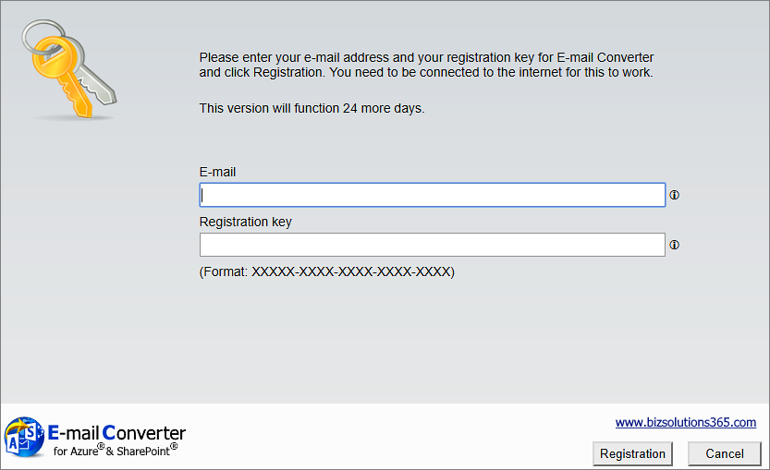

Upgrade E-mail Converter
Upgrades are done automatically by Microsoft Azure.

Subscription
E-mail Converter is licensed with a subscription. There are three subscription levels, Minimum, Medium and Premium. Support, upgrades and an unlimited number of users within the subscribing organization are included in all levels, but the Medium and Premium levels also give other benefits. Refer to the E-mail Converter Subscription page.

Contact
The solutions of bizsolutions365.com are supposed to be very easy to deploy, use and manage. However, if you have any kind of problem or questions about our software, there are several ways of contacting us:
E-mail | support@bizsolutions365.com | Technical issues
 | sales@bizsolutions365.com | General and sales issues
Telephone | +91 780 600 6234
Online Chat | www.bizsolutions365.com

Remove E-mail Converter
To remove E-mail Converter, delete the resource group in which E-mail Converter is installed. You may also delete the three resources individually, in case you have used an existing resource group.
To delete a resource group, click on the ‘Resource groups’ option in the left panel of the Microsoft Azure Dashboard.
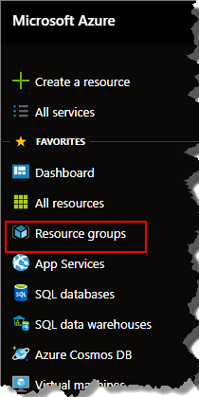
Check the box to select the resource group you want to delete and click on the horizontal ellipsis. Select ‘Delete this resource group’.
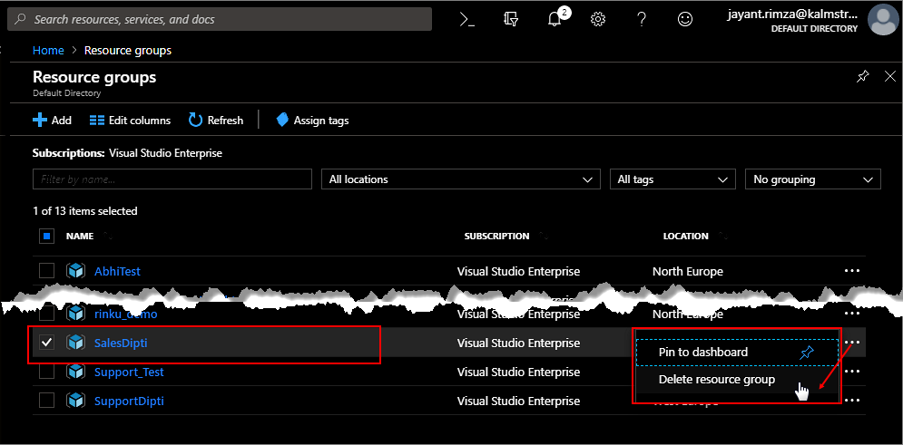
You will be asked to enter the name of the resource group to confirm the deletion.
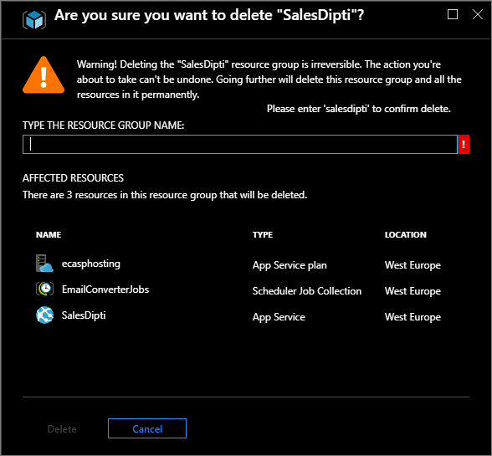
Enter the name and click ‘Delete’.

