Calendar Browser V10, User manual

Content
1 Introduction 2
2 Calendar Browser in Outlook 2
2.1 The Calendar View 2
2.2 The Calendar Browser Folder 2
3 Install the Calendar Browser Client 3
3.1 Add Calendar Group 6
4 The Calendar Browser Buttons 7
4.1 Several Calendar Groups 7
5 Browsing Resources 8
5.1 See Calendars 8
5.1.1 Views 8
5.2 See Descriptions of Resources 9
5.3 Search for Resources 9
6 Book a Resource 10
6.1 Book Supplies 11
6.2 Project 12
6.3 Extra Booking Information 12
6.4 Invite Attendees. 13
6.5 Cancel a Booking 14
6.6 Export a Booking to PDF 14
7 The Calendar Browser Overview 14
7.1 Choose Date and Period 16
7.2 Print 16
7.3 Book in the Overview 17
8 Remove Calendar Browser Client 17
9 Support 18

Introduction
Use Calendar Browser for Outlook when you want to book any kind of resource within your organization. It could be rooms, cars, machines or even people. Calendar Browser is an add-on to Outlook, so you don’t have to learn a new program to make the bookings.
In Calendar Browser each resource has its own calendar, and when you book a resource you make an appointment in that calendar.
Most of the installation is done centrally by the server administrator, but it is possible that you have to install a minimal client application to use Calendar Browser, see Install the Calendar Browser Client below.
For simplicity we talk about booking rooms in this manual. Your organization might use Calendar Browser for booking of other resources, but the principles are the same.
Most of the screenshots in this manual come from Outlook 2013, but where there is a significant difference we show 2007 also.

Calendar Browser in Outlook

The Calendar View
Calendar Browser works in the calendar view of Outlook. It is here you will find the resource calendars and the Calendar Browser buttons.
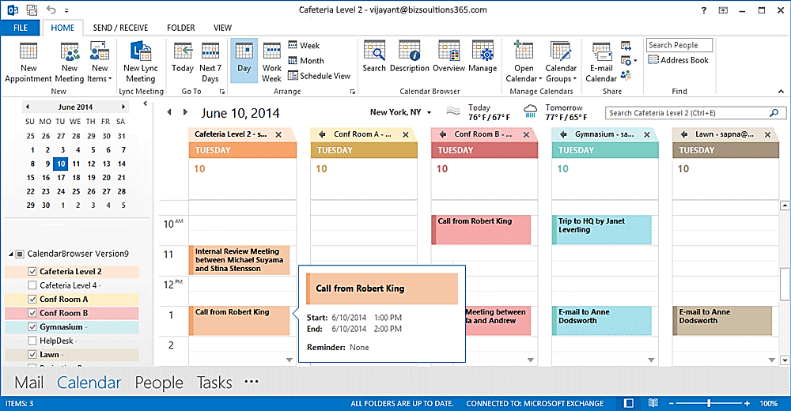

The Calendar Browser Folder
There is also a Calendar Browser folder among the Mail folders, the “Resort” folder in the image below, but you should never use that folder for bookings.
The only time you should use the Calendar Browser folder in Outlook is if you add a Calendar Group to your Outlook. See Add Calendar Group.
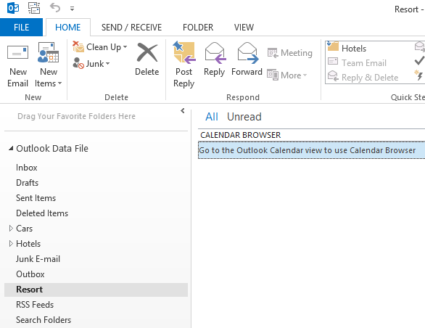

Install the Calendar Browser Client
If the Calendar Browser admin has not already installed Calendar Browser Client on your PC, you will have to do that before you can start booking resources and supplies.
Follow this procedure to install Calendar Browser Client:
- Close Outlook.
- From your PC, Go into the Calendar Browser folder on the server and click on the file CBClientSetup.msi. This screen will open:
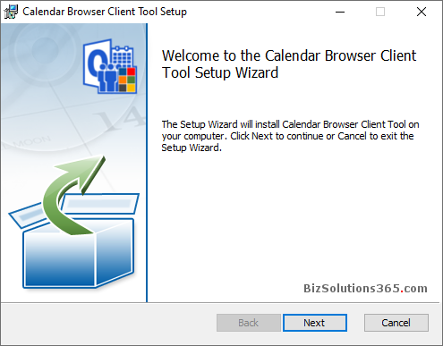

When you click Next you are asked to select folder for the Client installation. If you don’t select another folder, the Client installation will create a bizsolutions365.com folder under Program Files (x86) if you have 64 bit OS or Program Files if you have 32 bit OS and install Calendar Browser Client there.

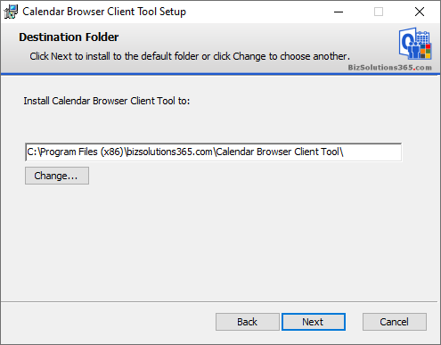

Click Next again and then Install:
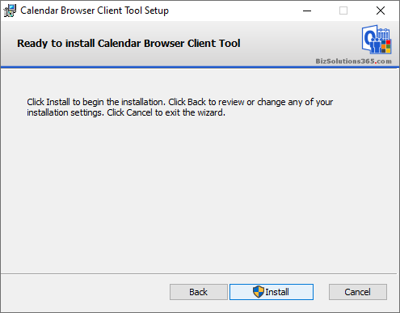

The installation starts.
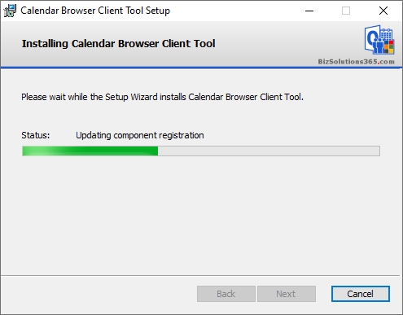

You will be told when the installation is completed. Then, just click Finish.
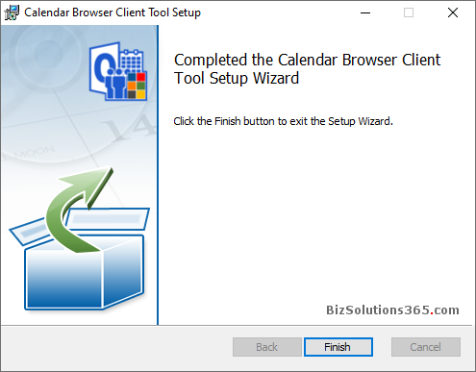

Add Calendar Group
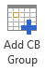
When your client tool has been installed successfully and you use the Calendar Browser for the first time, you might need to add the Calendar Group(s) you wish to use for bookings. This is done with the button in the new Calendar Browser toolbar in the Outlook Calendar View.
When you click the button a dialog opens which asks you to select a Calendar Browser installation folder in Outlook. Select the CB Group you want to use and you are ready to start using Calendar Browser.
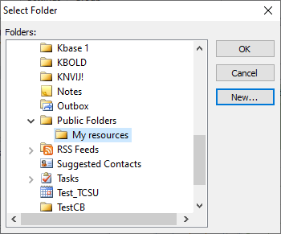
Should you want to add another Calendar Browser installation, select a calendar that is NOT a Calendar Browser calendar, for example your personal calendar. Then you will see the Add CB Group button again and can add a new installation.
It is also possible that you will not see this Add CB Group button but instead the Calendar Browser buttons mentioned in section 4 below In that case the administrator has already added Calendar Browser group(s) for you.

The Calendar Browser Buttons
When you have added a calendar group to Outlook you will have new Calendar Browser buttons in the ribbon. How many buttons you see depends on the administrator settings. You may see four, three or only two Calendar Browser buttons
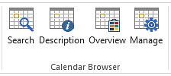
Outlook 2013 Outlook 2007
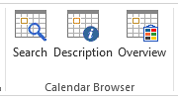
Outlook 2013 Outlook 2007
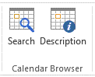
Outlook 2013 Outlook 2007

Several Calendar Groups
When you have several Calendar Groups you will have two different ribbon groups in Outlook. (The Manage and Overview buttons might be hidden by the administrator.)
When you have not selected a calendar in any of the Calendar Groups, the Calendar Browser ribbon group gives a possibility to either add a Calendar Group or to select one group to work with.
When one calendar or more in one of the Calendar Groups is selected, the Calendar Browser Outlook ribbon group will look like in the image below and the buttons will work for only that group.
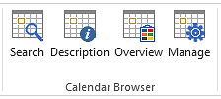

Browsing Resources
With Calendar Browser you can easily browse among your organization’s resources to find the most suitable one among those who are free at the time when you want to book.

See Calendars
To see the resource calendars, select the calendar(s) you wish to see from the list to the left.
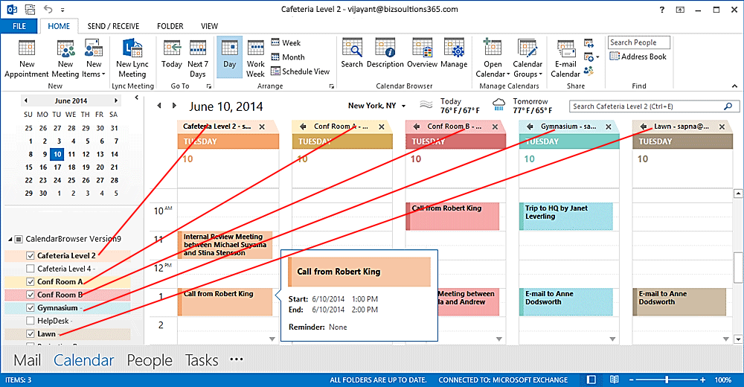

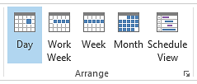
Views
You can choose between different views, day, week or month, just like you do in your own Outlook calendar. Select a resource calendar in the list and click on the desired view in the Outlook ribbon.

See Descriptions of Resources
Which one of the free resources is best for your needs? To decide this you can look at the descriptions of the resources. Select a particular resource and then click the Description button in the Calendar Browser ribbon group. Now the description comes up.  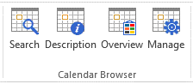 | 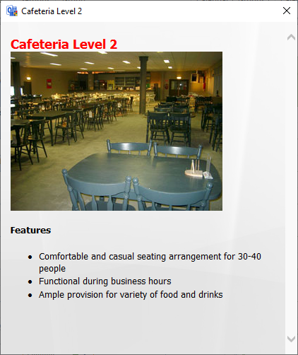

Search for Resources
You can search for resources that are free at specific dates and times and have as many seats as you need.
Click the Search button in the ribbon, and the Search dialog will be shown. Specify date and time and maybe how many seats you need. Then all the free resources on your specified data and time, with the desired number of seats or more are shown in the “Calendars found” list.
Click “?” to see
By clicking the question mark (“?”) you can see a description of the selected resources.
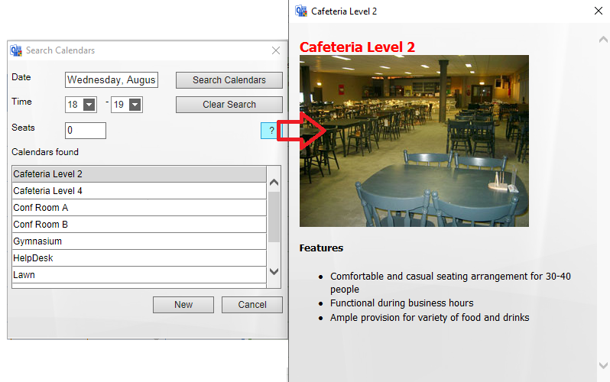

Click New to book
To book a resource directly from the Search dialog, select one of the resource calendars and press the New button. An appointment for the selected time and resource will open.
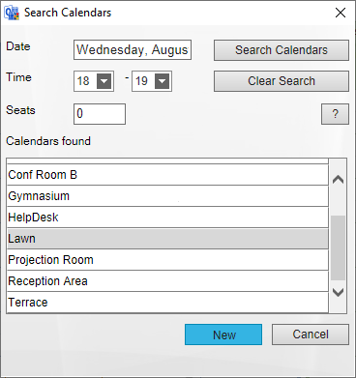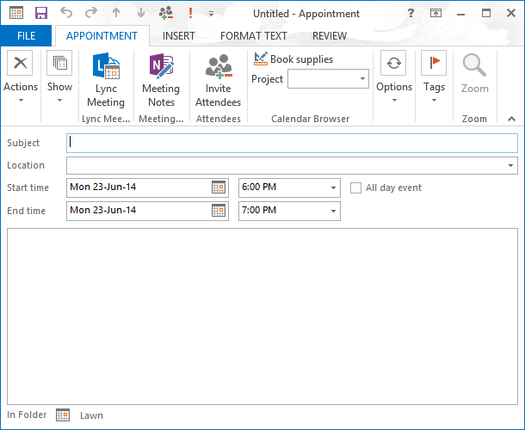

Book a Resource
When you are not in the Search dialog, book a resource by selecting its calendar in Outlook and making an appointment. You make the appointment as usual, by clicking on an empty space in the resource calendar.
A common Outlook calendar appointment opens, and you can fill out time and other booking information, such as project. You may also book additional services or supplies. When you are finished, click Save and Close.
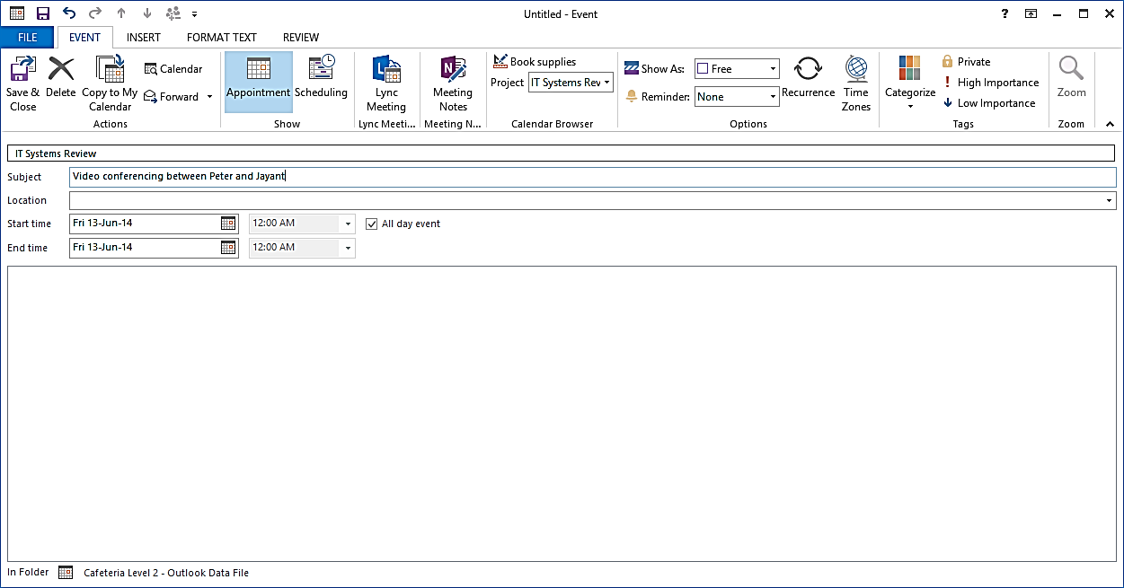
You can also book a resource from The Calendar Browser Overview.
.

Book Supplies
At the same time as booking a room you can book supplies for the meeting by clicking the button Book Supplies.
You will then be presented with a dialog where you can select what you need more than the resource you are booking. Define another number than the default 0, and the item will be booked.
Your name and the date will be filled out automatically. If you so wish, you can comment on your order. You might also be able to select among place settings defined by the administrator.
It might be mandatory to specify Cost Center. This is also defined by the administrator. If Cost Center is mandatory, you cannot save the booking without filling it out.
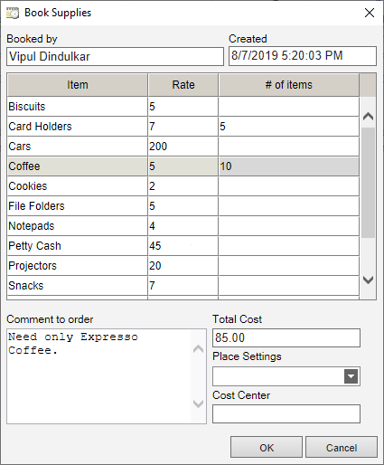

Project
The administrator may have predefined projects and maybe also made it mandatory to select a project for each booking.  Click the arrow to see the project list and select the project you will make the appointment for.  The administrator can change the caption “Project” to something else, so in your Calendar Browser maybe something else than a project can be selected. | 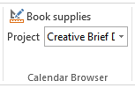
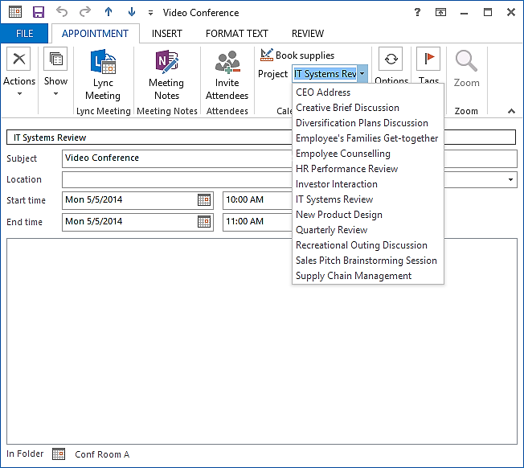

Extra Booking Information
The Calendar Browser administrator might enable Extra booking information. In that case each booking appointment has an additional task pane where you can select extra data. By default the extra info is about host and attendees, but in your organization the terms may be other than “Host” and “Attendees”.
The “Host” is selected from a dropdown, and if you create the appointment you will be added by default.
The “Attendees” are written in, but you only have to write the first letter. Then you will get suggestions and can select the correct name. Click on Add, and continue with the next person.
The additional information (e-mail address, company or department) is filled out automatically, just like the number of attendees
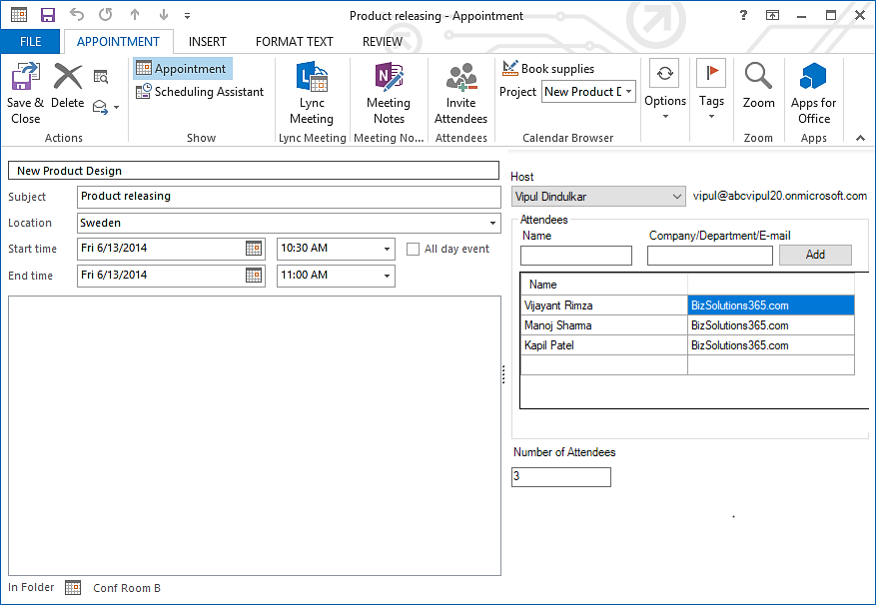

Invite Attendees.
If you want to invite attendees directly in the Calendar Browser booking sheet, you must know if the Calendar Browser calendar you are booking is are in the form of a mailbox or a public folder. Ask the administrator!

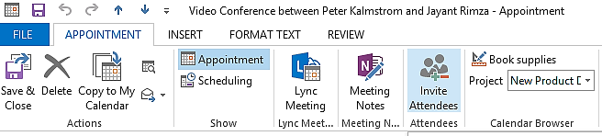

When your Calendar Browser calendars are mailboxes, you can invite attendees at the same time as you book the resources.
When the calendars are public folders, you must go to your personal calendar and invite the attendees from there.
Cancel a Booking  If you want to cancel a booking, you just delete it. Select the appointment, right click and choose Delete.  You can also do this by opening an appointment and select the Delete option from the ribbon.  If you have ordered any supplies with your booking, that order will also be cancelled automatically. | 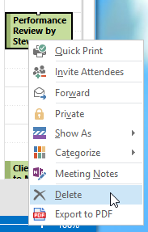

Export a Booking to PDF
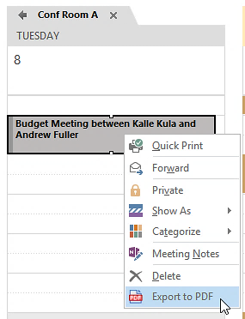
You can export a booking to a PDF file. This PDF file may be printed, saved or uploaded to a place where it can be downloaded or sent as an e-mail attachment.

To export, select the appointment you want to export and right click. Then select the option Export to PDF. You may also use a key combination: Crtl + Shift + P. This combination may also be used when the appointment is open.

When you need to print a booking, we recommend that you first export it to PDF, instead of using the Quick Print option. That way some specific Calendar Browser terms will not be included, so the print will get a cleaner look. You will still get the information about resource name and when it is booked.

The Calendar Browser Overview
Through the Overview button, you can reach an overview over future bookings. The orders for each room and meeting are also listed here.
The administrator can hide the Overview button, so you might not see it. In that case you cannot use the Overview.
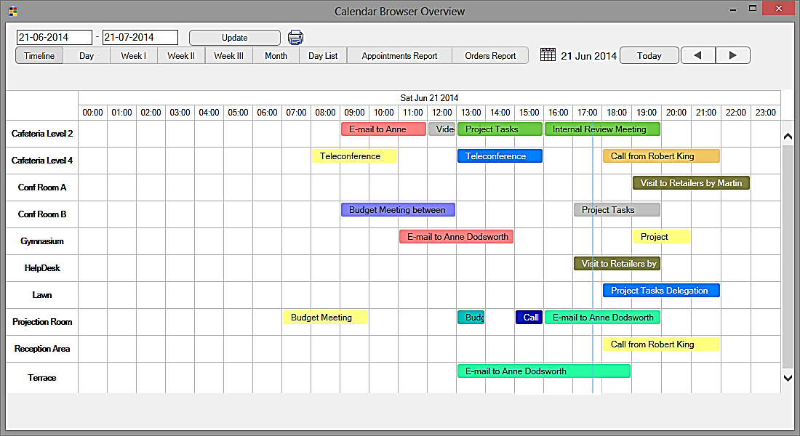
The bookings shown in the overview may be handled in different ways:
- Move the mouse cursor over the appointment and info about the booking is shown in a popup.
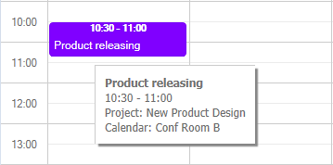

- Select the appointment and more info about the booking is shown at the bottom of the screen.
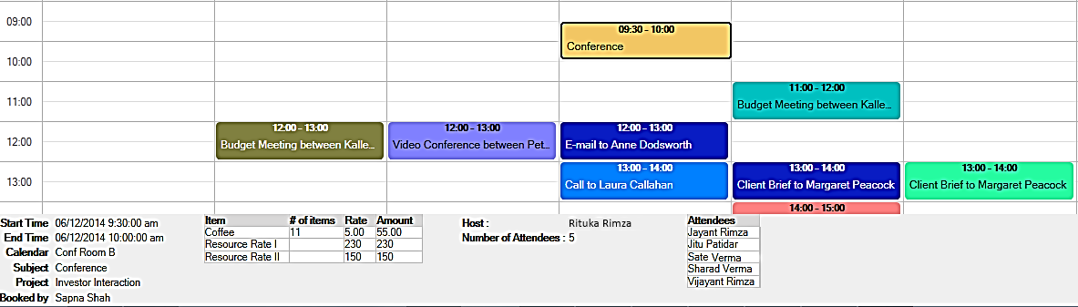
- Double-click the appointment to open it.

Choose Date and Period
Specify what date you are interested in and choose period, see the image below. The current day is shown by default.
You will also be able to see the resource booking done by a particular “host” if this feature is enabled by the administrator. Instead of “host” you may have something else to filter on. Refer to Extra Booking Information

Print
You may print the Overview, something that is especially useful for the Appointments and Orders reports and for the Booking summaries.
When you want to print the Timeline, Day, Week I, Week II, Day List, or Month view, open the desired view and press the Print button. The PC must be connected to the internet to print these views. A PDF file will be downloaded to your PC. Open it and print it.
When you want to print Week III, Appointments Report, Order Report or Booking Summaries, a window will open asking you to select a printer. Select it and click the Print button. No internet connection is required for these views.
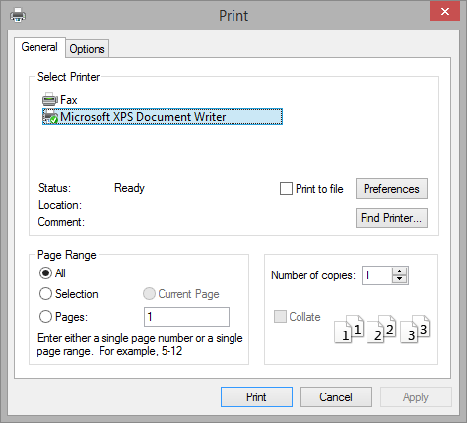

Book in the Overview
When you click in an empty cell in the Overview, an appointment for that time and resource calendar will open. That way you can book resources directly from within the Overview, with supplies and project, just as you do from the calendar.
You must update the Overview with the Update button to see the new appointment.

Remove Calendar Browser Client
To un-install Calendar Browser Client, go to the Control Panel, Add-Remove programs / Programs and Features. Right click on Calendar Browser Client Tool and choose Uninstall
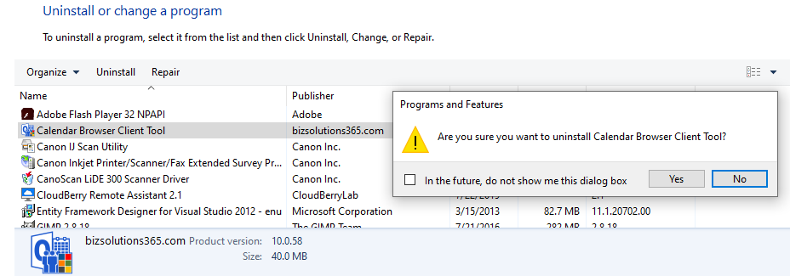

Support
If you get problems with Calendar Browser, you are welcome to contact the bizsolutions365.com Support, but we recommend you to first inform the Calendar Browser administrator about the issue.

