***Calendar Browser* V10 Administrator manual**

Content

1 Introduction 4

2 Requirements 4

3 Features 5

3.1 Descriptions 5

3.2 Search 5

3.3 Book 7

3.4 Order Supplies 8

3.5 Projects 9

3.6 Invite Attendees 10

3.7 The Calendar Browser Overview 10

3.8 Export a Booking to PDF 10

4 Installation 10

4.1 Create a *Calendar Browser* Directory on the Server 11

4.2 Central Installation 11

4.2.1 Client Installation 13

4.2.2 The *Calendar Browser* Outlook Folder 15

4.2.3 Installation Finished 17

4.3 Example Data 17

4.3.1 Load Example Data 17

4.3.2 Remove Example Data 18

4.4 Add Calendar Group 18

4.5 Multiple *Calendar Browser* Outlook Folders 19

4.6 Automatically Add CB Group To All Clients 19

4.7 The *Calendar Browser* Server Directory 20

4.8 The Calendar Browser Client 20

4.9 User Permissions on the Server *Calendar Browser* Folder 20

5 The Calendar Browser Settings 21

5.1 Configure 21

5.1.1 Prevent Double Bookings or Recurrence 22

5.1.2 Ribbon Settings 22

5.1.3 Copy Appointments 23

5.1.4 Change Log 23

5.1.5 Configure Extra Booking Information 23

5.1.6 Short Notice Flag 25

5.2 Calendars 26

5.2.1 Add Calendars 26

5.2.1.1 Add A New Public folder calendar 27

5.2.1.2 Add A Direct Booking Mailbox Calendar 27

5.2.1.3 Public Folder or Direct Booking Mailbox Calendars? 27

5.2.1.3.1 Public Folder Calendar 27

5.2.1.3.2 Direct Booking Mailbox Calendar 27

5.2.1.4 Add Personal Calendars 28

5.2.1.5 Browse To Existing Calendar 28

5.2.1.6 Remove Calendar 28

5.2.2 Description 28

5.2.3 Overview Images 29

5.3 Project 29

5.4 Supplies 30

5.4.1 E-mail Notifications 31

5.4.2 Remove supply items without disturbing existing bookings 32

5.5 Place Settings 33

5.6 New Appointments 34

5.7 Auto-Bookings 35

6 The Calendar Browser Overview 36

6.1 See More Info 36

6.2 Search the Overview 37

6.3 Print 38

6.4 Overview Images 38

6.5 Day View 39

6.6 Week Views 39

6.7 Month View 39

6.8 Day List View 40

6.9 Appointments and Orders Reports 40

6.10 Booking Summaries 41

7 Archive and Statistics 42

7.1 The Archive Dialog 42

7.2 Database 43

7.3 Archiving 44

7.4 Statistics 45

7.4.1 Default Reports 45

7.4.2 Custom Reports 47

8 Upgrade or Repair *Calendar Browser* 48

9 Subscription 50

9.1 Register 50

10 Support 51

10.1 Contact 51

11 Remove Calendar Browser 51

11.1 Remove Calendar Browser Client 51

# Introduction

*Calendar Browser* is an application for booking resources within an organization. It is totally integrated in Outlook and can be used with both public folders and shared mailboxes. The application is centrally installed and configured. Only a minimal client installation is needed.  
  
In *Calendar Browser* each resource has its own calendar, **and to book a resource the user simply makes an appointment in the calendar of that resource**. This appointment can also be copied to the user’s personal calendar or to another calendar of the administrator’s choice, *see Configure*. All the bookings are stored on the Exchange Server.

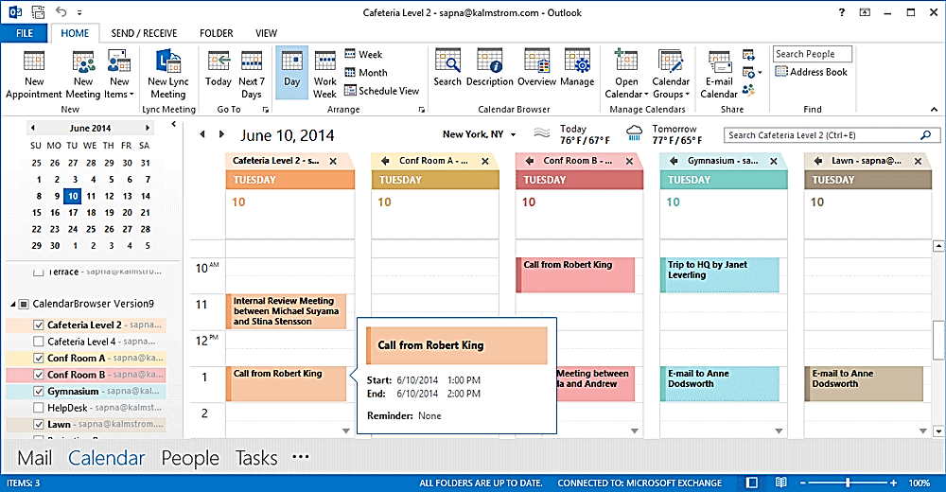

The example data in *Calendar Browser* used in this documentation shows mainly booking of rooms, and for simplicity we also talk about booking rooms in this manual. However, anything that is booked within an organization – cars, equipment, personnel – can of course be booked through *Calendar Browser*.

The **Outlook language** will be automatically used for *Calendar Browser*. Danish, Dutch, English, Estonian, Finnish, French, Italian, Norwegian, Portuguese, Russian, Spanish and Swedish are supported. If the Outlook language is not supported, English will be used instead.

The screenshots in this manual come from Outlook 2016.

# Requirements

To install and use *Calendar Browser* you need

* Microsoft **Outlook** 2010 or above installed on each client. Both the 32-bit and the 64-bit versions are supported.
* An **Exchange Server**, any version, or Office 365.
* Microsoft **Excel** 2010 and above for the statistics.
* Windows 7 or above.
* Microsoft .NET Framework 4.0 Extended or above. If it is not present, the installer will give a download link.

The application helps you get more out of Outlook and Exchange, but it does not assist you with the general configuring of those programs.

# Features

Here we will give just a short description of the features. For more extended explanations of each feature, refer to the [*Calendar Browser* User Manual.](https://bizsolutions365.com/our-products/calendar-browser/cb-manual/)

## Descriptions

To facilitate an adequate choice among the free rooms, *Calendar Browser* gives the users possibility to see descriptions of all the rooms – or of course other bookable resources within the organization.

|  |  |
| --- | --- |
| To reach a description follow these steps:   * Select the resource you wish to see info about in the resource list. * Click the Description button in the ribbon. * A new window with a description of the resource will open. |  |

## Search

|  |  |
| --- | --- |
|  | Users can search for rooms that are free at specific times and have the desired number of seats or more. Resource descriptions may be seen from the Search dialog, and the preferred resource may be booked directly from within the dialog. |

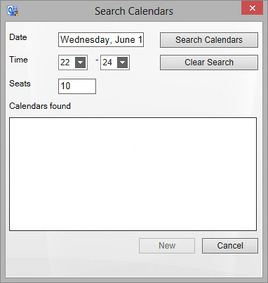

Select Date, hour and seats if applicable and then press the button “Search calendars”. Now all free resources for that time will be shown.

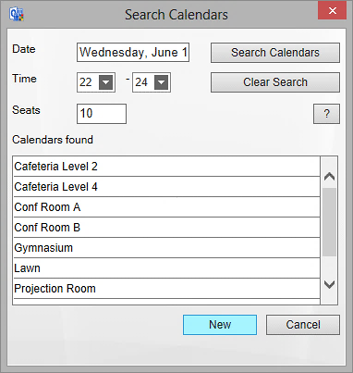

To see a description, press the question mark (“?”) button to the right.

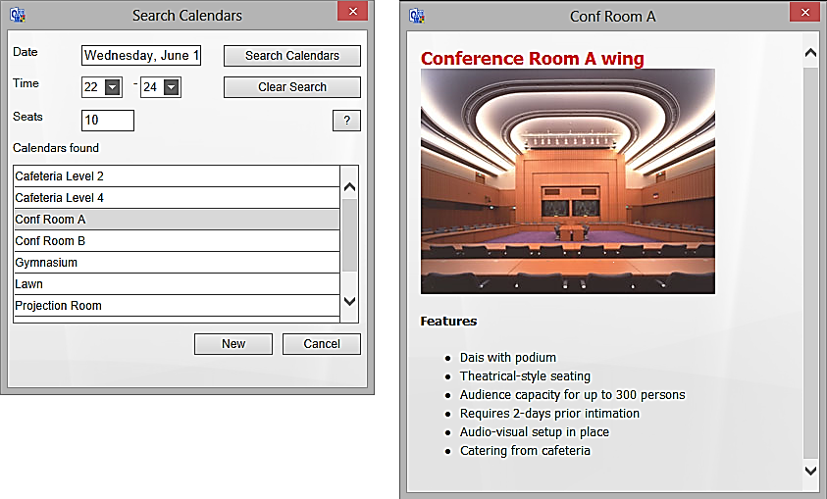

To book a resource directly from the Search dialog, select one of the resource calendars and press the New button. An appointment for the selected time and resource will open.

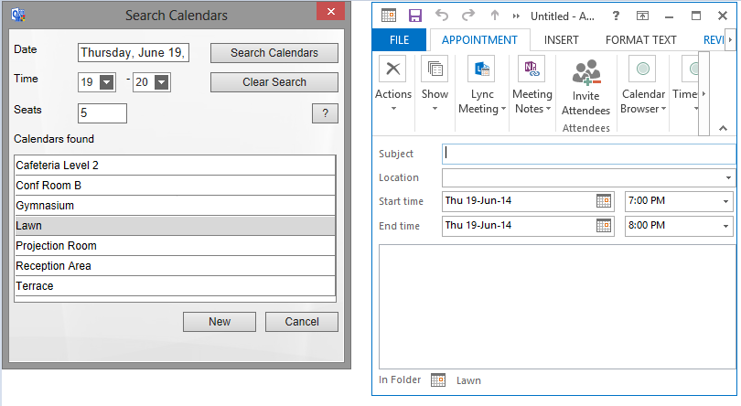 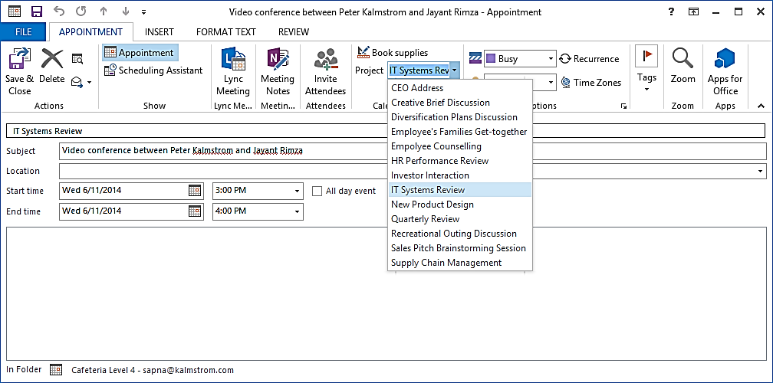

## Book

The main feature for *Calendar Browser* is of course the possibility to book resources without having to use separate software. For users already familiar with the Outlook calendar, it is very easy to learn how to book resources with *Calendar Browser*.

Create an appointment in the selected resource calendar by clicking on an empty space in the resource calendar, just as when you create a standard Outlook appointment.  
  


|  |  |
| --- | --- |
| When the appointment opens, all the Outlook calendar features can be used. Users can not only book the resource but also order the required supplies and specify the project for which the resource is booked. |  |
|  |  |

## Order Supplies

By clicking the Book Supplies button, users can order supplies for the resource booking inside the booking form. *See* Supplies on how to fill out the Supplies form in the Admin Settings. Specifying Cost Center can be set to mandatory. The Book Supplies dialog inside the appointment can give the following info:

* Booked by: The Outlook profile name is filled out automatically.
* Created time: This is also filled out automatically.
* Number of items: Here the user can specify the number of items of each supply item that is booked. The user selects the supplies by entering a value for the number of items ordered. The currency will automatically be the one specified by the system.
* Comment to order: Allows the user to specify any instructions for the supplies order.
* Total cost: This will be automatically calculated by *Calendar Browser,* based on the number of items ordered and their costs.
* Place settings: Allows the user to select the type of place setting arrangement needed for that particular appointment. The place settings to select from are specified in the Settings.
* Cost Center: This information can be numeric or free text. The administrator specifies the format in the Settings.

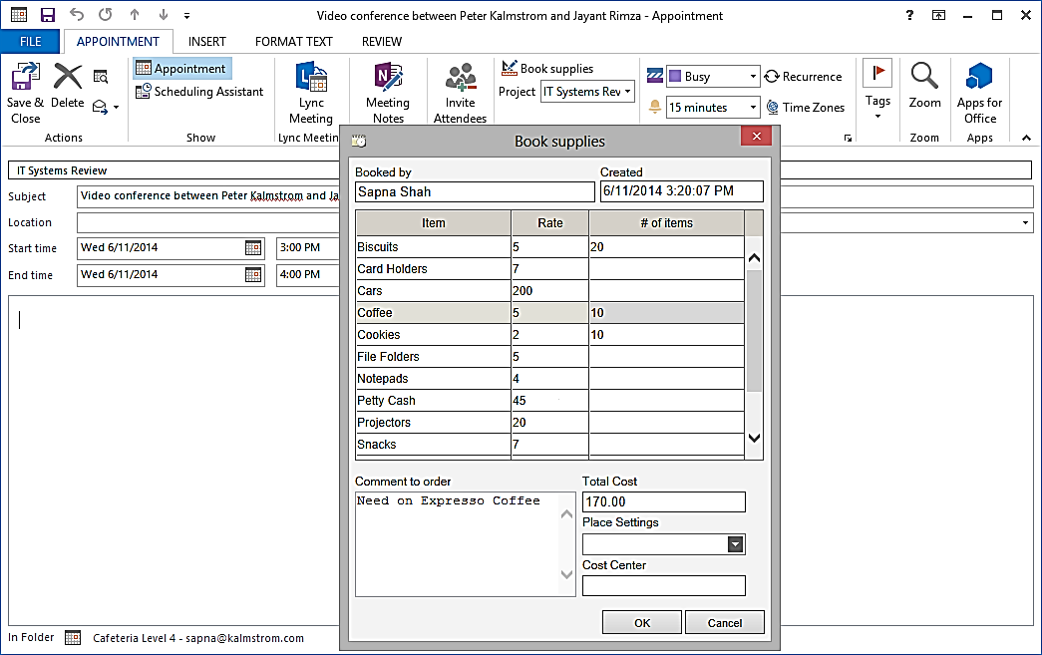

## Projects

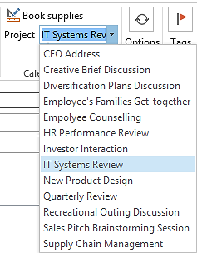Bookings may be attached to specific projects, and defining a project can be set to mandatory by the administrator, *see* Project. It is possible to change the caption “Project” in the settings, so you can give this parameter any name that suits your organization.

When the organization has more than 100 projects there is no dropdown. Instead there will be a button, and clicking it gives a dialog containing a list box with all the alternatives and a text box of the auto-complete type. This way the selection of the desired value is easy and fast also when there are many projects.

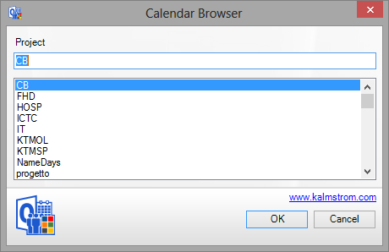

## Invite Attendees

When the resource calendar is within a mailbox, it is possible for the user to invite attendees in the booking form. *See* Public Folder or Direct Booking Mailbox Calendars?

## The Calendar Browser Overview

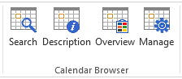The Overview gives an overview over bookings of all resources. The orders for each room and meeting are also listed here, and all activities and costs from a specified time are shown.   
It is also possible to **book resources** from within the Overview.   
For more info, s*ee* The *Calendar Browser* Overview.

## Export a Booking to PDF

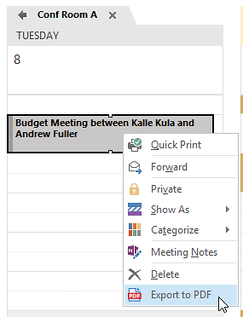You can export a booking to a PDF file.  This PDF file may be printed, saved or uploaded to a place where it can be downloaded or sent as an e-mail attachment.

To export, select the appointment you want to export and right click. Then select the option Export to PDF. You may also use a key combination: Crtl + Shift + P. This combination may also be used when the appointment is open.

When you need to print a booking, we recommend that you first export it to PDF, instead of using the Quick Print option. That way some specific *Calendar Browser* terms will not be included, so the print will get at cleaner look. You will still get the information about resource name and when it is booked.

# Installation

*Calendar Browser* is designed to be easy to install and distribute.

The installation has two steps:

1. From a client, install *Calendar Browser* on the server. During this process the client is also automatically installed on the PC used for the installation.
2. Install *Calendar Browser Client* on the other client machines. The Client MSI file may be used either for an installation on each machine or for a central installation via Active Directory.

Before *Calendar Browser* can be used some resource calendars must also be added.

## Create a *Calendar Browser* Directory on the Server

Downloaded the setup file, **CalendarBrowserSetup.exe**, from the bizsolutions365.com website to a PC. Create a *Calendar Browser* directory in any shared file folder on your server and save the file you downloaded into it.

You can use either a UNC-path, such as \\servername\sharename, or a mapped drive, such as Y:.If you use a mapped drive, the same network drive should be mapped with all users of *Calendar Browser*.   
  
Mapped drives are considered to be more secure than UNC paths, but if you specify an UNC path as installation place, all users of the Exchange Server will see it.

## Central Installation

The setup is done **from a client machine**, not directly on the server, so *from a client* go into the server directory where you put the file **CalendarBrowserSetup.exe** and click it to start the installation. The installation program will lead you through the installation.  
  
NOTE: Outlook should be **closed** when you install Calendar Browser.

You have to accept the license conditions before you can continue with the installation.

The first step is to select if you want to make a new installation, repair your installation or upgrade from an older version. Here a new installation is described. See below for information about Upgrade or Repair *Calendar Browser*.A screenshot of a cell phone

When asked for a folder path, you should give the path of the server folder where you want to place the *Calendar Browser* files. This could be a UNC path or a mapped network drive, *see* Create a *Calendar Browser* Directory on the Server.  
  
If you had already placed the setup file in the *Calendar Browser* Directory, as recommended above, that will be the default path.

### Client Installation

During the central installation the *Calendar Browser Client* is installed on the machine used for the installation.   
  
(From other machines where *Calendar Browser* should be used, close Outlook and go into the *Calendar Browser s*erver folder and run the file **CBClientSetup.msi.** For detailed instructions on this kind of client installation, refer to the [*Calendar Browser* User Manual](https://bizsolutions365.com/our-products/calendar-browser/cb-manual/).  
  
The .msi file may also be used for a central installation of the client via Active Directory.

Accept or change the client installation path on the local computer.

When you have clicked Next this screen is shown. Click Install to start the client installation.

Then the actual *Calendar Browser Client* installation will start.

This screen is shown when *Calendar Browser Client* has been installed. Click Finish to leave the Setup Wizard.

### The *Calendar Browser* Outlook Folder

When the client installation is finished, it is time to decide what **Outlook** folder *Calendar Browser* should be installed in.

*Calendar Browser* will now ask you to select Outlook folder. You may either select a folder you have created before the installation or create a new one.

If you want to create a new folder then click on New… 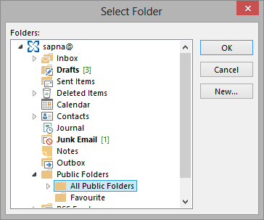

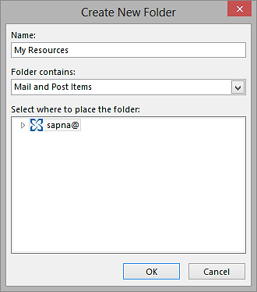

Enter a name for the new folder. Note that the folder must be of the type **Mail and Post Items**, *not* a calendar folder.   
  
The *Calendar Browser* Outlook folder may be a public folder or a shared mailbox:

If you use a **public folder** it is easy to let a group of users share the resource calendars. Normally no extra settings are needed, since the users have inherited permissions in public folders. Should you wish to only let part of the group use *Calendar Browser*, the server administrator has to set the permissions on the Exchange Server.

In the case when only a limited group should have the right to book resources, a **shared mailbox** might be a better alternative. For a bigger group a shared mailbox will take too much time to handle, since each user has to get permissions on the shared mailbox and on the calendars.

### Installation Finished

When the Outlook folder has been selected the installation is finished.  
  
## Example Data

If the software is new to you, it might be a good idea to load the Example Data. It gives you an opportunity to see how *Calendar Browser* works when you have a lot of data in it, what performance you can expect and so on.  
  
(When you select to *not* install Example Data, you will be asked to add a resource calendar the first time you open the *Calendar Browse*r folder in Outlook.)

### Load Example Data

When the central installation is finished you have a choice to load Example Data. Check the box before you click Finish, if you want to load the Example Data into your new installation.  
  
You can also create Example Data later, by running the file **CBCreateExampleData.exe** from the network folder where *Calendar Browser* is installed. When you choose to load Example Data, you will get the Example Data screen.

Here you will be able to see the details of the Example Data, like Resource calendars, Projects, Supplies, Organizers etc. You can choose period for the Example Data. Click OK when you are ready to generate the Example Data. When the Example Data has been loaded, you will get a confirmation message.  
  
### Remove Example Data

Remove the Example data through the Administrator settings, Calendars tab. *Refer* to Remove Calendar.

## Add Calendar Group

|  |  |
| --- | --- |
| Each user has to add at least one Calendar group before he or she can begin using *Calendar Browser*. This is done via a button in the Outlook ribbon/toolbar that is shown when the client installation is finished.  If there is only one installation, it is added automatically in the PC used for the installation. |  |

## Multiple *Calendar Browser* Outlook Folders

|  |  |
| --- | --- |
| You may have multiple installations of *Calendar Browser* in different folders in Outlook. Run the installer again and select new folders on the server and in Outlook.  The client users may then add the installations they need via the button “Add CB Group” in the *Calendar Browser* ribbon group.  The resource calendar groups are shown in the Outlook calendar view. This image is from a company with two campuses in same city with its different bookable resources or areas.  Most of the users only need to book resources at one campus, and therefore it is convenient to give them a possibility to only show the campus they use in Outlook. It gives shorter loading times, and users don’t need to see resources they are not interested in booking. |  |

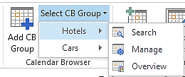  
When there are multiple installations of *Calendar Browser* and several calendar groups are added to a client’s Outlook, the user may select group for the Search, Overview and Manage (if shown to the users).

When a calendar in one of the calendar groups is selected, the *Calendar Browser* ribbon group will look like in the image below and the buttons will work for only that group.

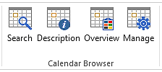

## Automatically Add CB Group To All Clients

If the administrator desires to automatically add a Calendar Browser group to all clients, he can do so by running the script file RegistryScript.vbs, present in the installation folder, individually or via Active Directory.

## The *Calendar Browser* Server Directory

When the installation is finished the *Calendar Browser* network folder will have the following content:

## The Calendar Browser Client

All users of the system have to install a minimal client application. During the installation in the server folder, the *Calendar Browser Client* is installed on the PC used for the installation.   
  
From other machines where *Calendar Browser* should be used, go into the *Calendar Browser* server folder and run the file **CBClientSetup.msi**. Outlook should be **closed** when the client is installed. The installer is designed to be run by the local administrator.  
  
For detailed instructions on this kind of client installation, refer to the [*Calendar Browser* User Manual.](https://bizsolutions365.com/our-products/calendar-browser/cb-manual/)   
  
A central installation via Active Directory of the *Calendar Browser Client* can be made with the same setup file, refer to [the bizsolutions365.com FAQ section.](https://bizsolutions365.com/faq/) (How do I deploy the Calendar Browser Client installation in an automated fashion?)

## User Permissions on the Server *Calendar Browser* Folder

To set the permissions on the server, right click the *Calendar Browser* installation folder on the server and choose Properties and then the tab Security.  
  
 The end users only need to have read permissions on the *Calendar Browser* folder.

(For running the CalendarBrowserArchive.exe application the users need write permissions on the folder, *refer to* Archive and Statistics.)

# The Calendar Browser Settings

When no Example Data is installed there are no resource calendars in *Calendar Browser* after the installation, so the first time you open it *Calendar Browser* will ask if you want to add calendars. If you click yes the Administrator settings will open.

In other cases the settings and configurations are done through the Manage button in the Outlook ribbon.

You can also open the Administrator Settings by running the file **CBAdminNET.exe** in the *Calendar Browser* directory on the server. If you choose to hide the Manage button from the Outlook ribbon, you have to use this method to open the settings.

All changes will be saved when you click OK, but sometimes you have to restart Outlook before the changes in the *Calendar Browser* Settings come into effect. In that case you will get a message about this after clicking OK.  
  
The management is organized under tabs, as described below. If your organization does not need some of the features, leave the corresponding checkbox unchecked and/or do not fill out any information under the corresponding Settings tab.

## Configure

This is the default dialog. Check the options you want to use and uncheck the ones you don’t want to use.

### Prevent Double Bookings or Recurrence

Via checkboxes in the Administrator Settings both double bookings and recurring appointments can be prevented.

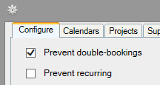Note that these preventions can be circumvented, for example using Outlook Web Access, so they are not a 100% block on doubles or recurring appointments. Also, due to the less than perfect way that the Outlook API works, it is not possible for us to fully check for double-bookings against recurring appointments. We therefore recommend that you disable recurring appointments also, if you want to prevent double-bookings.

If recurring appointments are allowed and users create them in *Calendar Browser*, a special icon is shown on the appointment in the Overview.

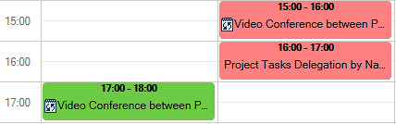

Note also that even if a double-booking should occur, *Calendar Browser* gives the advantage of showing who made the booking first. That feature is not readily available in Outlook itself.

### Ribbon Settings

|  |  |
| --- | --- |
| To give the end users a simpler interface you can hide the Manage and the Overview buttons by unchecking the checkboxes.  When you choose to hide Manage and Overview you must access the Administrator and Overview applications by running the files **CBAdminNET.exe** and **CBOverviewNET.exe** in the *Calendar Browser* server folder. |  |

|  |  |  |
| --- | --- | --- |
| The *Calendar Browser* ribbon group when the Manage and Overview buttons are hidden. The Manage and Overview checkboxes in the Settings are unchecked. | The *Calendar Browser* ribbon group when the Manage button is hidden. The Manage checkbox in the Settings is unchecked. | The default *Calendar Browser* ribbon group. The Manage and Overview checkboxes in the Settings are checked. |

### Copy Appointments

|  |  |
| --- | --- |
| The administrator can decide if copies of new appointments should be added to the personal calendar of the person booking or to another, specified calendar. |  |
|  |  |

### Change Log

When the checkbox for Change log is checked, all changes in bookings and supplies will be recorded in a Change log file in a subfolder in the *Calendar Browser* server folder.



### Configure Extra Booking Information

Check the box for Extra booking information if you want the users to be able to select Host and Attendees in each booking appointment.

The captions “Host” and “Attendees” may be changed into something else. Just write the terms you want to use in the fields under the checkbox.

The image below shows the Extra Booking Information pane in the appointment.

“Host” will be selected from a dropdown, and the logged in user is shown by default.

The “Attendees” are written in, but users only have to write the first letter for each person. Then alternatives are shown and the correct one can be selected.

The company, department or e-mail information will be shown automatically in the appointment when the name has been selected. The number of “Attendees” will also be filled out automatically.

When the Extra booking information box is checked, two new tabs will open in the Settings. They will be called Hosts and Attendees – or your own terms, if you have changed the default ones. Here you can fill out or paste names to be selected in the appointments and also their company, department or e-mail address.

When the Extra booking information box is checked, another Overview option will be shown for the Overview, Booking summaries. The Booking summaries give information about “Hosts” and “Attendees" for all meetings during a specified day, *refer to* Booking Summaries.

### Short Notice Flag

When this box is checked, reservations which have been made or modified at short notice will be highlighted with an hourglass in the *Calendar Browser* Overview. You must also decide how many days before the actual booking time the booking or change should be made to be highlighted.

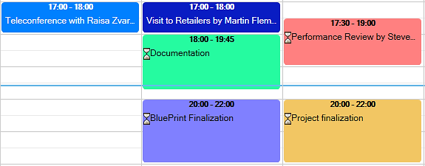

## Calendars

Under the tab Calendars you can add and remove resources and give each resource a description.

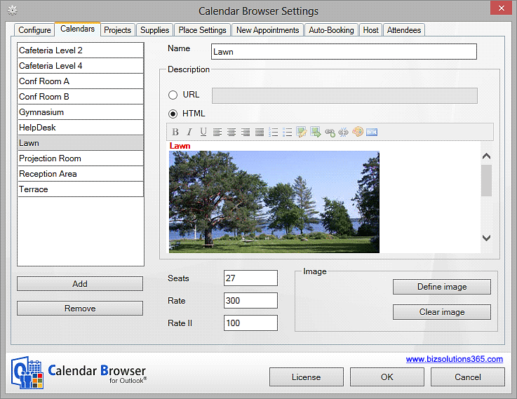

### Add Calendars

If there are no calendars in the *Calendar Browser* Outlook folder, you will be asked to create one when you open the Settings.   
  
You may also add a new calendar anytime by pressing the Add button under the Calendars tab.

The resource calendar can be a public folder calendar or a direct booking mailbox calendar. For differences, *refer to* Public Folder or Direct Booking Mailbox Calendars?

#### Add A New Public folder calendar

When you want to add a new public folder, type a name for it and a new folder with this name will be created.

#### Add A Direct Booking Mailbox Calendar

When you want to add a mailbox calendar, you need to type the name or SMTP address of an existing mailbox, because a new folder is not created in this case.   
  
The basic steps for creating a direct booking mailbox are:

1. Create a mailbox.
2. Assign send as permission to a security group containing *Calendar Browser* users.
3. Assign full permissions to the same security group.
4. Set auto response properties on the mailbox.

Specific resource mailboxes are available in Exchange 2007 and higher. For information on how to create a direct booking mailbox in Exchange Management Console, refer to the [Demonstrations page](https://bizsolutions365.com/our-products/calendar-browser/cb-demo/) on the bizsolutions365.com website.

#### Public Folder or Direct Booking Mailbox Calendars?

*Calendar Browser* works with both public folder calendars and direct booking mailbox calendars, and for every new calendar you add to *Calendar Browser* you can choose if it should be a public folder or a direct booking mailbox calendar. Both have their advantages and disadvantages. The most important differences regard invitation of attendees and access to and creation of the mailbox.

##### Public Folder Calendar

A public folder calendar can be accessed by all users who have permission to do so, normally all users with an e-mail account on the Exchange Server. Any update on this calendar is reflected in the public folder instantly, and therefore public folders are widely used for shared applications in network environments. With public folders it is easy to delegate the creation of new folders to for example reception personnel.

Public folders cannot invite to a meeting, so with public folder calendars there is no way to book a resource at the same time as you invite the other attendees. There must be a two-step operation. First the user will book the room or resource. Then, in a second step, he will book the meeting in his calendar and invite the attendees.

##### Direct Booking Mailbox Calendar

Direct booking mailbox calendars are a bit more complicated to administer. Creation of a new mailbox requires access to Active Directory, and you need to set up the mailbox to handle direct bookings. This must be done by a domain admin, so it is more difficult to delegate the administration of the resource calendars.  
  
 With mailboxes you have the advantage of being able to invite to meetings. When you use a direct mailbox booking calendar, the appointment is actually being saved into the user's personal calendar. That means that users can book their own calendar, the conference room and the attendees in one work flow, and if a meeting is rescheduled the resource will be updated and all attendees notified.  
The mailbox needs to be visible in the Global Address List for this to work. (New mailboxes are by default listed in the Global Address List in Exchange, so if it is not actively hidden it should be visible.)  
  
When the user makes a new booking through *Calendar Browser* in a direct booking mailbox calendar, the application automatically asks if the user would like to invite this calendar to a meeting. The user may also choose people to include in the invitation. A meeting request is sent automatically by Outlook, and if it is accepted a new meeting item is created in the accepting person’s personal calendar.

#### Add Personal Calendars

When you want to add shared personal calendars to *Calendar Browser*, select the mailbox option and write in the name of the calendar.

#### Browse To Existing Calendar

The alternative “Browse to existing Calendar” may be used to add all kinds of calendars that already exist in your Outlook to *Calendar Browser*.

#### Remove Calendar

Remove a calendar from *Calendar Browser* by selecting it and clicking Remove. When the calendar to be removed is a public folder, it is really deleted. When a mailbox calendar is removed only the link from *Calendar Browser* is deleted, not the mailbox itself.

### Description

Under the tab Calendars each room can be described with Seats and two different Rates. Just select the cells and write or paste in the digits. NOTE: If a calendar is described as having 0 seats, it will always show up in the search, since there is no filter for zero.

The second rate can be used if you want to separate some part of the cost for the resource. You might for example want to separate hire of the computers in a room because they need to be put on another account than the room itself.   


The resources can be described with words and images. When it comes to rooms, you can give the users information about each room’s features, such as type of room, air-condition, computers etc. The two methods for this are:

* URL: Here you can define a path to the description.
* HTML: Create a description directly in the .html description field to the right under the Calendars tab. The graphical WYSIWYG html editor makes it easy to create resource descriptions. You can also click the HTML icon in the editor and copy and paste .html code there.   
    
  *See* Descriptions for a picture that shows a description as the users see it.

### Overview Images

|  |  |
| --- | --- |
| If you want to use image headers in the Overview Timeline and Day views, define the image below the HTML editor. Valid formats are GIF, PNG, BMP and JPG.  Note that you also have to check the box “Show calendar images in Overview” under the Configuration tab for the images to be shown in the Overview. |  |

## Project

This function might also be used for other factors than project, because you can easily change the caption shown in the appointments to another word.

With different colors for different types of projects you will get a good overview over bookings in the *Calendar Browser* Overview. Write in the project name and select a color.   
  
Also decide whether to activate “Project mandatory”. When you do that, users cannot save a booking without specifying project ‒ or what you have decided to call it.

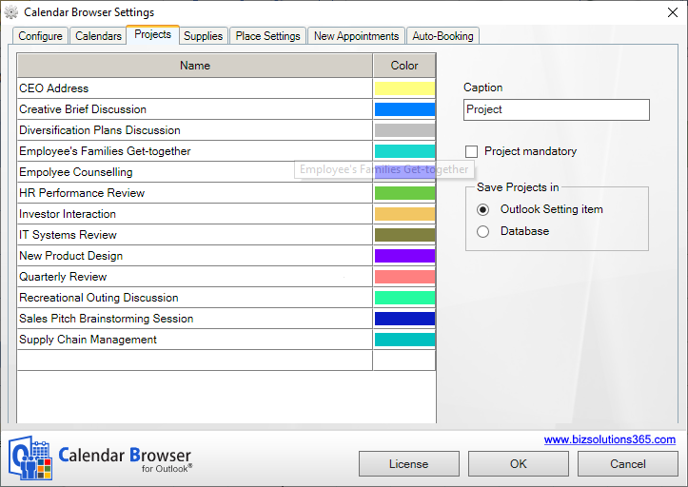

*Calendar Browser* requires no database if you don’t use the statistics application, and therefore the projects are saved in Outlook by default.   
  
However, if you want to use a database you can do that. This is especially useful if you already have a project list in a database. When the alternative Save in Database is selected, the projects are loaded from the database when *Calendar Browser* is run. The database options are Microsoft Access and SQL Server.

## Supplies

In the supplies section you can specify all supplies that might be needed with the resource and the cost for each item. The currency will be the one already specified for your system.   
  
You can also decide if information about Cost Center should be mandatory for each order, and Cost Center format can be specified.  
  
There are two Cost Center formats:

* XXX-XXX ‒ in this format users may only insert numeric values
* Free text ‒ in this format all types of values may be inserted (numeric, characters etc.)

### E-mail Notifications

When you want to send an automatic e-mail notification to the person responsible for the supplies, add an e-mail address after each supply item and check the box Auto-Email. Click on the Template button to open the template dialog. Here you can change the simple message into something that better suits your organization.

### Remove supply items without disturbing existing bookings

If an item is removed from the Supplies items list you will be asked if the item should be removed from existing bookings also. If you click No, the item will only be removed from the Supplies items list, so that it is not available for future bookings.

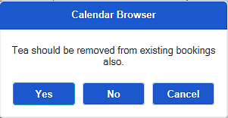

## Place Settings

Under place settings you can give the users several different room settings to choose from, like extra instructions on what tables should be used.

Another option is to use the Place settings for instructions on how the extra services ordered should be placed. For example:

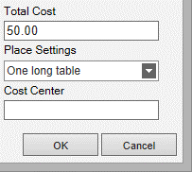On the side table

On the table

On a corner of the table

Or, if *Calendar Browser* is used to handle parties in a restaurant:

Blue china

Red china

White china etc.  
  
Or you can use any other configurations of the resources that can be made available. This option is free text, so it can be used in any way appropriate to the organization – or not be used at all.  
  
Enter a new Place Setting under the “Name” list. Click the Name list to add it to the list.

The users select the place settings in the supplies dialog of appointment:

## New Appointments

Here you can specify text that is to be filled into all new appointments. Use it if you for example want to give the end users a simple form to use when booking. The information is saved when you click OK. You can of course go back and edit the form if needed. (The information entered in such a form is not added to the Overview reports. If you want that, use the Configure Extra Booking Information instead.

|  |  |
| --- | --- |
| When a new appointment is created, the text from the template is copied into the appointments made by the users. |  |

## Auto-Bookings

When one resource is always booked together with another resource, it is convenient to auto-book the additional resource. This can be done under the Auto-Bookings tab.  
  
Here all the resource calendars are listed to the left, and the additional booking for each resource can be selected to the right. The list to the right is empty by default, and the admin may add “auto-booking-rules” as needed.

# The Calendar Browser Overview

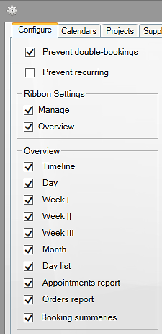 The Overview button gives access to different views of the resource bookings. These views can also be printed. Under the Configure tab you can specify what views the Overview should show.

What overview views the users will see depends on the *Calendar Browser* settings under the Configure tab.   
  
Resources can be booked from within the overview by clicking an empty space in one of the views. Then an appointment will be opened for the selected resource and time.

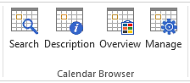To reach the Overview, click on the Overview button in the *Calendar Browser* ribbon group or run the file **CBOverviewNET.exe** in the Calendar Browser server folder.

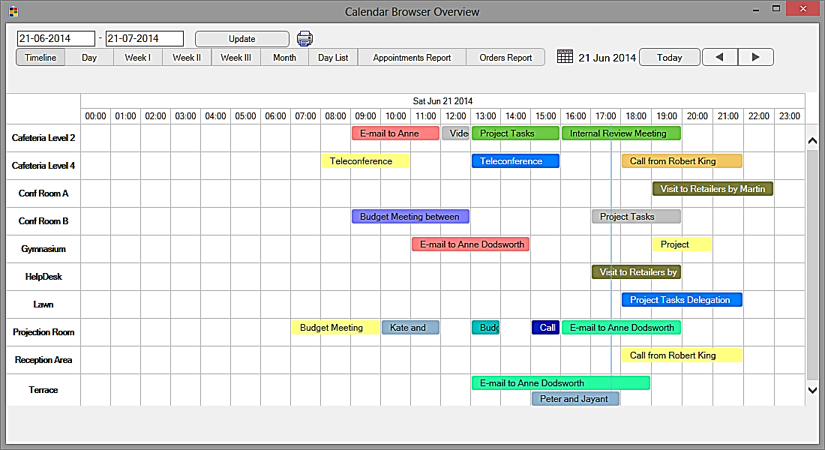Now a new Overview window with tabs for different views and reports will open.

## See More Info

The bookings shown in the Overview may be handled in different ways:

* Move the mouse cursor over an appointment and see info about the booking.

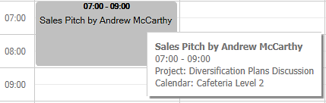

* Select the appointment to show more info at the bottom of the screen.  
    
  A screenshot of a social media post

  Description automatically generated
* Double-click the appointment to open it.

## Search the Overview

You can search the Overview by a given date range, and when Extra Booking Information is activated you can also search by a given date range sorted by Host (or any other term defined under the Configure tab in the Settings).When All is selected appointments from all hosts are shown, but if a particular host is selected, only appointments with that host will be visible.   
  
Note that Hosts are shown in the Overview only if the option “Extra booking information” is checked in the Calendar Browser settings, *refer to* Configure Extra Booking Information.



Else you will get an Overview screen without host information.



The Update button is for refreshing the data from Outlook. If you select a new date the information is updated automatically.

## Print

You may also print the Overview, something that is especially useful for the Appointments and Orders reports and for the Booking summaries.

When you want to print the Timeline, Day, Week I, Week II, Month or Day List view, open the desired view and press the Print button. Make sure that the PC is connected to the internet when you click on the Print button for these views. A PDF file will be downloaded to your PC. Open it and print it.

When you want to print Week III, Appointments Report, Orders Report or Booking Summaries, a simple window will open asking you to select printer. Select it and click Print. No internet connection is required for these views.

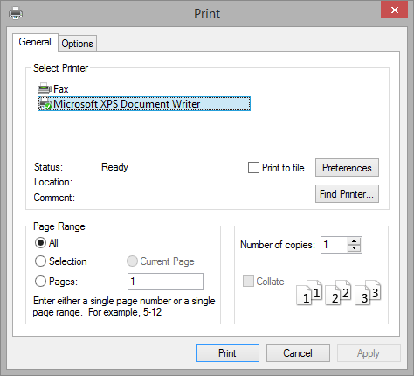

## Overview Images

The Timeline and Day views can show images. If you want to show images you must do two things in the Administrator Settings:

1. Check the box under the Configure tab.   
   
2. Add the image under the Calendars tab in the *Calendar Browser* settings.

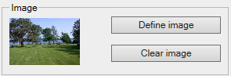

## Day View

In the Day view the bookings of each resource are shown for one day.

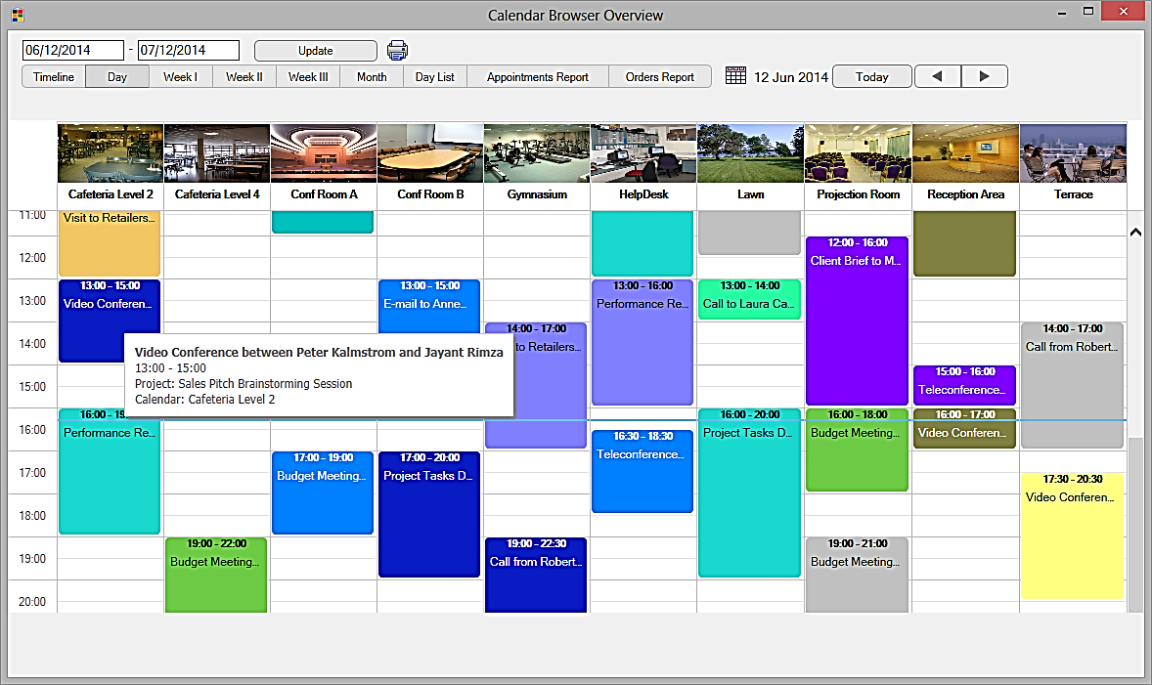

## Week Views

There are three different week views:

* Week I, from Sunday to Saturday
* Week II, from Monday to Sunday
* Week III, from Monday to Friday

## Month View

The Month view shows bookings for one month. By default all the resource calendars are shown, but you can filter the bookings by calendar. Select one calendar in the dropdown and only the bookings in that calendar will be shown.

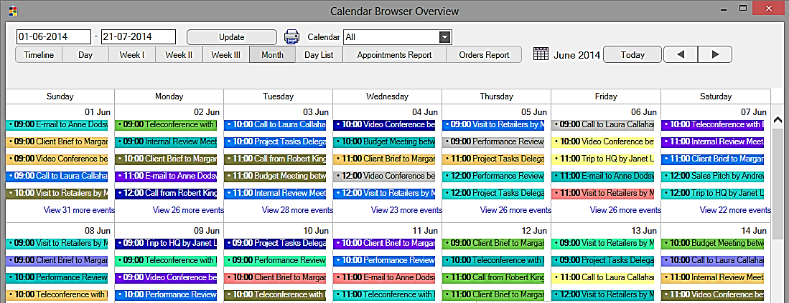

## Day List View

Under the tab Day List you get information about occupancy of and activities in the separate resources on the date you choose. If you click on the plus sign to the left of the appointment in the list, you will get info about the supplies ordered for the booking.

## Appointments and Orders Reports

The Appointments report shows all the appointments and their orders for the day or date range you have chosen.

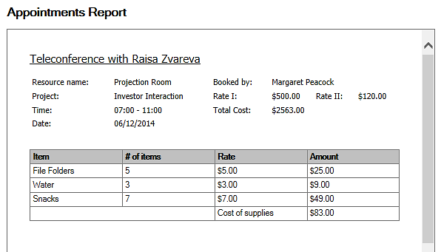  
  
The Orders report is like the Appointments report, except that all appointments that don’t have any supplies booked are filtered out, so that only appointments with orders are shown.

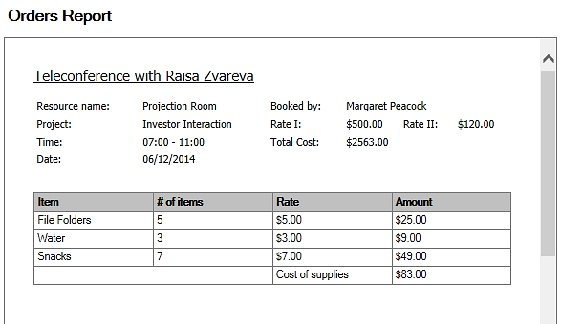

## Booking Summaries

All Overview tabs but the Booking summaries are shown by default and populated by the *Calendar Browser* example data. When you check the box for Extra booking information under the Configure tab in the *Calendar Browser* settings, you will get the possibility to use one more report, Booking summaries.   
  
This report gives summaries of bookings for certain dates and include host name, a name list of the attendees and information on when the booking was made and when it was last edited. When other terms than “Host” and “Attendees” are defined under the Configure tab in the *Calendar Browser* settings, these terms will be used in the Booking summaries too.

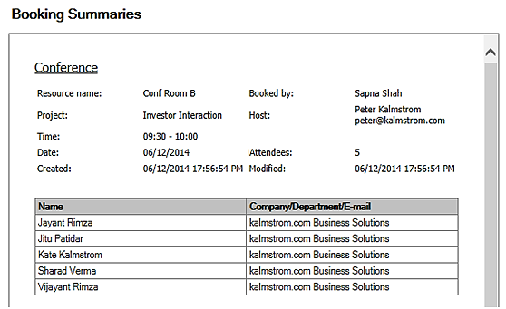

# Archive and Statistics

The Archive and Statistics are only meant for the management. After using *Calendar Browser* for a while you might want to study statistics on the resource usage, and you might also want to clear out old orders and appointments from Outlook. With this tool you can file away old bookings and generate Excel reports for analysis of the resource usage during a past period.

## The Archive Dialog

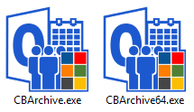You can file away old bookings with the **CBArchive.exe** application, a feature which saves the appointments into an Access database. You can find the file CBArchive.exe in the server folder where *Calendar Browser* is installed. Double click the .exe-file to start the application.   
  
There is another Archive application for the 64-bit version of Office, but if you run the wrong file *Calendar Browser* will correct this automatically.

Check the box for each resource calendar that you want to include in the statistics, and select time period.  
  
The box for Excel Reports is checked by default. Let it remain checked if you want to generate reports or update existing reports. Uncheck the box if you only want to archive old bookings and not generate statistics.  
  
Check the box for removal in the *Calendar Browser* Archive dialog, if you want the tool to remove the appointments from Outlook made for the period and resource calendars you have selected. In this case they will only be saved in the database, and you cannot reach them through Outlook.

## Database

The first time you run the CBArchive.exe file you will be asked to select database. The options are a new Access database that *Calendar Browser* creates for you in the *Calendar Browser* server folder, and a new or existing database on your in-house or hosted SQL Server

## Archiving

Click OK, and all the orders and appointments in the resource calendars and for the time period you have chosen are copied to the database.

When the files are copied (and removed, if you have checked that box) you will get a message about it.  
  
|  |  |
| --- | --- |
| Statistics When the checkbox for Excel Reports is checked at archiving, *Calendar Browser* will not only copy old appointments to the database but also create Excel reports on many aspects of the passed resource usage.   *Calendar Browser* will update the reports each time the Archive tool is run and the box for Excel Reports is checked. |  |

### Default Reports

The reports are stored in two files in the *Calendar Browser* server folder, CBAppointmentReports.xlsx and CBCostReports.xlsx.  
  
CBAppointmentReports.xlsx shows seven reports based on the resources, projects and organizers, while the CBCostReports.xlsx gives five reports on the costs of resources and supplies.

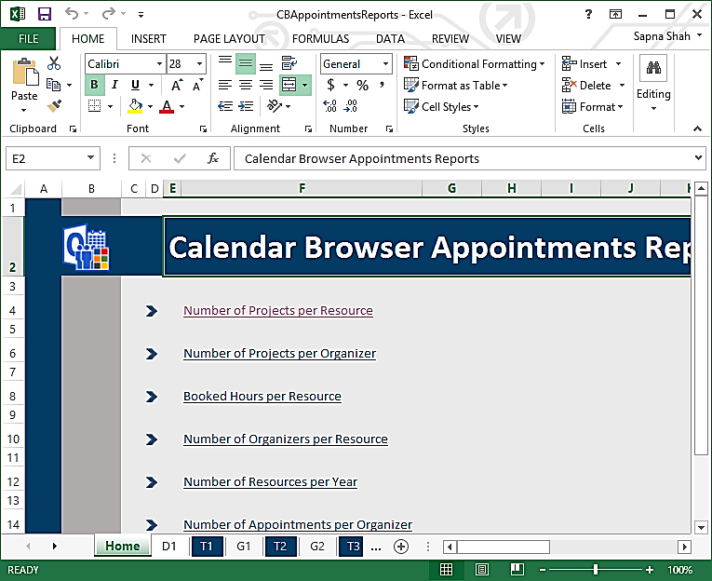  
  
The reports have both a pivot and a graphic presentation.

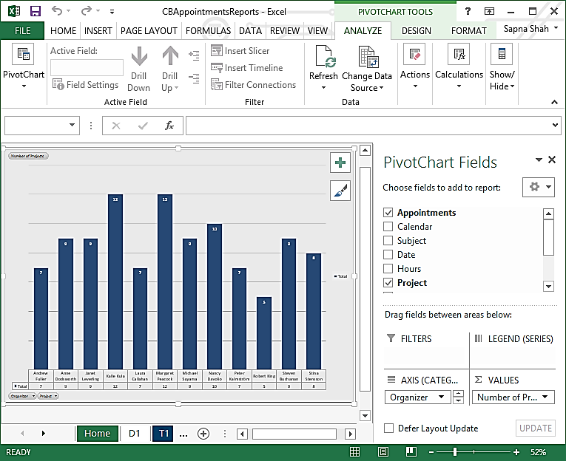

### Custom Reports

All the standard Excel features may be used with the default reports, so it is easy to modify these reports. If the changes are saved, the modified reports will be used instead of the default ones.   
  
To create a totally new report, go to the D1 tab, where you have all data, and insert a Pivot table. Select to add it to a new sheet.   
  
Now you can customize your report as you like. Then save the report.  
  
Next time you archive appointments, your modified or custom report will be refreshed with the new data just like the default reports.

# Upgrade or Repair *Calendar Browser*

To upgrade or repair *Calendar Browser*, run the installer (**CalendarBrowserSetup.exe**) from a client just as when you installed the application. If you can do the repair or upgrade from the same machine as you did the installer it is even better. Select the Repair/Upgrade alternative.

You are now asked to select the existing *Calendar Browser* installation. NOTE that *Calendar Browser* must not be running during repair or upgrade.  
  
Select the *Calendar Browser* Outlook folder and press OK, and the repair or upgrade will be performed automatically.

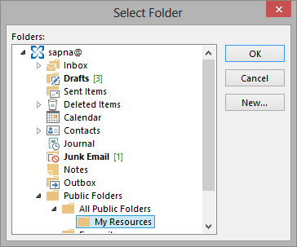

You will get a message when the upgrade or repair is finished.

When an upgrade has been performed, each user will be prompted to upgrade the *Calendar Browser Client* each time they use *Calendar Browser*, until they upgrade*.*

We recommend subscribers to always use the latest version of *Calendar Browser*.

# Subscription

*Calendar Browser* is licensed with a subscription model. There are two subscription levels, refer to <https://bizsolutions365.com/subscription/> Support, free upgrades and an unlimited number of users within the organization are included in both levels.

## Register

This information is only valid for organizations with a Minimum Subscription. *Premium Members do not have to register their installations.*  
  
You register *Calendar Browser* by clicking the License button in the Administrator Settings (When you have registered *Calendar Browser* this button will be hidden.)



Make sure the person who registers *Calendar Browser* has **Owner's right over the root Outlook folder**. This way, registration is done for all users using Calendar Browser.

When you have clicked the License button the register dialog is displayed. Add an e-mail address with the domain name of your company/organization and the registration key you have received from bizsolutions365.com.

# Support

To use *Calendar Browser* you must be a Member of the bizsolutions365.com Community. Free upgrades and the bizsolutions365.com Support Services are included in all Memberships.

## Contact

The solutions of bizsolutions365.com are designed to be very easy to deploy, use and manage. However, if you have any kind of problems or questions about our software, there are several ways of contacting us:

|  |  |  |
| --- | --- | --- |
| E-mail | support@bizsolutions365.com | Technical issues |
|  | sales@bizsolutions365.com | General and sales issues |
| Telephone | +91 780 600 6234 |  |
| Chat online | www. bizsolutions365.com |  |

# Remove Calendar Browser

To remove *Calendar Browser*, simply delete all the *Calendar Browser* folders and files.

## Remove Calendar Browser Client

Each user should also un-install the *Calendar Browser Client*. This is done from the Control Panel, Add-Remove programs / Programs and Features. Right click on Calendar Browser Client Tool and choose Uninstall.

If a dialog comes up, answer Yes to remove.

